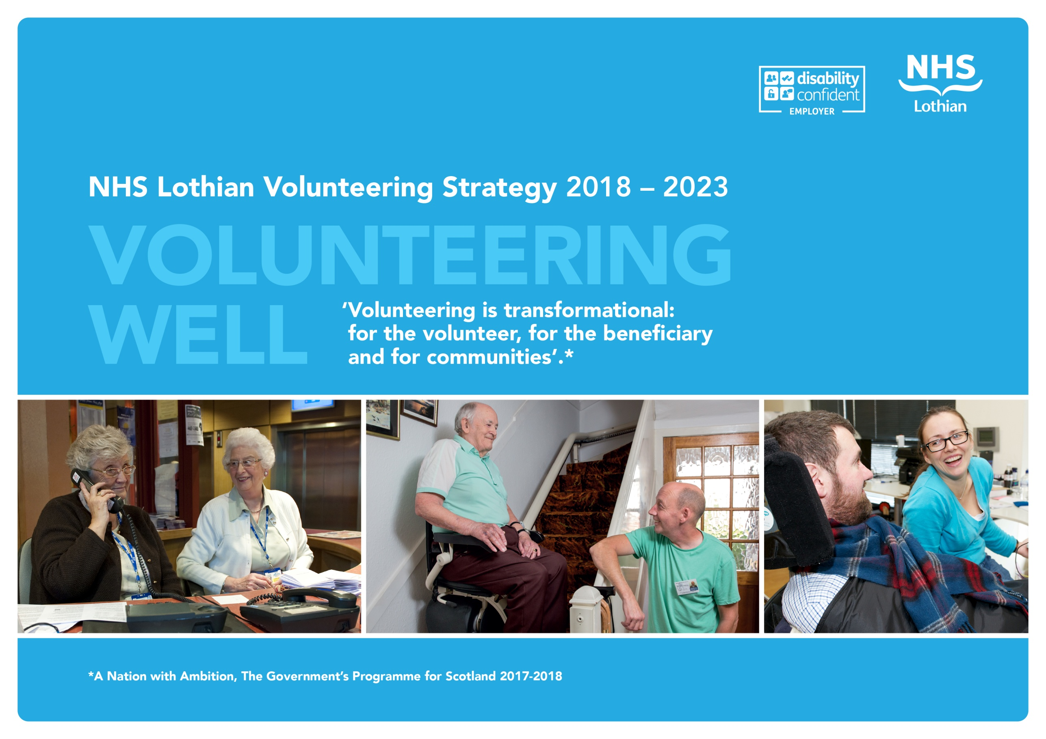
NHS Lothian Volunteering Strategy
2018 – 2023

“Volunteering Well”

‘Volunteering is transformational:
for the volunteer, for the beneficiary
and for communities’.

Vision, Key Principles and Strategic Objectives

1. Introduction

NHS Lothian has a proud history of volunteers being involved in supporting patients and staff for more than 80 years when the ‘RIE Ladies Extension Appeal Committee’ (the RIEVs) had their inaugural meeting at the City Chambers. Volunteers make a unique and valuable contribution to patients, carers, visitors and staff across NHS Lothian and it should be recognised that volunteers along with those employed by the Board are an essential resource in helping us achieve our goals.

This volunteering strategy is designed as the blue-print for achieving the full potential of volunteering for NHS Lothian, the community which it is a part of and the individual and organisations that make up the community. It is founded on a system wide review of current practice, undertaken by Volunteer Scotland and subsequent stakeholder engagement and focus group work.

Through the Volunteering Strategy 2018-2022, NHS Lothian will extend more opportunities to a wider volunteer population and will become a hub for individuals seeking to invest time, talent and commitment for the benefit of the local health economy. The strategy will help us become an exemplar of best practice in Scotland. It will offer focussed youth volunteering programmes in parallel with community activity, in patient and peer support volunteering roles. The management of volunteers will be enhanced to ensure that the opportunities offered deliver a personally rewarding experience for every volunteer and make a measureable difference to patients and colleagues across a range of services.

This strategy represents a step change in how we will recruit and manage volunteers, adopting fresh approaches to branding, technology, role design, staff and community engagement and communications. This means that our volunteer activity is targeted, scalable and sustainable for the long-term. The visibility and leadership of volunteering will be enhanced with specific roles developed to deliver a partnership working with specialist voluntary organisations and the youth volunteering programme.

2. NHS Lothian Volunteer Vision

The Volunteer Vision builds upon NHS Scotland’s Volunteering Programme key outcomes and is intended to have an threefold impact; to enhance the experience of the people using our services, to benefit those participating in volunteering activities and to have an impact on the wider community.
Volunteers will enhance the experiences of people using the services of NHS Lothian, and their unique perspectives of health care will help shape the care provided

Our approach to volunteering will strengthen our contribution to the life of our local communities

Volunteers will have a personally rewarding experience and know that their contribution is valued and has made a difference

NHS Lothian will focus volunteering efforts where there can be greatest impact and in areas of greatest need, either to support the efficiency and effectiveness of NHS Lothian services or to improve the patient experience. Some programmes will focus on social gain and positive outcomes for the volunteers. The Youth Volunteering Programme will run in parallel with all other volunteering and there are elements where the activities will overlap and elements where specific models will be applied for different groups.
The Volunteer Services will signpost to more appropriate opportunities where alternative options offer a better outcome for the interested party. This will mainly be around employability where work experience or supported activities via one of the many third sector organisations will better meet the needs of the volunteer.

3. The 4 Key Principles and 10 Aims & Objectives for Excellence in Volunteering in NHS Lothian 2018 - 23

4. The Volunteering Programmes

5. Making It Happen

The actions and the funding streams to deliver the 10 objectives are detailed in the tables below.

- Embedding volunteer leadership at board and senior management levels
- Form a Volunteer Strategy Implementation Group to provide leadership and ensure active delivery of the strategy (see roles and responsibility below), chaired by a Board ‘champion’, and including representation from the corporate management team, staff, third sector, volunteers and possibly key delivery partners(s)
- Include information about local volunteering activities and stories of high impact volunteering, where individual’s (patient, carer, staff, volunteer) experience has been enhanced to Board members on Executive walk rounds
- Utilise opportunities to present to Board / Corporate Management Teams / Nurse Directors’ Group / IJBs to raise the profile that volunteering brings
- Establish more robust reporting mechanisms and communications strategy including production of a regular news feed via facebook or a blog/twitter/ newsletter and updates in the Chairman’s commentary for the Annual Review

2. Establishing a positive and safe volunteering culture across NHS Lothian
- Provide a clear definition of volunteering and its role in NHS Lothian
- Build a culture that recognises and celebrates the role and contribution of volunteers e.g. recognising long volunteering service; attaining ‘Volunteer Friendly’ status
- Establish ‘volunteer hubs’ with dedicated space for volunteers to network, share learning/best practice and to attract new people to volunteer
- Create Volunteer Ambassadors within the volunteering community to support new volunteers
- Inspire staff confidence in volunteers as part of relationship building campaign, engaging clinical and non-clinical staff at all levels and across NHS Lothian to involve volunteers in wards and departments and support them to champion and celebrate the role of volunteers
- Ensure that all volunteers (whether directly or indirectly engaged) have been through a robust recruitment and induction process
- Create a highly visible volunteering identity e.g. with volunteers wearing identifiable ‘uniform’ – tabards or t-shirts
- Celebrate and communicate the impact and learning internally and externally
- Enhance volunteers’ role as a key constituent in supporting the strategic aims of NHS Lothian through volunteering, quality, patient and public involvement and fundraising

3. Identifying volunteer needs, now and into the future
- Work with staff to identify opportunities for volunteering roles to enhance patient experience and maximise the impact on patient outcomes
- Scope out and establish the optimum number of volunteers required to ensure each volunteering roles is covered and sustained support to services is provided
- Establish systems that enable services to be bold, including through the Young Volunteers Programme, in testing new and innovative volunteering projects, that are subsequently, described, approved, resourced and rolled out
- Identify opportunities for current and former patients to create either ‘peer support’ networks (e.g. similar to the network established with heart patients) or groups for new patients to learn from lived experience

4. Maximising the information recorded on the Volunteer Information System
- Develop electronic systems / an app for matching volunteers to appropriate roles across NHS Lothian
- Measure the contribution and recognise the contribution made by volunteers by tracking volunteers time, activity and progress in delivering role outcomes
- Enable re-engagement of volunteers who have had to dial down their commitment
- Learn from others to ensure that we are utilising potential opportunities to improve patient experience and the quality of care
- Reflect principles of the national Volunteering Framework once published

5. Developing and implementing a needs-based volunteer recruitment strategy
- Move to a ‘demand’ led service where volunteering opportunities are largely determined by NHS Lothian staff, recognising that volunteers never replace staff roles
- Develop multi-media channels to extend recruitment to new and hard-to-reach audiences
- Enhance the website, design a more ‘engaging’ volunteer section with clear demand led volunteering opportunities
- Introduce recruitment campaigns / recruitment cycle, target recruitment to appropriate audiences for priority volunteering roles whilst maintaining the simplicity and safety of a more swift application process
- Engage local business, education, voluntary and community sectors as sources of volunteering recruitment
- Increase the brand and visibility of volunteering to drive recruitment including the use of social media
- Reflect our core values across the volunteering cycle, starting with recruitment
- Acknowledge the requirements to enable “one off” entertainment volunteer contacts whilst maintaining the safety of patients and staff

6. Standardising our volunteer learning and development protocols
- Tailor and enhance the induction programme for volunteers, using a variety of a flexible and multi-media approaches to support learning that ensure volunteers, patients and staff are kept safe
- Empower volunteers to progress in their roles proportionate to their knowledge, skill and experience
- Facilitate knowledge exchange and support amongst the volunteer community within NHS Lothian and beyond

7. Building a system of evaluation for Quality Improvement
- Introduce Key Performance Indicators and utilise existing patient experience data to demonstrate the impact of volunteering
- Use evaluation data to drive the quality of the volunteering experience by establishing regular stakeholder surveys to capture experience from patients and their carers, staff, active volunteers and those that leave to build on what works well and address what works less well
- Harness volunteers’ unique insights as a driver to improving patient care
- Quantify the impact / productivity gain including (where appropriate) the economic
value of contribution

8. Building a robust and sustainable funding and resource framework
- Recruit a new Programme Manager for Volunteering / Head of Volunteering
- Appoint a permanent Volunteering Administrator
- Appoint a Young Volunteer Programme Manager
- Realign the workload of the Volunteer Service Managers to work more effectively and do what only they can do
- Identify and proactively compete for sources of funding and other investment to meet resourcing needs for an ambitious volunteering programme, re-prioritising as necessary to respond flexibly to new funding opportunities

9. Strengthen and Build upon our Partnership Working
- Appoint an External Relationship Manager to build relationships with partners, recognising the expertise and opportunities from 3rd sector organisations
- Develop formal partner engagement protocols / Service Level Agreements for all third party providers of volunteers to ensure appropriate governance to support and protect both patients and volunteers
- Working in partnership with different groups or organisations to develop a range of opportunities for people interested in volunteering e.g. providing ‘taster’ opportunities

10. Gaining a reputation for Excellence in Volunteering
- Develop a more robust communication strategy that
  - proactively communicates the quality and impact of volunteering at NHS Lothian using a variety of different media including production of a regular news feed via facebook or a blog/twitter/ newsletter
  - Articulates what makes volunteering at NHS Lothian unique
  - Promotes NHS Lothian as an opinion former in defining best practice in NHS volunteering
  - Markets NHS Lothian as the locally and nationally recognised ‘Go To’ provider for best practice in NHS volunteering

- Governance and Staffing
Within NHS Lothian the governance for Volunteering sits with the HealthCare Governance Committee and operationally under the Executive Director for Nursing, Midwifery and AHPs.

This strategy relies on a refreshed staffing structure to support the various workstreams and a Head of Volunteering to drive forward the ambitious plans and will ensure that the Board is compliant with the guidance issued by the Scottish Governments Healthcare Quality and Improvement Directorate “CLEAR PATHWAY: Supporting the safe, effective and person-centred involvement of volunteers from the third sector in NHS settings”.

- Funding the Volunteering Strategy
There is a core NHS funded establishment, corporately and in Edinburgh H&SCP, which together with contributions from the Edinburgh Children Hospital Charity fund the current staffing arrangements. The Edinburgh and Lothians Health Foundation (ELHF) have funded the Royal Edinburgh Volunteers Hub for the last 10 years and this commitment together with a commitment for the next 5 years will support the growth of roles to support this ambitious strategy. The Youth Volunteering Programme is being funded, in year 1, by the Pears Foundation. Future years funding will be from the ELHF allocation.

Source of Funding | Current Commitment | Proposed Commitment
NHS – Corporate | 2 wte Volunteer Services Managers (plus top up for ECHC VSM) | 2 wte Volunteer Services Managers
NHS – non recurring funding | 0.4 wte Voluntary Services Co-ordinator (RHSC)
NHS – Edinburgh H&SCP | 1 wte Volunteer Services Manager | 1 wte Volunteer Services Manager
Edinburgh Children’s Hospital Charity fund | 0.6 wte Volunteer Services Manager  0.6 wte Deputy VSM | 0.6 wte Volunteer Services Manager  0.6 wte Voluntary Services Co-ordinator
Pears Foundation | Nil | 1 wte Youth Volunteering Manager
Edinburgh and Lothian Health Foundation | Volunteer Hub @ REH | Volunteer Hub @ REH  1 wte Head of Volunteering  1 wte 3rd Sector Relationship Mgr  1 wte Volunteering Administrator  1 wte Youth Volunteering Manager (from year 3)

A Nation with Ambition, The Government’s Programme for Scotland 2017-2018
https://nursingbadges.wordpress.com/2011/01/31/royal-infirmary-of-edinburgh-volunteers-rievs/
Volunteer Friendly (Scotland) is funded by Big Lottery through the Supporting Voluntary Action Programme administered by Scottish Council for Voluntary Organisations.

