Equality and Human Rights Annual Report 2025 - 2026


Published
Contents
About this report 3
Summary of performance 7
PRIORITY 1: embedding equality and human rights 9
PRIORITY 2: we are an anti-racist organisation 15
PRIORITY 3: we meet the needs of disabled people 21
PRIORITY 4: we are gender inclusive 25
PRIORITY 5: people are involved in decisions about their care and treatment 28
PRIORITY 6: investing in education and training 31

About this report
In April 2023, the NHS Lothian Board agreed our equality and human rights strategy, Healthy and Better Lives for Everyone. The strategy guides us to make sure NHS Lothian is a safe and inclusive place for everyone who works for us and uses our services. It contributes to achieving our goal of improving the health of the people in Lothian. This is our third annual report and sets out the progress we are making towards achieving the six priorities in the strategy.
  - NHS Lothian Equality & Human Rights Team
The Equality & Human Rights team oversees delivery of the strategy and provides expert advice, support, education and leads projects across the system. We are responsible for providing support to ensure NHS Lothian fulfils its statutory equality and human rights duties. This year, Laura and Rakiya were joined by Jen, Clare, Louise, Charlie and Bolu.
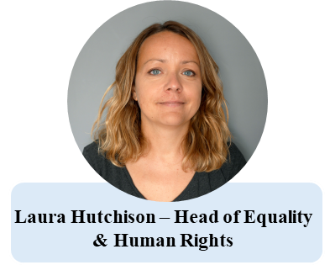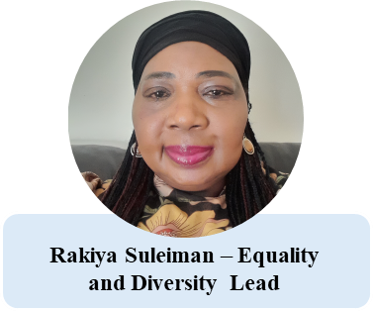

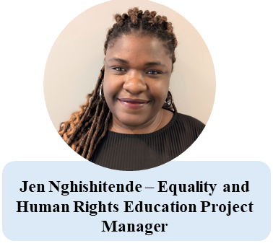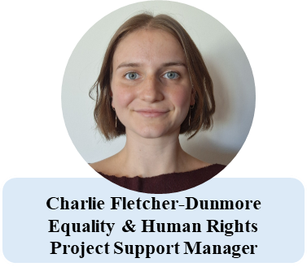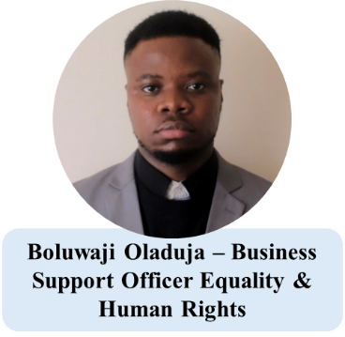
The team benefited from the knowledge and skills of Clare Gallagher, who was part of the team from May 2025 to January 2026 as one of the Equality and Human Rights Education Project Managers, and of Louise Addison who provided Project Management support from July 2025.
The work done this year and the progress towards achieving meaningful change was only possible because of the commitment to equality and human rights shown by thousands of people who work in NHS Lothian.
  - Structure of this report
This year’s annual report includes outcome measures and indicators for each equality and human rights priority. Our priorities are the outcomes we are aiming to achieve by April 2028. For each outcome measure we consider:
- Results
- What the results tell us
- Performance against the KPI.
  - Equality and Inclusion Staff Annual Survey
One of the ways we are trying to understand the progress we are making is by asking for feedback from staff as part of our Equality and Inclusion Annual Staff Survey which runs every January. This year 1,670 members of staff responded to the survey.
This survey involved a “non-probability sampling method” which means all NHS Lothian staff were invited to participate. Whilst this method is quick and practical, we acknowledge there is a possibility of not hearing from a representative sample of the entire workforce. Despite “probability sampling” being favoured by analysts and statisticians for large surveys, where we would be reliant on a pre-selected random sample of the workforce being asked to participate and respond, there is a risk of reduced response rates with this approach. Furthermore, this valuable exercise of providing our entire workforce an opportunity to share their honest opinions and experiences of working at NHS Lothian may become diluted and less informative, which is counter-productive in relation to our aims and objectives.
The survey was promoted through staff newsletters, the intranet news banners, line manager emails, team briefings, MS Teams Channels, posters in all main sites and leafleting at the Royal Infirmary of Edinburgh, Western General Hospital, West Port and the Comely Bank Centre. The survey collected information about how people heard about the survey, job family and protected characteristic. This information shows that we did achieve a reasonably representative sample. There were three particular differences between the survey responses and NHS Lothian workforce data.
- There are fewer staff under 30 in the survey group (7.4%) compared to the workforce (16.2%).
- A higher proportion of staff in the survey group (15.9%) declared that they have a disability compared to the workforce (2.6%). This is closer to the proportion of the Lothian population who declared they had a disability in the Scotland census 2022 (21.2%).
- There is a higher proportion of admin staff in the survey group (29.6%) compared to the workforce (15.5%).
  - CMT Equality and Children’s Rights Annual Audit
To help measure how we are embedding equality and human rights into our decision-making we are using the results of our Corporate Management Team (CMT) Equality and Children’s Rights Audit. There are two parts to the audit:
- Audit of CMT papers
- Audit of Equality and Children’s Rights Impact Assessment (ECRIA) Reports included in any proposed new or revised policies or practices considered by CMT.
For the first part, each year a sample of CMT papers are reviewed through the established RAG audit process. Papers are rated red, amber or green based on whether and how they consider equality and children’s rights. Improvement is measured by an increase in green rated papers and a reduction in red rated papers, year on year.
For the second part, ECRIA reports submitted as part of CMT papers are reviewed against 25 questions, which are based on Equality and Human Rights Commission (EHRC) and Scottish Government Children’s Rights guidance. Answers to each question are given a RAG rating. We then collate the RAG ratings for each question. Performance is measured by the number of questions that have a red, amber or green rating. Improvement will be shown by an increase in the proportion of questions rated green, and a reduction in the proportion of questions that were rated red.
  - Workforce equality data
NHS Lothian collects and analyses information from employees about their protected characteristics. We use this information to understand the diversity of our workforce and to help us understand if we need to take action to improve the representation of protected groups. In relation to this strategy, we are using our workforce equality data about ethnicity and disability to measure the progress we are making to achieve the priorities that aim to reduce racial and disability employment inequalities.
  - Patient equality data
NHS Lothian also holds some equality data as part of patient’s demographic information held on TRAK, our digital patient record management system. The protected characteristic information held on TRAK are – age, sex and ethnicity. Reliable patient equality data is important to allow NHS Lothian to understand, acknowledge and address differences in access to health services and outcomes disproportionately experienced by some protected groups in our population. We are using our patient ethnicity data to help understand, in part, the progress we are making to achieve our anti-racism priority, which aims to reduce racialised health inequalities.

Summary of performance
  - Priority 1 embedding equality and human rights
Our performance indicates that NHS Lothian is making strong, system-wide progress embedding equality and human rights into its core organisational functions. The evidence demonstrates improvement in staff perception, strengthened governance processes, significant use of equality evidence to inform decisions and high-quality equality and children’s rights impact assessment activity. Across the year, actions have been delivered that have contributed to achieving strong levels of assurance and alignment with our statutory duties.

Priority 2 we are anti-racist
NHS Lothian is making year-on-year progress. Staff confidence is growing, workforce diversity is increasing, data completeness is improving, and there is tangible evidence of anti-racist action being taken. Together, this shows we are building the conditions necessary to reduce racialised inequalities and embed anti-racist practice in our workplace culture.
  - Priority 3 we meet the needs of disabled people
NHS Lothian is performing well against this outcome. Clear and focused actions have been taken and there is improving disability representation. Staff continue to feel broadly positive that NHS Lothian is meeting the needs of disabled people. However, uncertainty has increased slightly. While this suggests staff views are being maintained, there is slow progress in growing staff confidence. This indicates there is more work to do in future years to achieve this priority.
  - Priority 4 we are gender inclusive
NHS Lothian is making meaningful progress towards becoming a gender inclusive organisation. Although staff agreement that we are gender-inclusive has fallen slightly this year, this is due to increased uncertainty and not disagreement. This uncertainty may be influenced by the increased level of public, legal and policy debate about the interaction of women’s rights and the rights of trans people, which became more visible in Scotland this year due to tribunal judgments about the use of single-sex spaces such as toilets and changing facilities. The reduction in staff confidence is balanced against strong evidence of action, engagement and system-wide work to improve inclusive practice and reduce gender inequalities.
  - Priority 5 people are involved in decisions about their care and treatment
Our performance indicates that NHS Lothian is improving the way people with mental health conditions and people with dementia are supported to know and claim their rights, and to participate in decisions about their treatment. Action is being taken to embed human rights in our practice in a deliberate and structured way and staff agreement that we are achieving this priority has increased. While this potentially indicates that rights-based approaches are becoming more visible and consistent, progress is slight and almost half of staff are uncertain how well we are performing against this priority. To address this, resources should be prioritised towards making human rights explicit in our organisational policies and procedures, and to provide support to more staff working in mental health settings to help them apply human rights in their practice.
  - Priority 6 investing in education and training
We are making steady and positive progress in strengthening equality and human rights education. Staff perceptions are improving, and we have put in place a strong, system-wide framework that is delivering high-quality education and training. This shows that NHS Lothian is building the infrastructure and opportunities needed to support an inclusive workplace culture and to embed equality and human rights into everyday practice.

PRIORITY 1: embedding equality and human rights
OUTCOME 1: Equality and human rights are a central part of NHS Lothian’s planning, decision-making, delivery and reporting.

MEASURE 1.1: There is clear evidence that actions have been taken across the year to embed equality and human rights into NHS Lothian’s work.
INDICATOR 1.1: Evidence of sustained actions taken, with progress maintained or increased every year.

  - Results
- The Chief Executive set and delivered her own Equality Diversity and Inclusion (EDI) objectives focusing on improving her understanding of people’s experiences of discrimination and harassment in NHS Lothian. These included doing EDI walk rounds of the three main hospital sites, offering staff the opportunity to share their experiences of EDI with her in person or through an anonymous online feedback form and meeting with individual members of staff.
- We developed and carried out an audit of how the CMT gives due consideration to equality and children’s rights in its decision-making process. We implemented the recommendations from the audit including drafting and publishing an NHS Lothian ECRIA Policy, updating the CMT cover paper template and updating the NHS Lothian ECRIA website, guidance and templates.
- The Public Health Intelligence Team has supported teams to access and use equality evidence to help understand how health access and outcomes are different across social and demographic characteristics.
- We carried out an ECRIA of the implementation of Scottish Government Waiting Times Guidance and identified a range of mitigating actions to reduce or remove the potential negative impact of some of these changes on groups of the population.
- The Equality and Human Rights Team started collecting data about enquiries about discrimination and harassment including requests for personal advice, line manager advice and bespoke training and development. This information is being used to identify actions within the Equality & Human Rights annual workplan and the Workforce Advancing Equality Action Plan.
- The Quit Your Way stop smoking service recognised the lack of equality data used in performance reporting and is exploring how different protected groups access Quit Your Way services.
- We developed Key Performance Indicators to be included in the Deputy Chief Executive performance management system.
- We are working with the Edinburgh Integrated Joint Board Strategic Planning Group to support routine consideration of SIMD data to support better understanding of health inequalities experienced by different protected groups experiencing socio-economic disadvantage.
- The Patient Experience Team are taking forward our Child Friendly Complaints Process following guidance from the Scottish Public Services Ombudsman (SPSO).
- The Child Health Commissioner is working with the UN Convention on the Rights of the Child (UNCRC) Leads’ Network and the UNCRC Observatory to share learning across Scotland and use it to support NHS Lothian teams and services embed children’s rights.
- A UNCRC Champions Network has been established in NHS Lothian and is working with the Children’s Parliament to inform and embed children’s rights into our practice.
- We started a Health Needs Assessment about access to services for pregnant people and parents of infants with HIV, which includes consideration of the needs of different protected groups.
- Midlothian Health and Social Partnership (HSCP) shared information about NHS Lothian staff equality networks during National Wellbeing Week, including having an equality network table to raise awareness of the peer support the networks provide to staff.
- We have created a Leading in Lothian Managers’ development programme which includes learning and development about inclusive recruitment practices.
- As part of the Anchor Institution Workforce priority, staff equality data is being used to identify and potentially prioritise positive action measures for groups of staff who may face barriers to recruitment, retention and progression in the workplace.

  - What this tells us
At the most senior level, NHS Lothian’s Chief Executive is leading by example by setting and delivering EDI objectives.
A comprehensive audit was completed to assess how the CMT applies ECRIA processes, its recommendations were fully implemented and the audit will be carried out annually.
Work to enhance the use of equality evidence has progressed significantly by teams across the organisation including Acute Services, Waiting Times Governance, Public Health Intelligence, Quit your Way and Healthy Respect and we are continuing to build a richer understanding of the needs of specific communities. Feedback and learning from these teams about why they are using equality evidence, what they are using it for and what difference it is making can be used to support other parts of the system do the same.
We are progressing work to embed respect for and promotion of children’s rights into services and influencing and learning from others.
Strategic performance structures are being strengthened through the development of equality KPIs.
  - Performance against this KPI
There is strong evidence that actions to embed equality and human rights have been taken across the year.
MEASURE 1.2: There is due consideration of equality and children’s rights within CMT papers.
INDICATOR 1.2: CMT audit results maintain or increase positive ratings (Green + Amber) every year.

  - Results
- The overall positive rate is 65.6% (Green + Amber).
- The overall green rate is 43.5%.

Audit 2025: Questions | Number of CMT Papers
Was there evidence that the need for an Equality and Children’s Rights Impact Assessment (ECRIA) had been assessed? | 24 (54.5%) | 9 (20.5%) | 11 (25%) | 0
Was a rationale to explain why an ECRIA was not required provided? | 13 (39.4%) | 8  (24.2%) | 12  (36.4%) | 11
Was the rationale provided appropriate? | 12  (40%) | 10  (33.3%) | 8  (26.7%) | 14
Was the ECRIA report attached to the CMT Paper? | 4  (33.3%) | 1  (8.3%) | 7  (58.3%) | 32
Has the ECRIA been published on the NHS Lothian website? | 4  (33.3%) | 1  (8.3%) | 7  (58.3%) | 32
KEY: GREEN – high level of information and ECRIA process followed. AMBER – adequate level of information and part of the ECRIA process followed. RED – not enough information and ECRIA process not followed. BLUE – the question was not applicable to the CMT paper.
  - What this tells us
This year, CMT papers demonstrated good consideration of whether an ECRIA was required and provided reasons. Where ECRIAs were required, the ECRIA results were not consistently attached or published. This can be rectified through improvements in process.
  - Performance against this KPI
There is evidence of due consideration of equality and children’s rights within CMT papers. We have a solid and good baseline on which to measure future performance.
MEASURE 1.3: Good quality, well evidenced ECRIAs are being carried out following NHS Lothian ECRIA policy and process.
INDICATOR 1.3: ECRIA reports maintain or increase positive ratings (Green or Amber) every year.

  - Results
- 96% of ECRIA reports were rated positively (Green + Amber).
- 48% of ECRIA reports were rated green.

Audit 2025: RAG rating of ECRIA reports | Number of questions rated R-A-G
Red – not enough information provided or the ECRIA process not followed | 1 (4%)
Amber – adequate level of information provided and part of the ECRIA process followed | 12 (48%)
Green – high level of information provided and ECRIA process followed | 12 (48%)

  - What this tells us
Good quality and well evidenced ECRIAs are being carried out. This indicates overall high compliance with the Equality and Human Rights Commission (EHRC) and Scottish Government guidance.
The red rating about publication of ECRIA reports indicates an isolated issue that can be remedied, rather than a systemic problem.
  - Performance against this KPI
Good quality ECRIAs are being carried out, with 96% meeting expected quality standards.
MEASURE 1.4: NHS Lothian staff agree that equality and human rights are a central part of NHS Lothian’s planning, decision-making, delivery and reporting.
INDICATOR 1.4: Staff survey results maintain or increase positive responses year on year.

  - Results
- Positive responses increased by 3.4 percentage points (pp).
- Disagree (2.2pp) and undecided (2.4pp) both decreased.
- Strong disagree increased slightly by 0.6pp to 4.2%.

Priority 1 | 2025 |  | 2026 |  | 2025-2026
Priority 1 | Number | Percentage | Number | Percentage | Percentage points
1. Strongly disagree | 37 | 3.6% | 70 | 4.2% | +0.6
2. Disagree | 102 | 9.9% | 129 | 7.7% | -2.2
3. Don’t know | 172 | 16.7% | 291 | 17.4% | +0.7
4. Undecided | 223 | 21.7% | 323 | 19.3% | -2.4
5. Agree | 287 | 27.9% | 492 | 29.5% | +1.6
6. Strongly agree | 206 | 20.1% | 365 | 21.9% | +1.8
Total | 1027 | 100.0% | 1670 | 100.0%

  - What this tells us
This year, more people explicitly agree that equality and human rights are a central part of NHS Lothian’s planning, decision-making, delivery and reporting and fewer are undecided or moderately opposed.
The shift of the median from “undecided” to “agree” may signal that the centre of opinion now leans towards agreeing that equality and humans are a central part of our work.
  - Performance against this KPI
Positive responses increased from 48% to 51.4% showing improvement in staff confidence that equality and human rights are embedded in NHS Lothian’s core functions.

PRIORITY 2: we are an anti-racist organisation
OUTCOME 2: We are an anti-racist organisation, and our work helps to eliminate racism, remove racialised inequalities and reduce racial prejudice.
MEASURE 2.1: There is clear evidence that anti-racist actions have been taken across the year.
INDICATOR 2.1: Evidence of sustained actions taken, with progress maintained or increased every year.

  - Results
- We advertised and appointed members to the Trans-Atlantic Slavery Recommendations Implementation Group (TASRIG). There is a diverse representation from NHS Lothian staff and the community. We held the inaugural meeting of the group and discussed expectations, ambitions and ways of working to achieve our aims.
- The work of the Maternity Services Black Minority Ethnic (BME) EDI sub-group continued, improving engagement between communities from BME background and maternity and neonatal services.
- We promoted attendance, and will monitor NHS Lothian participation, at NHS National Education Scotland (NES) Anti-Racism Leadership Development sessions with executives, non-executives and senior leaders.
- We proactively challenged racist graffiti found in a staff only area at the Royal Infirmary of Edinburgh, sending out site wide communication to all staff, reinforced by an instruction to managers to have discussions with their teams.
- The work of the BME Nursing and Midwifery Career Progression Group continued, including surveys to understand experiences of career progression and track current position and potential differences from previous surveys. The Group has improved communication and coaching opportunities.
- The work of the Royal Edinburgh and Associated Services (REAS) EDI group continued, focusing on celebrating diverse cultures and promoting participation in NHS Lothian equality and human rights education.
- We have established and improved links between Lothian’s Gypsy Traveller Community Health Worker and NHS Lothian services.
- We have developed a zero tolerance to racism and discrimination campaign that will be launched in April 2026.
  - What this tells us
NHS Lothian is continuing to ensure governance structures are in place to embed anti-racism into organisational decision-making and addressing inequalities by strengthening trust, communication and involvement with BME communities.
Leadership accountability is increasing, and anti-racism is being framed as a responsibility of all managers. There is active work to normalise and celebrate racial diversity.
  - Performance against this KPI
There is clear evidence that anti-racist actions have been taken across the year.
Measure 2.2: There is progress each year in achieving a workforce that reflects the ethnic diversity of the Lothian population.
Indicator 2.2: Ethnic diversity is maintained or increased each year, moving towards alignment with the most recent census profile of the Lothian population.

  - Results
- Fewer staff are withholding information about their ethnicity on the NHS Lothian electronic Employee Support System (eESS), with a 2.7%pp decrease in those preferring not to share their ethnicity since 2023.
- There has been a drop in the proportion of White Scottish/Other British staff, down by 2.2pp, while White Irish levels remain unchanged at 2.5%.
- There is growth across other White groups, including a 0.3pp increase in White Polish and a 0.2pp increase in White Other staff.
- There are increases in BME staff, including a 1.9% rise in African staff and a 1.6% rise in Asian staff.
- Smaller increases are seen across other minority groups, with 0.2% rises in Other ethnic groups and Mixed/Multiple groups, and a 0.1% rise in Caribbean or Black staff.
- Comparison with the Lothian population is unreliable because of the high percentage of staff who have not disclosed their ethnicity data.

Ethnic group | NHSL Feb-23 | NHSL Feb-25 | NHSL Dec-25 | Lothian census- 2022 | Difference NHSL Dec 2025 – Loth census 2022
White Scottish or White Other British | 59.5% | 58.0% | 57.3% | 79.36% | -22.06%
White Polish | 0.3% | 0.5% | 0.6% | 2.8% | -2.2%
White Irish | 2.5% | 2.5% | 2.5% | 1.5% | +1.0%
White other | 6.8% | 6.8% | 7.0% | 5.8% | +1.2%
White Gypsy/Traveller | 0.0% | 0.0% | - | 0.04%
African, Scottish African, British African or Other African | 1.0% | 2.0% | 2.9% | 1.3% | +1.6%
Caribbean or Black | 0.2% | 0.3% | 0.3% | 0.2% | +.01%
Asian, Scottish Asian, or British Asian | 3.5% | 4.4% | 5.1% | 5.8% | -0.7%
Mixed or multiple ethnic group | 0.7% | 0.8% | 0.9% | 1.9% | -1.0%
Other ethnic group | 0.5% | 0.6% | 0.7% | 1.3% | 0.6%
Prefer not to say | 19.0% | 16.1% | 16.3% | - | +22.7%
Don't know | 5.6% | 6.4% | 5.8% | - | +22.7%
Unknown | 0.5% | 1.7% | 0.6% | - | +22.7%
Total | 100.0% | 100.0% | 100.0% | 100.00%

  - What this tells us
Known ethnicity improved meaning a larger share of staff can be included in ethnicity analysis. This may suggest growing trust and/ or better prompts to update equality data. Better disclosure rates reduce bias in equality monitoring and make analysis of representation, recruitment and progression data more reliable.
The increases in African and Asian groups may be consistent with gradual improvement in representation and/ or confidence to disclose.
Non-disclosure of ethnicity data is still high. Therefore, until non-disclosures reduce to a lower level, comparisons with the Lothian population are not yet reliable.
  - Performance against this KPI
There is year on year progress towards a more ethnically diverse workforce. Representation and disclosure are improving.

MEASURE 2.3: There is an increase in the completeness and accuracy of ethnicity data collected for people on NHS Lothian waiting lists.
INDICATOR 2.3: The proportion recorded as ‘unknown’ is reduced to allow meaningful analysis of equality of access and outcomes across different ethnic groups.

  - Results
- 64% of people on NHS Lothian waiting lists have their ethnicity recorded.
- Ethnicity information is missing for 29% of patients (“unknown”).
- 7% have refused or not provided their ethnicity.

  - What this tells us
For more than a third of people on our waiting lists, NHS Lothian does not have usable ethnicity data. The data gap limits meaningful analysis of equality of access to health services and health outcomes and our ability to use ethnicity data to inform actions to reduce racialised health inequalities.
Refusal rates are relatively low, which may indicate that most data is missing due to people not being asked or it not being recorded. This suggests that improvement might be achievable through process and practice changes.
  - Performance against this KPI
There is a solid foundation to work on to allow measurement of performance in future years.
Measure 2.4: NHS Lothian staff agree that we are an anti-racist organisation.
Indicator 2.4: Staff survey results maintain or increase positive responses year on year.

  - Results
- 55.6% of responses are positive (agree + strongly agree) and responses are maintained this year with a small increase (+0.3 pp).
- Strongly agreed increased by 2.6 pp.
- Negative responses fell by 1.2 pp.

Priority 2 | 2025 |  | 2026 |  | 2025-2026
Priority 2 | Number | Percentage | Number | Percentage | Percentage points
1. Strongly disagree | 41 | 4.0% | 61 | 3.7% | -0.3
2. Disagree | 85 | 8.3% | 123 | 7.4% | 0.9
3. Don't know | 112 | 10.9% | 232 | 13.9% | +3.0
4. Undecided | 221 | 21.5% | 325 | 19.5% | -2.0
5. Agree | 347 | 33.8% | 526 | 31.5% | -2.3
6. Strongly agree | 221 | 21.5% | 403 | 24.1% | +2.6
Total | 1027 | 100.0% | 1670 | 100.0%

  - What this tells us
While a growing group of staff responding to the survey may feel very strongly that NHS Lothian is taking anti-racism seriously, others may feel less certain or less informed. This can be quite common in organisations developing anti-racist approaches, where some staff may connect strongly with the work and others may be new to the terminology, unsure about what actions are happening or unclear about expectations.
The rise in “strongly agree” responses may indicate that more staff see visible, credible action being taken on anti-racism and NHS Lothian may be building trust and confidence in its equality and anti-racism commitments.
The drop in both “disagree” and “strongly disagree” responses may show that fewer staff believe NHS Lothian is failing to act on anti-racism, resistance is decreasing and staff who previously did not see action may now recognise improvements are being made. This may indicate a slight, but important, shift in culture.
  - Performance against this KPI
Confidence that NHS Lothian is anti-racist is stable to slightly stronger. Intensity of agreement for NHS Lothian being an anti-racist organisation increased, and disagreement declined.

PRIORITY 3: we meet the needs of disabled people
OUTCOME 3: We anticipate and meet the needs of disabled people so they can access services and employment opportunities.
MEASURE 3.1: There is clear evidence that actions have been taken across the year to anticipate and meet the needs of disabled people.
INDICATOR 3.1: Evidence of sustained actions taken, with progress maintained or increased every year.

  - Results
- Our Fair Recruitment Training has been reviewed and updated to include understanding bias and neuro-inclusive recruitment practices.
- With the Disabled Employee Network (DEN) we co-developed and co-delivered new training and development sessions on disability and reasonable adjustments and neuroinclusive healthcare.
- We held focus groups with disabled staff, line managers and trade unions and updated the Reasonable Adjustment in the Workplace Guidance.
- We established a short life working group to develop neurodiversity support for line managers.
- We established the NHS Lothian Children’s Services D/deaf Children and Families Steering Group to involve D/deaf children and their families in decisions about how to improve access to children’s health services and improve relationships with services. NHS Lothian uses the term ‘Deaf people’ to describe people who identify as part of a cultural and linguistic group of people who use British Sign Language (BSL) as their first language. Deaf people share a visual language, experiences and a sense of identity and often do not recognise themselves as disabled. We use the term ‘deaf people’ to describe people who have acquired hearing loss and use spoken and written language. We use the term ‘D/deaf’ to explain that the group is about the experiences of both Deaf and deaf children and families. Membership of the steering group includes organisations representing D/deaf children and families and children’s services. The Steering Group has met four times and agreed it’s terms of reference, safer spaces framework and action plan.
- We added BSL to patient information videos on the Royal Hospital for Children and Young People website.
- We agreed to provide second and fourth year Heriot Watt students learning British Sign Language (BSL) with opportunities to visit NHS Lothian hospitals and observe NHS Lothian BSL interpreters.
- We are setting up a text messaging service to allow people who are D/deaf or have difficulties speaking to contact us.
- We are developing a pilot volunteering programme for Deaf people who use BSL.
- We are running a new pilot for Occupational Therapy in primary care to support disabled people who want to access employment.
  - What this tells us
NHS Lothian is taking proactive steps to remove barriers for disabled people to ensure that we anticipate and meet diverse needs.
The actions that have been taken are grounded in engagement, involvement and co-production. This should strengthen the relevance of this work and ensure it is based on lived experience.
We are taking targeted action to support neurodivergent staff and patients.
  - Performance against this KPI
There is strong evidence that actions have been taken across recruitment, workforce support and service delivery.
MEASURE 3.2: The NHS Lothian workforce reflects the disabled population in Lothian.
INDICATOR 3.2: The proportion of staff who identify as disabled is maintained or increased each year, moving towards alignment with the most recent census profile of the Lothian population.

  - Results
- The percentage of staff disclosing they are disabled increased from 2.1% to 3.6%.
- The data suggests a potential disability employment gap of 17.6% (number of disabled staff compared to the Lothian population).
Disability | Feb-23 | Feb-25 | Dec-25 | Lothian-2022 | Difference Dec 2025-Loth 2022
Declared disability | 2.1% | 2.6% | 3.6% | 21.2% | -17.6%
No declared disability | 97.9% | 97.4% | 96.4% | 78.8% | +17.6%
Total | 100.0% | 100.0% | 100.0% | 100.0%

  - What this tells us
More staff are telling us that they are disabled, which may suggest improved disclosure and/ or better representation.
The disabled workforce remains far below the Lothian population, which may indicate substantial under-disclosure and/ or representation. The “no-declared disability” likely includes people who are not disabled and people who have not disclosed or updated their status. Comparisons with the Lothian population should be treated with caution due to different definitions/ measurements (NHS Lothian self-declared versus the census measure of long-term conditions).
  - Performance against this KPI
There is year on year increases in the percentage of staff disclosing they are disabled.
MEASURE 3.3: NHS Lothian staff agree that NHS Lothian is anticipating and meeting the needs of disabled people in services and employment.
INDICATOR 3.3: Staff survey results maintain or increase positive responses year on year.

  - Results
- Almost 50% of responses agree (agree + strongly agree) that NHS Lothian is meeting the needs of disabled people. The overall percentage of staff who agree remains essentially unchanged (47.4% to 47.1%)
- 12.5% of staff disagreed and negative responses dropped slightly by 0.5pp.
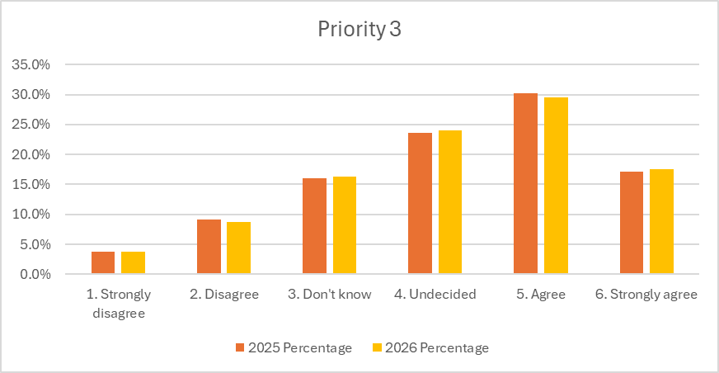
Priority 3 | 2025 |  | 2026 |  | 2025-2026
Priority 3 | Number | Percentage | Number | Percentage | Percentage points
1. Strongly disagree | 39 | 3.8% | 64 | 3.8% | 0.0
2. Disagree | 94 | 9.2% | 146 | 8.7% | -0.5
3. Don't know | 164 | 16.0% | 272 | 16.3% | +0.3
4. Undecided | 243 | 23.7% | 402 | 24.1% | +0.4
5. Agree | 311 | 30.3% | 494 | 29.6% | -0.7
6. Strongly agree | 176 | 17.1% | 292 | 17.5% | +0.4
Total | 1027 | 100.0% | 1670 | 100.0%

  - What this tells us
Staff continue to feel broadly positive that NHS Lothian is meeting the needs of disabled people. Uncertainty has increased slightly and there has been no notable decline in responses either. While this suggests staff views are being maintained, confidence in how well we are achieving this priority has not grown, indicating there is more work to do in future years.
  - Performance against this KPI
Staff agreement that NHS Lothian is meeting the needs of disabled people has been maintained, with a slight rise in strong agreement.

PRIORITY 4: we are gender inclusive
OUTCOME 4: We are gender inclusive, we do not discriminate on grounds of sex or gender identity and our work helps to tackle persistent gender inequalities.
MEASURE 4.1: There is clear evidence that actions have been taken across the year to be gender inclusive.
INDICATOR 4.1: Evidence of sustained actions taken, with progress maintained or increased every year.

  - Results
- We have developed and delivered staff training on recognising and preventing sexual harassment in the workplace.
- An Equality and Children’s Rights Impact Assessment was carried out and the results are being used to inform the development of Phase 2 of NHS Lothian’s Women’s Health Plan.
- Menopause support sessions are provided across sites, and we carried out an evaluation of the implementation of NHS Scotland Menopause and Menstruation Policy in NHS Lothian.
- Midlothian HSCP Staff Wellbeing service has organised a women-only swimming group which has allowed women to attend who require support during the menopause and/ or whose culture or religion means they need a women-only swimming lane.
- We are working with the Women’s Staff Equality Network to implement a Women’s Mentoring Programme.
- We published our Gender Pay Gap Report 2025 and Equal Pay Statement 2025 - 2029.
- The information and practices around maternity leave have been reviewed with the Women’s Staff Equality Network and we have published a staff maternity hub webpage.
- We are delivering a detailed programme of work aimed at reducing avoidable harm within Maternity and Neonatal services using the findings of the KWISA Nothing About Us, Without Us report.
- We are continuing to work towards gaining Equally Safe at Work accreditation.
- A short life working group has been established to ensure all staff have access to suitable workplace toilets and changing facilities. This group oversees progress of the workplace facilities audits being carried out across all NHS Lothian sites, proposals for suitable single occupancy universal toilet facilities and responding to enquiries about suitable staff changing and toilet facilities.
- We have carried out a human rights assessment of NHS Lothian Gender Affirming Surgery pathways and are using the results to develop an action plan to ensure the pathways are rights respecting and help reduce the health inequalities experienced by trans and non-binary people.
- The Trans and Non-Binary Stakeholder Group met three times and is improving engagement and communication with Lothian trans and non-binary communities.
- We have co-produced and co-delivered staff training on trans inclusive healthcare.
  - What this tells us
A wide range of activities have taken place over the last year that aim to strengthen equality, safety, wellbeing and inclusion for women, trans and non-binary people and to understand and reduce health inequalities.
Meaningful engagement and involvement with people with lived experience is being used to develop programmes of work to improve gender inclusion and reduce inequalities.
  - Performance against this KPI
There is clear evidence that actions have been taken across the year to help NHS Lothian be gender inclusive.
MEASURE 4.2: NHS Lothian staff agree that we are gender inclusive.
INDICATOR 4.2: Staff survey results maintain or increase positive responses year on year.

  - Results
- Over half of responses are positive and agree or strongly agree (55.9%).
- The number of staff responding that they are unsure increased by 3.9 pp.
- Agreement fell by 3.3 percentage points and disagreement fell by 0.6 pp.
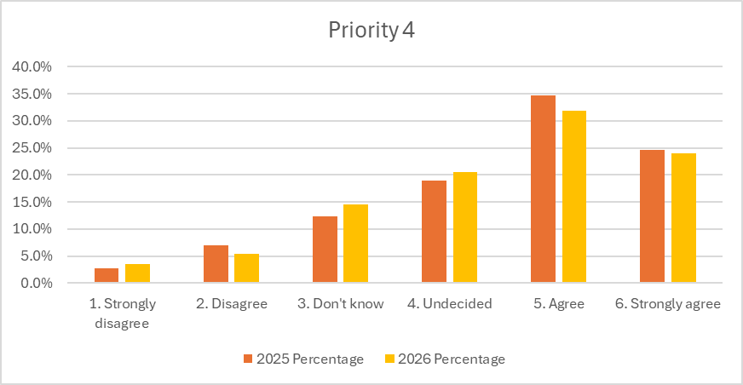
Priority 4 | 2025 |  | 2026 |  | 2025-2026
Priority 4 | Number | Percentage | Number | Percentage | Percentage points
1. Strongly disagree | 28 | 2.7% | 60 | 3.6% | +0.9
2. Disagree | 71 | 6.9% | 91 | 5.4% | -1.5
3. Don't know | 126 | 12.3% | 244 | 14.6% | +2.3
4. Undecided | 194 | 18.9% | 342 | 20.5% | +1.6
5. Agree | 356 | 34.7% | 532 | 31.9% | -2.8
6. Strongly agree | 252 | 24.5% | 401 | 24.0% | -0.5
Total | 1027 | 100.0% | 1670 | 100.0%

  - What this tells us
Over half of staff who responded still agree NHS Lothian is gender-inclusive, but agreement fell. The drop is not due to rising disagreement. Instead, more staff are uncertain.
This uncertainty may be influenced by the increased level of public, legal and policy debate about the interaction of women’s rights and the rights of trans people. In Scotland this year, this has become more visible due to tribunal judgments and related public debates about the use of single-sex spaces such as toilets and changing facilities.
  - Performance against this KPI
The majority of staff responses (55.9%) agree NHS Lothian is gender-inclusive, but agreement has dipped this year because more staff are unsure.

PRIORITY 5: people are involved in decisions about their care and treatment
OUTCOME 5: We support people who use our mental health services and people with dementia to know about and claim their rights, and to make decisions about their care and treatment.
MEASURE 5.1: There is clear evidence action has been taken across the year to support people with dementia and people who use our mental health services to know about and claim their rights, and to make decisions about their care and treatment.
INDICATOR 5.1: Evidence of sustained actions taken, with progress maintained or increased every year.

  - Results
We developed the NHS Lothian Care About Rights human rights training and development programme. This programme is based on the Scottish Human Rights Care About Rights project. It aims to increase participants knowledge and understanding of human rights and to empower them to take their learning and put it into practice through interactive group work applying the SHRC FAIR model to case studies. The programme supports staff to use human rights to help resolve complex issues and make decisions about care and treatment in a way that respects the dignity, autonomy and rights of the people receiving care and treatment while supporting staff to provide safe, effective and rights-respecting care.
We delivered Care About Rights to 38 staff working in the Melville Unit (NHS Lothian’s purpose built inpatient mental health ward for children and young people aged 12 to 18 years).
The feedback from the sessions was that they were well received, with high ratings for clarity, participation and balance between presentation and interaction. On average staff rated the sessions 8.3 out of 10 indicating a high level of satisfaction and all 31 staff who completed the feedback said they were able to participate and actively engage in discussions and activities.
Four more sessions are planned in 2026 to ensure all staff working at the Unit have completed the training programme. The Equality and Human Rights team will also develop a coaching programme to support Melville Unit staff put their learning into practice by incorporating a rights-based approach to decisions that are made during Multi-Disciplinary Team (MDT) meetings.
  - What this tells us
The Care About Rights Programme is a new and ambitious human rights initiative for NHS Lothian. It is long-term and aims to meaningfully support staff so they can apply human rights to their clinical practice. The goal is to support safe, effective, rights-respecting care.
It is resource intensive for clinical teams and can be challenging to incorporate into busy working schedules where clinical demand and safety must be prioritised.
However, learning about human rights has provided staff with the knowledge and skills to apply to complex situations and find possible ways to reduce restrictive practices. This provided optimism and reassurance to staff working in particularly challenging environments.
  - Performance against this KPI
There has been structured, meaningful action to embed human rights into care and practice. This demonstrates strong progress and is a solid foundation to build on.
MEASURE 5.2: NHS Lothian staff agree that we support people with dementia and people who use our mental health services to know about and claim their rights, and to make decisions about their care and treatment.
INDICATOR 5.2: Staff survey results maintain or increase positive responses year on year.

  - Results
- Overall agreement increased by 1pp (42.9% to 43.9%).
- There were increases in strong agreement and strong disagreement (1.3 pp in both) and a fall in those who don’t know (-2.4 pp).
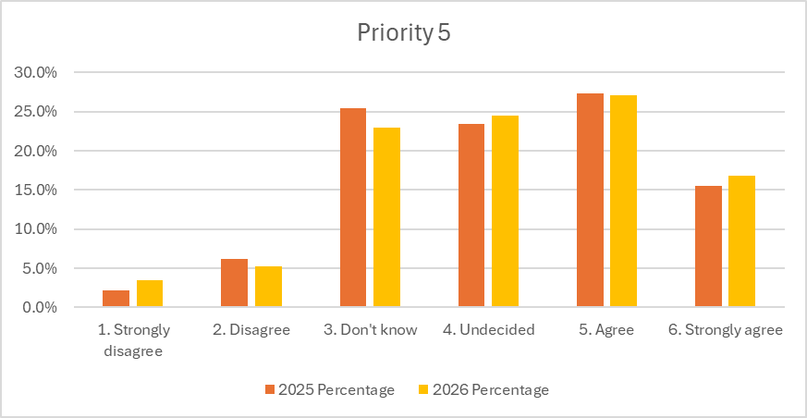
Priority 5 | 2025 |  | 2026 |  | 2025-2026
Priority 5 | Number | Percentage | Number | Percentage | Percentage
1. Strongly disagree | 22 | 2.1% | 57 | 3.4% | +1.3%
2. Disagree | 63 | 6.1% | 87 | 5.2% | -0.9%
3. Don't know | 261 | 25.4% | 384 | 23.0% | -2.4%
4. Undecided | 241 | 23.5% | 408 | 24.4% | +0.9%
5. Agree | 281 | 27.4% | 453 | 27.1% | -0.3%
6. Strongly agree | 159 | 15.5% | 281 | 16.8% | +1.3%
Total | 1027 | 100.0% | 1670 | 100.0%

  - What this tells us
Almost half of staff responding to the survey are unsure (47.4%) if NHS Lothian supports people with dementia and people who use our mental health services to know about and claim their rights, and to make decisions about their care and treatment. However, uncertainty has reduced slightly since last year and slightly more staff agree.
The ongoing high proportion of staff who are unsure about this priority suggests we should prioritise making human rights explicit in our organisational values and policies, and provide support to more staff in mental health settings to help them apply human rights in their practice.
  - Performance against this KPI
Slightly more staff agree but almost half of staff remain unsure.

PRIORITY 6: investing in education and training
OUTCOME 6: We reap the benefits of equality and human rights education and training.

MEASURE 6.1: There is clear evidence that actions have been taken across the year.
INDICATOR 6.1 Evidence of sustained actions taken, with progress maintained or increased every year.

  - Results
- Two fixed term Equality and Human Rights Education Project Managers were recruited in April-May 2025.
- The Embedding Equality and Human Rights Education Steering Group completed its work to develop a framework to support NHS Lothian integrate equality and human rights into education and training. This framework will be tested throughout 2026. It includes resources to ensure NHS Lothian staff training is accessible and inclusive and is based on relevant quality assured equality and human rights content. The Group has created:
  - An equality and human rights knowledge and skills framework
  - 16 equality and human rights standards for education and training
  - A training assessment tool
  - Criteria for good equality and human rights education resources
  - A scoring template to quality check equality and human rights education resources.
- Four training sessions about the UN Convention on the Rights of the Child (UNCRC) have been delivered jointly with Lothian Association of Youth Clubs (LAYC) and 2 follow-on training sessions with the Children’s Parliament have also taken place.
- The Equality and Human Rights Education calendar for 2025 and 2026 was developed and published on the NHS Lothian staff website and has been promoted widely across all internal communication channels, with ongoing support from corporate communications and local directorate and site communications.
- In-person sessions have been developed and delivered covering:
  - EDI in NHS Lothian
  - Understanding and challenging microaggressions
  - Understanding intersectionality
  - Learning how to do and use Equality and Children’s Rights Impact Assessments (ECRIAs)
  - Cultural humility for everyday practice
  - Recognising and preventing sexual harassment in the workplace
  - How to be neuro-inclusive
  - Trans-inclusive healthcare in NHS Lothian
  - Disability and reasonable adjustments
  - Care About Rights
  - Anti-racism
  - Gypsy/ Traveller inclusive healthcare
- Staff can request training for their team using our contact form.
- Over 500 staff have attended the core equality and human rights and tailored team development sessions.
- The results from the evaluation forms show overwhelmingly positive feedback with 84% of participants rating sessions 8 out of 10 or higher. 99% of people providing feedback said they did feel able to participate and 73% would like more learning on equality and human rights.
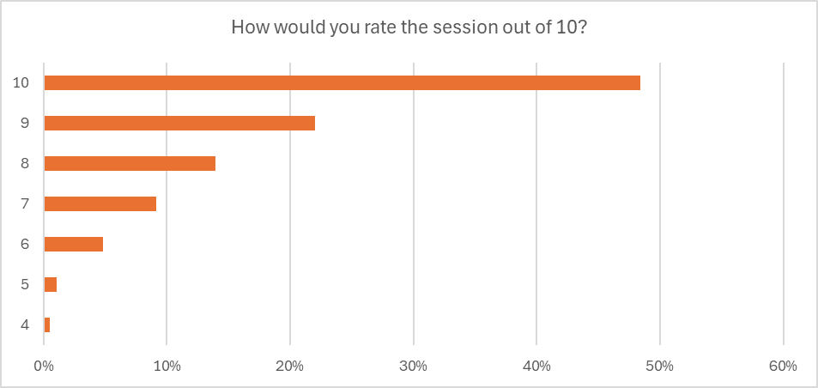

  - What this tells us
Supported by additional capacity in the team, NHS Lothian has moved from ad-hoc equality and human rights education and training to a planned and resourced equality and human rights education infrastructure.
A wide range of staff education and training has been delivered to provide staff with access to training that is relevant for their roles and services.
Staff are aware of and engaging with training. They are offered opportunities and are actively taking them up.
Evaluation demonstrates very strong staff satisfaction. This suggests that the education and training is well designed and meeting workforce needs. Further work is needed to understand how what people have learned has been applied to their practice and the impact on people’s experiences of accessing our services.
  - Performance against this KPI
NHS Lothian is performing strongly. An organisation-wide equality and human rights education system has been created that supports the development of an inclusive and rights respecting culture.
MEASURE 6.2: NHS Lothian staff agree that they have opportunities to participate in equality and human rights education and training.
INDICATOR 6.2: Staff survey results maintain or increase positive responses year on year.

  - Results
- Positive responses increased by 2.3 pp, with strongly agree significantly increasing by 5 pp.
- Negative responses fell by 2.6 pp.

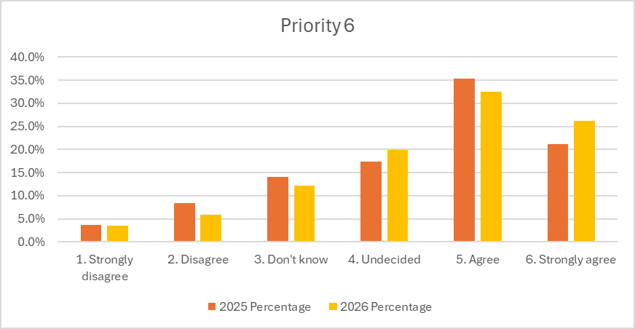
Priority 6 | 2025 |  | 2026 |  | 2025-2026
Priority 6 | Number | Percentage | Number | Percentage | Percentage
1. Strongly disagree | 37 | 3.6% | 58 | 3.5% | -0.1%
2. Disagree | 86 | 8.4% | 98 | 5.9% | -2.5%
3. Don't know | 145 | 14.1% | 203 | 12.2% | -1.9%
4. Undecided | 179 | 17.4% | 331 | 19.8% | +2.4%
5. Agree | 362 | 35.2% | 542 | 32.5% | -2.7%
6. Strongly agree | 218 | 21.2% | 438 | 26.2% | +5.0%
Total | 1027 | 100.0% | 1670 | 100.0%

  - What this tells us
There are high numbers of positive responses agreeing that staff have opportunities to participate in equality and human rights education and they have strengthened this year in the strongly agree category. Negative responses have fallen overall, indicating fewer staff disagree. While some staff remain uncertain, the overall direction is positive.
  - Performance against this KPI
A larger share of staff (58.7%) agree, indicating that staff confidence that they can access opportunities for equality and human rights education and training is high and increasing.

