Equality and Human Rights Annual Report 2024 - 2025


Published April 2025

Introduction
In April 2023, the NHS Lothian Board agreed an ambitious five-year strategy. It's called Healthy and Better Lives for Everyone. The strategy drives compliance with our equality and human rights duties. It commits NHS Lothian to achieving six strategic equality and human rights priorities. The aim is to put equality and human rights at the centre of everything we do and integrate it into our work.
NHS Lothian Equality & Human Rights team

The Equality & Human Rights team supports NHS Lothian meet its equality and human rights duties. It oversees delivery of the strategy and provides advice and support across the system.
We carried out a staff survey in January 2025. This helps us to understanding if we’re making a difference and if we need to do anything different. 1,027 members of staff responded over a two-week period. We will run this survey each year. In Autumn 2025, we want to start running a similar survey for people who use our services.
The team benefited this year from service management support from Karen Gray in the Public Health and Health Policy Directorate, and administrative support from Andrew Mahady in the Lothian Employability Programme.
The work done this year was possible because of the efforts of thousands of people who work in NHS Lothian.

Priority 1 embedding equality and human rights
We agreed to focus on:
- Strengthening performance of the Public Sector Equality Duty, Fairer Scotland Duty, children’s rights and meeting the needs of care experienced children and young people.
- Collecting, analysing, sharing, and using equality and human rights evidence.
In 2023, we updated our approach to impact assessments. We include consideration of the impact on health and employment inequalities caused by socio-economic disadvantage and the impact care experienced people. We also carry out a separate assessment of compatibility with children’s rights.
Actions taken
- The Public Health Intelligence Team produced summary reports about the results of the 2022 Scotland Census. This includes information about the population of Scotland and Lothian.
- NHS Lothian staff can now access waiting list data broken down by age, sex, ethnicity and the Scottish Index of Multiple Deprivation (SIMD) and understand how it compares to Lothian population data.
- The Human Resources Team published workforce equality information. We discussed this with the staff Equality Networks to agree the Advancing Equalities Action Plan.
- In the staff survey we asked about people's experience of discrimination at work. We will collect and report on this information every year and use it to prioritise action.
- The Public Engagement Manager and Quality Improvement Academy delivered public engagement training. This included information about how to make sure we hear from marginalised groups.
- We spoke to children and young people about their experiences using our services. We used what they told us to complete an assessment about how we are meeting the duties in the UNCRC Incorporation Act (Scotland) 2024.
- The Child Health Commissioner produced NHS Lothian’s UNCRC Strategic Framework and Implementation Plan.
- The Patient Experience Team ask questions about people's protected characteristics in their survey. They use this information to make sure everybody can tell us about their experiences.
- We delivered in-person Equality and Children’s Rights Impact Assessment (ECRIA) workshops. We started a MS Teams Channel for peer support and guidance. In March 2025, there were 84 members.
- We updated our ECRIA process, guidance and templates based on learning and feedback.
- We tested monitoring compliance with our equality impact assessment duty.
- We took steps to ensure that we use ECRIAs in financial decision-making.
- We used ECRIAs to understand if financial decisions in 10 Acute Services may disproportionately disadvantage equality groups. We identified actions to reduce disproportionate negative impact.
- We worked with local authorities and health and social care partnerships to find out what people in Lothian think are the most pressing inequalities in their lives. We used this to inform our equality outcomes for 2025- 2028.
Impact
These actions have:
- Helped NHS Lothian meet its public sector equality duty when making decisions.
- Helped us to act in a way that is compatible with children’s rights.
- Provided staff with access to more consistent equality data to use in ECRIAs. We understand better if our decisions might disadvantage some groups more than others. We have identified ways to reduce or remove this disadvantage.
- Let us take steps to improve representation and participation, where under representation and low participation exists.
- Improved our understanding about the prevalence of discriminatory behaviour in NHS Lothian.

Results of 2025 staff survey
We asked staff to tell us if they agreed that equality and human rights are a central part of planning, decision-making, delivery and reporting processes in NHS Lothian.
Table 1: Priority 1 All responses (6 is strongly agree – 1 is strongly disagree)
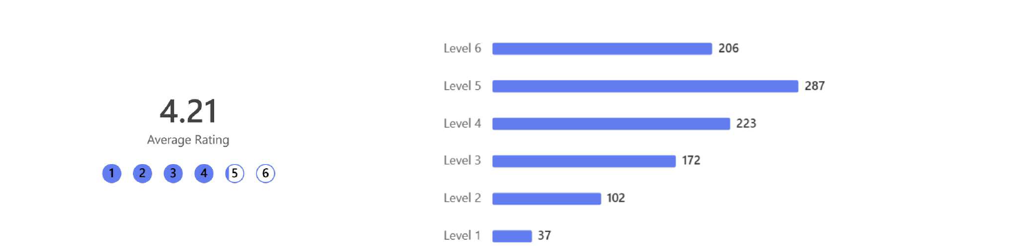
Table 2: Priority 1 Responses by job family

Note the totals for job families add up to 1,013 (not 1,027) because not all respondees identified themselves within the standard job families used by NHS Lothian.

Priority 2: we are an anti-racist organisation
To help achieve our commitment to be an anti-racist organisation, where our work helps to eliminate racism, remove racialised inequalities and reduce racial prejudice we agreed to focus on:
- Learning from the legacies of our historical connections with transatlantic chattel slavery.
- Understanding and acknowledging the prevalence of racism, race discrimination and harassment, and taking action.
- Providing leadership and confidence to understand and actively challenge racism.
- Using positive action to address the under-representation of Black and Minority Ethnic (BME) people in senior positions.
- Having formal structures to hear the voices of people from our ethnically diverse communities and use their lived experience to make sure all parts of our system and services are welcoming and inclusive for everyone.
- Taking action to reduce and remove racialised health inequalities.
BME is the term we use in NHS Lothian to describe black and ethnically diverse people. It is the term preferred and adopted by NHS Lothian staff agreed through the BME staff network.
The action taken to achieve this priority includes work to achieve our 2023-2025 equality outcome that BME staff feel integrated into teams and supported to lead healthy lives.
Actions taken
- We asked staff to volunteer to be part of NHS Lothian’s Transatlantic Slavery Recommendations Implementation Group and appointed three co-chairs (one non-executive member and two members from the BME staff network).
- We agreed draft terms of reference for the Implementation Group after considering advice from the Scottish Government and the Chair of Edinburgh City Council Implementation Group.
- Each member of the executive leadership team set themselves an anti-racism objective, either stand alone or linked to a wider programme of work.
- We continued our work to understand and address the under-representation of BME nurses and midwives in senior positions by establishing a working group with a diverse and representative membership. The working group has agreed and started to deliver actions under five workstreams – data and metrics, recruitment and selection, communication, education and career development, and leadership and cultural change.
- We continued to participate on the National Ethnic Minority Forum and the Scottish Government Racialised Health Inequalities Community of Practice to help inform anti-racism actions in NHS Lothian and across Scottish health boards.
- We brought together available data about complaints and feedback about racism from staff and people who use our services and carried out a review of current policy and best practice.
- We held three drop-in sessions at the Royal Edinburgh Hospital to encourage staff to share their thoughts and experiences of racism and other equality issues. This allowed us to identify a diverse and representative group of staff to form the REAS EDI Group and agree terms of reference, ways of working and priority actions.
- We published and promoted NHS Lothian Understanding Racism training video and facilitator’s guide. This is incorporated in NHS Lothian in-person EDI education workshops, and it is available to all NHS Scotland staff via TURAS online learning platform.
- The Medical Education Team developed and promoted online anti-racism resources and delivered workshops.
- We agreed and implemented an action plan with the Minority Ethnic Carers of People Project (MECOPP) Gypsy/ Travellers Community Health Workers (CHW) Project. This includes link work between the Lothian Gypsy/ Traveller CHW and NHS Lothian services and the development and delivery of an in-person training session and facilitator’s guide. This training is designed to improve understanding of the Gypsy/ Traveller community and the barriers they face in accessing public services, and to help develop ways of working that will appropriately meet community needs and improve health outcomes.
- The Public Health Immunisation Team has commissioned qualitative research with pregnant women and marginalised parents and carers from Polish, African, Asian and Gypsy/Traveller communities from across Lothian to understand vaccination experiences, barriers and enablers. The work is led by Blake Stevenson and MECOPP who have reported on findings and a dissemination and action plan with recommendations is being developed to inform planning and service improvements to these communities.
- The vaccination programme continues to work with NHS Lothian Minority Ethnic Health Inclusion Service (MEHIS) and wider community and voluntary sector partners to support inclusivity of all vaccination programmes. Vaccination outreach sessions utilising MEHIS link workers who support conversations and engagement with community members have taken place in community and faith settings to support vaccination access to minority ethnic communities.
- Women and Children’s Services developed and shared an Equality, Diversity and Inclusion Mission Statement and Plan with all staff. This includes five areas of work to deliver the Mission Statement, which includes working with KWISA and Lothian Maternity Voices Partnership to improve engagement between women of African and Caribbean heritage and maternity and neonatal services.
Impact
These actions have:
- Increased awareness and understanding of the prevalence and impact of racism and resulted in anti-racism action plans.
- Helped to people from Lothian BME communities to access to NHS Lothian services.
- Prompted more requests to the Equality & Human Rights team for advice, support and development sessions.
Results of 2025 staff survey
We asked staff to tell us if they agreed that NHS Lothian is an anti-racist organisation and that the work we do helps to eliminate racism, remove racialised inequalities and reduce prejudice.

Chart 2: All responses (6 is strongly agree – 1 is strongly disagree)
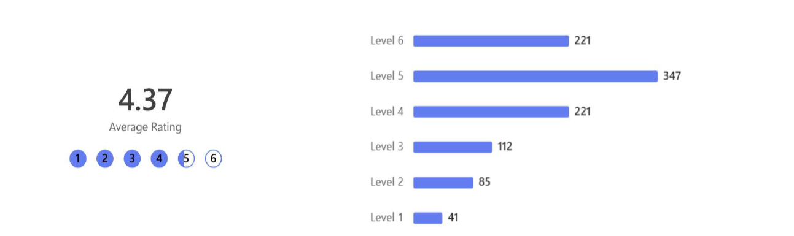

Table 4: Priority 2 responses by job family

Table 3: Priority 2 responses by ethnic group

Priority 3: we meet the needs of disabled people
To help us anticipate and meet the needs of disabled people so that they can access services and employment opportunities, we agreed to focus on:
- Recording and using information about reasonable adjustments.
- Establishing formal structures to hear the voices of disabled people and using their lived experience.
- Providing information in accessible ways.
- Ensuring staff have a good understanding and awareness of disability and reasonable adjustments.
- Updating and implementing our BSL Action plan.
The action taken to achieve this priority includes work to achieve our 2023-2025 equality outcome, disabled people get accessible information from us that supports them to use NHS Lothian services.
Actions taken
- We established the Additional Support Needs (ASN)/ reasonable adjustments on TRAK Steering Group, chaired by the Director of Public Health and Health Policy.
- Lothian Analytical Services identified benchmark data about the number of people on outpatient waiting lists with recorded ASN/ reasonable adjustments. This will help us to monitor progress after we have implemented technical changes to TRAK (our patient management system).
- The Equality & Human Rights team worked with disabled people’s organisations (DPOs) and disability charities to understand disabled people’s views and experiences of accessing hospital appointments, and what is considered to be acceptable terminology about disability/ conditions and additional support needs. This information will be used to implement technical changes to TRAK and staff disability awareness education.
- We started to explore potential improvements to the categories related to disability and reasonable adjustments on TRAK.
- We mapped out communication channels, ways to raise staff awareness and support Health Records staff.
- We started sending information to patients about appointments electronically so that they can be viewed on mobile phone, tablet or computer and we built in an assessment of equality and children’s rights into each stage of the roll out. This included gathering the views of disabled people through DPOs and disability charities.
- We developed guidance for wayfinding signage, and took the views and experiences of disabled people into account. This includes guidance about accessible information and pictograms.
- The Human Resources (HR) team, working with the staff Disabled Employee Network, has continued to promote and monitor awareness of NHS Lothian Reasonable Adjustment Passport during Disability Pride Month and Lunch & Learn sessions.
- We achieved Disability Confident Leader Level 3 accreditation. We promoted this to staff through our internal communications and encouraged disabled staff to update their equality monitoring information.
- The HR team published the first Disability Workforce Report.
- We have co-produced equality training with the staff Disabled Employee Network to raise awareness of the barriers facing disabled people who work for us and use our services.
- We used information from engagement events with BSL users in Lothian to develop and publish our BSL Plan.
- We started to collect information about BSL and tactile BSL in NHS Lothian equality monitoring forms.
Impact
These actions have:
- Improved the accessibility of information sent out from NHS Lothian including increasing text size, read out function and changing to another language.
- Helped to raise awareness of the importance of making reasonable adjustments.
- Increased our understanding of participation and representation of BSL and tactile BSL users in employment and services.
Results of 2025 staff survey
We asked staff to tell us if they agreed that NHS Lothian anticipates and meets the needs of disabled people so they can access services, employment opportunities and have good lives.

Chart 3: All responses (6 is strongly agree – 1 is strongly disagree)
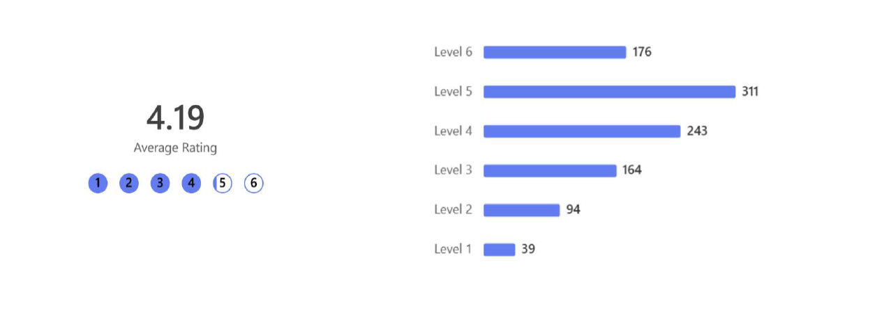
Table 5: Priority 3 responses by whether respondents identify as disabled

Table 6: Priority 3 responses by job family

Priority 4: we are gender inclusive
To help us be gender inclusive, and to make sure we do not discriminate on grounds of sex or gender identity and our work helps to tackle persistent gender inequalities we agreed to focus on:
- Taking action to reduce women’s health inequalities as set out in the National Women’s Health Plan.
- Preventing sexual and sexist harassment.
- Reducing the negative impact on the health and wellbeing of trans and non-binary people caused by Gender Clinic waiting times and barriers to accessing health services.
- Supporting staff who are transitioning.
- Fostering good relations.
The action taken to achieve this priority includes work to achieve our 2023-2025 equality outcomes, trans and non-binary people feel welcome and safe to be themselves when using NHS Lothian services, and women and girls in Edinburgh and the Lothians are supported to lead healthy lives.
Actions taken
- We made progress against the actions in the Women’s Health Plan by:
- Supporting a personalised approach to care and providing alternatives to face to face appointments in Psychological Therapies, all CAMHS teams and the Substance Use service and primary care.
- Improving access to abortion services by working with Scottish Government and other stakeholders on safe access zones and running additional clinic at Chalmers Centre for Sexual Health to maintain maximum waiting time limits.
- Considering actions in the proposed update to the Community Pharmacy Pharmaceutical Care Services Plan.
- Submitting a TRAK change request to help improve the recording of antenatal contraceptive discussions.
- Training all school nurse teams across Lothian with the aim of increasing young people’s access to non-clinical Healthy Respect services in High schools.
- Reviewing and updating the process for recording pregnancy testing on TRAK for young women accessing this support within our non-clinical Healthy Respect services.
- Updating and creating accessible, consistent information for young people age 13-18 and age 19-25 with additional needs about what sexual health services are available across Lothian.
- Delivering a two-year quality improvement programme in West Lothian to create smoother and faster pathways between sexual health services used by marginalised and vulnerable women.
- Developing a detailed programme of work aimed at reducing avoidable harm within maternity and neonatal services.
- Carrying out an ECRIA to help prioritise actions in the NHS Lothian Women’s Health Plan.
- The Medical Education Team developed and delivered sexual misconduct workshops to a wide range of staff in NHS Lothian and NHS Scotland. This included staff in education and leadership roles. The quality and impact of their work was recognised when they won the NES Medical Directorate award for EDI.
- We agreed to participate in the Equally Safe at Work Accreditation Programme and the work to achieve accreditation has started.
- Maternity services produced training resources for staff to improve awareness and understanding about inclusive maternity care for LGBT+ families. This includes a training video sharing the experiences of LGBT+ families who have used NHS Lothian maternity services with questions to prompt teams to have reflective discussions about their practice.
- We re-established a stakeholder group to help NHS Lothian to reduce health inequalities experienced by trans and non-binary people and improve access to health care.
- We agreed to review the treatment pathways for gender services against equality and human rights principles and standards.
- We delivered in-person sessions on trans inclusive healthcare to pharmacists and pharmacy technicians who work in GP practices in North-East Edinburgh, the SMART Centre at the Astley Ainslie Hospital and the Public Health and Health Policy Directorate.
- We continued to implement NHS Scotland Pride Pledge and Badge scheme to allow staff who choose to, to show their commitment to support equality for LGBT+ and other marginalised people.
Impact
These actions will help:
- To reduce health inequalities for women, trans and non-binary people.
- Make sure we are creating the right environment and culture where staff feel safe and supported.
Results of 2025 staff survey
We asked staff to tell us if they agreed that NHS Lothian is gender inclusive and does not discriminate on grounds of sex or gender identity, and the work we do helps to tackle persistent gender inequalities.

Chart 4: Priority 4 all responses (6 is strongly agree – 1 is strongly disagree)
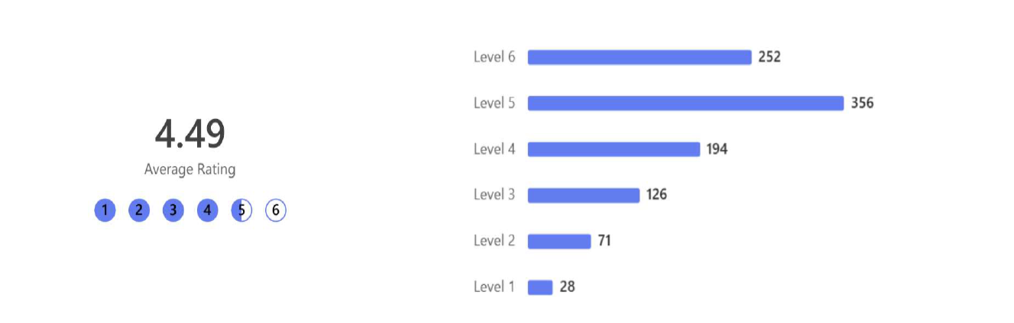
Table 7: Priority 4 responses by sex

Table 8: Priority 4 responses by whether respondent identified as trans

Table 9: Priority 4 responses by job family

Priority 5: people are involved in decisions about their care and treatment
To achieve our commitment to supporting people who use our mental health services and people with dementia to know about and claim their rights, and to make decisions about their care and treatment we agreed to focus on:
- Delivering recommendations from the Scottish Mental Health Review and Mental Welfare Commission inspection reports.
- Reducing the use of coercive (involuntary) medical practices and develop alternative or non-coercive (voluntary) practices.
- Using experienced based co-design to hear the voices of people who use and work in our mental health services, including with dementia.
The action taken to achieve this priority includes work to achieve our 2023-2025 equality outcome that everyone receiving care and treatment is involved and can participate in decisions about their care and treatment.
Actions taken
- We developed a patient information leaflet to explain the person-centred and rights-based approach to care and treatment at the Regional Eating Disorder Unit (REDU) and why recommendations might be made to protect patients from the risk of serious harm. The aim of the leaflet is to support patients to make informed decisions about consent for these aspects of their treatment.
- The Equality & Human Rights and Child Health Commissioner’s teams developed and started delivery of our first Care About Rights education programme for all staff working in the Melville Unit.
- We continued to promote the Mental Welfare Commission ‘Rights in Mind’ guidance to support patients using our mental health services and our staff who provide these services.
- We continued to take a person-centred approach to make sure people are involved in the development of their own care plan at each stage of their pathway.
- We continued to support and promote advocacy involvement in our inpatient areas as well as the Royal Edinburgh Hospital Patients’ Council team, who provide independent advice, guidance, and support.

Impact
These actions will help to support staff understand and uphold the human rights of patients who may lack capacity to make decisions about their care and treatment.
Results of 2025 staff survey
We asked staff to tell us if they agreed that NHS Lothian supports people with dementia and people who use our mental health services to know about and claim their rights, and to make decision about their care and treatment.
Chart 5: Priority 5 all responses (6 is strongly agree – 1 is strongly disagree)
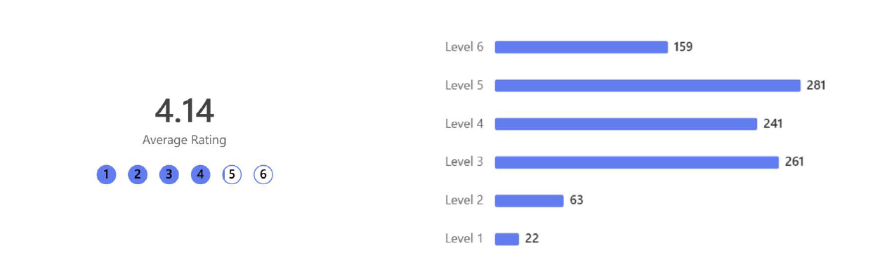
Table 10: Priority 5 responses by job family

Priority 6: investing in education and training
We agreed to focus our investment in equality and human rights education and training on:
- Additional staff resource to allow us to take an innovative and effective approach across the organisation.
- Developing and implementing a new equality and human rights education framework.
- Co-designing equality and human rights education and training with people with lived experience.
- Tackling prejudice and promoting understanding of other people’s circumstances and attributes.
Actions taken
- The Equality & Human Rights team developed and delivered in person:
  - 5 all-day Equality, Diversity and Inclusion (EDI) workshops.
  - 5 ECRIA workshops
  - Continued Professional Development (CPD) sessions on:
    - Microaggressions (x 2)
    - Trans inclusion (x 4)
    - Reducing Gypsy Traveller inequalities (x 1)
    - Preventing sexual and sexist harassment (x 1).
- The Child Health Commissioner’s team developed and delivered an initial training session for UNCRC ‘Champions’ jointly with Third Sector. The training raised awareness and understanding of the UNCRC, Scottish legislation and policy, and develop rights-based practice. Eight NHS staff from different service areas attended and are supporting the roll-out of awareness-raising and training in their service areas and across the organisation. In collaboration with the Children’s Parliament, we developed a champions network of ‘Unfearties’ – people who are willing to speak up for and stand alongside children to make their rights real.
- The Equality & Human Rights team developed and facilitated tailored sessions for:
  - All staff with line management responsibility in the Royal Edinburgh and Associated Services (REAS)
- Estates and facilities senior managers
- Obstetricians and Gynaecologists
- Patient Experience Complaints team
- Volunteer Service
- Neonatal senior consultants
- Neonatal B7 nurses
- International Medical Graduates
- Modern Apprenticeships
- Laboratory and Microbiology staff
- The Medical Education Team developed and delivered workshops on:
- Anti-racism
- Sexual misconduct in the workplace
- Beyond bystander
- The Equality & Human Rights team developed and published online resources about EDI best practice on the staff Equality and Human Rights Education website.
- The Equality & Human Rights and Organisational Development (OD) teams established an embedding equality and human rights education and training steering group. The Group co-produced its vision, SMART objectives, action plan and established three working groups to develop and implement NHS Lothian equality and human rights competency framework, a self-assessment toolkit and quality standards and, quality assured resources and peer support networks by 2028.
- The Equality & Human Rights team created and maintained two new MS Teams Channels, Equality Matters (93 members) and ECRIA Information Hub (with 84 members) to provide continued support to everyone who has participated in the EDI and ECRIA workshops, including resources and peer support.
- We reviewed and updated our online learning modules on:
  - Introduction to EDI and Human Rights
  - Trans inclusion
  - Introduction to BSL.
- The Equality & Human Rights team moved the administration of education and training onto the our online Employee Self Service platform (eESS) and the evaluation and feedback system to MS Teams.
- The Equality & Human Rights team recruited two Education and Training Project Managers for a one-year fixed term period who will start in April 2025.

Impact
These actions will:
- Support NHS Lothian staff to understand, acknowledge and take action to eliminate discrimination and advance equality of opportunity and good relations.
- Provide a more efficient way of understanding the participation of staff in equality and human rights education and its quality and impact.
Results of 2025 staff survey
We asked staff to tell us if they agreed that NHS Lothian gives staff opportunities to learn about equality and human rights.
Chart 6: All responses (6 is strongly agree – 1 is strongly disagree)
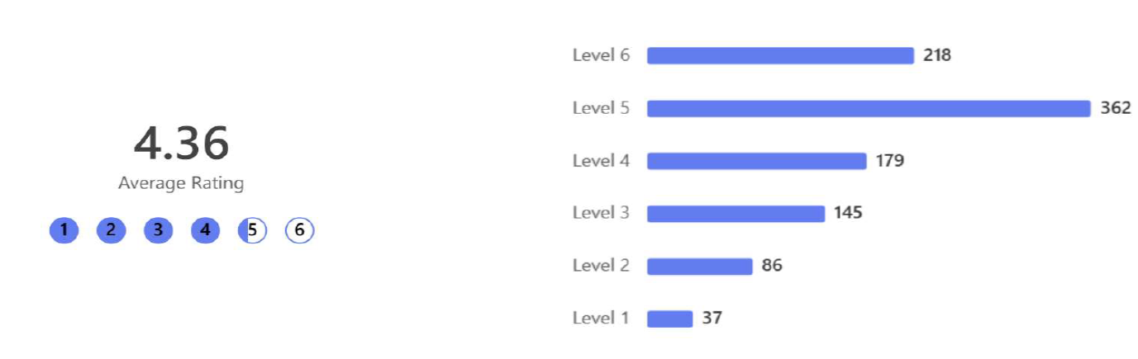
Table 11: Responses by job family

How will we know we’re making a difference
NHS Lothian is committed to being a psychologically safe place for the people who work for us, and this means encouraging everyone to express their thoughts, provide feedback, share disagreements, and voice opinions respectfully without fear of judgement of repercussions. Psychological safety is vital if we’re to achieve our ambitions for equality and human rights. This will only happen if we create safe and inclusive environments for everyone to learn about equality and human rights and apply this learning in their work. We are committed to taking a proportionate approach to measuring if we are achieving this.
Equality & human rights surveys
The Equality & Human Rights team has been developing ways to measure if the actions NHS Lothian are taking are making a difference.
As well as asking for people’s opinion about how well were doing, the annual equality and human rights staff survey that started in 2025 collects information on the prevalence of discriminatory behaviours and confidence in reporting discrimination. We were given permission from the General Medical Council (GMC) to use the relevant survey questions that they use in their Annual Training Survey. Our survey asks people if they:
- Hear insults, stereotyping or jokes in your presence that relate to someone’s protected characteristics? Daily, weekly, monthly, less than once a month or never and the protected characteristic this experience related to.
- Experience micro-aggressions, negative comments, or oppressive body language? Daily, weekly, monthly, less than once a month or never and the protected characteristic this experience related to.
- Experience unwelcome sexual comments or advances causing you embarrassment, distress or offence? Daily, weekly, monthly, less than once a month or never.
- Experience this behaviour/ treatment from colleagues and/ or people who use our services.
- Know, or are able to find out, how to report discrimination and/ or harassment.
- Feel confident about reporting discrimination where they work without worrying that something bad will happen to them.
- Feel able to object to discriminatory behaviours by colleagues and people who use our services.
Our survey also asks people to complete information about their protected characteristics and NHS Lothian job families. This is used to identify if there are different responses for protected groups, if we are reaching a representative sample of our workforce and the population we serve and allows us to prioritise actions to address any disparities or low participation.
Education monitoring & feedback
For the past two years we have had 95% response rate for our education feedback because we have successfully encouraged people to complete paper forms before they leave the training. However, this has made the analysis of information administratively resource intensive. In 2025, we moved to using MS Forms to collect and analyse feedback about equality and human rights education and training. This will allow us to identify how effective the sessions have been and what people will do differently because of their learning. The recruitment of two fixed term education posts will allow us to test collecting follow up information about the difference the sessions have made to people and their work.
Education monitoring
The move in 2025 to allow staff to register for education sessions on the digital Employee Self Service platform (eESS) will make it easier to report annually on how many people are taking part in equality & human rights education and training and allow staff to have this recorded on their employee record.
Next steps
We think these steps strike the correct balance between using our available resources to encourage, support and take action, and making sure we understand if the actions we’re taking are making a difference. In 2025, we will define ‘impact indicators’ and use the data we are collecting to understand the outcomes or changes that we could attribute to the actions we are taking to deliver our strategic equality and human rights priorities.

