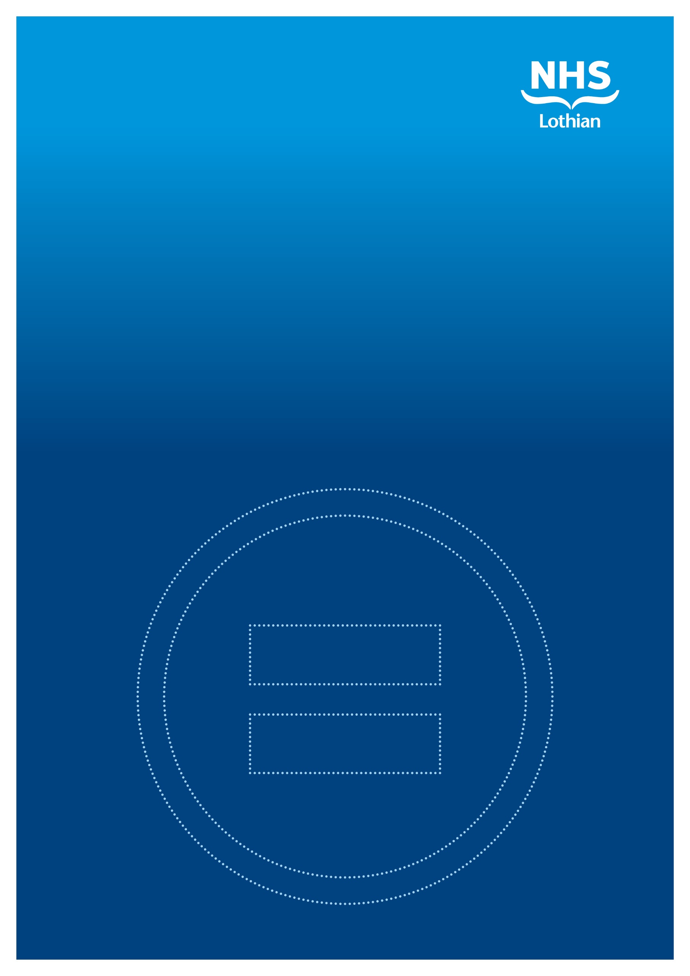

**Gender Pay Gap Report**

Published April 2025

To ask for this report in another format or language email: [Loth.equalityandhumanrights@nhs.scot](mailto:Loth.equalityandhumanrights@nhs.scot)

**Table of Contents**

1. Introduction 3

2. What does this report cover 3

3. Mean and Median Pay Gap Data by sex 4

4. Mean and median pay gap data by staff grouping 6

5. Mean and median pay gap data by pay quartile 11

6. Conclusion 13

7. Additional Notes 14

# **Introduction**

NHS Lothian is committed to the principles of equality, diversity and inclusion in employment. We believe that staff should receive equal pay for the same or broadly similar work, for work rated as equivalent and for work of equal value.

NHS Lothian is committed to mainstreaming equality in the workplace and one way we do this is by carrying out an annual analysis of gender pay gaps. The gender pay gap is the difference in average hourly pay between men and women. In compliance with the Equality Act 2010 (Specific Duties) (Scotland) Regulations 2012 (as amended), NHS Lothian has published gender pay gap reports since 2017.

Pay rates within NHS Lothian are in line with national pay arrangements which are determined by the Scottish Government. Staff are appointed to Agenda for Change (AfC) bands and Executive and Senior Manager grades through recognised national job evaluation processes. Progression through the AfC pay bands is then through incremental progression, so those staff with longer time in the role will be paid at the upper end of a pay scale compared to those new into post. Appointment to a Medical and Dental grade is based on the definitions in the terms and conditions of service and then progress through the scale is through incremental progression, with length of time in role influencing the rate of pay.

New for this year’s report is the inclusion of approximately 5,700 bank staff (who received payment for work in March 2024). This provides a fuller picture of equal pay in NHS Lothian. The comparisons to previous years should be read with this in mind. The majority of bank staff are roles within AfC bands 2-5.

# **2. What does this report cover**

This report provides information about gender pay gaps in NHS Lothian, based on workforce and payroll data from 31st March 2024 and includes both the mean and median pay gap data.

**Mean pay** is the average hourly rate of pay, calculated by adding the hourly pay rate for employees then dividing by the number of employees.

**Median pay** is the middle hourly pay rate, when you arrange your pay rates in order from lowest to highest.

The gender pay gap is then calculated by taking the mean/median pay for men and subtracting the mean/median pay for women. Then, dividing this sum by the mean/median pay for men, and multiplying by 100.

Given that the mean pay gap is calculated from the basic hourly rates of all individual employees, it therefore includes the highest and lowest rates across the organisation and provides an overall indication of the size of the pay gap. The median basic hourly rate, on the other hand, is calculated by taking the mid-point from a list of all employees’ basic hourly rates of pay and provides a more accurate representation of the ‘typical’ difference in pay that is not skewed by the highest or lowest rates across the organisation.

The specific equality duty to publish gender pay gap information requires publication of information about the difference in average hourly pay (mean). The Equality and Human Rights Commission non-statutory guidance explains that both the mean (average) and median calculations help to illuminate different aspects of gender pay gap information. Therefore, where practicable, throughout this report, both mean and median pay gaps are looked at for women and men.

A negative value in the pay gap indicates that it favours women.

# **3. Mean and Median Pay Gap Data by sex**

In March 2024, NHS Lothian employed 33,674 people - 26,582 female (78.94%) and 7,092 male (21.06%). The table below provides mean and median gender pay gap data for the organisation as a whole.



Calculating the pay gap using the mean basic hourly rate presents a gap that favours male staff (on average men are paid more than women). However, when looking at the pay gap based on the median basic hourly rate it points to female staff being paid 6.58% (£1.06) more than male staff. While this measure eliminates extreme outliers, and generally presents a fairer and more accurate picture of the pay gap, it is also flawed. This is because in NHS Lothian there is not an even distribution of men and women across all bands and roles. Male staff have a higher representation in the lowest and highest paid roles, while female staff have high representation in roles in the middle of the overall pay range. Therefore, the median woman and the median man do not have the same role and increment/experience (see section 4). However, the median method of calculating the gender pay gap provides a more accurate picture when looking at the workforce grouped into pay quartiles (see section 5).

Whilst more than three quarters of the NHS Lothian workforce are women, the mean gender pay gap points to male staff being paid 11.21% more than female staff. However, as discussed in the paragraph above, the median gender pay gap points to female staff being paid more than male staff. The graphs below show the pay gaps going back to 2019. Note that this year’s report includes bank staff, which was not included previously. This should be born in mind when comparing years.



From 2019 to 2024, the mean gender pay gap within NHS Lothian shortened from men, on average, being paid 15.99% more than women, to 11.21%. A possible explanation for the shortening of this pay gap is in relation to Medical and Dental staff who are amongst some of the highest earners in the organisation. Traditionally medicine was a more male dominated profession. However, this has been changing over the years with a gradual increase in the number of females now employed within medical and dental roles. Between 2021 and 2024, there has been an increase in the number of women employed in medicine with a headcount of 1,312 rising to 1,589 in 2024.



The median gap increased between 2019 and 2021, and then further in 2023. However, it has fallen in 2024. Including bank staff (85% of whom are female in line with the nursing workforce overall) in this year’s report, is the main reason why the median pay gap has decreased. The majority of bank staff hold roles in Bands 2-5, and it has therefore brought down the median pay to a lower basic hourly rate, compared to last year.

# **4. Mean and median pay gap data by staff grouping**

NHS Lothian staff are employed under three distinct contract groupings - Agenda for Change (AfC), Executive and Senior Managers (E/SM) and Medical and Dental (including Resident Doctors) - each with a separate set of pay, terms and conditions of employment. The following tables provide the mean and median gender pay gap data for each of the three contract groupings.



Using both calculations, on average female staff on AfC contracts are paid more than male staff.



Using both calculations, on average male staff on Executive and Senior Management contracts are paid more than female staff.



Using both calculations, on average male staff on Medical & Dental contracts are paid more than female staff.

In comparison to the Gender Pay Gap Report published in 2023, the pay gap for AfC staff has reduced in favour of women from 6.17% in 2023 to 5.66% in 2024. The pay gap has also reduced for both Medical and Dental (decreasing from 9.80% in 2023 to 8.01% in 2024) and Executive and Senior Managers (decreasing from 6.96% in 2023 to 6.36% in 2024), as explained below.

**Agenda for Change**

Staff employed under AfC pay, terms and conditions are recruited into a post with a confirmed AfC pay band, assigned through the application of the NHS Job Evaluation Scheme. The evaluation is undertaken by a trained panel of evaluators and is based on the skills and responsibilities of the post. As such, all employees aligned to the same post/job description will be paid, regardless of their sex, according to the evaluated band outcome for the post.

It is also important to note that each AfC pay band consists of a number of incremental points. In line with AfC terms and conditions, each employee should start in post at the minimum of the pay scale, or in the case of promotion, on the first available point on the scale that will afford the employee a salary increase. Thereafter, incremental progression through the scale applies on an annual basis and is based only on length time in role.

This means that starting salary, length of service in band and timing of each employee’s yearly incremental date will have a direct influence on the pay gap within this contract group.

The specific data for this cohort confirms that there are significantly more women than men in all the AfC pay bands, most noticeably in bands 3-8a. One reason for this is that administrative and nursing/caring roles which sit within these bands are traditionally female dominated, although this is beginning to change slowly. The table below provides a breakdown of the mean gender pay gap across the AfC Bands:



Note that hourly rate in these figures is the average basic hourly rate.

The negative values in pay gap indicates that it favours women.

In terms of the gender pay gap across the AfC bands, whilst the overall gap is 5.66% in favour of women, men are, on average, paid more than women in two of the pay bands. The reason for the overall balance being in favour of women is due to the significantly higher numbers of female staff compared to male staff being employed in bands 2 to 7.

**Executive and Senior Managers**

The smallest contract grouping within NHS Lothian is Executive and Senior Manager (E/SM) staff. In this group men, on average, are paid 6.36% more than women.

Pay progression through the Executive and Senior Manager grades is based on the employee’s annual performance rating, which is determined through the appraisal process and a cost of living uplift. A percentage salary uplift is applied within the salary range for the grade based on the performance rating received. This suggests that length of time in role plays a part in the level of pay. However, in this case the pay gap between men and women in Executive and Senior Manager roles could partly be explained by pre-role pay rate/salary, which would have determined the entry salary for the Executive or Senior Manager role. The time in the role, as well as performance rating is also likely to contribute to the pay gap, although less so. Further analysis is needed to understand the pay gap for senior managers fully. The table below provides a breakdown of the mean gender pay gap across the Executive and Senior Manager Grades.



Note that hourly rate in these figures is the average basic hourly rate.

The negative values in pay gap indicates that it favours women.

In terms of the 6.36% pay gap across the Executive and Senior Manager grades, this is skewed by a very high pay gap of 10.64% in the Senior Manager Grade A group and the 10.86% gap in Executive Grade G. Further analysis is needed to understand these gaps fully. As staff leave the lower Senior Manager pay grades, in the future the replacement post maybe moved across to AfC terms and conditions and in time the use of the lower Senior Manager pay grades may cease.

In NHS Lothian, only Executives and Senior Managers have a bonus element in their pay. This bonus element is a performance related pay scheme based on the previous year’s appraisal. In 2023/2024 only 0.01% of NHS Lothian total staff received a bonus payment.

The percentage of men receiving performance related pay in 2023/2024 was 0.20%, and the percentage of women receiving performance related pay was 0.06%. It is important to note that when an individual Executive or Senior Manager reaches the maximum of their pay scale, whilst their performance will still be graded, they will not receive the corresponding pay uplift as under the National Terms and Conditions of Service, pay for those on Executive and Senior Manager’s scales as capped at the maximum of the scale. This will have a direct impact on the numbers of staff who will receive performance related pay in any one year. The below table looks at the performance related pay gap.



**Medical and Dental**

The mean gender pay gap for medical and dental staff indicates that male staff are, on average, paid 8.01% more than female staff.

Medical and Dental staff progress incrementally on their pay scales, in a similar way to AfC staff. As such, starting salary placement, length of service in grade and timing of each employee’s annual incremental date help to remove potential bias and discrimination.

For the more experienced medical staff such as Consultants, the percentage of male staff (51.13%) is slightly higher than female (48.87%). In the lower medical grades including Resident Doctors, the percentage of female staff is higher (59.96%) than male staff (40.04%). As the Consultant grade is one of the highest earning grades, this will have an impact on the overall pay gap. However, as noted above this position has begun to change with more female medical and dental staff now in post compared to male staff and as these female staff progress through the medical grades to Consultant level, this should close the gender pay gap further.

The mean gender pay gap in Dental is 22.57% in favour of male staff. This is caused mainly by three male high earners. If they are excluded from the analysis, the mean gender pay gap for dentists is -0.02% in favour of female staff. The table below provides a breakdown of the mean gender pay gap across the Medical and Dental Pay Grades.



Note the hourly rate in these figures is the average basic hourly rate.

The negative values in pay gap indicates that it favours women.

# **5. Mean and median pay gap data by pay quartile**

By ranking all employees from lowest to highest paid then dividing them into four equal groups, it is possible to identify four pay quartiles as follows:

* Lower Quartile – includes AfC band 1-5, and non-AfC (TUPE staff).
* Lower Middle Quartile – includes AfC band 2-6, Medical Staff (trainees only), and non-AfC (TUPE staff).
* Upper Middle Quartile –includes AfC band 5-7, Medical Staff, and non-AfC (TUPE staff).
* Upper Quartile – includes AfC Band 6-9, Medical Staff, Executives & Senior Management, and non-AfC (TUPE staff).

Due to the numbers of staff on each pay band, particularly AfC bands, there will be some overlapping of pay bands over the 4 quartiles. The tables below set out the number and percentage of female and male employees in each pay quartile and the mean and median basic hourly rates of pay.









Mean pay gaps have been calculated within each of the four quartiles. This shows lower differences in average basic hourly rates for the 3 lowest quartiles which is also reflected in the reduced gender pay gap.

* Lower quartile – 0.55%, in favour of women
* Lower middle quartile – 0.77%, in favour of women
* Upper middle quartile – 0.87%, in favour of men
* Upper quartile – 21.44%, in favour of men

Despite the organisation being predominately female, the distribution of employees across quartiles reveals a higher representation of men in the lower and upper quartile, compared to the middle quartiles. This could be attributed to several factors, including men traditionally being more likely to occupy higher-paying senior roles and lower-paying manual labour positions, while women being more likely to occupy nursing/caring roles.

Looking at gender pay gaps by pay quartiles highlights that the upper quartile is the only quartile to have significant gender pay gaps in relation to both the median and mean pay gap.

Further analysis of the upper quartile pay data confirms that, although there are a higher number of women within the group, a greater proportion of the female headcount are in posts at the lower end of this quartile’s pay range (i.e. in salaries across AFC bands 6 and 7). Additionally, there are a higher proportion of men in posts at the top of the salary range in this quartile as this includes Executive and Senior Managers grades and Medical and Dental Consultant grades which as noted above have traditionally been a more male dominated environment, with length of time in role playing a significant factor in hourly rate.

Currently more male consultants are further up the pay scale. Over time, this situation will change as more of the females who are joining the medical and dental profession get further into their career and progress further up the pay scale. As a result in time, the pay gap should close.

The above figures demonstrate that when the pay gap is calculated across narrower band/salary groupings within the organisation this shows a small mean gender pay gap across the lower paid quartiles, and no median gender pay gap when looking at the lower paid quartiles. This may also support that factors such as length of time in grade and associated incremental pay progression are key contributors to the gender pay gap.

The gender pay gap is influenced by the uneven distribution of men and women across different roles. In many cases, more women tend to be in lower-paying positions in the upper quartile, while men are more likely to hold higher-paying roles in the upper quartile. This imbalance can skew the upper quartile pay gap, making it appear larger than it would be if men and women were equally represented in all roles.

# **6. Conclusion**

Gender pay gaps in NHS Lothian have reduced since 2023, with an overall decrease of 1.4 percent since 2023.

The AfC gender pay gap favours female staff and has reduced by 0.51 percent. The Executive and Senior Managers gender pay gap favours male staff and has reduced by 0.6 percent. The Medical and Dental gender pay gap favours male staff and has reduced by 1.79 percent.

Overall, the NHS Lothian Gender Pay Gap 2025 reports a positive position showing that where pay gaps exist, they are reducing. The more detailed analysis of gender pay gaps confirms that on average, men in Medical and Dental and in the more senior positions in NHS Lothian are paid more than women. We have considered the possible reasons for this, and it appears that it may be attributed to length time in role with longer serving employees (more of whom are men) earning more. However, as the data demonstrates this position is gradually changing, and if women in these roles continue to work for NHS Lothian the gender pay gaps should reduce.

# **7. Additional Notes**

‘Non-AfC’ staff are TUPE staff that are not on the AfC bandings, however, they are in roles that would align with the AfC job families. They are therefore included in the AfC category when looking at the organisation divided into groups. These are members of staff who are employed by NHS Lothian but have transferred into the organisation on their existing terms and conditions from their former organisation under the TUPE regulations.

Note that people will be included in the report more than once if they hold more than one role.

Excluded from this report are also bank staff who did not work in the period March 2024.

Note that the Medical & Dental Discretionary Points have not been included in this report as part of ordinary or bonus payments. Discretionary Points are a separate non-consolidated payment that Medical staff can apply for, and the points awarded through a peer marking process are based on work undertaken over and above their normal role.

Executives and Senior Manger’s performance pay is only paid subject to the maximum of the pay scale. When an individual Executive or Senior Manager reaches the maximum of their pay scale, they receive no further uplift for performance regardless of the rating achieved. The only subsequent uplift to salary is the cost of living uplift.