Uncovering Origins of Hospital Philanthropy:
Report on Slavery and the Royal Infirmary of Edinburgh

By
Dr Simon Buck
Lothian Health Services Archive
Centre for Research Collections | University of Edinburgh

October 2022
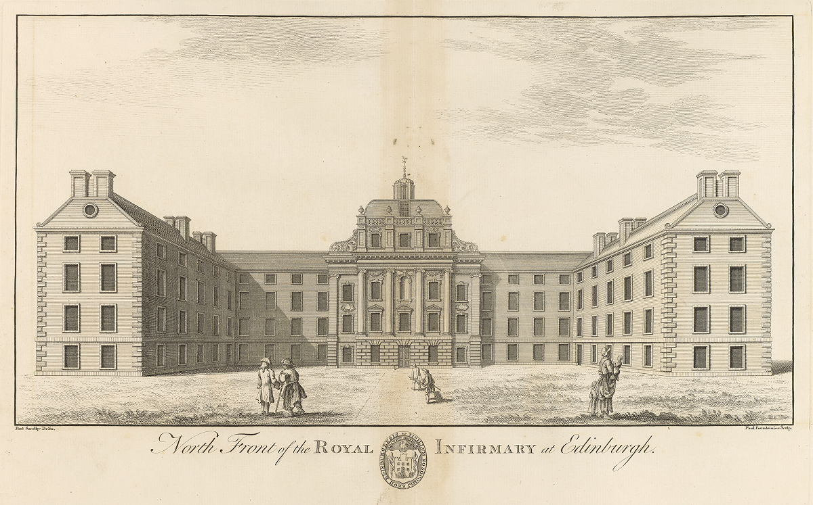

Prologue:
Real and Personal Property, Jamaica, 1749

Aimee. Robin. Jack. Simon. Plato. Frank.
Jamaica. Essex. Hercules. Roger. Cato. Peter.
Friday. Edinburgh. Jeffery. Bob. Thom. Archie.
Oxford. Jack. Cesar. Dick. Thom. Will.
Scotland. Berwick. Lucy. Toucham. Nancy. Kingston Amelia. Ebo Amelia. Venus. Maria. Diana. Hannah. Calia.
Chloe. Rachel. Pheba.
Very little is known about the lives of the 39 people who went by the above names. Some were children. Some were related to one another. Some were tradesmen. All were African or of African descent. All were enslaved by a white Scottish surgeon on a 420-acre estate called Red Hill pen in the Parish of St Thomas-in-the-East in Jamaica in 1749. Most were probably given these names – some referring to antiquity, others to places in Scotland and England, and one to the name of their enslaver – by their white Scottish enslaver; those named Ebo possibly belonged to the Igbo people of West Africa. These human chattels were compelled to labour for their white ‘owner’. A principal activity on Red Hill (the name in colonial Jamaica for land used for livestock) involved rearing and herding cattle and other livestock probably for selling to nearby plantation owners who typically focused all their land on money-making crops such as sugar. Many would also have been involved in the felling of the estate’s timber, possibly to make fences for livestock, and so, in the process, contributing to a centuries-long process of deforestation that forever transformed the island’s natural environment. Others, including, children, older and disabled people, would have worked domestic jobs on the estate’s single ‘Pen House’ or in their own ‘slave houses’. Some will have spent long days under the scorching Caribbean sun at Red Hill digging, hoeing, weeding, planting, and fertilising soil for the growing of sugar cane, and later cutting it down with machetes. Others would have then crushed and boiled the raw sugar cane into molasses and rum on the estate’s ‘sugar work’. Their long days of labour would have been conducted under the watchful eyes of white overseers who most likely used violence – and certainly the threat of violence – to ensure their compliance.
Little did any of them know (or perhaps would ever know) that early that year, a single document, written by someone as an act of charity, would legally pass ownership over all of them – along with the rest of their Scottish owner’s ‘real and personal property’ – into the hands of the Managers of the relatively newly established Royal Infirmary of Edinburgh. Over the next 143 years, the exploited labour of those who worked on Red Hill – generations of enslaved and then, after the abolition of slavery, ‘apprentice’ labourers – would generate a considerable amount of wealth for the Infirmary that enabled the buying of medicines, the construction of new buildings, the employment of staff, and the healing of Edinburgh’s ‘sick poor’.
Red Hill, however, was not the only case in which individuals with ties to slavery contributed to medical philanthropy in Edinburgh: considerable sums of slavery-associated money flowed through the Infirmary’s accounts in the eighteenth and nineteenth centuries. This report is the first significant step towards acknowledging, understanding, and reckoning with this historical fact: that the Royal Infirmary of Edinburgh – a place of humanity, charity, and healing – was, in part, built upon, and sustained by, the horrific enslavement and cruel exploitation of enslaved and colonised people of African descent in Britain’s colonies.

Contents

Executive Summary 5
Background 6
Terminology and Slavery Acknowledgement 7
Timeline 8
The Royal Infirmary of Edinburgh: Institutional Context 9
Blood Money: Slavery-Associated Donations and Legacies 13
Red Hill Pen: Dr Archibald Kerr’s Legacy 33
Medicine, Race and Empire: Inside the Royal Infirmary of Edinburgh 69
Conclusion 76
Avenues for Further Research 81
Research Connections 85
Sources in LHSA 86
Glossary 86
Tables 87

Executive Summary
- From 1729 to 1850, the Royal Infirmary of Edinburgh (RIE) received at least £28,080 from 43 individuals with ties to Atlantic slavery.

- These donors included physicians, surgeons, politicians, colonial officials, bankers, and a range of merchants, both in Britain and its colonies, who were connected to the enslavement of people of African descent in the British West Indies and Americas, specifically Carolina, New England, Jamaica, Barbados, Antigua, Demerara, Grenada, Tobago, St Vincent, Montserrat, and St Croix.

- From 1749 to 1892, the RIE owned and leased an estate in St Thomas-in-the-East, Jamaica, called Red Hill pen, bequeathed to them in the will of the Scottish surgeon and enslaver Dr Archibald Kerr. Until the abolition of slavery in Britain’s colonies came into effect in 1834, the RIE owned and leased the enslaved people upon it, drawing substantial rents from the property. After Abolition, the estate employed ‘apprentice’ Black labourers.

- Between 1773 and 1801, the RIE was involved in requests for the manumission (the granting of freedom) of an enslaved Black woman (Juliet) and later her two enslaved children (John and William Moodie) on Red Hill at the request of their father, the white Dr John Moodie.

- The enslaved people of African descent on Red Hill were involved in incidents of insurrection against white overseers near the time of Abolition in Jamaica in the 1830s.

- Via a complex series of events, the RIE eventually received approximately £832 from the British Government after the abolition of slavery (1834) as ‘compensation’ for the loss of labour of the enslaved people they owned on Red Hill.

- Some of the medical profession who trained or worked within the RIE had connections to British slavery and the medical study of ‘race’.

- During the eighteenth and nineteenth centuries several Black patients were admitted to the RIE, including one unnamed enslaved individual who escaped their bondage while an inpatient.

- The African-American radical, abolitionist, and previously enslaved William Wells Brown visited the RIE during his stay in Edinburgh in 1851.

- NHS Lothian owns a portrait of the enslaver Archibald Kerr and a bust and portrait of Provost George Drummond, a key figure in dealing with Kerr’s estate on behalf of the Managers of the RIE.

Background
In August 2021 NHS Lothian and NHS Lothian Charity (formerly Edinburgh and Lothians Health Foundation) released the following joint statement:
We are aware that hospitals across Lothian have benefited from funds realised from the Atlantic slave trade.
With colonialism and slavery being central to the national economy from the seventeenth to the nineteenth centuries, both Edinburgh and Lothians Health Foundation and NHS Lothian can be considered as joint descendants of the legacies of these donations and endowments.
We do not believe that there is a limitation period on such contributions and have a responsibility to address this legacy of colonialism, racism and slavery and use this learning to help remove inequality and shape a positive future for all.
Both organisations agreed to commit to ‘research, understand and acknowledge’ this history so they could ‘learn from it and act’. Following the creation of a consultative Advisory Group to help guide and shape the research, learning and related outputs, a research post was funded to review archival evidence to ‘compile a thorough documented history of the links between the old Royal Infirmary of Edinburgh and the Atlantic slave trade’. This report is the result of research completed between February and July 2022. It is not intended to be read as the final say on the Royal Infirmary of Edinburgh’s diverse connections to British slavery and colonialism; rather, it is an empirical investigation of relevant materials about British slavery within Lothian Health Services Archive’s (LHSA) Royal Infirmary of Edinburgh collection (LHB1), particularly in relation to the bequest of an estate and the enslaved people upon it in Jamaica. This report aims to provide an introduction to the topic and a guide for future research. In the process, it aims to contribute to a wider conversation about the connections between medicine, healthcare, African enslavement, and British colonialism, particularly in relation to Edinburgh and Lothians.

Terminology and Slavery Acknowledgement
This report quotes historical documents during the period of British colonial expansion and Atlantic slavery during the eighteenth and nineteenth centuries. The language typically used during that period to describe enslaved, colonised, Black, Indigenous, and Asian people is derogatory, racist, and offensive. Some readers will find some of the language quoted within this report disturbing or triggering. The language of colonialism served to dehumanise enslaved and colonised people. It also served to ‘sanitise’ enslavers by describing those who traded, owned, and exploited human chattels with generic labels such as ‘merchant’ or ‘planter’, rather than as human traffickers or enslavers. By including such language in this report, including historical ‘valuations’ of the ‘worth’ of enslaved people, the intention here is not to reproduce the objectification, commodification, or dehumanisation of historically enslaved and colonised people or replicate the violent power relations that defined Atlantic slavery. It is hoped that the inclusion of this language, where appropriate and necessary, is understood in the spirit of historical research. As painful as much of this language is, it is important that we understand the precise nature of the RIE’s relationship to colonialism and slavery. There is a glossary at the end of report to aid readers with historical terminology.
Research for this report was conducted by the author over a period of six months in 2022 as an embedded researcher at the Centre for Research Collections (CRC), home to the University of Edinburgh’s cultural and heritage collections. Although the focus here is on the Royal Infirmary of Edinburgh’s connections to slavery, it is important to acknowledge that the institution which provided a home for this research – and which preserves and maintains the primary archive on which the research is based – was itself entangled in British colonialism and slavery, both in terms of funding and as an influential centre of learning within the British Empire. The University of Edinburgh is committed to reckoning with these histories and investigating its colonial past.

Timeline
1773
First patients admitted to the hospital that, with a Royal Charter in 1736, will become the Royal Infirmary of Edinburgh.
The Royal Infirmary of Edinburgh sells Red Hill estate in Jamaica.
The Slavery Abolition Act (1833) comes into effect, providing for the gradual abolition of slavery in the British Empire. The Slave Trade Act (1807) prohibited the slave trade to British territories and by British ships.
Dr Archibald Kerr, a Scottish surgeon and enslaver in Jamaica dies, leaving his estate, Red Hill Pen, and 39 enslaved people, to the Royal Infirmary of Edinburgh.
Acts of Union between Scotland and England.
Kingdom of Scotland attempts to establish the colony of New Caledonia in the Gulf of Darien, Panama.
Dr John Moodie in Jamaica requests the Infirmary’s Managers grant freedom to an enslaved woman, Juliet, and then later, in 1793, the freedom of his and Juliet’s children, John and William Moodie.
1892
1834
1749
1729
1706
1698

The Royal Infirmary of Edinburgh:
Institutional Context
‘[B]eing desirous to promote so good and laudable a charity …’
Extract from the Royal Infirmary of Edinburgh’s Royal Charter (1736).
Alongside the establishment of the Royal College of Physicians of Edinburgh (1681), the University of Edinburgh’s Medical School (1726), and the institutions that predated the Royal College of Surgeons of Edinburgh (dating as far back as 1505), the opening of the doors in 1729 to the hospital that would later become the Royal Infirmary of Edinburgh marked a major sea change in the history of medicine in Scotland. Influenced by developments in Leiden in the Netherlands, where many Scots had studied, John Monro and other prominent surgeons in the city began circulating pamphlets promoting the establishment of a hospital for the ‘sick poor’ that could also serve as a venue for clinical training. Monro’s son, Alexander, picked up his father’s ambition. A 1725 public meeting soon drew in subscriptions of ‘voluntary bonds’, with subscribers promising to pay £5 towards the new hospital if £2,000 could be collected before a certain deadline (an eighteenth-century crowdfunder campaign). The voluntary bonds for the RIE promised that funds would help erect and maintain ‘a hospital or Infirmary for Sick poor’ of a ‘most Pious and Charitable Design’ that would be of ‘great advantage and credible to the Nation in General’. George Drummond, a prominent banker and civic figure in Edinburgh who served as Provost repeatedly over his lifetime, and helped build Edinburgh’s New Town, was a leading figure in the campaign.
In December 1728 a group of civic leaders, original subscribers, physicians and surgeons met for the first time to begin to realise the project. Meetings during the first year were held at John’s Coffee House, a popular meeting place for the city’s intellectual, political, and merchant classes; many who drank there likely had connections to the British West Indies. Drinking from their cups of coffee – an increasingly fashionable beverage amongst Britain’s upper classes, made from beans cultivated by enslaved people in the Americas, and sweetened by slave-grown sugar from Britain’s sugar colonies – the Managers got to work.
A property was bought on Robertson’s Close in Edinburgh and staff employed to service the four- and then six-bed hospital. The first patients were admitted on August 6, 1729. In 1736 King George II granted the hospital a Royal Charter to promote ‘so good and laudable a charity’ in the city. As the newly named Royal Infirmary of Edinburgh (hereafter RIE) grew in size, a new property was acquired on ground known as Thompson’s Yards, to the South of Robertson’s Close. The new foundation stone for the larger hospital was laid in on the property beside what became known as Infirmary Street on August 2, 1738.
The RIE archive collection details the highs and lows of the running of the RIE from the perspective of its Managers and ‘agents’ (those who worked or volunteered for the RIE, but were not directly involved in its day-to-day affairs). The responsibilities of Managers were as diverse as might be expected: accounting, rule-making, hiring and firing, correspondence with medical professionals and learned societies, dealing with large intakes of patients during periods of war, rebellion, or epidemics, communicating with other infirmaries and hospitals, and even disciplining staff for ‘bodysnatching’. As a ‘volunteer’ hospital funded by public donations – unlike English infirmaries, which used a subscription model in which patients had to apply to donors for recommendations, and so could only admit a limited number of patients – the RIE was in constant need of funds. Sourcing and processing donations and legacies (bequests) were time-consuming responsibilities. Managers (particularly treasurers) intermittently despaired during their meetings at the institution’s very future, especially on those occasional years when expenditure outweighed income. In 1763, the treasurer wrote to a Jamaican contact of his ‘concerns’ about the hospital’s funds, and Managers’ efforts to ‘keep the full number’ of patients up, despite ‘struggling with [the RIE’s financial] difficulties’. Likewise, the portentous concluding remarks to an early history of the Infirmary published in 1778, probably produced with the intention to help to raise funds for the institution, warned that
Though the funds of the Infirmary have exceeded the most sanguine expectations … its present annual revenue is no more than sufficient for its maintenance. The family and patients together have sometimes arisen to two hundred and thirty; and were sickness in the country, the price of vivres [food], or demands for the repairs of the fabric, and more especially, were all these together to increase to an uncommon degree, it is feared the managers would find it necessary to diminish the number of patients considerably, in order to preserve their capital.

RIE records provide insights into the philanthropic world revolving around Edinburgh in the eighteenth and nineteenth centuries. Figures mentioned include William MacGibbon, a famous eighteenth-century composer and violinist, who donated his whole estate and effects to the RIE; Andrew Forbes, a brandy and wine merchant based for a time in Rotterdam, who collected more donations from Scots in the Province of Holland; the Scottish peer, David Murray, 6th Viscount of Stormont; even a member of the royal Russian family found time to send a £50 donation after visiting Scotland. Non-monetary donations included beds, drugs, whisky (courtesy of the Haig company), and, bizarrely, a ‘very great Curiosity’ given by passengers on a ship returning from Greenland: the ‘head and Horn of a Sea Unicorn’ (presumably a narwhal). An iron donation box inside the RIE also brought in small funds from the general public (although a £100 note was discovered in the box in 1804). The largest donation during the RIE’s early years was the Earl of Hopetoun’s grant of £420 per annum over 25 years, an income source which was so significant the treasurer gave it its own separate column in his Receipt Book. RIE records, however, as primarily administrative sources, give only slender insight into the moral, religious, social, cultural, and economic drivers of charitable giving generally, and medical philanthropy more specifically: some donors appear to have wanted to personally ‘thank’ the RIE for caring for a relative or friend; others seemingly did so because of their business or family ties to Managers or the RIE’s agents.
As the initial burst of interest in the 1720s and early 1730s began to dissipate, Managers found themselves once again desperately searching for more funds. The answer to their funding problem lay in part beyond Scotland’s borders, to London, and then abroad, to Britain’s colonies.

Blood Money:
Slavery-Associated Donations and Legacies
‘The morning mists still haunt the stony street;
The northern summer air is shrill and cold;
And lo, the Hospital, grey, quiet, old,
Where Life and Death like friendly chafferers meet’.
Extract from William Ernest Henley’s poem, ‘Enter Patient’,
written while a patient at the old RIE in the 1870s.
The RIE received thousands of subscriptions, donations, legacies (bequests), and other financial and non-financial support (all of which can be called ‘gifts’) between its establishment in 1729 and the abolition of slavery in 1834. Most are documented in one way or another within LHSA’s RIE collection (LHB1), particularly Cash Books (LHB1/13), Receipt Books (LHB1/9), Managers’ Minutes (LHB1/1), and Eighteenth-Century Correspondence (LHB1/72). Nevertheless, gaps, limitations, inconsistencies, and accounting errors exist across these different documents. Where gifts are mentioned, sometimes only names and amounts are provided; sometimes an address, profession, title, name of a relative, year of death, or some other identifying characteristic also features, which helps to identify historical donors. Some donations, however, were given anonymously or came from ‘collections’ in particular communities (e.g. Scottish parishes or British colonies). Time constraints means this reports only provide insights into the tip of the iceberg of the vast number of connections the RIE must have had to individuals and families in the post-Abolition period whose inherited wealth can be traced back to slavery. For example, Robert McVie, the baker, businessman, and founder of the eponymous confectionary brand, served on the RIE’s Chamber of Commerce in the 1870s. It appears that McVitie’s family on his mother’s side owned plantations and enslaved people in Grenada. Similarly, further research into RIE records will provide valuable examples of the connections the Infirmary had to individuals whose wealth derived from racial enslavement in territories where slavery remained legal later into the nineteenth century. David Milne, for example, who made a substantial donation to the RIE (£1500), was based in St Croix in the 1840s, a Danish colony where slavery was not abolished until 1847. Equally, the RIE bought large amounts of cotton cloth to use as bandages (2,290 feet in the year 1842 alone). It is not clear from records whether the cotton was picked by enslaved labour in the southern United States, but statistically it is very likely at least some of it was. These limitations aside, the RIE archival collection provides valuable information about the institution’s diverse connections to enslavement and colonialism.
To ask whether gifts were ‘associated’ to slavery is itself a very difficult exercise given the dramatic influence of the slavery economy on Britain. As well as identifying the giver of the gift, it requires outlining where their wealth came from: for those who owned enslaved people, the matter may seem clearer, although even some of those may have derived the majority of their wealth from other sources; for mercantile businesses who traded in slavery-related goods (e.g. sugar) or services (e.g. financial), the picture is even more complicated. Sometimes, all that is known about a certain donation is that it came from a British colony such as Jamaica. This report includes figures who worked for the British Empire in a military or administrative capacity, or who wrote tracts or pamphlets in support of colonialism and enslavement, because their working lives entailed the practical or ideological maintenance of the system of British slavery: some may disagree as to their ‘complicity’ in enslavement. It is therefore extremely difficult, and arguably impossible, to ‘catch’ all those contributions to the RIE that we can say with confidence were ‘associated’ with slavery – let alone find consensus on what it means for an individual to be ‘associated’ with racial enslavement. This report thus provides only an underestimation of the proportion of slavery-associated money (broadly defined) that flowed through the RIE’s coffers during the era of British slavery, and only a glimpse into the period thereafter.
It is also difficult to assess how much money was ‘worth’ in different periods of time. This report covers a vast period of time, from the founding of the RIE in 1729 to the sale of Red Hill pen in Jamaica in 1892. Due to time constraints, donations have only been investigated up until around the 1840s. The reader should be conscious that the worth of a £5, £50, or £500 donation changed dramatically over time. There are many ways of calculating the modern-day value of historical wealth or income depending on the nature of the wealth, income, or investment. To aid the reader in this regard, Table 3 includes some sample modern-day values using three different types of calculators provided by Measuring Worth, a website designed by academics and used by economic historians and historians of slavery. The reader is recommended in the first instance to use the middle column - Relative Wage or Income Worth (RWIW) - as a general guide. This calculator calculates an amount of money as a proportion of the average earnings for all workers during a particular year, and then applies that proportion to modern-day figures. It has been chosen because it provides a useful middle-ground between other calculators that tend to under- or over-estimate values, and so an estimation that can aid readers in assessing the relative value of donations in any particular year. Still, these modern-day values should be interpreted as guides rather than an exact science: as other research in this field highlights, ideally all calculators should be used in combination with one another to produce more appropriate modern-day equivalencies. Due to the complexities involved in accurately assessing wealth over time, this report has opted not to include a modern-day equivalence for the total amount of slavery-associated money the RIE received, as any such calculation would require complex, year-by-year study that is not possible within the timeframe of this research. Rather, the focus is here is on the proportional impact of this money within the context of the RIE’s wider activities.
Research so far has identified approximately £28,080 of slavery-associated money as entering the RIE books in the form of donations and legacies between 1730 and 1850 (see Table 4), and, in one special case, income deriving from a Jamaican plantation and the enslaved people thereupon (see the separate section in this report for more on Red Hill). £14,450 of this total amount was gifted in the years 1744-1795, a period for which more robust and accessible accounting information exists for the making of comparative study. From these figures we can say that slavery-associated money during 1744-1795 constituted at least 11.1% of the RIE’s entire income and 42% of its charitable gifts. For 1807-1821, another such period where relevant accounting data is available, this income constituted 7.4% of the RIE’s entire income and 29.7% of its charitable gifts. Further research is required to unpack the relative value of these donations in different periods of the RIE’s history given factors such as inflation and the changing values of cash and credit. We can nevertheless get a sense of the impact that donations from individuals with ties to slavery had on the RIE by looking at the institution’s other available statistics. For example, 18,785 patients were admitted to the RIE between 1808 and 1817. Although the financial ‘cost’ of admitting a patient would vary from case to case, it can be estimated from these numbers that the slavery-associated income of the RIE during these years paid for the entire treatment of an average of 1,390 patients.
How representative are these figures for an eighteenth-century British infirmary? The University College London’s Legacies of British Slavery (LBS) database, which features records of individuals with ties to slavery drawn from a variety of sources, cites several hospitals and infirmaries (including the RIE) with varying ties to enslavement through donations, bequests, and endowments. Research conducted in 2021 on the St Thomas’ and Guy’s Hospitals in Southwark is another indication that there existed a strong connection between wealth derived from enslavement and hospital philanthropy in eighteenth-century Britain. In Scotland, we know that the planter and once enslaver James Ewing left around £10,000 to the Royal Infirmary of Glasgow after his death in 1853. Historian Douglas Hamilton cites the Inverness Inﬁrmary, which attracted subscriptions worth more than £2,000 from the Caribbean, as an example of how investment of colonial wealth in Scotland was ‘not driven only by the pursuit of proﬁt … it is clear that continuing attachment of Scots to their home areas, and to their families still resident there, encouraged some Scots to invest in local social infrastructures’, including educational establishments as well as hospitals. The RIE, therefore, was not unusual in accepting gifts from individuals whose wealth derived from enslaved labour.
What do we know about the donors? In a list of the ‘original’ (pre-1730) 350 subscribers to the RIE, approximately 129 are identified as being based in Edinburgh. There are likely more in this list who were based in Edinburgh who have not yet been identified. Most of the rest resided elsewhere in Scotland, including the Borders, Islands, and Highlands, as well as other major cities like Dundee and Glasgow. Some came from England, though only four were based in London. None, significantly, have yet been identified as having residing abroad. The aristocracy are heavily represented in the group. The biggest identified professional groups are merchants (49), advocates or barristers (26), physicians (21), writers (16), Writers to the Signet (15), Ministers of the Gospel (11), and Senators of the College of Justice (11). That there were more donors who were women (19) than surgeons (15) highlights some of the interesting gender dynamics at work in early hospital philanthropy. Of the 49 merchants, only four have been identified as having economic ties to British slavery. This is likely a gross underestimation given what we know of Scottish involvement in colonialism, especially after the Acts of Union (1707) between Scotland and England. Further research is required of the backgrounds to the remaining 301 subscribers. Subscriptions, however, if collectively a significant force in the establishment of the RIE, were individually relatively very small (£5 per annum). Beyond subscriptions, one-off donations from people with ties to slavery ranged from £1 to £2000 (this does not include Dr Archibald Kerr’s legacy, which is covered separately in this report). It is these donations where the influence of British colonialism on the RIE is most clear.
In the late 1730s, Managers began to reach out beyond Scotland and England. No figure had a greater impact in soliciting donations for the institution in its early years – or in internationalising its fundraising base – than Adam Anderson. Hailing from Aberdeen, Anderson was an agent in London for the Society in Scotland for Propagating Christian Knowledge. Anderson helped to source and process donations for the mission whose aims included the establishment of the Anglican faith in colonies and plantations in the Americas and India (the Society also donated books to the RIE, probably at Anderson’s suggestion). A stern advocate of colonialism, Anderson later wrote an influential 1776 treatise on economics (a work that some contend anticipated the work of Adam Smith) in which he argued how ‘vastly profitable’ Britain’s colonial plantations were, and his desire that they should more fully ‘flourish’ in the near future. He referred to Africans on the Guinea Coast, with whom the British traded goods and arms for human chattel, as ‘wretched Natives’. Anderson had earlier served as a chief clerk of the South Sea Company (a joint-stock company granted a monopoly in 1713 to supply captive Africans to the ‘South Seas’ and Americas) and played a pivotal role in shoring up support for philanthropic and commercial enterprises amongst London’s growing Scottish business community. King George II listed Anderson as one of the Trustees for establishing the Colony of Georgia in America.
As early as 1738 the RIE’s Managers had discussed whether it ‘might be of service of the Infirmary to have Some Correspondents at London to solicit there for donations to the Infirmary’. After Anderson advised Managers in 1748 of a large bequest from a deceased widow in London, they suggested he ‘be put on same footing as he is for the Society with the Infirmary’. In 1749, Managers allowed him ‘a discretionary power to act and do what he thinks most proper for the service and interest’ of the RIE, paying him a retainer for expenses amounting at one stage to £180 a year. Anderson was attentive to detail in his fundraising. He organised advertisements in the London Evening Post instructing interested parties to contact him at South Sea House, the once home of the South Sea Company (Fig. 1). He believed sending sketches and engravings of plans and accounts of the hospital would help to solicit funds, especially among what he considered key target groups in the City of London: ‘gentlemen of fortune’ and ‘fellow countrymen’ (i.e. Scots). Anderson and the Managers recognised that potential and past donors across the British Empire would benefit from seeing plans of the building. In 1742 Managers sent dozens of framed glass plans of the RIE’s new building to William Mathew, Chief Governor of the Leeward Caribbean Islands, in Antigua, to circulate amongst wealthy planters. Meanwhile, in London, Anderson sent prints to be placed in the Jamaica Coffee House and other coffee houses used by London’s colonial merchants ‘for putting [possible donors] in mind of so good a charity’. These plans, some of which reside in the RIE collection – an example can be seen on the front cover of this report – were thus simultaneously architectural, philanthropic, and colonial objects, designed to solicit interest, and, ultimately, donations, through their strategic placement in the colonial homes and offices in the West Indies and in the Empire’s capital.
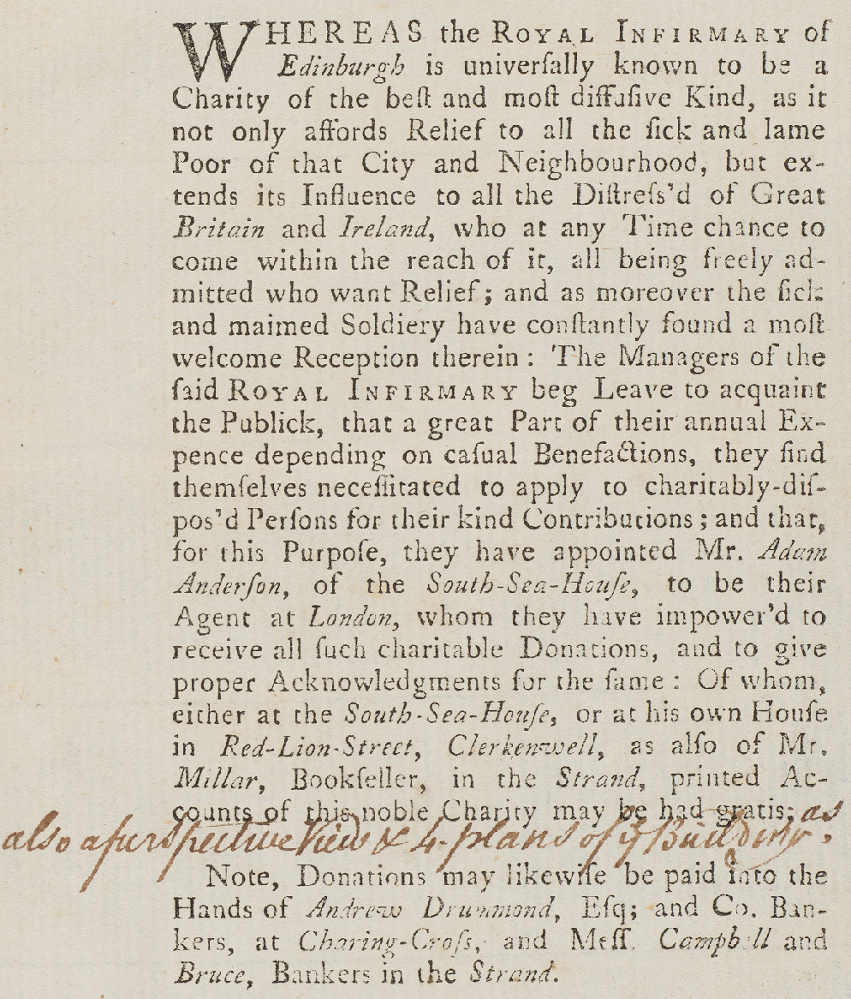
Fig. 1: Example of an advertisement for donors for the RIE, printed in a London newspaper,
requesting individuals contact the Infirmary’s agent Adam Anderson at South Sea House, London.
Anderson believed passionately that the RIE was a ‘Charity which does equal honour to our common country and to its Metropolis; a charity which is as much a National as a local one and should therefore surely be the care of All’. For the RIE to grow, Anderson believed, it was necessary to present some degree of British rather than only Scottish identity in order to solicit donations from England. His belief was not entirely unfounded. W. Cuming, in Dorchester, wrote to Anderson concerning a potential benefactor to the RIE who ‘considered Scotland and England as part of the same Kingdom and therefore that the Infirmary at Edinburgh was so far equally entitled to his Encouragement’ but felt that ‘the nobility and gentry of Scotland considered things in a more confined & limited view as none of them that he knew of had even contributed toward the General Hospital of Bath’ (where said benefactor acted as Manager).
In 1748, Anderson advised Managers that ‘as there are great numbers of our nation [underline in original] all over the world’ that ‘somewhat may be gotten’ from ‘American Plantations’ or by ‘getting one or two Gentlemen (in Jamaica, Barbados, New York, Carolina) to take a little pains’ in recommending the charity to their wealthy contacts (Fig. 2). The Managers had already implemented such a tactic. In 1740, they had contacted Jonathan Belcher, Governor of New England, for the countenance towards a collection in Boston to help fund the hospital’s new building. From colonial Massachusetts, Belcher was a trader and owner of enslaved people who pushed to ‘promote economic viability by constraining slavery’ for the betterment, he argued, of the white race: ‘We have but few [enslaved people] in these parts and I wish there were less … From every white we may hope for a good man to add to the common wealth’. In 1740 Managers also wrote to John Wanton, an enslaver and Governor of the Colony of Rhode Island and Providence Plantations who founded the College that would later become Brown University. Other American contacts included George Clarke, Governor of New York, who was involved in the brutal suppression of a purported insurgent plot of enslaved people that became known as New York’s ‘Conspiracy’ of 1741. After his mansion at Fort George was burnt down (allegedly by enslaved people), Clarke ordered militia to patrol the streets and round up enslaved people. Another contact was Thomas Penn, the son of a prominent Quaker family and proprietor of the Colony of Pennsylvania, who inherited enslaved people from his father, William Penn. A donation of 100 guineas (£105) also came from James Crokatt (1701-1777), a Scottish indigo planter in Charles Town (Charleston, South Carolina). Crokatt was a vivacious promoter of Carolina’s indigo trade (a trade dominated at that time by West Indian plantations) in London’s trading houses and newspapers. He published his own pamphlets on the topic and secured a parliamentary bounty on American-grown indigo in 1748. Crokatt later inherited his brother’s estate in Jamaica, and ‘owned and employed slaves in his house and warehouse and defended slavery as an economic necessity in the Lower South, later advocating its introduction in Georgia’.
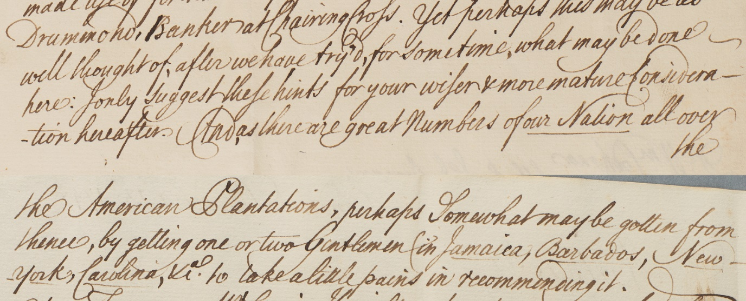
Fig. 2: Extract from a letter from the RIE’s agent, Adam Anderson, to the Managers advising them to write to American plantations and British colonies in the Caribbean to solicit funds for the Infirmary.
Jamaica became an equally important target for the RIE. The impact of colonial Scots in Jamaica was undoubtedly great, although exact numbers vary as to the Scottish presence on the island as land- and slave-holders, with figures ranging from 11 to 30% around the time of Abolition. In January 1740 Managers made application to Edward Trewlany, Governor of Jamaica, to ‘give his countenance of a Collection in that island [Jamaica] for carrying on the building [of the Infirmary]’. A year later, Trewlany and Joshua Crosby reported back to the Managers on their success in securing £1000 of ‘Jamaica money’. As well as Trelawney, Managers wrote to wealthy individuals in Jamaica including significant colonial figures, medical professionals, and enslavers: Alexander Campbell (surgeon and lieutenant), John Baillie (surgeon), John Gregory (Chief Justice of Jamaica, and Governor during the last years of the First Maroon War), Patrick Adam (merchant and planter), William Lindsay, Col. John Campbell, Rt. Hon. Henry Dawkins, and William Cunninghame. Not all of these individuals responded to the call directly, although a subsequent £500 collection from the Island of Jamaica suggests some of them had contributed in some way. In any case, the intention on the part of the Managers was to attract Scottish-Jamaican wealth (nearly all of which we can be confident derived from enslaved labour). This relationship with Jamaica would continue: as late as 1832, the RIE received a legacy of £200 from William Paterson of Ayr, an attorney and owner of slave estates in Jamaica.
Alongside the letters to Jamaica, Managers agreed to acquire ‘the names of the Governors of all the British settlements abroad and of the people of distinction in the several settlements, and apply to all of them for aid to forward the work’. Over the next 80 years, planters in Grenada, Antigua, Barbados, and St Croix were asked to donate; some seemingly donated on their own initiative. In 1742, colonial administrators Charles Dunbar, Surveyor General of Customs in Barbados, and William Mathew Jr., Capt. General and Chief Governor of the Leeward Islands, forwarded the RIE’s call for subscriptions onto prospective colonial donors. In 1742, Thomas Finley of Balkirshire, Fife, who had ‘acquired an opulent fortune’ in Barbados, donated £136 he had collected from ‘gentlemen’ on the island. In 1745 he donated another £10 from his own pocket. The contributions of Finley and other West Indian ‘gentlemen’ indicate a strong commitment amongst Scottish planters abroad to charitable causes at home. Such philanthropy helped Scots in the colonies to sustain ties with businesspeople and politicians at home, especially given the crises engulfing Britain, its colonies, and Scotland during the 1740s and 1750s, including conflict with France in 1744 over the sugar colonies in the West Indies, a threat of French invasion on British shores the same year, and the Jacobite Rising of 1745. ‘French support of the Stuart pretender to the British throne’, historian Richard B. Sheridan writes, and the threat of simultaneous invasions from Scotland and France in 1745, brought ‘near panic to the West India interest.’ Sheridan demonstrates how war and political unrest affected West Indian planters, including Thomas Finley of Barbados, whose request of £3,000 credit from the firm Lascelles and Maxwell was denied in January 1746. ‘It is impossible to describe the calamities of these times’, Henry Lascelles told Finley with an apology. Although more evidence would be required to make a robust argument, it is possible that that the act of donating money to philanthropic endeavours in Edinburgh, like the RIE, was one method for Scots in the West Indies to reintegrate themselves and their interests into the occasionally volatile business networks of the mid-eighteenth-century British Atlantic world.
The RIE also received donations from individuals who – often alongside owning enslaved people themselves – worked within and alongside British colonies’ administrative, legal, and military organs that maintained the chattel slavery system. It seems that Thomas Fairholme, who donated £160 to the RIE in 1742, was an Edinburgh merchant who owned land, property, and enslaved people in Tobago. In 1774, Fairholme, as Speaker for the Council and Assembly on the island, petitioned the King because ‘The Number of slaves being greatly in excess of the white people’ meant he and white planters were ‘in danger of an insurrection which they have no means to quell. Pray that the Island may be put into an immediate state of defence, that the number of troops may be increased’. From 1733 to 1754, Lord Patrick Grant of Elchies who, along with his wife, was a regular donor to the RIE, presided as a Senator of the College of Justice over several cases in Edinburgh’s Court of Session concerning the land, ships, and inheritances of West Indian merchants. General Duncan Campbell, who donated £500 to the RIE in his will, served as Regimental Colonel of the 91st (Argyllshire Highlanders) Regiment of Foot from 1796 until his death in 1837. He fought in Jamaica, elsewhere in the British West Indies, and in the British invasion of the Cape Colony (South Africa) in June 1795, a conflict with the Dutch over the slave port and the access it gave to South Asia.
British, and particularly Scottish, merchants in major European cities such Stockholm, Rotterdam, Amsterdam, Dublin, and Boulogne also answered the RIE’s call. Some donors residing in Britain, if not owners of enslaved people, traded in slave-grown produce. William Alexander, a Glaswegian merchant, banker, and briefly Lord Provost of Edinburgh (1752-54) donated £50 to the RIE in 1754. Alexander was involved in the re-export of most likely slave-grown Virginia tobacco via Greenock to France. Likewise, in 1818 J. Stainton donated £50 to the RIE on behalf of the Carron Company, a company which produced sugar pans used on British colonial plantations. Leith and parts of Edinburgh housed several sugar refineries. William Sharp, an early subscriber to the RIE, was seemingly involved with the Edinburgh Sugar Company, which imported slave-grown sugar. Other RIE donors (e.g. William Alexander, John Hay, William Ramsay of Barton, Sir William Fettes, Bart.), Managers (e.g. George Drummond, David Spence, William Forbes, Samuel Anderson), and agents (e.g. Archibald Campbell, 3rd Duke of Argyll) were founders, treasurers, governors, and/or shareholders in Scottish banks, including the Bank of Scotland, British Linen Bank, Ramsay’s, Bonar & Company, and Forbes, Hunter & Co. Scottish merchant finance was implicated in the business of transatlantic enslavement through stocks, investments, loans, and, in the case of the British Linen Bank, the sale of clothes for enslaved people. Further financial ties to slavery can likely be traced through the RIE’s connection to the North British Insurance Company, a company whose board had links to several slave estates.
Some royal donors included King George IV, who donated £200 to the RIE in 1822 after a rare royal visit to Scotland. In an 1824 proclamation, the King warned ominously that the ‘Slave Population … will be undeserving of Our Protection if they shall fail to render entire Submission to the Laws, as well as dutiful Obedience to their Masters’. Earlier, in 1747, Prince William Augustus, 1st Duke of Cumberland and youngest son to King George II, donated £50 to the RIE. A watercolour by Paul Sanby suggests that he at one stage seemingly employed a ‘negro servant’ (possibly a page boy), although it is unclear what the Duke’s relationship to the individual was, or whether the latter was real or fictional, or, enslaved or ‘free’. The Prince’s donation to the RIE arrived a year after his defeat of the Jacobites at the Battle of Culloden, and his reportedly ruthless suppression of rebels in the Highlands had earned him the name ‘Butcher Cumberland’. Although the topic is debated by historians, the Duke of Cumberland at one stage countenanced the idea of deporting rebellious Highlanders to Britain’s colonies.
The RIE was implicated vicariously in some of Britain’s earliest forays into the transatlantic slave trade. Patrick Crawford, ‘merchant in Edin[burgh]’, was the owner of the original property near to College Wynd deemed a ‘convenient situation for building an infirmary’. It appears Crawford was an early subscriber (£200) to the Company of Scotland Trading to Africa and the Indies (1695-1707), a Scottish trading company that tried and failed to establish the New Caledonia colony in Darien (modern-day Panama). Although Crawford’s property was sold rather than gifted to the RIE Managers, it is significant to recognise that the original building itself was previously owned by someone who had invested in Scotland’s most infamous attempt to colonise the New World, an endeavour which, had it been successful, would have involved the enslavement and trade of African and Indigenous people in the Americas.
Others donors similarly had at one stage invested in the South Sea Company. Alexander Blackwood, an original subscriber to the RIE, acted as creditor to his brother John Blackwood’s company that, on a South Sea Company grant, conducted trade in the 1730s in ‘the province of Incatan in the Kingdom of New Mexico’. Francis Charteris, a beneficiary of the South Sea Bubble, left £100 to the RIE on his death, which, after accruing twelve years of interest while Managers remained ignorant of his will, made a total donation of £164. Charteris was an Edinburgh gambler, soldier, and adventurer better known as the ‘Rape-Master-General’ because of his reputation for sexual assault, allegations which led to a very public trial in 1730. James Amour, who donated £8 to the RIE in the name of his deceased sister Margaret Armour, wrote a tract in 1722 on improving the credit situation for ‘sufferers’ of the South Sea Company. Another donor more directly involved with the slave trade was Claude Johnston, who contributed £180 to the RIE in 1745. Maritime historian Eric J. Graham identifies a Scottish merchant in Edinburgh, and later London, by that name who was involved in the purchase of ‘essential Guinea goods’ for sale to African traders.
At least one donor with ties to slavery gifted goods rather than money to the RIE. In 1834 Sir John Sinclair of Ulster, 1st Baronet, once part-owner of 264 enslaved people in St Vincent, donated (along with other subscribers) several beds recently invented by John Johnston of Annan; ironically the new invention was designed ‘for the relief of human suffering’.
It is no surprise that medical practitioners in British colonies – Dr James Shaw (Scottish physician in Montserrat), James Drysdale (surgeon in Grenada), and Dr. John Cochran (Fellow of the Royal College of Physicians in Edinburgh, resident in Jamaica) – responded to the RIE’s call for contributions. Unlike the management of English infirmaries, which, because of their subscription model, tended to be donors, the RIE’s Board of Managers was mostly made up of physicians. Managers likely drew on their own professional networks in seeking out donations from physicians: in 1741, they wrote to the Edinburgh-born brothers, Drs John and Alexander Hamilton, in Maryland to solicit funds. It is not known whether the Hamiltons responded to the RIE’s call. The latter brother, who ran a practice in Annapolis, wrote a memoir of his travels through the British colonies with Dromo, an enslaved person of African descent whom he owned. Aside from derogatory remarks throughout the text about Dromo and other Black people he encountered (including a ‘stupid negro wench’), Hamilton’s shock and then scepticism on encountering a Black man on his travels who claimed Scottish descent and property reveals something of the intersection of race and national identity in the Scottish colonial mind:
There was a negro fellow on board, who told me he was a piece of a fiddler, and played some scraping tunes to one Wilson, who had come on board of us in a canoe. This was an impudent fellow. He accosted me with ‘How do you, countryman?’ at first sight, and told me he was a Scotsman, but I soon found by his howl in singing the Black Jock [a Scottish song] to the negro fiddle that he was a genuine Teague. He told me some clever lies, and claimed kin to Arncaple in Scotland. He said he had an estate of houses by heritage in Glasgow, swore he was born a gentleman for five generations, and never intended for the plough; therefore he had come to push his fortune in these parts.
It was common for women to donate to the RIE, although it is often harder to identify the sources of their wealth than for their male counterparts. The example of Maria Margaretta, Lady Elibank, who donated a relatively small sum of £6 to the RIE in the 1750s, suggests further research is required in this field. Lady Elibank was the wife of Patrick Murray, 5th Lord Elibank, who served in the Battle of Cartagena de Indias, a battle in the Colombian slave port between Britain and Spain for control over Caribbean colonial territory. He was an East India Company proprietor, and received a West Florida grant of 20,000 acres from his nephew, Governor George Johnstone. It is unclear whether he owned enslaved people, but it can be presumed that he shared his income with his wife, who then used that wealth for charitable causes.
Dig deep enough into many of the donors’ lives and one will find they also donated to other charitable causes in Edinburgh and beyond. The merchant Alexander Bruce left money in his will to both the RIE and the city’s Orphan’s Hospital. Alexander MacFarlane (1702-1755), a Scottish planter, judge and member of the legislative assembly of Jamaica who owned 791 enslaved people on a large estate called Serge Island in 1756, like many philanthropists, deployed his slavery-associated wealth to a variety of charitable causes. A Fellow of the Royal Society, astronomer, and one of the best mathematicians of the age, MacFarlane gifted £500 to the RIE and left valuable astronomical instruments to the University of Glasgow.
Managers treated donors of slavery-associated money with the same courtesy and gratitude they would any other major contributor. For donors based in Britain, there may have been no way for Managers to know where a particular donor’s wealth had come from. Nevertheless, it feels uncomfortable to read the thanks which RIE’s representatives gave to donors with associations to slavery. Following a bequest from Henry Douglas, a planter and enslaver in Antigua, RIE agent Adam Anderson insisted in a 1753 letter that Managers should recognise ‘that [it] is extremely proper [that we send] letters of thanks [to the executors of Douglas’s will], for obvious reasons’. In 1718-19, Douglas was awarded a bond of £1,600 in a judgement in Antigua over the ‘delivering up [of] some negroes’ from another slave-owner. In 1736, he appears to have presided as a judge for a case in Antigua involving a ‘slave plot’ in which he and his peers sentenced 25 enslaved people to death by fire.

Red Hill Pen:
Dr Archibald Kerr’s Legacy
‘[I]t is my intention, and desire, that the said Estate may still be
kept and not be sold or otherwise disposed of …’
Extract from Dr Archibald Kerr’s will, bequeathing his Jamaica estate to the RIE.
Dr Archibald Kerr died from unknown causes at sea, a few days into a journey from Jamaica to Britain in 1749. From 1514 to 1866, Europeans forcibly transported 12.5 million Africans across the same ocean over more than 36,000 voyages. Unlike most of the nearly two million Africans who died during their transatlantic crossing and whose bodies were thrown unceremoniously overboard, Kerr’s body was likely given the decency of a proper funeral, either at sea or back home in Scotland.
Little is known about Dr Kerr’s life. A surgeon by the same name married a woman called Elizabeth Abercrombie in Edinburgh on July 14, 1712. Kerr, or potentially a relative with the same name, possibly worked in an apothecary (medicine dispensary) in the city in 1722, just a few years before the movement to found a hospital in the city would begin to gather steam. He was possibly a Freemason and member of the Mason Lodge of Holyrood House (St. Luke’s). A surviving portrait of him dating from around 1740 suggests he was born in the late-seventeenth century, and remained associated with surgical work in his middle age: medical beakers and a skeleton can be seen in the backdrop of this portrait. It is unclear when or why he moved to Jamaica, nor how he acquired property in St Thomas-in-the-East, or whether he worked in the area as a surgeon. At one stage he worked for his friend and fellow Scottish enslaver Alexander McFarlane, although it is not clear in what capacity.
In his last will and testament dated June 30, 1749, after the payment of outstanding debts, Kerr gifted £500 to his ‘good friend’ William Forbes of St Thomas-in-the-East. Forbes owned the York estate there: no enslaved people are registered there until 1817, but it is likely to have been a slave estate as it produced sugar and rum. Kerr’s will also gave Jemmy, described by the doctor as his ‘trusty negro man slave’, his freedom along with £5 Jamaica currency annually and fifty square yards of land ‘in some remote corner of my estate where it can be of the least prejudice’. Jemmy’s manumission record has not yet been found, though it may reside in the Jamaica Archives in Spanish Town. Kerr then bequeathed:
the annuall profits of my estate [Red Hill Pen] (real and personal) situated & lying in the parish of St Thomas in the East … for use of the Royall Infirmary at Edinburgh in North Brittain … for ever, willing and desiring that as a soon as the lease of my estate and slaves, be now hired out are expired, they may be put & kept upon the said estate there employed for the aforementioned … or hired out to the highest bidder. … [A]nd the estate together with the slaves again leased or hired out to the highest bidder the profits [sic].
In colonial Jamaica, a ‘pen’ usually meant a small lot of land used primarily for rearing livestock. Most plantations were used primarily for the cultivation of crops like sugar, so would buy in the necessary animals from nearby pens. In mid-eighteenth century Jamaica, historian Verene A. Shepard writes, ‘pens had generally become adjuncts of the dominant sugar economy, supplying close to one-third of the estates’ demand for working animals in addition to services such as wainage and pasturage’. By 1832 pens employed 40,000 enslaved people, or 12.8% of ‘the labouring population of the island’. In later years, the estate was also used to cultivate small amounts of sugar, rum, and molasses, although Red Hill’s designation as a ‘pen’, and later reference to the felling of trees on the property, suggests it was primarily a site for the production of livestock and timber.
Partly because it did not rely on a subscription model, as the English infirmaries did, it was not unusual for the RIE to accumulate rents as a landlord. In 1747, the RIE acquired the Durris estate in Aberdeenshire as a gift. An entire floor of the RIE was rented out to the Hamilton Company in 1750, and converted into a print shop and warehouse. Several rooms were turned into an apothecary. The RIE also owned a public bathhouse. In 1769, John’s Coffee House in Edinburgh, where Managers had first held their meetings, became part-owned by the RIE. In the early 1800s William Forbes, a Scottish banker, recommended the RIE invest in property to help balance the books. The RIE soon acquired the Scottish farm estate of Prieston and Hillfield, which accrued significant rents for the institution over several years.
In an ‘Inventory and appraisement of the goods and chattels, rights and credits’ of Kerr’s estate, beneath a list of his possessions – chairs, pictures, backgammon table, a copper kettle, bedstead, curtains, New England horse, and pillow – there is included a list of the 39 enslaved people on the Jamaica estate with their monetary ‘worth’. They appear to be grouped into family units (See Table 1). As discussed in the introduction to this report, their names reflect Kerr’s ownership, national background, and probably his interests, or possibly their African origins (Fig. 3).

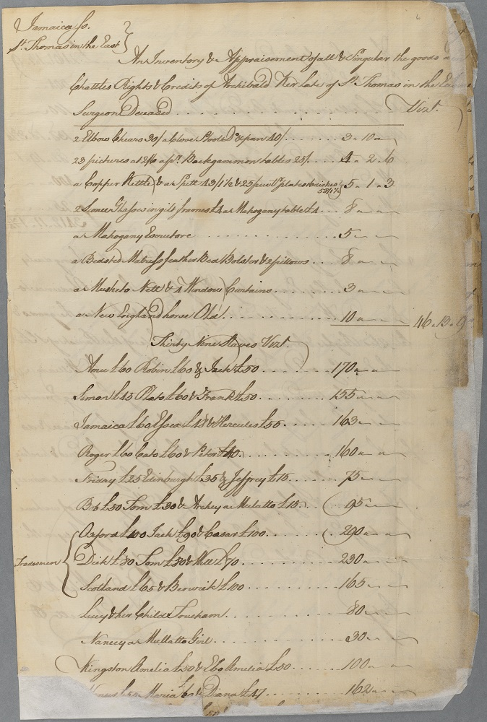
Fig. 3: An inventory and appraisement of the goods and chattels of Archibald Kerr, including a list of 39 enslaved people on Red Hill, 1750.
In January 1750, James Barclay, one of the executors of Kerr’s will, a ‘junior merchant’ in Kingston, Jamaica, wrote to the Managers with a copy of Kerr’s will. Word of Kerr’s legacy quickly reached the wider world. In June 1750 Scots Magazine reported that ‘lately, in Jamaica, Dr Archibald Kerr … has left his whole estate, a few legacies excepted to the Royal Infirmary, Edinburgh’. In July, Managers received a letter from William McFarlane with a message from his brother Alexander McFarlane, a ‘merchant in Jamaica’ and friend of Kerr’s. Managers concluded that Kerr’s donation ‘may turn out greatly to the Benefit and Advantage of the Royal Infirmary’ and decided to ‘make all the Inquiry about it they can that so they may with Certainty know the situation of Mr Kerr’s affairs and the extent of his estate and debts due to him’. A letter of attorney was sent to Alexander McFarlane, who was instructed to ‘inquire into the Extent of the estate and other debts, means and effects whatsoever real or personal which belonged to this said Doctor’. Already, discussion had begun about the possibility of leasing the estate.
Adam Anderson, the RIE’s agent in London, was soon informed of the development. That summer Anderson, who was not acquainted with McFarlane, enquired about the Jamaican bequest around London’s coffee houses, including the Jamaica Coffee House in the City of London, but uncovered no further detail about Kerr’s bequest. In October, Managers received another letter from the other executor of Kerr’s will, James Barclay, who valued the estate of 420 acres of land, ‘most of which is but very indifferent’, at £3412 Jamaican currency. The lease at £290 Jamaican currency per annum included ‘24 of the Negroes’. £300 at that time could pay for the annual wages of ten ordinary physicians. Kerr’s estate bore ecological as well as human scars: Barclay did not believe the Managers could ‘expect so much for the future’ of the estate because the current lease had ‘cut most of the valuable timber of[f] it’. In Barclay’s summation, ‘it would be of more advantage to the [I]nfirmary if it was to be disposed of together with the Negroes, but that can’t be done without an act of Parliament which I apprehend might be procured at [great] expense. In the meantime we shall do the best we can for the benefit of the estate & remit the money arising therefrom into your hands’.
In January 1751, Alexander McFarlane warned against the wisdom of the Managers in seeking an Act of Parliament to sell the estate. First, he advised that renting the estate annually rather than selling could draw in between three to five times more income, albeit over a longer period. Second, he wondered whether any such action might ‘not discourage Legacys of the same kind being left to the Infirmary, when they see the will of other Testators is not complyed with’ [sic]. McFarlane took more notice of this issue because he ‘knew a person who has his will ready made in favour of the Infirmary for the value of his all which will be equated to Kerr's legacy at least’. By selling Red Hill, in other words, Managers risked deterring other West Indies merchants from bequeathing their colonial wealth.
To ascertain ‘what method the Managers should take’ with regards the legacy, copies of the will were sent to Robert Hamilton, resident near Aryn, and David Campbell. Both were ‘well acquainted with the affairs of Jamaica’. Campbell had known Kerr well and considered him an ‘honest, Sober, Wise man’. His main concern was whether Red Hill was fit for sugar production or only for yielding cotton and ginger or mahogany, which he believed was how the enslaved people there were then ‘probably employed’. Of the enslaved, Campbell reckoned they were ‘of the very best … by the high price put on the most of them’. Typically, he explained, sugar plantations on the island, ‘slaves and all’, were sold from seven to ten years purchase ‘on the appraised value & no Higher because of the [risk] from Hurricanes destroying the Works, of epidemical Distempers carrying off the slaves’. Timber plantations, where little of the capital rested in edifices (as with sugar), ‘would sell for a little more.’ In 1744 what the white Jamaica historian and enslaver Edward Long called a ‘great hurricane’ had wrought havoc over much of the whole island, laying waste to 104 ships, a new fort at Mosquito Point (now Fort Augusta), the wharves at Port Royal, Kingston, Passage Fort and Old Harbour. A subsequent outbreak of disease took even more lives. Campbell had reason to believe that 24 of the enslaved people were labourers, while the others were ‘House or Domestick slaves, with some Children in care’. He noted, too, that ‘some tradesmen slaves will fetch £18 & £20 [per] annum. In Robert Hamilton’s assessment, meanwhile, he ‘heartily wish[ed ] [Kerr] had left [Red Hill] to the discretion of his executors, to have kept it or sold it … because many events may happen that would make such a power very necessary’. Until the issue of the will was resolved, Hamilton recommended Managers hire sworn appraisers and attain security for the property so they could attain a short lease for it and ‘see how it fares’. In both their advisory letters, it was made clear to the Managers that, in Hamilton’s words, the ‘estate’ meant ‘the land and the negroes that are leased along with it’. Of the enslaved people seemingly not included in the previous lease (the domestic staff), Hamilton recommended selling them on, although conceded that others with expertise of the island might recommend hiring them out.
In February 1751, George Drummond wrote to Barclay with the Managers’ ‘humble and hearty thanks’ to Barclay ‘for giving [them] this trouble.’ ‘The care of the interest of the infirmary’, he said, was ‘in so very good hands’. Drummond understood that the Managers could never expect to sell the estate at its previous sum (£290 Jamaican currency) again, and so kept his belief that it would be ‘of a more advantage to the Infirmary … if [Red Hill] were disposed of’ with the aid of an Act of Parliament. But Drummond and the Managers believed the following clause in Kerr’s will made this impossible: ‘that it is my [Kerr’s] desire that … the estate may still be kept and not sold or otherwise disposed of’. Drummond viewed this as ‘so strong an indication of the Doctor’s intention to have the estate kept … that we think it is our duty in the first setting out of this [issue] … to comply strictly with it, … and keeping consistent with the good which the Doctor intended … [so we] cannot justify taking any step towards disposing it’.
As Drummond’s name is so intimately attached to the history of both the RIE and Edinburgh, it is worth pausing here to ask: What was Drummond’s role in all of this? It was he, after all, who signed off (on behalf of the Managers) much of the correspondence about Red Hill and the enslaved people upon it from this first period (1750-51) right up until his death in 1766; letters from Jamaica concerning Red Hill rents continued to be addressed to him for a few years after his death. Decisions relating to Red Hill were made collectively at Managers’ meetings; but Drummond’s position within the organisation and the city more widely meant his opinion came with a certain weight. It was Drummond who wrote the following on behalf of the Managers to representatives in Jamaica: ‘I am directed by the Managers to Pray that you will be pleased to let the said 24 negroes on a short lease and let us know the terms on which you sell them’ (Fig. 4).
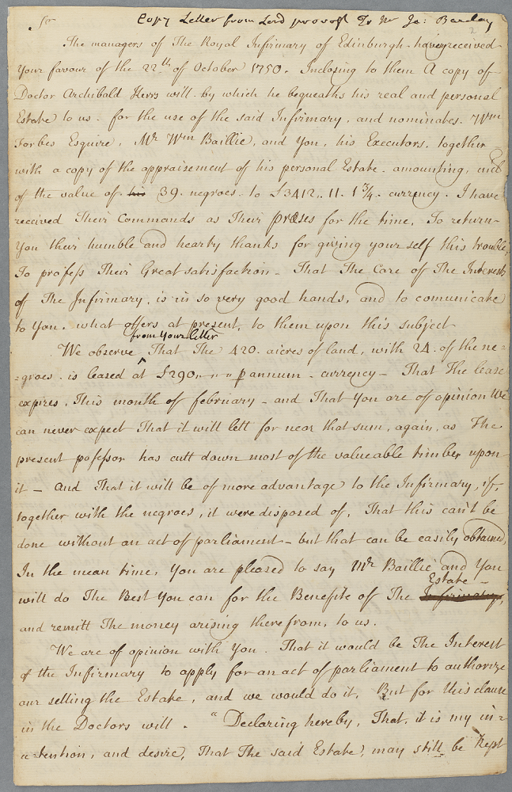
Figure 4: Part of a letter from Provost George Drummond, on behalf of the RIE Managers, instructing representatives in Jamaica to lease Red Hill and the enslaved people upon it.
Despite their initial desire to sell Red Hill, the property could not be ‘disposed of’. Why did Kerr stipulate this in his will? Other bequests of estates typically allowed the inheritor a power of sale. It is possible that the surgeon-enslaver believed (correctly, it turned out) that letting, in the long-term, would draw in more money for the RIE than selling. Equally, he may have been concerned about his own ‘legacy’: his bequest, ultimately, established a close connection between him and the charitable institution, one that lasted long after his death. It is also feasible, although by no means certain, that Kerr felt an ‘emotional’ attachment to his human chattels, and did not wish for them to be sold on. The only indication for this is the manumission and provisions for his ‘trusty man-slave’, Jemmy, stipulated in his will. Speculations aside, the effects of his decision were to be profound: the RIE would not sell Red Hill until 1892. For 143 years the RIE owned 420 acres of land in Jamaica, and drew funds from the ownership of enslaved people and, later, after Abolition, the hire of ‘apprenticed labour’, upon it.
James Barclay and William Baillie, two executors of Kerr’s will in Jamaica, quickly got to work. By April 1751 they had secured a new lease of 21 years at £300 per annum and ‘put on [the estate] six carpenter Negroes that were not upon it before’, an indication of their intention to either rebuild the property or cultivate timber. This new income stream was much needed. In late 1751, Anderson wrote repeatedly to the Managers of the lack of donations coming via him to the RIE, despite his extensive promotion of the cause in London’s newspapers and coffee houses. In London, Anderson explained, there was
such a frolicsome Disposition for new Charities, that the very best, old and established ones suffer and [are] not a little neglected! But this can’t surely hold long: Men of solid reflexion will soon See that how well soever intended some of the new ones may be, they are not comparable in their consequences, as to many of the old ones; and as they can't support so many as one now on foot, their Began and will return to those of the most general usefulness. During this prevailing humour for new things, the [RIE] must suffer its proportion! I have, however, done everything in my Power to spread the usefulness of it by continuing to recommend it in private, to give Gentlemen Books + plans of it.

The Managers’ plan to sell (‘dispose’) 15 of the enslaved people soon hit an obstacle: James Barclay informed them that ‘Negroes are only Personall Estate so far as they are Subject to the payment of debts ... In other respects they are as a Real Estate as the land is, consequently nothing can impower you or us to dispose of them but for an Act of Parliament for that purpose [sic]’. Missing rents on the estate were also proving difficult to recover: Barclay resisted a suggested idea to accept a remittance in sugar or rum. Only bills of exchange should be accepted as rent, he insisted, given the ‘uncertainty of Markets’. The land, in Barclay’s opinion, was only fit for cotton or pastorage (livestock), as most of the valuable timber had been cut down. The house on the estate had been torn down by a hurricane the previous year (as discussed by Campbell and Hamilton). Nonetheless, Red Hill at that time, understood to be situated about a mile from the sea and ‘bounded upon land laid out for the town of Morant [Bay]’, was, in Barclay’s estimation, valuable real estate.

Leases and Arrears
By 1757, Managers faced more issues relating to Red Hill Pen. The lessee, John McLeod, was in arrears of his rent for the RIE’s ‘land and negroes’ to the sum of £1,794. John McLeod appears to have owned considerable land in Jamaica in 1754, of which he evidently added Red Hill: 513 acres of land in St Thomas-in-the-East, the 666-acre Clarendon estate and 3,396-acres St Dorothy property. RIE Managers’ Meeting Minutes document McLeod’s regular delay or shortfall in rent over subsequent years. In 1758, William Baillie, working on the Managers’ behalf in Jamaica, requested a letter from the RIE to aid him in chasing up payments. The Managers replied that the delayed payment ‘surprise[d] and vexe[d]’ them as ‘the rent for this estate is for the most charitable purpose … for maintaining and curing the sick and diseased of our fellow creatures, who have no other way in the world to be relieved but by this fund’. They pushed Baillie to ‘use every method which the laws of the Island afford you to force Mr McLeod to pay up’, while also offering him their forgiveness in ‘persisting on it’. In 1760, after a ‘great deal of trouble’, Baillie forced McLeod by legal arbitration to pay his debts. McLeod demanded £72 deducted from his arrears because Kerr, before he died, had leased the property to Robert Paton, who in turn had sublet two tenements to Abraham Sarzedas and Neil McLeod (presumably a relative of John). Because of this arrangement, John McLeod believed he was due six years rent of £12 from Sarzedas, a Jewish merchant born in Portugal, who after some years in Jamaica naturalised to the British Crown, but then moved to New York while seemingly still in arrears of rent for Red Hill.
McLeod appears to have then sold the remainder of his lease on or before 1760 to Barlow Trecothick, a City of London merchant, founder of the firm Trecothick, Apthorp, and Thomlinson, and later MP for the City of London and Mayor of London. Trecothick had grown up in the colonial Province of Massachusetts Bay and spent some years in Jamaica. He became the owner of Addington Palace in Croydon, Surrey. In his penultimate reported speech in Parliament on 9 December 1772, Trecothick demanded an inquiry against the brutal repression of an uprising in St. Vincent:
There was a time when the British [name] stood high for humanity. To all the enormities in the West Indies we are about to add another ... I doubt the justice of the cause. I doubt the justice to dispossess poor, defenceless, innocent, some of them aborigines inhabitants. Are we to take example from the Spaniards?

Security for the property (insurance) was taken on Jamaican planters and enslavers Colonel Peter Vallete and David Milner, gentlemen reckoned to be economically stable. Over subsequent years, Drummond politely complained about and chased up delayed payments with Baillie. After receiving no payment on Red Hill in the years 1762-64, Drummond told Baillie of the hospital ‘struggling with difficulties’ to take its full number of patients due to a lack of funds. In 1765, having not heard from Baillie for three years, Managers presumed their representative dead and resolved to make a letter of attorney in favour of Charles James Sholto Douglas, Collector of the Customs of the Island of Jamaica, in Kingston. After four year’s silence, Baillie finally responded to express his frustration that Managers had selected Douglas to replace him, arguing that the estate would have lost £1000 had it not been for him. Drummond apologised and thanked the attorney for his ‘valuable services’ to their ‘charitable undertaking’.
In 1768, a small number of Managers, including Stewart Threipland and William Hunter (the famed anatomist and obstetrician), were selected to organise a new lease on Red Hill. Hunter discovered more detail on the estate, including its number of ‘servants’ (an interesting, if not uncommon linguistic obfuscation of their enslavement). As may appear apparent already, RIE Managers were hardly ‘hands-off’ landlords: they kept afloat of developments in Jamaica relevant to their property, such as the payment of £132 in ‘quit rents’ (an annual duty taken on Jamaican land by the British Crown) and regular updates on the numbers of enslaved people (sadly these are mentioned but not usually documented in their Minutes).
In 1772 Managers secured a new lease with Barlow Trecothick at £300 per annum for 21 years. Red Hill was given to Trecothick on the condition he put the ‘Pen House’ damaged by hurricane and lack of care into good repair and to make fences around the estate, and, at the end of the lease, to leave both the house in good condition and clear the ground of bushes from either side. In an indication of the Managers’ concerns about the ‘condition’, if not the welfare, of their human chattels, another requirement was that Trecothick must leave ‘sufficient quantity of provisions for the negroes’ at the end of the lease. On the property existed a stone house built by McLeod and ‘the Pickanynes’ [probably ‘picknies’, see glossary]’ which was being rented as a dwelling house. In line with colonial Jamaican law, the enslaved people on the estate were to be valued at the end of the lease, and the ‘difference between their present value and their [current] value to be made good to the infirmary’. John McLeod, the previous tenant, continued to communicate with Managers about the property, even recommending they lower their rent for the new tenant (whom he considered a ‘gentleman … of character’) to £230, because £300 was too high for the property; in the end Trecothick appears to have accepted a compromise of £260, perhaps because he could see, as McLeod put it, the RIE’s status as a ‘charitable establishment of very great publick utility’. When Barlow Trecothick died in 1775, the lease for the property appears to have passed to his sister’s son, James Ivers, a merchant with investments in the London Docks Company who, under the conditions of his uncle’s will, changed his last name to Trecothick.

Juliet and the Moodie Children

It was around this time that the RIE’s Managers received an unusual request. In October-December 1773, Managers communicated with Dr John Moodie about an enslaved Black woman called Juliet on Red Hill. In a letter from William Baillie in Jamaica read out to the Managers during their monthly meeting, Moodie expressed his desire to ‘purchase a negro wench named Juliet belonging to the estate of Dr. Kerr’. In their responding letter, the Managers expressed ‘in the strongest manner’ that they were ‘exceedingly inclinable to have indulged Dr. Moodie if it could be done legally but [were] doubtful how’. The Managers were ‘of opinion [that any action] would be liable to be challenged afterwards’. They agreed to take further advice as ‘they think the case [is] very hard’ (Figs. 5 and 6).
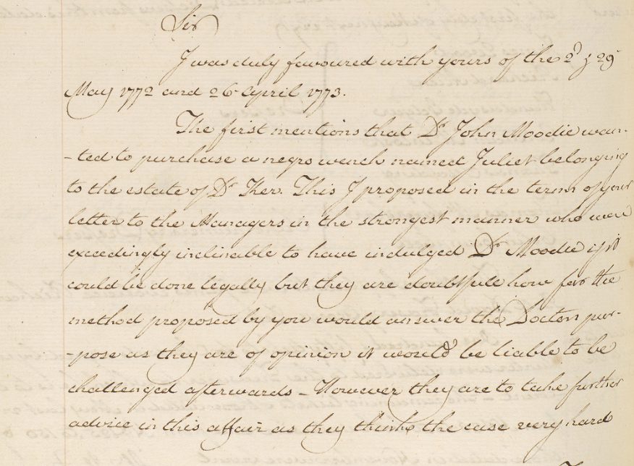
Fig. 5: Request of Dr Moodie that RIE Managers allow him to purchase an
enslaved Black woman on Red Hill called Juliet.
It is not known what Managers or their lessee decided to do about Moodie’s request; no manumission record has yet been found for Juliet. In December 1793, a petition signed by John Gray in the name of Dr William Fife, an enslaver, physician and Apothecary General in Kingston, Jamaica, on behalf of Moodie, was read at a RIE meeting ‘praying the Managers to grant freedom to John and William Moodie[,] two children born to Dr Moodie, the Petitioners Partner, … by a Negro woman [Juliet] belonging to the Plantation called Redhill Pen, the property of the Infirmary … upon the petitioners paying to the treasurer, what shall be fixed as a reasonable consideration for their Manumission’. On reading the petition, the Managers opted to delay confirmation on the matter as they understood a similar application had been made to Trecothick. Again, no manumission record has yet been found for John and William Moodie. Trecothick’s next lease for Red Hill with the RIE, made in 1801, stipulated that John and William Moodie, the ‘children of a female slave called Juliet’ were declared ‘not to be included on the lease’. The lease confirms the obvious suspicion that Juliet was the mother of the Moodie children. Her absence from the conditions of the lease implies that she had either gained her ‘freedom’ (possibly into the ‘care’ of Moodie), had died in the intervening years, or was destined to remain enslaved on Red Hill.
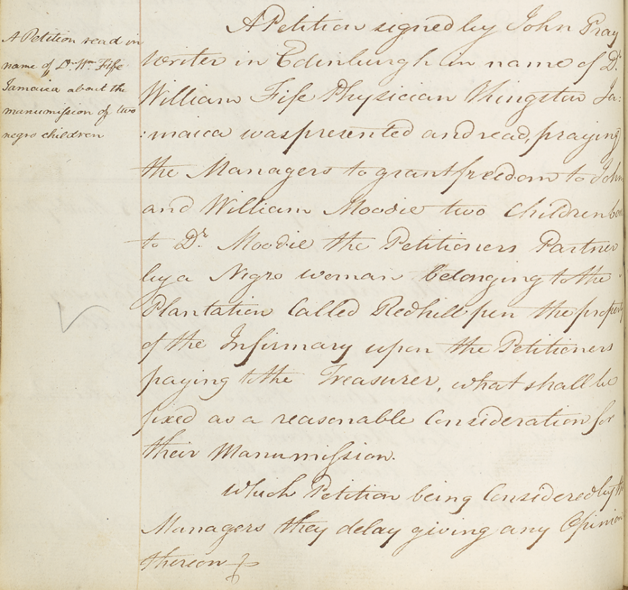
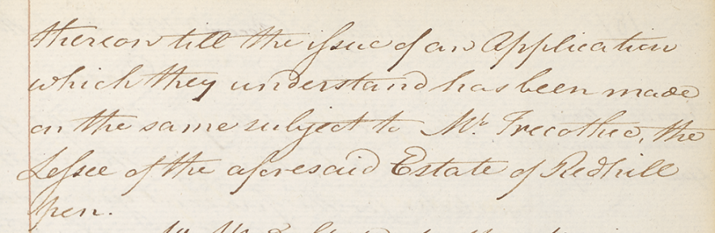
Fig. 6: Request on behalf of Dr Moodie that Managers grant freedom
to the enslaved children of Dr Moodie on 1793.
We know very little about Juliet, let alone the nature of her association with Dr Moodie. Given what we do know about the vastly unequal power dynamics that would have existed between a white male doctor and an enslaved Black woman in colonial Jamaica in the late-eighteenth century, we must consider the possibility that Juliet was raped or, at the very least, sexually coerced. A little more is known about John Moodie than Juliet. His father, David Moodie (b. 1723), appears to have lived in Sciennes, Edinburgh, during the latter part of his life. John Moodie, meanwhile, appears to have spent upwards of 40 years in the Roslin Hill area of northern Jamaica. Several estates holding enslaved people in that area were run by Scottish merchants, such as Robert Dunmore of Ballindalloch and Samuel Cunningham of Kirknewton. The large Roslin Castle property belonged to Henry Wisden, a ‘practitioner of physic and surgery’ who had acquired it in 1684. Significantly, in 1776 Moodie appears to have ordered £1,000 of assorted drugs from the Plough Court pharmacy in London, run by Joseph Gurney Bevan, a Quaker who was forbidden from having direct involvement with the slave trade, and privately abhorred what he called ‘the man-trade’. This evidence, along with the fact that Moodie was identified as a ‘partner’ of Fife, Jamaica’s Apothecary General, suggests the doctor was engaged in the sale of pharmaceuticals on the island; if correct, this may explain the circumstances that brought Moodie from Roslin Hill to Red Hill.

Legislation, Compensation, and Insurrection
In 1797 Managers established a committee to decide upon a new lease for the estate ‘for the best interest of the hospital’. They feared securing a new lease then would be ‘difficult in the present times’, possibly in reference to the Second Maroon War (1795–96) or, more widely, to economic difficulties and the beginning of what is known as the ‘amelioration’ period in the West Indies, when enslavers attempted to ‘improve’ conditions for those they enslaved in response to the Haitian Revolution, French revolutionary wars in the Caribbean, and the continuing threat of abolition to enslavers’ wealth and power. Managers attempted to reach out for advice on their new lease from Mr Grant of Kilgraston (presumably John Grant, once Chief Justice of Jamaica), whom they understood to be visiting Edinburgh, but Grant never replied, having died in 1792 while back in Scotland. Henry Jardine, the RIE’s treasurer, and grandson of George Drummond, was appointed the task of sorting out the business of the estate, including discussing the matter with Trecothick in London. Edinburgh banker and longstanding Manager of the RIE, Sir William Forbes, then reported that McLeod of Colbeck, the previous tenant, had been appointed by Trecothick to negotiate with the Managers on the subject of the lease, a ‘matter of much importance to the hospital’. An extraordinary meeting of the Managers reported that Trecothick agreed to a rent increase to £300 upon a year’s lease; William Mitchell, a planter, attorney, and official in Jamaica – and member of the Society of West India Planters and Merchants – was appointed power of attorney to deal with the lease.
In 1801, the subject of a new lease on Red Hill pen resurfaced, with letters of attorney given to John Ramsay, an enslaver in Jamaica recommended by RIE Manager John Wauchope. Eventually, however, the lease for Red Hill pen and ‘every Negro and other slaves thereupon’ was given to Trecothick on July 29, 1801, who asked to extend the length of the contract from 31 to 35 years. The following year, Managers raised doubts about Trecothick’s obligatory audit of the estate at the end of the lease and his late payment of debts to the RIE, so sought legal advice from solicitor James Campbell. He recommended instead selling the estate to Trecothick. In 1804, RIE Managers Sir William Forbes, Sir James Innes, and John Wauchope formed another special committee to deal with the sale of the estate. It seems, however, from the original lease and agreement with Trecothick in 1801, that the idea was always to sell him the estate, as long as an Act of Parliament could be secured.
By 1806, the Managers had received a draft of an Act of Parliament to authorise the sale of Red Hill. After first petitioning the House of Lords, the Managers were encouraged to submit a bill entitled ‘An Act for enabling the Managers of the Corporation of the Royal Infirmary of Edinburgh to sell and convey a certain Penn, called Redhill Penn, in the Island of Jamaica, to James Trecothick Esq., pursuant to an Agreement entered into for that Purpose’. The House of Lords ordered to dispense with Standing Order No. 126 (concerning ‘selling lands in one place, and buying lands in another place’) so that the Committee for the Bill might proceed. Lord Walsingham then reported that the Lords Committee had considered the bill which set out the RIE’s intention to sell the estate for £7,000 in ten yearly instalments. Witness testaments from Jamaica and Scotland were called to the Committee. In support of the Allegations of the Bill, John Howell reported to the Committee that he had visited Red Hill within the last year and that it was in ‘no Kind of Cultivation, that it was very indifferent Land, and that it was made use of by the Lessee chiefly for pasture’. Richard Grant, attorney in Jamaica, argued that 16 year’s rent would be a far more typical price than the RIE’s asking price of 20 year’s rent. Lords also heard evidence on the ‘fluctuating’ funds of the RIE, which over the previous year had only barely broke even. The Committee made several amendments to the Bill. On July 10, the Committee decided to ‘put off’ consideration of the report for three months hence. It seems the Lords never returned to the matter: in October, Parliament was dissolved, and a new Parliament not formed until December, after which time, for whatever reason, the Bill seems to have disappeared. In 1807, Managers noted Trecothick’s annual lease as continuing.
Over subsequent years, Red Hill evidently deteriorated in rental value. Over 1824-25, Trecothick requested a reduction of rent from £300 to £260 per annum, which the Managers obliged; in 1831-32, he asked for a further reduction to £200. In 1836, Messrs Christie, Taylor & Co, merchants and solicitors in Kingston, were employed to deal with the case. Christie, Porteous and Carson, who seem to have picked it up, then filed a report on the estate.
A major point of contestation for the Managers was that Trecothick had claimed compensation money from the British Government on the loss of ‘property’ (enslaved people) following the abolition of slavery in 1834. After the abolition of slavery in 1833, the British government ‘compensated’ slave-owners with taxpayers’ money; loans for this money were only formally paid off in 2015. On February 1, 1836, James Trecothick was awarded £797 17s 3d for 44 enslaved people on Red Hill. But Managers only received £500 as ‘share of compensation for loss of labour of the Negroes in the West Indies’ in 1836 (Fig. 7). Managers formed another Special Committee in 1840 consisting of James Mackay, A. Gillespie, and Harry Maxwell Inglis to deal with the property and report ‘what are their expectations from it’. They found that ‘no time should be lost in bringing that affair [the estate’s future] to some settlement’. It was agreed that another solicitor, William Wemyss Anderson, of Kingston and later Spanish Town, should be consulted because the committee had found that no rent for Red Hill had been paid for the years 1836-40 (amounting to over £800); additionally, ‘a large sum arising from a balance of the compensation allowed for the emancipation of the slaves on the Estate is still unadjusted’. Managers desired to contact Trecothick in London about debts owed on rent and compensation money, to possibly sign a new lease, or, failing that, to advertise the lease anew. A letter from the Managers to Trecothick attempted to resolve ‘disputes’ between him and the Managers over the ‘fulfilment of the clauses … and conditions of said lease and payment of the rent and after the payment of the balance of the compensation funds’: they claimed his £500 (at that time worth the annual wages of five doctors) in 1836 was only part of the total amount, which, with interest, then came to £832.
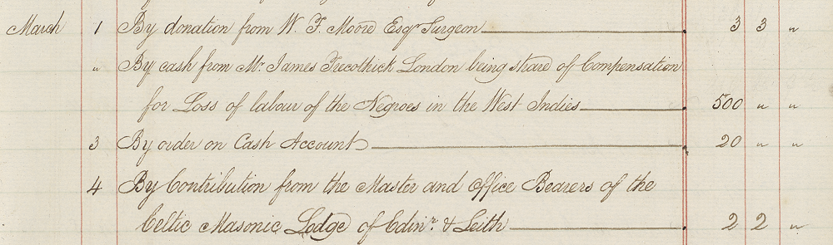
Fig. 7: Treasurer’s Cash Book with record of the RIE receiving compensation money for the ‘loss of the labour’ of the enslaved people on Red Hill on the abolition of slavery.
A series of letters from Trecothick in London addressed to the Managers tell a slightly different story. He wrote to them on February 15, 1836 informing them that he had been awarded for the ‘loss of the labour of the Negroes’ two weeks earlier and that ‘the RI [Royal Infirmary] should have the greatest part, if they will say what they think right, I should find they may draw for such part as they judge fair & proper.’ He wrote again on February 28, possibly after having taken advice on the matter, that it was his ‘wish the Royal Infirmary should have as full & just proportion of the sum awarded to me’ and suggested they receive £500. In March he wrote twice, warning that his lease was ending and complaining to Inglis, the RIE’s treasurer and then first point-of-contact for affairs relating to Red Hill, that he had heard nothing from the Managers and so had ‘continued to support the Negroes [on Red Hill] for the accommodation of the Royal Infirmary’. After finally being contacted by the RIE, he responded in June that he had no copy of the lease. He also complained that the lease (either the old or potentially the new lease) was too short. In order to ‘enable the managers to come to a determination’ on the lease and value of the estate, Trecothick calculated that the ‘worth’ of the recently freed Black labourers was for ‘45 hours a week, or five days, 9 hours a day from which deduct 3 hours for meals in the time they are to labour’. He understood there to be a ‘present disinclination” on the part of Red Hill’s labourers ‘to work when for pay’ and claimed the ‘lease must have been sent Jamaica’ but did not recollect receiving it, having searched through his ‘voluminous papers’. Still awaiting a decision from the Managers, his August letter told them they would be disappointed to learn of Red Hill’s depreciated value, along, he claimed, with much of the property in post-Emancipation Jamaica. In a self-congratulatory tone, Trecothick claimed that if Red Hill had not been so long ‘in his possession ... [then] the separation of the Negroes I fear would [have] worsened’, seemingly referring to the decision of formerly enslaved Black labourers to stay on the estate after their emancipation. After finally receiving an offer, Trecothick wrote to the Managers in September with his ‘wish to recompensate’ the RIE but that the current state of property values on the island and the ‘considerable’ expense of running Red Hill made it ‘impossible’ for him to accept their terms. The next month, after further silence from the RIE, Trecothick claimed the property was ‘worth scarce anything’ from what he had heard of the island in recent years.
During this period, RIE Managers were busy taking their own action. In January 1837, they gave power of attorney to the solicitor’s firm Chrystie, Porteous, and Carson, who reported that the estate was ‘of little value’ with ‘no apprentices upon it’ (contradicting Trecothick’s claim). Any apprentices that had been on it, they claimed, had been moved by Trecothick to his nearby Boston and Buckingham estates (Fig. 8). A member of their firm planned a trip to inspect the property. In May, their report informed Inglis that 31 Black apprenticed labourers belonging to Red Hill were currently employed on the Boston and Buckingham estates: 15 in a ‘great gang’ (the primary work gang); seven in a second gang; five in a third gang; one domestic worker; and three ‘invalids’ (described as a ‘grasscutter’, ‘field nurse’, and ‘runaway’, respectively). The annual value of those workers amounted to over £200, so they instructed Managers to charge Trecothick £200 on top of their rental fee. They also expressed some disapproval at the ‘removal’ of those labourers from Red Hill to Trecothick’s nearby estates without the Managers’ sanction, it being ‘impossible in the present day to remove these people from Boston and Buckingham as they have been located there for such a number of years’. Red Hill, they wrote, was in ‘such a perfect state … of ruin’, and without any valuable stock or buildings, that there was no point to moving them back to the property.
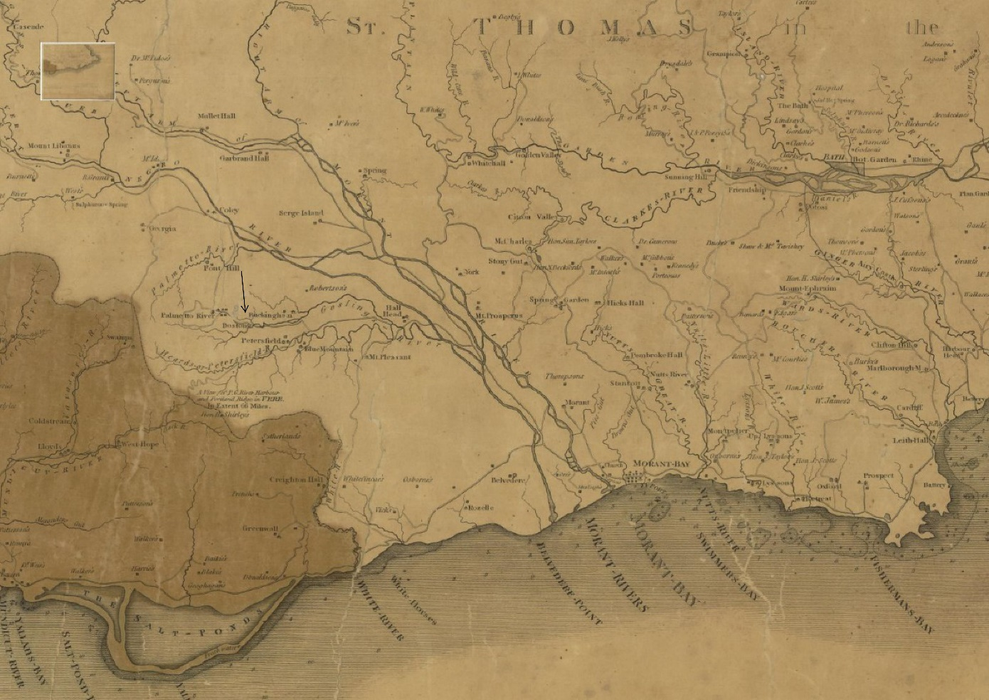
Fig. 8: Location of Buckingham and Boston estates (indicated by an arrow), nearby to Red Hill, in St Thomas-in-the-East. Maps of Jamaica by James Robertson, 1804, reproduced with the permission of the National Library of Scotland.

In London, meanwhile, the solicitors Murray, Rymer and Murray went directly to the Slave Compensation Commission office in London, and were shocked to report to the Managers that Trecothick had claimed for the ‘compensation for the loss of labour of the slaves of the Red Hill Penn Estate in his own name and as if he were the owner of the freehold [underline in original]’. Fascinatingly, officers told them of another compensation claim to ‘another estate belonging to another charity in Edinburgh derived under the same will’ that was put in the same name as the charity, with the claim paid directly to its treasurers. When the lawyers questioned Trecothick on these matters, he appeared ‘either intentionally or constitutionally very oblivious upon all points’:
As to the compensation he at first appeared to forget all about it but we so shaped our questions as at last to extract from him his admissions that the claim was made in his own name and with other property belonging to him but he added that had he not done so as the time for making the claim would have gone by. Why, however, the demand on the Commissioners was not made by him in the name of the Infirmary, he could not explain. He has evidently been dealing with the Estate as if it were his own and some prompt and decided measures should be resorted to with the view to place the matter on a proper footing. We do not conceive that he was entitled to receive any portion of the compensation and we think that the payment of the balance of the £800 and odd should be insisted upon … He complains that he has written frequently to the Royal Infirmary but that no attention has been paid to his letter.
Inglis argued that he had been in communication with attorneys in Jamaica at the times when Trecothick was pressing for a new arrangement; the unsatisfactory account of the property Trecothick had given him meant he did not want to deal with him until a full evaluation of the situation in Jamaica had been conducted. ‘I fear much’, Inglis wrote, ‘that Mr Trecothick is disposed to give trouble’.
In February 1841, more attorneys, Anderson and Kemble in Kingston, Jamaica, provided further updates on Red Hill. They noted it held an ‘old sugar work, worn out and abandoned’ that was used by Buckingham estate, potentially confirming that Red Hill had once been used to produce sugar. They reported, too, that a small house (now in ruins) had been rented out to a succession of tenants, including John Mactus, who ‘cut down every stick of logwood’ in it. Duncan McPherson, another tenant, had let out small lots of the land to any of the population he could find because the soil was generally poor as it had no enclosures. In May, McPherson contacted the RIE to inquire whether the estate was for sale.
In the meantime, Privy Councillor, lawyer, and ‘agent in Jamaica’ William Burge was called upon in 1842 to arbitrate on the dispute over whether Trecothick was the ‘tenant of the Pen’ since the end of the lease in 1836. Trecothick alleged he had paid all rates, taxes, and island expenses, and had ‘maintained the Negroes upon’ Red Hill since the lease’s expiration. Burge ruled that Trecothick had enjoyed the ‘lands and services of the … negroes as apprenticed labourers’ from 1838 onwards, but not 1836-38, during which time the estate had not been used as a sugar plantation. No ‘allowance’ (seemingly financial compensation or a tax break) was to be rewarded to Trecothick for the ‘maintenance’ of the apprenticed labourers other than that which Burge had factored into the payment due for the rent, and Trecothick was to pay the remainder of the compensation money.
Perhaps related to this arbitration are some documents in the RIE collection from 1842 described as an ‘examination’ and ‘cross-examination’ made by James McWilliam of St Thomas-in-the-East (residing at Osbourne’s Hotel), an ‘agent’ of Trecothick in the late 1830s. McWilliam had been given power of attorney from Trecothick to ‘manage’ Red Hill, seemingly sometime around 1837. His reports, presumably evidence for the arbitration, provide great insight into the transition period from slavery to abolition from the vantage point of Red Hill. Managers seemed to be under the impression that the enslaved people at Red Hill had been ‘removed’ by Trecothick to his nearby Boston and Buckingham sugar estates at some stage during the lease starting in 1801. McWilliam, however, was unsure, and confirmed to them any such removal would have been entered into the Plantation Books (no Red Hill plantation book has so far surfaced). As long as he could recall, there were then no enslaved people on the estate:
I have looked at the Plantation books of Mr Trecothick’s estate and from there it appears that there had not been during Mr Trecothick’s lease any Negroes residing on the Penn. The Plantation Books are kept on the Plantation by the overseer and … They contain the number of Negroes belonging to the property their names and sexes with any other slaves who may be living. In the Plantation Book I saw the names of the Negros belonging to Red Hill Penn and … in the lease the houses wherein these Negroes resided were on Boston and Buckingham Estates and not on Red Hill.

In 1817 Meredith Moore, Trecothick’s overseer on Red Hill, reported there being 46 enslaved people (21 male and 25 female) on Red Hill (see Table 2), but perhaps they did not reside there. It appears likely that around this stage the larger Boston and Buckingham estates absorbed the enslaved labourers on Red Hill (and, after 1834, its apprenticed labourers), who probably work across all the properties; it is not clear what the estate was producing at this time, or whether it was used exclusively for livestock. During McWilliam’s involvement with the estate, there were ‘28 negroes all effective’ and potentially 16 more worked but did not reside there. Some apprentices were employed to work the estate for £240 (it is unclear how many received the wage, or how that money was distributed) and Trecothick sublet the property to an individual called Martin some years before 1838 at £140 Jamaican currency until October 1839, leaving the property around £180 in arrears. ‘It cost us a good deal of trouble to get the man out’, McWilliam complained.
McWilliam also reported there being ‘great disturbances in the neighbourhood’ although he was unsure if any had occurred on Red Hill. The local magistrate was frequently called upon to deal with the ‘great disturbances in the valley’: ‘The Negroes were bad’, McWilliam explained, ‘During [Trecothick’s] lease and before the [A]ct for the [A]bolition of Slavery there was great insubordination amongst all the negroes at Boston and Buckingham including Red Hill negroes’. There was to his mind ‘no distinction’ between the Black workers on Red Hill and those on Trecothick’s neighbouring plantations: ‘We never thought of speaking of Red Hill People’, he explained. At various times from the 1770s onwards, the yield of Trecothick’s Boston, Buckingham, and Red Hill properties were filed together for accounting purposes, further indication of the estates being seen as ‘one’ property. McWilliam located Red Hill approximately 1.5 miles from the sea and four to five miles from Trecothick’s sugar estates of Boston and Buckingham, which formerly were two estates but which in practice had been consolidated into one. He could not report whether there was damage sustained to the property in the years 1831 or 1834 (possibly in reference to the 1831 Baptist War, a rebellion of around 60,000 enslaved people on the western part of the island), and conflicts in 1834 between newly emancipated Black Jamaicans and white planters. ‘I cannot say whether [Trecothick] lost as to Red Hill Negroes’, McWilliam wrote of those years, but he nevertheless speculated that ‘the agitation by the Abolition of Slavery might have had the effect of causing Mr Trecothic[k] to lose by the Red Hill Negroes £300 to £400 [sic]’. It appears that Trecothick did not visit the estate during this time. McWilliam dated the agitation on the estates as going back to 1828, with the estates’ value diminishing from at least 1834: ‘The ‘Buckingham and Boston Negroes were … engaged in the insurrection which took place in the Parish of Red Hill’. McWilliam also noted that they ‘Could not get negroes to cook’ on Red Hill, a less dramatic, but no less telling indication of insurrectionary sentiments among Black domestic workers on the property. As historian Verene A. Shepherd explains, when Jamaican pens adopted the ‘transitional system’ – between enslaved and apprenticed labour, itself an exploitative mode of labour relations – pen apprentices became ‘bent on displaying their opposition to the continuation of the apprenticeship system; but, predictably, such opposition was deemed “intransigence” by proprietors and officials. Thus, Stipendiary Magistrates complained increasingly of indolence, disaffection and a “lack of respect to masters” on the part of the apprentices’. Red Hill appears to fit this broader model of Black resistance to the Jamaican apprenticeship system.

Decline and Sale
McWilliam’s report indicates that John McPherson and his brother Duncan became Red Hill’s latest tenants in 1839. In 1832, John McPherson owned six enslaved people on the Cluny plantation in St Thomas-in-the-East, inherited from John McPherson (presumably a father or uncle), who was an heir chieftain presumptive to the McPherson Clan, members of which had fought in the 1745 Jacobite Rebellion. An article in the Inverness Courier about the life of the older McPherson painted a picture of an individual determined to maintain his Scottish roots while in colonial Jamaica; the enslaved people on his plantation, meanwhile, were presented as subservient admirers of their ‘master’, with a ‘child-like’ fascination for his odd folkways:
The old gentleman, in defiance of mosquitoes and everything else, continued to wear the philabeg [kilt], composed of the tartan of his clan; and at the skirl of the piobrach [pibroch, a style of highland bagpipe music] every negro within reach of its sound was heard to exclaim, ‘God bless my old Massa; he make plenty of noise for we’. So universally was this gentleman respected in the quarter, that a holiday was granted to all the negroes to attend his remains to the ‘narrow house’; and a poor old Highlandman who could scarcely crawl to his kinsman’s grave, produced his bagpipe, and played the ‘Macpherson’s Lament’ [a Scottish song supposedly written by a famous fiddler of the same name], in a style which was responded to by every Celt present, by doffing his bonnet.
At Red Hill, the McPhersons built ‘a good many nice cottages … and gardens’. During their tenancy there existed 20 ‘Negro houses’ on the property, costing between £5 and £10 each (mostly the smaller amount). The main ‘Red Hill house’ had become old, decayed, and unliveable, and had probably been that way ever since ‘the Negroes were recovered’ (the meaning here is unclear). Red Hill’s soil was too ‘poor’ for growing food for workers: there were no ‘Negro grounds’ on Red Hill as there were on Boston and Buckingham. ‘It must have been a Battle [to grow food] whilst the negroes were there’, McWilliam reflected, before arguing, without further explanation, that it was Red Hill’s Black workers who had ‘brought the estate to the verge of Ruin’.

In March 1857 RIE Managers instructed their solicitor, William Wemyss Anderson (who also donated to the RIE), to chase up rent from their new tenants, who, along with practically all of their predecessors, were late-payers. It seems rent was reduced again, to ‘£80 payable half yearly in the months of April and September’. Later that year, Anderson wrote to the Managers that ‘the matter of Redhill Pen has lain over much too long’. The previous tenant (presumably the younger John McPherson) had died ‘considerably indebted’. Worse still, ‘the value of the Pen [because of] the disastrous measures of 1846 has so fallen’, like much Jamaican property that year. Anderson was likely referring to the Sugar Duties Act (1846), which Jamaican planters claimed had afflicted the colony’s dominance in the global sugar economy. The effects of the equalisation of sugar duties had ‘ruined’ McPherson. The estate, Anderson claimed, could not ‘under any arrangement yield even an approximation to the terms of the old lease’. He accordingly adjusted the current annual rent to the remarkably low figure of £30. Anderson recommended taking the deceased McPherson’s house in Morant Bay, occupied by his mother, to rent as compensation for his debts, although he feared getting tradesmen to repair the property might prove difficult (Anderson again blamed the Sugar Duties Act).
Red Hill, meanwhile, left in charge of John’s brother Duncan, was only earning £13 a year in rent (Duncan also attempted to pay debts owed by his brother in smaller amounts). Mr Wright, a schoolmaster in the local parish, agreed to rent the property for £40 a year but died while still in arrears. ‘I am afraid I must in candour admit’, Anderson wrote to the Managers, ‘that this property has not had the attention it was entitled to. Its distance from Kingston and a long term of severe adversity has been against it’. In 1859, a new tenant (seemingly Stephen McCook) refused to pay rents because the wooden house on the property was uninhabitable. In 1861 Anderson warned that some properties in Jamaica were selling for one-tenth of their original price. Red Hill, he believed, had ‘never been fenced, and, the house, notwithstanding all that has been spent on it, being originally a wooden structure, is again much dilapidated’. The current tenant only used the property for keeping a few bulls and, in a phrase telling of racial tensions and land conflict in St Thomas-in-the-East, to ‘keep negro settlers from coming too near his houses’. The tenant offered £250 for the property, although Anderson believed it might go for £300, despite also believing that ‘No one would now hold property of that kind in this island. It cannot be made profitable or satisfactory [underline in original]’. Managers advised Anderson to sell for £300 if he could find a buyer.
From around 1864, Archibald Kerr’s name begins to disappear in the indexes to the Managers’ Minutes; ‘Red Hill’ or ‘the Jamaica property’ become its go-to names, whereas before phrases such as the ‘Kerr estate’ were commonly used. Memory of the original bequest perhaps had disappeared over several generations of RIE administrators. That year, George of Douslow reported to the RIE that he had ‘been all over Red Hill and I must say it is s a most miserable place. The House is entirely gone to ruin … the old timbers on it are so rotten that they would be of no use in building a new one. I do think that if anyone were to give ten shillings per acre for the land that he would give a high price … there are little or no logwood fit to chip’.
Over the 1860s and 1870s, Managers were busily occupied with more pressing issues than a reportedly dilapidated and nearly valueless property in Jamaica. The building of the new Infirmary (formerly opened in 1879), changes to nursing and clinical care, and radical pushes to allow women medical education all dominate the RIE records for this period. Yet Red Hill nevertheless lingered on in the background: in 1868, Managers received a letter from the Colonial Secretary in Jamaica with an update on the estate. Minute books document that from 1862-71 rents received amounted only to £190, while costs in maintaining it came to £61. In September 1871 they received an offer to buy the estate for £300. The RIE’s relatively newly established Finance Committee began to deal with the estate, first by looking back through the RIE records to understand the origins of its ownership of Red Hill. After digging up Kerr’s will, Maxwell Inglis, a long-time member of the Committee (and seemingly descendent to a long line of Inglises involved with the Infirmary), concluded that it gave them ‘no power to sell’ the estate, although raised a doubt about the century-old document’s legitimacy: ‘it is now upwards of 100 years since the will was executed … it might be questionable whether such a destination had not lapsed and it might be worthwhile to write to the solicitor at Jamaica to see how far the restriction against the sale was still in force’. Managers unanimously agreed that it was best to sell the estate, especially given no rent had been accrued on the property for three years. Inglis also discovered in the RIE records documentation relating to the attempt to attain an Act of Parliament to sell the estate in the early 1800s. ‘As far as appears’, he reported, ‘the act had not been procured’. Another Finance Committee meeting in December 1871 reported that ‘Looking to the small return and to the difficulty of making any permanent improvement the Committee were of opinion that it would be better to sell the Estate as proposed’. The potential purchaser (then unnamed) requested Managers give absolute warrandice, defined as ‘a clause in a charter or deed by which the grantor obliges himself that the right conveyed shall be effectual to the receiver’. It appeared to the Committee, however, to be
a serious question whether [they] should come under such obligation - and it was also a matter for consideration whether under any conditions the Managers should so far deviate from the terms of the will under which the property was left to them. There might not be any great legal difficulty as the period since the will was executed was so very long ago & none of the heirs of the deceased could in all probability interfere.

Conveyancers were hired in preparation for the sale. By June 1872 the buyer (which later sources reveal was Samuel H. Watson of Jamaica) was now asking for warranty of title (a firmer guarantee from a seller that they have the right to transfer ownership over their property), which Managers again were unwilling to grant. In September, a conveyance of the property was cancelled because the buyer’s solicitors were concerned that the RIE had no power to sell the property, but merely ‘a right to the income thereof in perpetuity’. Anderson and his firm’s partner Hendrick broke the bad news: ‘We really see no chance of affecting a sale in consequence of the terms and conditions of [Kerr’s] will. The title has been declined by two of our most eminent solicitors and conveyancers’. In light of this, Managers authorised a new 21-year lease at £40 per annum to Mr Henry Mais.
In 1877 another possible sale led to nothing. In 1886, solicitor John Holden wrote on behalf of an unnamed client of their interest in the property, despite their awareness that ‘no house or other buildings [are] on any part of the estate, and that the land is uncultivated and unproductive, a part only being used for grazing purposes’. At this time the property seems to have been leased to David Marchalleck (who Mais possibly sold the lease to), although Managers were slightly disconnected with the current situation regarding the estate. The next year, the Parochial Board of St Thomas (previously the Parish of St Thomas-in-the-East) offered to buy five acres of Red Hill for the extension of the burial grounds which adjoined it; the Board offered £40, but the Managers’ solicitors (now Anderson and Watson) increased the amount to £50. If Managers did not approve of the sale of the parcel of land, the solicitors warned that because the sale was for a ‘public purpose’, a local statute allowed the Board to take the land by merely paying the treasury. In May of that year, the solicitor John Holden wrote to the Managers to express his unnamed client’s shock at hearing news of the sale. The price, they believed, was extortionate (ten times the land’s actual value) given the property’s lack of buildings and fences and its ‘wild uncultivated state’; they offered £350 for the remaining land, which Managers deemed insufficient given annual rents were set to £40. In November, power of attorney was granted to the Jamaican solicitors Oughton & Garsia.
In 1891, the RIE received two offers to buy the estate: Joseph Bravo contacted the RIE to offer £500 for the property; through Oughton & Garsia, Charles Levy offered £450. Oughton & Garsia commissioned a valuation of the estate, finding it to be worth £500. It seems some sort of bidding war then ensued, as by October the offer had risen to £600 ‘on the understanding that the purchaser was prepared to take all risk as to the title the Infirmary could give with the property’. However, on February 29, 1892, Oughton and Garsia reported to the Managers that they had finally sold Red Hill to Julia Adelaide Cressar, seemingly an innkeeper, for the sum of £650 (leaving £600 for the RIE after expenses), a price the firm had ‘pressed for’. It is unclear why Cressar bought the property or, indeed, what happened to the land and property over subsequent years; she appears to have been the first female owner of the estate. After 143 years and countless conveyances, reports, committee meetings, correspondence, solicitors, potential buyers, tenants of varying reliability, and the insurrection and exploitation of generations of enslaved people and indentured labours, the 1892 sale marks the moment the RIE finally ‘disposed’ of Red Hill.
How much money did Red Hill earn for the RIE? So far, approximately £20,298 (including rent, interest, and compensation money) of Red Hill money has been identified between Kerr’s death in 1749 and 1842 (more work is required for the final decades of the RIE’s ownership of the estate). For the period 1749-1795 (for which records exist to make comparative study), Red Hill income alone constituted an astonishing 8% of the RIE’s total income, 31% of all charitable gifts, and 73.8% of all gifts from individuals with ties to slavery. The money the RIE received from Red Hill in any one year ranged from relatively large amounts (e.g. £817 in 1769, which included rent arrears) to comparatively tiny sums (£80 in 1857). A more detailed analysis of the value of Red Hill rents – or any other slavery-associated donation – would involve comparing this income source with expenditure in any given year. For example, in 1810 Red Hill raised £350 in rent (approximately £317,400, using the Relative Wage or Income Worth calculator); that figure was slightly greater than the RIE’s average monthly expenditure that year (£320) and roughly equivalent to the cost that year of 761 carts of coal, or the annual wages of ten doctors. Such equivalences, it should be emphasised, will change dramatically depending on the year in question; but they nevertheless suggest something of the relative importance of Red Hill as an income source for the RIE.
We should recognise, too, just how long this relationship lasted. The RIE’s ownership of the estate stretched from a period before the steam engine had begun to revolutionise British capitalism, all the way to the era of electricity; or from the reign of George II to that of George V. Provost George Drummond was the first to correspond with agents in Jamaica about Kerr’s estate in 1750; by 1836, it was Drummond’s grandson, Sir Henry Jardine, who, then in his seventies, was responsible for communicating about Red Hill as an RIE Manager. From a Jamaican perspective, Red Hill was a relatively small property. Owning 39 enslaved people placed Kerr amongst the lesser ranks of Jamaican enslavers; others owned hundreds, even thousands of enslaved people. The Scots-Irish planter Neill Malcolm 12th of Poltalloch, by comparison, owned over 2,000 enslaved people over ten estates in the early-nineteenth century. This is not to diminish the enslavement that existed on Red Hill, or the estate’s economic clout; to the contrary, if we can better understand how just one relatively small slave estate in Jamaica could so profoundly impact one Scottish hospital – financially and administratively – then we can begin to appreciate the wider set of consequences of slavery in Britain. What’s more, that Red Hill made such a remarkable impact on the RIE in spite of administrative problems, depreciating value, and issues with tenants and subletters, says a lot about the influence of the slavery economy on hospital philanthropy: from a financial point of view, Red Hill during the slavery era never extracted as much wealth as it potentially could have done; yet the estate still constituted an important revenue stream for the Infirmary.

Medicine, Race, and Empire:
Inside the Royal Infirmary of Edinburgh

‘Ad sanitatem gentium. Patet omnibus’
[‘Towards the health of the nation. Open to everyone’]
Text on the old Royal Infirmary of Edinburgh’s foundation stone

Drs Archibald Kerr and John Moodie were what might be called fairly typical ‘medical men’ of the eighteenth century. Their association with the RIE highlights an important medical dimension to the complex story of the Infirmary’s encounters with Atlantic slavery. As recent scholarship suggests, the medical profession in Britain and in its colonies, as well as ensuring the health of enslavers and their human chattels, also played a pivotal role in codifying and pathologising the idea of ‘race’ that underpinned and legitimised enslavement and colonial expansion. The effects of ‘race medicine’ are still felt today amongst racialised people, reflected, for example, in modern-day racial inequalities in healthcare such as those experienced during the COVID-19 pandemic. The RIE, situated within an Edinburgh medical environment that also included the University of Edinburgh’s Medical School, the Royal College of Physicians of Edinburgh, the Royal College of Surgeons of Edinburgh, and several other hospitals, asylums, and other medical bodies, was part of this racial history. Countless physicians walked through the RIE’s doors: finding the colonial connections or unpacking the racial thinking of each one of them would be an enlightening but mammoth exercise. As this is beyond the scope of this report, what follows here is brief sketch of how the Scottish medical ‘enlightenment’, as it played out in contact with the RIE, was closely associated with the making of empire and race.
As Richard B. Sheridan explains, Edinburgh followed Leiden as a ‘center of medical education’ in eighteenth-century Europe. Sheridan’s research indicates that 500 white West Indians studied medicine at the University of Edinburgh from 1744 to 1830; half came from Jamaica, and others from Barbados, Antigua, St. Kitts, and Dominica. Students at the School of Medicine were allowed to
visit ordinary physicians and surgeons of the [RIE], who visit the Patients every day, examine their cases, and prescribe in presence of the students, keeping regular journals of the progress of the disease, of the various prescriptions, of the effects of the medicines, and of the final issue of the case … As the University of Edinburgh is the Chief School of Medicine in the British dominions, whatever contributes towards rendering the system of education there more perfect, will, it is hoped, be considered the Public, not merely as an arrangement of local utility, but as an object of general and national benefit.
From data in David Dobson’s Scots in the West Indies, 1707-1857, we know the names of 78 Scottish doctors in the West Indies. Some from this list, like John Cochrane of Kingston, Jamaica, donated money to the RIE. From 1714 to 1743, Cochrane corresponded regularly with his brother William Cochrane, a medical doctor in Edinburgh, of the difficulties of running a medical practice in Jamaica, including sourcing basic medical instruments and medicines; at one stage he worked as a surgeon’s mate on a Guinea voyage. Many from this list matriculated or graduated from the University of Edinburgh. It is reasonable to assume that many bought student tickets to attend lectures, ward visits and surgeries at the RIE before finding their way to Guinea Coast or the West Indies as slave voyage or plantation doctors.
Some RIE physicians financially benefited from enslaved labour. Dr Thomas John MacLagan Jr., a physician who worked for a period as a clerk at the RIE, was the son of Dr Thomas John MacLagan Sr., who managed two slave plantations in Kingston, Jamaica, in the 1810s. William Pulteney Alison, a Professor of Forensic Medicine at the University of Edinburgh, owned enslaved people on the Bellevue Estate on St Vincent and received over £4,000 compensation on the abolition of slavery. Alison’s experiences at the RIE were politically and morally transformative for him: he wrote reformist tracts about poverty and health after encountering Edinburgh’s sick and poor in the Infirmary.
Some of those who worked or volunteered for the RIE were implicated in the wider colonial knowledge extraction from Indigenous, enslaved, and colonised people that characterised the study of medicine during the period of the British Empire. Alexander Munro (Primus), one of the principal founders and first Managers of the RIE, communicated with a surgeon in Jamaica on a novel way for treating worms on the island. Sometimes this colonially-sourced knowledge was applied within the RIE. In 1803 the physician James Gregory wrote about a fever patient in the RIE who, after having previously suffered fever in the East Indies and been cured of it by arsenic (rather than the traditionally used Peruvian bark), was given an arsenic tonic again and subsequently became cured.
There is some indication of the presence of African and South Asian patients in the RIE during the eighteenth and early-nineteenth centuries. In 1807 Andrew Duncan Sr., Professor of the Institute of Medicine at the University of Edinburgh, wrote a short paper on the case of a 31-year-old ‘servant’ called John Williamson, described as an ‘African negro’, who came to the RIE with a particularly troubling array of symptoms: blisters, pains to the chest, respiration problems, headaches, vertigo, tinnitus, soreness of the throat, inflammation, foot pain, loss of appetite, and many more beside. Previously a trumpeter for a regiment of dragoons, for the past five years he had served as a ‘gentleman’s servant’. The foot pain, Williamson reckoned, was caused by wearing damp shoes for some time; a pain to his side, meanwhile, was attributed to living in a cold house. Doctors reported that Williamson became ‘deranged’ by pain while in their care, and was soon confined to a solitary space so he would not ‘disturb’ other patients. Williamson died in the RIE and was soon dissected; practically all of his organs were closely examined. Duncan believed this to be the first reported case of an African suffering from gout, an ailment physicians had typically considered to be ‘principally a disease of the rich, the luxurious, and the indolent’. ‘Had the same phenomena’, Duncan argued, ‘occurred in a rich and indolent Englishman, no one could have hesitated in considering him as subjected to gout’. Although Duncan’s conclusions about the intersection of social class, race, and disease are an interesting window into white early-nineteenth-century medical attitudes, his paper is also historically valuable in giving us an example of how Africans resisted the RIE’s use of Black cadavers to further medical science. He writes, ‘An opportunity was not afforded us of examining all the parts with the minute attention which could have been wished; for two of [Williamson’s] African friends insisted on being present, and would, on no account, allow any of the morbid parts to be removed for more particular examination’.
In 1818, Duncan – a member of a large family of doctors involved at various stages in British colonial expansion in the East Indies, – reported of another case at the RIE involving a ‘native of Bengal’ who had ‘gradually lost his native dark colour, and became white’. The patient described his parents as ‘Mahometans’ and ‘dark’. The shock for the doctors of the patient’s unexplainable change of skin colour warranted mention in a report on notable cases in the RIE. Examples of non-white patients and cadavers in the RIE later in the century suggests something of the diversity of the populations in the Hospital’s wards and morgue. Cases in the RIE involving white patients from across Scotland also fed into the production of imperial medical knowledge. In 1855 the case of a leper from the Hebrides admitted to the RIE featured in a study of leprosy in Jamaica that explored the prevalence of the illness in British colonies.
Research has not yet unearthed a case of an individual refused admission because of their race (although that does not mean it did not happen). Unlike English infirmaries, the RIE’s lack of a subscription model meant it opened its doors to cases other hospitals refused to take on moralistic reasons, including venereal disease and unmarried pregnant women. The RIE’s motto insisted that the ‘Hospital will be open to all the Curable distressed from whatever Corner of the world they come without restriction’. One donor took this motto further than its white originators had probably intended. In 1802 Mrs Murray Keith bequeathed £2,000 to the RIE to alleviate ‘the distress of some of the most wretched of mankind’ who being found incurable were ‘turned out of the hospital to starve’. Keith herself died from ‘the most painful and incurable lameness’ which had afflicted her over the last fifteen years of her life. ‘[I]f any poor Negroes should chance to be amongst the incurables’, Keith said in relation to her donation, ‘not to let their colour be any objection, but rather cast the balance in their favour, as they are friendless, and without connections in this country, [and] consequently in greater danger of starving than our own people’. Keith’s charity towards Black ‘incurables’, influenced perhaps by the period’s abolitionist literature, is certainly paternalistic and patronising – not least given the RIE’s wider involvement with Atlantic enslavement – but nevertheless marks a notably rare recorded instance of a white person connected to the RIE at least considering Black people’s health needs.
There is one known case of an enslaved person in Edinburgh escaping their bondage while a patient in the RIE. In early December 1746, a reasonably tall, 22-year-old Black man only just recovered from smallpox escaped while a patient in the RIE. The individual was marked by his enslaver on the shoulder with the letters G. M., possibly his or his enslavers’ initials. In two identical advertisements for his capture published in the Edinburgh Evening Courant and Caledonian Mercury a few days after his escape, a reward of a guinea was set for his capture. Readers were warned that if the individual was found to be in anybody’s custody following the public notice those responsible could be prosecuted. It is not known what became of this particular freedom seeker, but it can be inferred that he possibly recognised, either in advance or opportunistically, that the RIE might serve as a launch pad for his route to freedom.
The RIE was seemingly not unusual in this regard. A ‘Madagascar black Fellow’ by the name Hercules ran away from the London Infirmary in 1750. He was possibly there because of a nose injury, as his owner, Capt. Cleaveland of Wapping, cited his deformed nostril as an identifying characteristic. In 1742, 20-year-old Black maid Flora (alias Lucy) absented from her master Mrs Cuming in Deptford, London. One identifying characteristic in the notice for her capture was a sore leg. The notice highlighted that her injury had brought her several times to St Bartholomew’s Hospital, perhaps in case anyone spotted her returning there for care. In 1761, enslaver Abel Dottin told the public that Stephen Walcott, then suffering from smallpox, had recently been in the Phoenix Hospital Ship near the Tower of London. Finally, Thomas Jaycocks’ enslaver in 1772 instructed anyone who found his ‘apprentice’ to contact a Mr Lewis at the Foundling Hospital in London.
Several Black abolitionist and radicals from North America visited Edinburgh in the eighteenth and nineteenth centuries. At least one visited the RIE. The formerly enslaved dramatist, novelist, and antislavery radical William Wells Brown even visited the RIE during his stay in the city in February 1851:
I had an opportunity during my stay in the city, of visiting the Infirmary, and was pleased to see among the two or three hundred students, three coloured young men, seated upon the same benches with those of a fairer complexion, and yet there appeared no feeling on the part of the whites towards their coloured associates, except of companionship and respect. One of the cardinal truths, both of religion and freedom, is the equality and brotherhood of man.
Brown’s testimony, alongside these other cases, proves that people of colour have always passed through the RIE’s doors. We should remember, though, that the institution which Brown praised for its equality had been funded in part by wealth drawn from exploited labour. In 1851, the RIE was receiving around £100 annually from Red Hill; during his visit Brown even have walked past the painting of Archibald Kerr, bought by the Managers to honour the enslaver’s gift to the hospital.

Conclusion
Every penny or a pound of wealth extracted from enslavement is a stain on the RIE’s history; that the RIE actually owned enslaved people is even more reprehensible. Nevertheless, it is necessary to understand the scale of slavery-associated money that came into the RIE in order to more adequately understand how slavery shaped medical philanthropy in Edinburgh and, more widely, in Britain. Numbers, however, do little to translate to us today the human suffering of those enslaved, let alone their acts of resistance against their enslavers. Further research, ultimately, is required to better understand the lives of the women, children, and men in places like Red Hill whose labour benefited the RIE.
Financial figures, if significant in their own right, only partly explain what, to modern eyes, was a gross moral miscalculation on the part of the administrators of an otherwise ‘charitable’ institution. In providing access to the administrative and procedural dimensions to slavery-associated money in the RIE, the archival record contains vast silences regarding what the RIE’s Managers, treasurers, attorneys, agents, or staff felt about slavery, colonialism, or, specifically, acting on behalf of a corporation that was a recipient of slavery-associated funds and, via Red Hill, an enslaver itself. The RIE collection, for example, provides no indication that any figures working for the RIE who were involved in the ownership of Red Hill felt any sense of contradiction, concern, discomfort, guilt, or shame about the RIE’s human chattels. In none of the over 200 RIE documents relating to Red Hill that helped to write this report is there a single clear example of anyone expressing an opinion that it was wrong, unjust, or inhumane to enslave people. To the contrary, as this report outlines, Managers, if at first ambivalent about the estate, became grateful of the revenue stream. Kerr, meanwhile, was lauded by those connected to the RIE as saintly: the ‘good man’ Kerr and his ‘noble legacy’. In 1757, Managers purchased and hung in the RIE a portrait of Kerr, considered at the time to be ‘a very considerable donor to the hospital’. In a strange coincidence, in 1765 Managers became aware that one of the RIE’s chaplains, Rev. Gillis, was Kerr’s ‘heir of law’. The nature of Kerr’s and Gillis’ relationship remains unclear, as the latter received nothing in Kerr’s will (Kerr does not appear to have had children either). Managers, however, felt it right to donate eight guineas to the chaplain’s annual wage, a donation ‘in gratitude to [Kerr’s] memory’ which they honoured until his retirement in 1769. Beyond Kerr’s estate, until very recently the RIE displayed a donor board detailing the names of early donors: the board, a recognisable fixture of the old RIE, and still much loved by many of the people of Edinburgh, included ‘The Island of Jamaica’ and the ‘The Island of Barbados’ amongst its roll call.
Why did the Managers, who often voluntarily gave their time to the charitable cause of running the RIE, not express any concern about the immorality of the RIE benefiting from the exploitation and ownership of other human beings? Although it would be wrong to simplify their (in)actions as being ‘men of their time’, their nonchalance in managing a corporation which benefited from enslavement reflects the dominant attitude of many, if not all, white Europeans towards people of African and Indigenous descent – colonised, enslaved, or free – during the era of British colonialism. Although none of the RIE’s hundreds of Managers over the years has so far been identified as owning enslaved people directly, many were embedded in the economics surrounding British slavery and colonialism, mostly, as already discussed, via their professional lives in the financial sector. Managers viewed the human beings on Kerr’s estate as ‘negroes’, ‘slaves’, and ‘part of the property’. Their discussions about the enslaved people typically revolved around the ‘interests’ of the hospital. ‘Act in the matter’, Managers instructed a subcommittee dealing with Red Hill in 1807, ‘as [you] shall judge best for the interest of the Hospital’. The RIE collection indicates that Managers and agents were believers in the ‘good’ of the hospital: their blinkered philanthropic drive, however, appears to have obscured them from seeing the horrific truth that their charitable corporation was complicit, directly and indirectly, in the enslavement of others. This has long been an issue with charity. As far back as the eighth century, the Northumbrian Saint Bede had wrestled with the moral problem of ‘dirty money’ in alms-giving. Explanations for the Managers’ behaviour must, in the end, be contextualised by those vehemently opposed to slavery and colonialism in the eighteenth and nineteenth centuries, from Black and white abolitionists operating in Edinburgh during this period, to those defiant ‘Red Hill people’ who rose up against their oppressors in the 1820s. It is hardly surprising that Managers felt no sympathy towards their human chattels in the 1750s, before the development of any major abolitionist movement in Britain; by the nineteenth century, however, debate about the ethics and morality of slavery could be found across the city of Edinburgh.
NHS Lothian and NHS Lothian Charity, in partnership with stakeholders, staff, patients, and the general public, may now wish to begin to talk about, and come to terms with, the legacies of British slavery and colonialism in Edinburgh’s and Lothians’ current healthcare environments.
Some uncomfortable physical inheritances from this era are still owned by NHS Lothian. First is the portrait of Archibald Kerr (Fig. 9). In 1757 RIE Managers confirmed purchase of a picture of Archibald Kerr (‘a very considerable donor’) from Mrs Strange (spelling unclear) for six guineas. The portrait, attributed to ‘Mosma’, was seemingly made in Scotland in the 1740s by the Aberdonian artist William Mosman; other Mosman portraits bear a similar style to the Kerr portrait. With books, glass jars, and, more disturbingly, a literal skeleton in the closet behind him, Kerr appears in the typical style of portraits of ‘learned’ and ‘scholarly’ eighteenth-century ‘medical man’. Although the skeleton may not have been added into the work by the artist, it is possible that the backdrop was actually the surgeons – if the portrait was made by Mosman, however, it is more likely that the portrait was taken in Scotland rather than in Kerr’s Jamaican home. Although not created because of his charitable donation, the purchase and hanging of the portrait in the RIE, for an unknown number of years, indicates the desire of subsequent generations of Managers’ to show gratitude towards one of their most ‘generous’ donors.
Second is a bust and portrait of George Drummond who died in 1766 (Figs. 10 and 11). As this report shows, Drummond played a key role in the early years of the RIE’s ownership of Red Hill and the enslaved people thereupon: he was the one who most often, alongside the RIE’s treasurers, signed correspondence relating to the estate’s enslaved people.
These artworks remind us of the complex origins of hospital philanthropy in Edinburgh. They are only the physical remnants of the at times remarkably close connections between the RIE, slavery, and colonialism. This kind of research enables a reappraisal of the complex story of the RIE’s history, centring the enmeshment of a place of healing in wider systems of oppression. A better understanding this history can, in turn, hopefully encourage new thinking about the RIE’s contemporary role in the world.

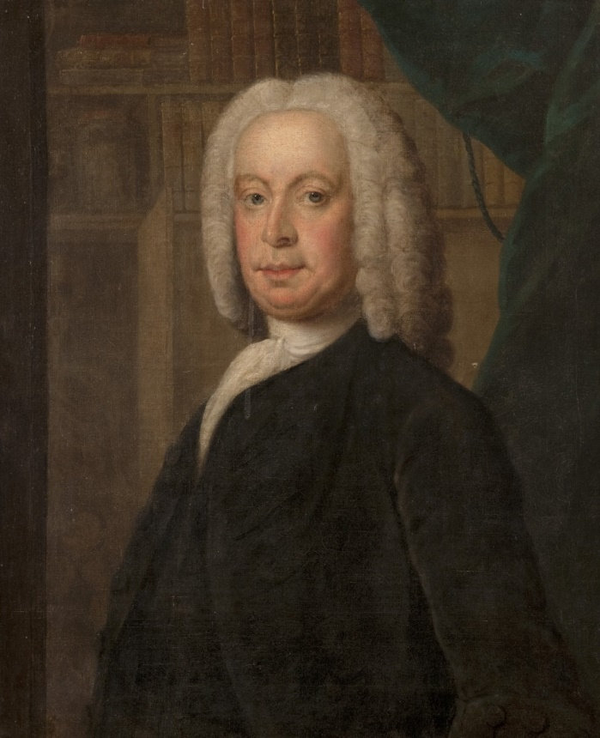
Fig. 9: Dr Archibald Kerr portrait
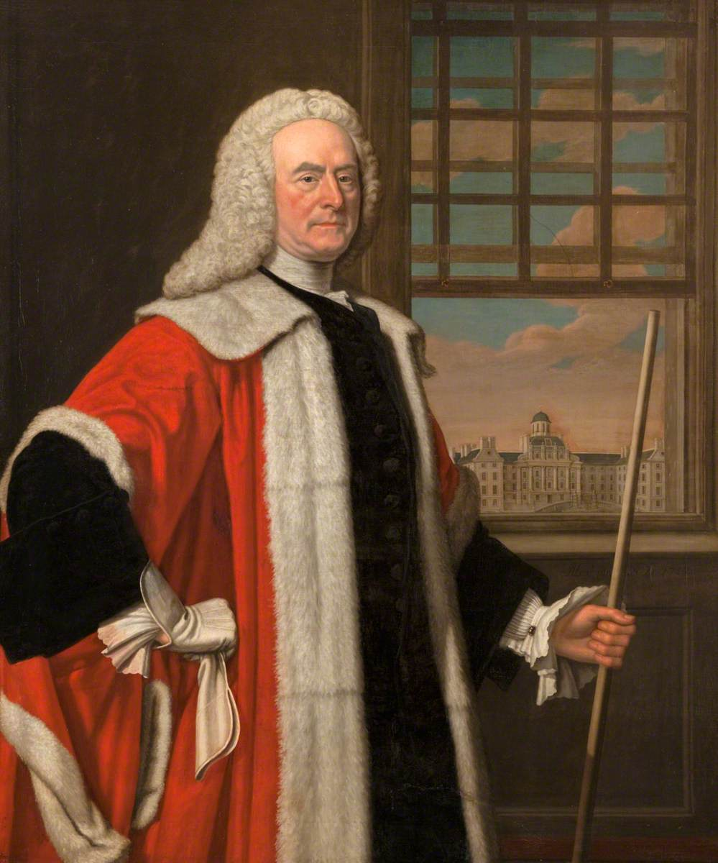 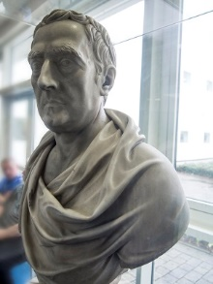
Figs. 10 and 11: George Drummond portrait and bust

Avenues for Further Research
Limitations of time and resources means further research would be required to more adequately understand the connections between the RIE, slavery, and colonialism. Some avenues for further research include:
- Papers within the LHSA’s RIE collection still to be investigated: Letter Books: Clerk/Treasurer and Clerk, 1836-1970 (LHB1/74); Minutes post-1833; Cash Books post-1848.
- Research in the Jamaica Archives: especially Kerr’s original will and manumission records for Jemmy, Juliet, and the Moodie children.
- Biographical detail about the lives of the enslaved people on Red Hill (including Juliet and the Moodie children) and other plantations financially tied to the RIE.
- Other methods to assess the relative value of slavery-associated gifts.
- Other enslavers’ involvement in slave-trade and -ownership, and their re-investment of slavery-associated wealth in Britain, particularly other cultural and social institutions (e.g. schools).
- Ties between the RIE and the East India Company and British colonialism in South and East Asia.
- Connections between the RIE and the abolitionist movement.
- Other healthcare spaces in Edinburgh and Lothian: the General Lying in Hospital (est. 1793, precursor to the Edinburgh Royal Maternity Hospital); the Royal Edinburgh Hospital (est. 1792); Edinburgh Society for Relief of the Destitute Sick (est. 1795).
- Black and white medical students from the West Indies who worked in the RIE.
The remit for this report was to investigate the RIE’s ties to Atlantic slavery, with a focus on the RIE collection at LHSA. The RIE collection also demonstrates, however, that a substantial number of donors were involved in British colonialism in South Asia (the ‘East Indies’). The East Indies attracted many Scottish merchants, doctors, and military personnel, some of whom, like John Lumsdaine of Lutherton, a major in the East India Company, donated £21 to the RIE. Colin Campbell, who donated slates to the RIE in 1740, and then £50 in 1757, is an illustrative example of the far-flung, transoceanic nature of Scottish involvement in the British Empire, and the impact of colonial wealth back in Scotland. After losing money during the South Sea Bubble crash in 1722, Campbell left Britain (likely to avoid debtor’s jail) to briefly work for the Ostend Company, an Austrian Netherland trade organisation that competed with British interests in the West and East Indies, and their slave trade on the Guinea coast. He then founded the Swedish East India Company, and became an envoy to China for the Swedish government, even penning a memoir of the first Swedish expedition to China.
Astronomer and President of the Philosophical Society of Edinburgh James Douglas, 14th Earl of Morton, donated £50 to the RIE in 1738. As well as owning estates in Antigua and Demerara, he raised funds for James Cook’s voyage to the Pacific, and in 1776 sold his Orkney and Shetland properties to Scottish landowner Sir Lawrence Dundas, who also owned slave estates in Dominica and Grenada. Some East Indies donations were substantial: George Reid donated his China estate worth £16,000 in 1889; Dr Alex Boswell, a surgeon in the East on company, donated £4,500 in 1836. Another doctor, James Nasmyth, who worked in India for much of his life, donated £100 to the RIE in his will when he died in 1813. More research is needed, too, of doctors who worked at the RIE before or after their service as medical officers in the East Indies. Dr Oliver Coult, who donated £50 to the institution in 1750, may be the physician of the same name who arrived in India as a ship’s surgeon in 1709 before joining the East India Company’s medical service in 1713, and communicated with fellow physician (and possibly relative) Robert Coult about the existence of inoculation in Bengal prior to contact with Britain. Beyond the East Indies, there is also the case of Alexander Drummond, brother of RIE Manager George Drummond, who donated money to the RIE on behalf of Freemasons of the Union Lodge of Aleppo.
The RIE also accepted donations from early industrialists in Britain who employed ‘serf’ labourers. The Erksine family, who donated money and coal to the RIE from the 1750s to 1830s, owned a serf-labour colliery estate in Alloa. This estate occasionally issued notices for the ‘capture’ of runaway apprentices. Although such workers’ conditions and legal ‘bondage’ were distinct from those of enslaved people of African descent in placed like Jamaica, the RIE’s Managers seemingly did not see any problem in accepting donations from some of Britain’s domestic exploitative industries.
Although they appear to be smaller in number than those with financial ties to enslavement, some donations came from individuals connected to different phases of the transatlantic abolitionist movement. Israel Pemberton, a Quaker in Philadelphia, collected funds and donated £60 of his own money to the RIE in 1741. Active in Philadelphia’s Quaker abolitionist community, Pemberton founded the Philadelphia Hospital and donated money to Moor’s Indian Charity. In 1745, Pemberton was sent an ‘Indian slave’ from the West Indies to sell, but he refused to comply. ‘I decline dealing in Slaves on any account’, he wrote, ‘I should be unwilling to encourage the importing such fellows here as prove too refractory here’. In 1773, Pemberton filed through the courts for Dinah Nevill, an enslaved woman of Native American and African descent, to receive her freedom (their case was not successful, but influenced subsequent Quaker abolitionists). Another case is John Kirk, involved with the RIE around 1854, who later became Medical Officer to the British Consulate in Zanzibar and was ‘a moving force in ending the local slave trade and was influential in the building of the Zanzibar Anglican Cathedral that symbolically stands on the site of the former slave market’. There are likely more cases of abolitionists who donated to, worked for, or supported the RIE during the era of British slavery.
No evidence has yet been found of any abolitionist (Black or white) from the period who privately or publicly criticised the RIE for taking slavery-associated money or owning enslaved people. In 1824, six members of the Edinburgh Society for Promoting the Mitigation and Ultimate Abolition of Negro Slavery were doctors, at least some of whom presumably performed clinical work at the RIE. Another subscriber to the Society was the bank William Forbes & Co: the Forbes family held a long connection with the RIE; their bank, meanwhile, was enmeshed into the Atlantic slavery economy through investments. Notably, one white abolitionist, Charles Bonnor, speaking to the Aberdeen Anti-Slavery Society in 1826, between the British abolition of the slave trade (1807) and of slavery (1833), used the rhetorical idea of the ‘hospital’ to lambast pro-slavery lobbyists and those ‘gradualists’ who believed abolition should be a slow process:
to imagine, for a single moment, that [the abolition of slave trade] was not meant as the precursor of [the abolition of slavery], would be little less absurd and abominable than, after having put a stop to the spread of an epidemical disease out of doors, its miserable victims in the Hospitals and Infirmaries were to be left to all the hours of a cruel and criminal abandonment.
Another unresolved question is how the RIE interacted with, and impacted the development of healthcare in the British colonies. Before the abolition of slavery, pro-slavery voices often used the existence of ‘slave hospitals’ as evidence of the ‘benevolence’ of the institution of slavery. In a committee in the House of Commons on the abolition of slavery in 1833, one witness gave evidence on what the existence of a hospital on the Archedckne estate in St Thomas-in-the-East in Jamaica said about the ‘benevolence’ of enslavers. Scottish abolitionists, too, believed healthcare to be key to improving the welfare of enslaved people. In a series of letters between the Barbados planter-turned abolitionist Joshua Steele and the Edinburgh-trained Dr William Dickson edited, annotated and published by the latter as an influential abolitionist text, Steele recommended a series of ‘local laws’ in place on some plantations that might improve the lot of ‘negro labourers’, including ‘an ample sick-house, or infirmary, with separate apartments for the sexes, with medicines from Apothecaries’ Hall, and medical attendance, are to be provided at the charge of the proprietor’.

Research Connections
This project is one of several projects to uncover the connections between slavery, colonialism, medicine, and philanthropy in Edinburgh and in the UK. During this phase of the project, the author made connections with some individuals working in these interconnecting fields who he would like to thank, including: Dr Daisy Cunynghame, Heritage Manager and Librarian, Royal College of Physicians of Edinburgh; Neil Roger, Project Manager, Friends of the Meadows and Brunstfield Links; Northern Network for Medical Humanities; Melvyn Roffe, Principal of George Watson’s College; Dr Michael D. Bennett, University of Manchester; Penelope Hines, Guy’s and St. Thomas’ Foundation; Dr Margaret White, NHS Lothian, researcher on connections with the East India Company and the Royal Edinburgh Asylum’s founding; Jane Lawrence, Art Consultant, Royal Scottish Academy; David Carey, Loyola University, researcher on medical science and Indigenous approaches to healing; Dr Paul Kosmetatos, University of Edinburgh; and Nick Draper, Director of the Centre for the Study of the Legacies of British Slave-ownership from 2016-2019.

Sources in LHSA

Bound Statements of Account, 1840-1870, LHB2/12/1-4.
Managers’ Minutes, 1728-1892, LHB1/1-4, 6-32;
Cash Books, 1769-1930, LHB1/13/1, 3, 5-6;
Eighteenth Century Correspondence, LHB1/72;
Legal Papers relating to Managers, c. 1770s-1830s, LHB1/7b (uncatalogued deeds and documents relating to Trecothick and Kerr estate in Jamaica).
Receipt Books, 1744-1963, LHB1/9/1-2;
RIE Donor Board database

Glossary

Abolition | In this context, the legal prohibition of slave-trade and -ownership. An abolitionist was someone who campaigned for abolition.
Chattel Slavery | A specific type of servitude that legally defined and treated African and Indigenous people as moveable property who could be purchased, sold, loaned, mortgaged, used as collateral, and inherited.
Colonialism | A practice where a powerful country directly controls a less powerful country or territory (the “colony”) and uses the colony’s resources to increase its own power and wealth. Colonisers usually impose elements of their culture, including religion, language, economics, and other cultural practices, on those they rule. Colonialism is an expression of power that generally relies on oppression, extraction of resources and silencing other ways of being and knowing.
East Indies | A term used during the era of European colonisation that referred to colonies in South and Southeast Asia.
Enslaver | In this report, someone who was subjected to chattel slavery. We generally avoid the term ‘slave’ to emphasise that enslavement was not inherent to the people enslaved.
Enslaved person | In this report, someone who was subjected to chattel slavery. We generally avoid the term ‘slave’ to emphasise that enslavement was not inherent to the people enslaved.
Indentured labourer | A person who is contracted to work for a specific number of years without the option of terminating the contract. This system of bonded labour was revived in the British Empire in the period of the abolition of slavery. Indentured labourers were recruited to work on sugar, cotton and tea plantations, and rail construction projects in British and other European colonies in the Caribbean, Africa and South East Asia.
Legacy | A gift of property or wealth by will or testament.
Manumission | When an enslaver granted freedom to an enslaved person. In Jamaica, manumission was rare.
Pickney | A Jamaican/West Indian word for a child; in other contexts, the related word ‘piccaninny’ is derogatory and offensive.
Planter | Someone who owned a plantation and often the enslaved people on it; unless quoting original material, where possible this report uses ‘enslaver’ when it is known that an individual owned enslaved people.
West Indies | A term that refers to the Caribbean, especially those places colonised by Britain, and the successor independent countries.

Tables
Table 1: Enslaved people on Red Hill Pen, St Thomas-in-the-East, Jamaica, in 1750 from Copy of Inventory and Appraisement of the Goods and Chattels, Rights and Credits of the Late Archibald Ker', 1750, Correspondence, LHB1/72/5/6.
Name | ‘Valuation’ | Comments |  | Name | ‘Valuation’ | Comments
Aimie | £60 |  |  | Tom | £80 | ‘Tradesmen’
Robin | £60 |  |  | Will | £70 | ‘Tradesmen’
Jack | £65 |  |  | Scotland | £65 | ‘Tradesmen’
Simon | £50 |  |  | Berwick | £100 | ‘Tradesmen’
Plato | £60 |  |  | Lucy | £80 | ‘and her child Toucham’
Frank | £30 |  |  | Toucham |  | ‘Valued’ with her mother, Lucy.
Jamaica | £60 |  |  | Nancy | £30 | ‘A mulatto’
Essex | £48 |  |  | Kingston Amelia | £50
Hercules | £55 |  |  | Ebo Amelia | £50
Roger | £60 |  |  | Venus | £55
Cato | £60 |  |  | Maria | £60
Peter | £60 |  |  | Diana | £47
Friday | £25 |  |  | Hannah | £50
Edinburgh | £35 |  |  | Calia | £50
Jeffery | £15 |  |  | Chloe | £50
Bob | £50 |  |  | Rachel | £40
Tom | £30 | ‘A boy’ |  | Pheba | £50
Archie | £15 | ‘A Mulatto boy’ |  | TOTAL | £2135
Oxford | £100 | ‘Tradesmen’
Jack | £90 | ‘Tradesmen’
Casar | £100 | ‘Tradesmen’
Dick | £80 | ‘Tradesmen’
Table 2: ‘A return of slaves in the parish of St Thomas-in-the-East, in the possession of Meredith Moore as overseer to James Trecothick Esq, lessee of the Edinburgh Royal Infirmary no other representative being in the country on the 28th day of June in the year of our lord 1817’, ‘Slave Registers of British Colonial Dependencies’, series on Ancestry.com, original in National Archives, London, T71/145 844-846.

Name | ‘Colour’ | Age | ‘African’ or ‘Creole’ |  | Remarks | Male or Female
James Cair | Negro | 42 | Creole |  |  | Male
Charles Coghlan | Negro | 26 | Creole |  | Son of Bessy Coghlan | Male
William Ellis | Negro | 26 | Creole |  | Son of Mary Francis | Male
Charles Crawford | Negro | 23 | Creole |  | Son of Mary Hunter | Male
John Coghlan | Negro | 33 | Creole |  | Son of Bessy Coghlan | Male
Seaforth | Negro | 16 | Creole |  | Son of Nancy Williams | Male
Duncan Stuard | Negro | 17 | Creole |  | Son of Nancy Williams | Male
Louis Monroe | Negro | 31 | Creole |  | Son of Sally Wallace | Male
Louis Carr | Negro | 63 |  |  |  | Male
Henry Falconer | Negro | 49 | Creole |  |  | Male
Peter Wallace | Negro | 45 | Creole |  |  | Male
George Goolin | Quadroon | 13 | Creole |  | Son of Harriet Graham | Male
John Goolin | Quadroon | 11 | Creole |  | Son of Harriet Graham | Male
William Barratt | Negro | 3 | Creole |  | Son of Bella Wallace | Male
William Russell | Negro | 9 | Creole |  | Son of Rachael Hunter | Male
Matthew Goolin | Quadroon | 5 | Creole |  | Son of Harriet Graham | Male
James Ford | Negro | 2 | Creole |  | Son of Susan Bishop | Male
William Christie | Negro | 4 | Creole |  | Son of Fanny Coghlan | Male
William Cameron | Negro | 1 | Creole |  | Son of Fanny Coghlan | Male
Charles Goolin | Quadroon | 2 | Creole |  | Son of Harriet Graham | Male
Charles Moore | Negro | 1 | Creole |  | Son of Bella Wallace | Male
Henney Williams | Negro | 21 | Creole |  | Daughter of Sally Wallace | Female
Nancy Williams | Negro | 40 | Creole |  |  | Female
Lethie McPherson | Negro | 41 | Creole |  |  | Female
Susan Bishop | Negro | 24 | Creole |  | Daughter of Elizabeth Wallace | Female
Minney Robert | Negro | 24 | Creole |  | Daughter of Mary Hunter | Female
Bella Wallace | Negro | 21 | Creole |  | Daughter of Mary Hunter | Female
Fanny Coghlan | Negro | 28 | Creole |  |  | Female
Nancy Ellis | Negro | 24 | Creole |  | Daughter of Mary Frances | Female
Cont.
Elsey Richards | Negro | 18 | Creole |  | Daughter of Mary Hunter | Female
Phoeba Opsop | Negro | 25 | Creole |  |  | Female
Mary Hunter | Negro | 55 | Creole |  |  | Female
Mary Francis | Negro | 57 | African |  |  | Female
Elizabeth Wallace | Negro | 53 | Creole |  |  | Female
Grace Sands | Negro | 53 | Creole |  |  | Female
Rachael Hunter | Sambo | 30 | Creole |  |  | Female
Sally Wallace | Negro | 43 | Creole |  |  | Female
Harriot Graham | Mulatto | 37 | Creole |  | Daughter of Grace James | Female
Mulatto Eliza | Mulatto | 13 | Creole |  |  | Female
Bessy Coghlan | Negro | 60 | Creole |  |  | Female
Mary Phillips | Negro | 63 | Creole |  |  | Female
Sarah Shard | Negro | 7 | Creole |  | Daughter of Rachel Hunter | Female
Catherine Rainey | Negro | 5 | Creole |  | Daughter of Nancy Ellis | Female
Edie Hasty | Negro | 5 | Creole |  | Daughter of Susan Bishop | Female
Cecilia Mason | Negro | 5 | Creole |  | Daughter of Minney Robert | Female
Mary Haig | Negro | 3 | Creole |  | Daughter of Nancy Ellis | Female

Table 3: 2021 values of £5, £50, and £500 for the years 1730-1892 by Relative Price Worth (RPW), Relative Wage or Income Worth (RWIW) (average earnings), and Relative Output Worth (ROW). This report uses RWIW (in italics). Figures generated by Measuring Worth, www.measuringworth.com/calculators/ukcompare.

 | Value of £5 in 2021
Year | RPW | RWIW | ROW
1730 | £815 | £10,800 | £138,000
1740 | £771 | £11,400 | £126,000
1750 | £847 | £10,700 | £116,000
1760 | £804 | £9,960 | £98,600
1770 | £737 | £9,650 | £88,900
1780 | £706 | £8,720 | £73,600
1790 | £636 | £7,860 | £60,600
1800 | £429 | £6,400 | £33,600
1810 | £377 | £4,750 | £24,900
1820 | £425 | £4,550 | £26,600
1830 | £476 | £4,620 | £25,700
1840 | £480 | £4,680 | £21,400
1850 | £569 | £4,440 | £21,300
1860 | £500 | £3,910 | £14,800
1870 | £509 | £3,240 | £10,700
1880 | £530 | £2,700 | £9,380
1890 | £585 | £2,670 | £7,980
 | Value of £50 in 2021
Year | RPW | RWIW | ROW
1730 | £8,150 | £108,000 | £1,380,000
1740 | £7,710 | £114,000 | £1,260,000
1750 | £8,470 | £107,000 | £1,160,000
1760 | £8,040 | £99,600 | £986,000
1770 | £7,370 | £96,500 | £889,000
1780 | £7,060 | £87,200 | £736,000
1790 | £6,360 | £78,600 | £606,000
1800 | £4,290 | £64,000 | £336,000
1810 | £3,770 | £47,500 | £249,000
1820 | £4,250 | £45,500 | £266,000
1830 | £4,760 | £46,200 | £257,000
1840 | £4,800 | £46,800 | £214,000
1850 | £5,690 | £44,400 | £213,000
1860 | £5,000 | £39,100 | £148,000
1870 | £5,090 | £32,400 | £107,000
1880 | £5,300 | £27,000 | £93,800
1890 | £5,850 | £26,700 | £79,800

 | Value of £500 in 2021
Year | RPW | RWIW | ROW
1730 | £81,500 | £1,080,000 | £138,000,000
1740 | £77,100 | £1,140,000 | £126,000,000
1750 | £84,700 | £1,070,000 | £116,000,000
1760 | £80,400 | £996,000 | £98,600,000
1770 | £73,700 | £965,000 | £88,900,000
1780 | £70,600 | £872,000 | £73,600,000
1790 | £63,600 | £786,000 | £60,600,000
1800 | £42,900 | £640,000 | £33,600,000
1810 | £37,700 | £475,000 | £24,900,000
1820 | £42,500 | £455,000 | £26,600,000
1830 | £47,600 | £462,000 | £25,700,000
1840 | £48,000 | £468,000 | £21,400,000
1850 | £56,900 | £444,000 | £21,300,000
1860 | £50,000 | £391,000 | £14,800,000
1870 | £50,900 | £324,000 | £10,700,000
1880 | £53,000 | £270,000 | £9,380,000
1890 | £58,500 | £267,000 | £7,980,000

Table 4: List of donors with ties to slavery, all figures rounded to neared £.

Name | Amount | Modern-Day Value (RWIW) | Date(s) | Location | Type | Connection to slavery | LHSA Reference
Alexander, William (c.1690-1761) | £50 | £103,000 | 1754 | Edinburgh | Donation | Tobacco | Receipts 22 April 1754; Minutes 22 April 1754; LHB1/72/9/10
Anderson, William Wemyss (1802-1877) | £50 | £46,800 | 1840 | Jamaica | Donation | Solicitor working on leases relating to Red Hill estate on behalf of RIE in Jamaica | Cash Books, 1840
Armour, James (active c. 1722) | £8 | £17,200 | 1745 | Edinburgh (?) | Donation | Wrote in support of ‘sufferers’ of South Sea Company | Receipts, 2 June 1745
August, Prince William, 1st Duke of Cumberland (1721-65) | £50 | £108,000 | 1747 | England | Donation | ‘Employed’ a Black 'servant' | Minutes, 2 February 1747
Barclay, Dr Al (d. 1777) | £200 | £356,000 | 1777 | Jamaica | Legacy | Exact nature unknown | Receipts, 15 May 1777
Blackwood, Alexander (active c.1730-59) | £5 | £10,800 | 1730 | Edinburgh | Subscription | Investor in South Sea Company | List of original subscribers
Campbell, Colin (1687-1757) | £100 | £212,000 | 1757 | Gothenburg | Donation | South Sea Company investor | Minutes, 4 February 1740; 7 February 1757
Campbell, General Duncan of Lochnell (1763-1837) | £500 | £446,000 | 1837 | Edinburgh | Legacy | Regimental Colonel of the 91st (Argyllshire Highlanders) Regiment of Foot, in Jamaica, West Indies and Cape Colony (South Africa) | Minutes, 24 April 1837
Charteris, Francis (1675-1732) | £164 | £352,000 | 1745 | Edinburgh | Legacy | Investor in South Sea Company | Receipts, 1 April 1745.
Cleland, James (active c.1729) | £5 | £10,800 | 1730 (pre-) | Edinburgh | Subscription | Subscribers to the Company of Scotland, Trading to Africa and the Indies (could possibly be his son, also called James Cleland) | List of original subscribers
Cochran, Dr John (active c. 1744) | £1 | £2,130 | 1744 | Jamaica | Donation | Exact nature unknown. | Receipts, 26 June 1744
Crokatt, James (d.1777) | £105 | £227,000 | 1749 | South Carolina | Donation | Indigo | Receipts, [no exact date] March 1749
Cunninghame, William | £65 | £143,000 | 1741-1745 | Jamaica | Donation | Exact nature unknown | Receipts 1745
Douglas, Henry | £20 | £42,400 | 1753 | Antigua | Legacy | Provost Marshal of the Leeward Islands, planter and enslaver | Correspondence, June 1751, LHB1/72/8/20a
Douglas, James, Earl of Morton (1703-1787) | £50 | £108,000 | 1738 | Britain/ Antigua/ Demerara | Donation | Admiral in Navy in the West Indies. Owner of estates in Antigua and Demerara | Minutes, 10 May 1738
Drysdale, James | ? | ? | pre-1815 | Grenada | Legacy | Surgeon | Donor board
Dundas, Lawrence, Sir, 1st Baronet (1710- 1781) | £200 | £410,000 | 1763 | Edinburgh | Donation | Enslaver and planter in Dominica and in Grenada | Minutes, 7 November 1763
Elibank, Lady (Maria Margaretta) (d. 1762) | £6 | £12,900 | 1750-1758 | Lothian | Donation | Wife of Patrick Murray, 5th Lord Elibank who served in Battle of Cartagena de Indias, a conflict with the Spanish Empire in the Caribbean | Receipts, 13 June 1750; 14 March 1758
Fairholme, Thomas (d. 1786) | £160 | £343,000 | 1745 | Tobago | Donation | Enslaver, planter, and Speaker for the Council and Assembly of Tobago | Receipts, [no exact date, damaged paper] September 1745
Fettes, Sir William, 1st Baronet (1750-1836) | £100 | £89,200 | 1837 | Edinburgh | Legacy | Director of British Linen Bank | Minutes, 6 February 1837
Finley, Thomas (includes collection from Island of Barbados) | £146 | £319,000 | 1742-1745 | Barbados | Donation | Barbados resident, seemingly enslaver | Minutes, 13 April 1742; 29 January 1745; Receipts, 1745.
Forbes, William Sir, 6th Baronet (1739–1806) | £250 | £350,000 | 1796-1809 | Edinburgh | Donation/  Legacy | Forbes & Co | Receipts, 31 March 1796; Minutes, 1 December 1809
George IV, HRH | £200 | £203,000 | 1822 | London | Donation | An 1824 Royal Proclamation by King George IV asserted that the ‘Slave Population … will be undeserving of Our Protection if they shall fail to render entire Submission to the Laws, as well as dutiful Obedience to their Masters’ | Minutes, 26 August 1822
Graham, O. | £100 | £85,300 | 1783 | Jamaica | Legacy | Exact nature unknown | Receipts, 16 January 1783.
Grant, John, of Elchies (d. 1775) | £1 | £2,130 | 1752 | Grenada (?) | Donation | Owner of sugar estates in Grenada | Receipts, 2 March 1752
Grant, Patrick, Lord of Elchies (1694-1750) | £5 | £10,800 | 1749 | Edinburgh | Donation | Judge who made several decisions on colonial affairs; his eldest son, John, had sugar estates in Grenada | Minutes, 10 April 1738; Receipts, 9 March 1749
Hay, John, 4th Marquess of Tweeddale (1695-1762) | £100 | £219,000 | 1742 | London (?) | Donation | Governor of the Bank of Scotland | Minutes, 2 March 1742; 4 October 1742
Henderson, John | £500 | £1,000,000 | 1768 | Jamaica | Legacy | Doctor of Medicine, Parish of Surrey, Jamaica | Minutes, 2 May 1768
Hunter (Blair). James, 1st Baronet (1741- 1787) | £200 | £403,000 | 1765 | Edinburgh | Donation | Banker, Edinburgh | Receipts, April 9 1765
Irving, Mr [first name not known] | £1 | £913 | 1838 | Tobago | Donation | Exact nature unknown | Cash Book, 20 December 1838
‘Island of Jamaica’ | £500 | £958,000 | 1741-45 | Jamaica | Donation | Exact nature unknown. Most likely included some/all of the following: Lieutenant John Baille, John Gregory, Patrick Adam, William Lindsay; Col. John Campbell, and Rt. Hon. Henry Dawkins | Minutes 7 Dec 1741; 20 May 1751
Johnston, Claude (active 1745) | £180 | £386,000 | 1745 | London | Donation | Involved in trade of produce to Guinea coast, in return for enslaved people | Minutes, 24 April 1745
Kerr, Dr Archibald (d.1749) | £20,298 | £27,849,000 | 1749-1892 | Jamaica | Legacy | Surgeon, Jamaica. Enslaver. Owner of 39 enslaved people in 1749 | Various.
Maxwel, David (active c. 1729) | £5 | £10,800 | 1730 (pre-) | Edinburgh/  Dundee | Subscription | Subscribers to the Company of Scotland, Trading to Africa and the Indies | List of original subscribers.
McFarlane, Alexander (1702-55) | £500 | £1,100,000 | 1741-45 | Jamaica | Donation | Mathematician, astronomer, and Slave-owner in Jamaica | Minutes 20 May 1741; 16 July 1744; Receipts, 2 August 1745; Correspondence, LHB1/72/1/5
Milne, David (active c. 1840s) | £2,395 | £1,780,000 | 1840-42 | St Croix | Legacy | Exact nature unknown | Minutes, 28 September 1840; Cash Book, 25 August 1842; 3 April 1843; 3 March 1845
Paterson, William, of Ayr (d. 1832) | £200 | £187,000 | 1832 | Jamaica | Legacy | Enslaver and planter | Minutes, 9 July 1832.
Ramsay, William, of Barnton | £100 | £171,000 | 1789 | Edinburgh | Donation | Shareholder in the Royal Bank of Scotland, founder of Ramsay, Bonar & Company | Minutes, 2 March 1789
Seaman, George (active c. 1769) | £500 | £991,000 | 1769 | South Carolina | Donation | Exact nature unknown. Leith merchant in South Carolina, traded in 'dry goods' including claret, sherry, enamelled China trenchers, sewing silk, linen, weighs, scales etc. | Receipts [exact date not known] 1769; Donor board
Sharp, William | £5 | £10,800 | 1730 (pre-) | Edinburgh | Subscription | Involved with the Edinburgh Sugar Company | List of original subscribers
Shaw, James Dr. | £5 | £10,700 | 1748 | Montserrat | Donation | Exact nature unknown | Minutes, 1 February 1748; Receipts 24 January 1748
Sinclair, Sir John, 1st Bt. (1754-1835) | Beds | n/a | 1834 | Ulbster (Scotland)/  St Vincent | Donation | Member of Parliament, one of several owners of 264 enslaved people in St Vincent | 7 April 1834
Stainton, J., Carron Company | £50 | £46,000 | 1818 | Falkirk | Donation | Produced Sugar Pans used on British colonial plantations | Minutes, 21 September 1818

‘A joint statement from NHS Lothian and Edinburgh and Lothians Health Foundation’, NHS Lothian, https://news.nhslothian.scot/2021/08/30/statement-on-historical-links-with-atlantic-slave-trade
Voluntary bond by subscribers towards erecting and maintaining an Infirmary in Edinburgh, c.1729-30, LHB1/72/10/1, LHSA, Centre for Research Collections, University of Edinburgh.
Managers’ Minutes, 16 December 1728, Royal Infirmary of Edinburgh, in Managers’ Minutes, 1728-1892, LHB1/1, Lothian Health Services Archive, Centre for Research Collections, University of Edinburgh (hereafter ‘Minutes’).
For the arrest of a nurse for bodysnatching, see Minutes, 21 February 1816.
Minutes, 7 November 1763.
The History and Statutes of the Royal Infirmary of Edinburgh (Edinburgh: Balfour and Smellie, 1778), 32.
Minutes, 30 May 1739; 30 July 1739; 17 August 1818.
Minutes, 4 December 1749; 23 May 1831; Derby Mercury, 19 July 1754, 2.
Chester Chronicle, 2 March 1804, 2.
William Ernest Henley, In Hospital, 2nd edition (London: David Nutt, 1889).
The following record gaps have been identified, either because they were never created or because they are now lost: Minute Books, 1775-1788; Receipt Books, 1729-1743, 1796-1834; Cash Books, 1729-1768, 1787-1804. This report has drawn from all three types of extant sources. See section near the end of the report for a list of LHSA sources consulted here.
For McVities’s mother Jean Green’s familial ties to slavery in Grenada: T. A. B. Corley, ‘McVitie, Robert (1809–1883), baker and confectioner’, Oxford Dictionary of National Biography, 23 Sep. 2004, https://www.oxforddnb.com/view/10.1093/ref:odnb/9780198614128.001.0001/odnb-9780198614128-e-39025.
For Milne’s donation, see Minutes, 28 September 1840; Cash Book, 25 August 1842; 3 April 1843; 3 March 1845. Slavery did not end in St Croix for another twelve years after Abolition.
‘By the late 1850s’, Sven Beckert writes, ‘cotton grown in the United States accounted for 77% of the 800 million pounds of cotton consumed in Britain’: Sven Beckert, Empire of Cotton: A Global History (New York: Knopf, 2014), 243. For cotton expenditure at the RIE in 1842, see Bound Statement of Accounts (Receipts and Payments), Oct. 1840-Oct. 1847, LHB1/12/2.
This report uses the term ‘slavery-associated money’. Other similar reports have used different terminology, such as ‘slavery-tainted’ money. For more on these issues, see Stephen Mullen and Simon Newman, ‘Slavery, Abolition, and the University of Glasgow: Report and Recommendations of the University of Glasgow History of Slavery Steering Committee (2018), 11-13. The same report also goes into greater detail about the issues of sourcing modern-day values for historical donations.
Total income includes: donations and collections; interest and other sums proper to revenue; house, rent, and ticket sale money; charity box; and funds towards the entertainment of sick soldiers. It excludes stock uplifted from previous years. All figures rounded down to nearest £.
Gifts include donations, legacies, and annual income on known legacies (i.e. rents from Kerr estate, or the Earl of Hopetoun’s salary), donation box, parish collections. They do not include interest on legacies aside from Kerr estate. All amounts rounded to nearest £1 and 0.1%.
It may be possible to produce figures for the RIE’s total income and total donations for the period 1730-1744 by using Minute books. Similar work could be done with Cash Book records for the period 1833-1892; both activities would require further work beyond the scope of this report. Accounts during these period are not always separated obviously into donations/bequests and other sources of incomes as they are in the Receipt Books, the source which has most helped to generate the figures in this report.
No patient admissions figures have yet been found for the year 1807.
Some institutions listed in the database include Glasgow Royal Infirmary, Bath Hospital, the Salisbury Infirmary, Infirmary of Aberdeen, Bristol Infirmary, Cheltenham Hospital and Gloucester Infirmary, Glamorganshire and Monmouthshire Infirmary, Liverpool Infirmary, Greenwich Hospital, St George’s Hospital, and the Royal Infirmary in Miles End Road.
Michael D. Bennett and Esther J. T. Brot, ‘Report on Thomas Guy, Sir Robert Clayton, and Our Shared Colonial Past: Sources, Context, Connections' (2021), https://gsttfoundation.org.uk/wp-content/uploads/2021/08/Historical-Report.pdf.
Stephen Mullen, Wisnae Us: The Truth about Glasgow and Slavery (Edinburgh: Royal Incorporation of Architects in Scotland, 2009), 49.
Douglas Hamilton, Scotland, the Caribbean and the Atlantic World, 1750-1820 (Manchester: Manchester University Press, 2005), 204. For more on Northern Inverness Infirmary, see David Alston, ‘“The Habits of These Creatures in Clinging One to the Other”: Enslaved Africans, Scots and the Plantations of Guyana’. In Recovering Scotland’s Slavery Past: The Caribbean Connection, edited by Tom M. Devine (Edinburgh University Press, 2015), 108.
An Account of the Rise and Establishment of the Infirmary, or Hospital for the Sick Poor, erected at Edinburgh, (Edinburgh: n.p., 1730), 19-31.
Those individuals were Alexander Blackwood, David Maxwel, William Sharp, and James Cleland.
Minutes, 3 September 1744.
Adam Anderson, An Historical and Chronological Deduction of the Origin of Commerce, from the Earliest Accounts to the Present Time. … (London: A. Millar, J. and R. Tonson, J. Rivington [etc.], 1764), xvii, xxiii.
Rusty Roberson, ‘Enlightened Piety during the Age of Benevolence: The Christian Knowledge Movement in the British Atlantic World’, Church History 85, no. 2 (2016): 267-68.
Andrew Drummond and Thomas Forest were other agents for the RIE in London before Anderson: 27 March 1738; 6 December 1738.
Minutes, 26 October 1748.
Minutes, 13 June 1749; RIE Managers, letter of accounts with Adam Anderson, December 1749, Correspondence, LHB1/72/4/1.
See letter from Anderson to Managers, reprinted in Minutes, 7 August 1749; Royal Infirmary of Edinburgh, letter of accounts with Adam Anderson, December 1749, Correspondence, LHB1/72/4/1.
Minutes, 3 May 1742; ‘Henry Douglas’, Legacies of British Slavery (hereafter LBS) database, The University College of London, https://www.ucl.ac.uk/lbs/person/view/2146653101.
Adam Anderson to Gavin Hamilton, 18 August 1750, Correspondence, LHB1/72/4/18.
‘North Front of the Royal Infirmary facing the City of Edinburgh’, n.d., Plans: General, 1738-1988, LHB1/68/1.
Minutes, 5 November 1748.
W. Cuming (Dorchester) to Adam Anderson, Correspondence, 8 October 1753, LHB1/72/9/9.
‘Adam Anderson to William Cochran, Chairman, RIE Managers, 13 December 1748, Correspondence, LHB1/72/2/16.
Minutes, 22 April 1740
James J. Allegro, ‘“Increasing and Strengthening the Country”: Law, Politics, and the Antislavery Movement in Early-Eighteenth-Century Massachusetts Bay’. The New England Quarterly 75, no. 1 (2002): 17.
Jill Lepore, New York Burning: Liberty, Slavery, and Conspiracy in Eighteenth-Century Manhattan (New York: Vintage Books, 2006), xv, 60-61.
Hans Fantel, William Penn; Apostle of Dissent (New York: William Morrow & Co, 1974) 298-250. Reference to Wanton, Clarke and Penn can be found in Minutes, 27 April 1740.
Receipts, March 1749 [exact date missing in original document], Royal Infirmary of Edinburgh, in Receipt Books, 1744-1963, LHB1/9/1 Lothian Health Services Archive, Centre for Research Collections, University of Edinburgh (hereafter ‘Receipts’).
‘James Crokatt’, LBS database, https://www.ucl.ac.uk/lbs/person/view/2146665715; Huw David, ‘James Crokatt’s ‘Exceeding Good Counting House’: Ascendancy and Influence in the Transatlantic Carolina Trade’’ The South Carolina Historical Magazine 111, no. 3/4 (2010): 155.
Stephen Mullen and Simon P. Newman, ‘Scotland and Jamaican Slavery: the problem with numbers’, Centre for the Study of the British Legacies of Slavery blog, 2021, https://lbsatucl.wordpress.com/2021/11/12/scotland-and-jamaican-slavery-the-problem-with-numbers/.
Minutes, 7 January 1740; 7 December 1741. This appears to mean GBP Sterling, rather than Jamaican currency.
Minutes, 20 May 1741; Minutes & January 1740. Patrick Adam, for example, owned 139 enslaved in 1748: ‘Patrick Adam’, LBS database, http://wwwdepts-live.ucl.ac.uk/lbs/person/view/2146655783. Likewise, it is possible that Col. John Campbell is ‘Col. John Campbell of Black River’, an early Scottish colonist in Jamaica who previously served in the Darien expedition, and owned 460 enslaved people at his probate in 1740. Presumably the news of his death had not reached the Managers of the RIE when they wrote to him for a donation: Col. John Campbell of Black River’, LBS database, https://www.ucl.ac.uk/lbs/person/view/2146637757. Henry Dawkins seems to have been one of a family of wealthy sugar-plantation owners in Clarendon, Jamaica: ‘Henry Dawkins McKenzie’, LBS database, https://www.ucl.ac.uk/lbs/person/view/2146640377.
Minutes, 9 July 1832. Paterson also left a perpetual annuity of £180 per annum to the Baillies and Ministers of Kilmarnock for the indigent poor of the town to promote ‘rivalry and emulation’ among the scholars at its schools: ‘William Paterson of Ayr’, LBS database, https://www.ucl.ac.uk/lbs/person/view/2146660697.
Minutes, 7 January 1740.
Minutes 13 April 1742, 3 May 1742. Dunbar was suspended from this role a year later for fraud: Kenneth Morgan, ‘Robert Dinwiddie’s Reports on the British American Colonies’, The William and Mary Quarterly 65, no. 2 (2008): 312-314. For William Mathew’s involvement in British-Danish-French power struggles in the Leeward Islands, including his response to slave uprisings, see Jeppe Mulich, In a Sea of Empires: Networks and Crossings in the Revolutionary Caribbean (Cambridge: Cambridge University Press), 64.
Caledonian Mercury, 29 October 1753, 3.
Minutes, 13 April 1742; 29 January 1745.
Richard B. Sheridan, Sugar and Slavery: An Economic History of the British West Indies, 1623-1775 (Kingston, Jamaica: Canoe Press, 1994), 436-7
Receipts, 24 April 1745.
Thomas Fairholme, Speaker, and Charles Ashwell, ‘Address and Petition to The King from the Council and Assembly’, 7 April 1774, in Report of the Royal Commission on Historical Manuscripts, Vol 14, Part 10 (London: HMSO, 1895), 539; ‘Thomas Fairholme’, LBS database, https://www.ucl.ac.uk/lbs/person/view/2146632907. For more of the enslaved people on Fairholme’s estates, see ‘Slavery Documents in the Warwick Castle Archive’, Our Warickshire, https://www.ourwarwickshire.org.uk/content/article/slavery-documents-in-the-warwick-castle-archive.
See various cases in Patrick Grant of Elchies and William Maxwell Morison, ed., Decisions of the Court of Session From the Year 1733 to the Year 1754, Collected and Digested Into the Form of a Dictionary, by Patrick Grant of Elchies, Esq., One of the Senators of the College of Justice Volume 1 (Edinburgh: s.p., 1813).
Minutes, 24 April 1837. For the regiment’s history, see Gerald Lionel Joseph Goff, Historical records of the 91st Argyllshire Highlanders, now the 1st Battalion Princess Louise's Argyll and Sutherland Highlanders, containing an account of the Regiment in 1794, and of its subsequent services to 1881 (London: R. Bentley, 1891).
Minutes, 15 May 1740; 30 May 1739; 1 June 1747; 3 November 1740; 30 May 1739.
Minutes 5 March 1754. Also see letter from William Alexander to treasurer Gavin Hamilton, LHB1/72/9/10.
‘Alexander, William (c.1690-1761), of Edinburgh’, in The History of Parliament: the House of Commons 1754-1790, https://www.historyofparliamentonline.org/volume/1754-1790/member/alexander-william-1690. For detail on William Alexander and Sons, a major bank and tobacco trader with France’s United General Farms, and later Grenada, see ‘William Alexander, late Lord Provost of Edinburgh, against John Miller tobacconist in Greenock,’ 1756, in Houghton Library, Harvard University, Cambridge, Massachusetts; ‘Decisions of the Court of Session, From November 1765 to December 1769’, 1777, Bodleian Library, University of Oxford, Oxford, England.
Lesley Ramsay, ‘Carron Co. Sugar Pans – the Slavery connection’, Our Stories: Falkirk, http://www.ourstoriesfalkirk.com/story/carron-co-sugar-pans--the-slavery-connection.
For debate about the extent and depth of Scottish banks’ links to Atlantic slavery, see Nicholas Draper, ‘Scotland and Colonial Slave Ownership: The Evidence of the Slave Compensation Records’, Recovering Scotland's Slavery Past: The Caribbean Connection, edited by Tom M. Devine (Edinburgh: Edinburgh University Press, 2015), 180-81.
Reference to the RIE’s relationship with the North British Insurance Company can be found in bonds of annuity dating to the 1830s-1840s in Bundle 13, Box 1, GD13, ‘Hope, Mann, Todd and Kirk, Royal Infirmary of Edinburgh law agents’ Collection (uncatalogued). For the company’s connections to slavery, see ‘North British Insurance Company’, LBS database, https://www.ucl.ac.uk/lbs/firm/view/1333016065.
Minutes, 26 August 1822; Quoted in Graham Jevon, ‘The Legacy of Slavery: A 19th Century Newspaper and 21st Century Racial Inequity’, British Library: Endangered Archives Blog, 17 June 2020, https://blogs.bl.uk/endangeredarchives/2020/06/the-legacy-of-slavery-a-19th-century-newspaper-and-21st-century-racial-inequity.html.
Minutes, 2 February 1747; Paul Sandby, ‘The Duke of Cumberland’s Negro Servant’, Royal Collection’, Windsor Castle. For more on the painting and courtly depictions of Black people, see David Bindman and Helen Weston, ‘Court and City: Fantasies of Domination’, in The Image of the Black In Western Art, Volume III: From the ‘Age of Discovery’ to the Age of Abolition, Part 3: The Eighteenth Century, edited by David Bindman and Henry Louis Gates Jr (Cambridge, Massachusetts: Harvard University Press, 2011), 125-170.
For debate on this issue, see Jonathan Oates, Sweet William or the Butcher? The Duke of Cumberland and the '45 (Barnsley: Pen & Sword Military, 2008), 161.
Minutes, 4 June 1733.
A List of the Subscribers to the Company of Scotland, trading to Africa and the Indies: Taken in Edinburgh & c. until the 21 of April inclusive 1696 (Edinburgh: Company of Scotland Trading to Africa and the Indies, 1696).
After the company went bankrupt, Alexander Blackwood took his brother’s partner in the company, John Cathcart, to the Scottish Court of Session to reclaim his loans: Information for John Cathcart of London, Merchant, Defender, against Alexander Blackwood, Merchant in Edinburgh, Pursuer (Edinburgh: Scottish Court of Session, 1759), 1-14.
Receipts, 1 April 1745.
Antony E. Simpson, ‘Popular Perceptions of Rape as a Capital Crime in Eighteenth-Century England: The Press and the Trial of Francis Charteris in the Old Bailey, February 1730’. Law and History Review 22, no 1 (2004), 27–70; Page Life, ‘Charteris, Francis (c. 1665–1732), gambler and rake’, Oxford Dictionary of National Biography, 23 September 2004, www.oxforddnb.com/view/10.1093/ref:odnb/9780198614128.001.0001/odnb-9780198614128-e-5175.
Receipts, 2 June 1745; James Armour, Proposals for Restoring Credit; For Making the Bank of England More Useful and Profitable; For Relieving the Sufferers of the South-Sea Company; For the Benefit of that of the East-India; And for Raising the Value of the Land-Interest of Great Britain. Humbly Offered to the Consideration of Both Houses of Parliament (London: s.p., 1722).
Receipts, 24 April 1745.
Eric J. Graham, Seawolves: Pirates and the Scots (Edinburgh: Birlinn Press, 2005), 70-73.
Minutes, 7 April 1834; ‘Sir John Sinclair of Ulbster’, LBS database, https://www.ucl.ac.uk/lbs/person/view/-1108801994.
Minutes, 1 February 1748 (5 guineas); Donor board database, LHSA archives; Receipts, 26 June 1744.
Alexander Hamilton and Carl Bridenbaugh, Gentleman's Progress: The Itinerarium of Dr. Alexander Hamilton, 1744 (University of Pittsburgh Press, 1948, originally published 1744), 85.
Receipts, 13 June 1750 (£5); 14 March 1758 (£1).
William C. Lowe, ‘Murray, Patrick, fifth Lord Elibank (1703–1778), literary patron’, Oxford Dictionary of National Biography, 23 September 2004, https://www.oxforddnb.com/view/10.1093/ref:odnb/9780198614128.001.0001/odnb-9780198614128-e-19643.
Minutes, 13 December 1745.
Receipts, 2 August 1745; ‘Alexander Macfarlane’, LBS database, https://www.ucl.ac.uk/lbs/person/view/2146644157. For MacFarlane’s legacy in Glasgow, see Stephen Mullen, ‘Glasgow, Slavery and Atlantic Commerce: An Audit of Historic Connections and Modern Legacies’, Glasgow City Council report, March 2022, 59, https://www.glasgow.gov.uk/CHttpHandler.ashx?id=56499&p=0.
‘A Anderson, London, to Gavin Hamilton, Edinburgh sending a copy of Dr Cuming’s letter, which enclosed a donation for the Infirmary collected from various (front) Correspondence’, 12 July 1753, LHB1/72/9/1; ‘Henry’ Douglas’, LBS database, https://www.ucl.ac.uk/lbs/person/view/2146653101.
‘Benjamin Eversden and John Wright v Henry Douglas, Nathaniel Crump, et al’, Acts of the Privy Council, Colonial Series, v.2 [1306], 21 Dec. 1718 – 28 March 1720, p.751
For more on this case, see David Barry Gaspar, ‘The Antigua Slave Conspiracy of 1736: A Case Study of the Origins of Collective Resistance’, The William and Mary Quarterly 35, no. 2 (1978): 309.
‘Will and Testament of Archibald Ker, late of the Parish of St Thomas in the East, Jamaica, surgeon, 3 Jun 1749, copy’, LHB1/72/5/7. Kerr’s last name was occasionally spelled ‘Ker’ with one ‘r’. For consistency, I have referred to the more commonly written version (‘Kerr’) in the RIE collection records, although both seem to have been used interchangeably.
Kerr’s death at sea on his way to Britain is mentioned in Minutes, 9 July 1750. For data and analysis of the transatlantic slave trade, including statistics relating to the ‘Middle Passage’, readers are recommended to consult resources available on the Slave Voyages website and database, managed by a consortium of universities and heritage organisations, available at www.slavevoyages.org.
Rev. Henry Patton, ed., Register of Marriages of the City of Edinburgh, 1701-1750 (Edinburgh: James Skinner & Company, 1908),
An individual with the same name is listed with this profession as a subscriber to George Mackenzie, The Lives and Characters of the Most Eminent Writers of the Scots Nation …(Edinburgh: J. Watson, 1722), vii. Mackenzie was a Fellow of the Royal College of Physicians. They had a son of the same name: William Forbes, A Journal of the Session: Containing the Decisions of the Lords of Council and Session, in the Most Important Cases, Heard and Determin'd from February 1705, Till November 1713… ( Edinburgh: W. Brown's, 1714), 237.
Mark Coleman Wallace, ‘Scottish Freemasonry, 1725-1810: Progress, Power, and Politics’ (PhD dissertation, St Andrews University, 2006), 321.
Alex McFarlane to George Drummond, 22 January 1751, Correspondence, LHB1/72/5/13.
Sources spell the property variously as ‘Red Hill’, ‘Redhill penn’, ‘Redhillpen’, and other formulations. For clarity, this report only uses ‘Red Hill’ unless quoting directly from a source; ‘Will and Testament of Archibald Ker, late of the Parish of St Thomas in the East, Jamaica, surgeon’, 30 June 1749, copy, LHB1/72/5/7.
Verene A. Shepherd, ‘The effects of the abolition of slavery on Jamaican livestock farms (pens), 1834–1845’, Slavery & Abolition 10, no. 2 (1989): 187-188.
Minutes, 5 October 1747.
For the RIE’s leasing of property, see Guenter B. Risse, New Medical Challenges During the Scottish Enlightenment (Netherlands: Rodopi, 2005). 36.
Receipts, 23 August 1768; Minutes, 6 February 1769.
Minutes, 7 May 1804; 15 January 1811.
Copy of 'Inventory and Appraisement of the Goods and Chattels, Rights and Credits of the Late Archibald Ker', 1750, Correspondence, LHB1/72/5/6
Minutes, 23 January 1750.
Scots Magazine, 1 June 1750, 302.
Minutes, 9 July 1750.
Minutes, 9 July 1750.
Adam Anderson to Managers, 18 August 1750, Correspondence, LHB1/72/4/18. For the Jamaica Coffee House and coffeehouse culture in the British sugar trade, see E. Wesley Reynolds, Coffeehouse Culture in the Atlantic World, 1650-1789 (London: Bloomsbury Academic, 2022).
This figures comes from Minutes, 7 January 1751.
James Barclay to RIE Managers, 22 October 1750, Correspondence, LHB1/72/5/5.
Alex McFarlane to George Drummond, 22 January 1751, Correspondence, LHB1/72/5/13.
Minutes, 23 January 1750. Their responses appear not to have arrived until the following year.
Long quoted in ‘History of Hurricanes and Floods in Jamaica’, History Notes, The National Library of Jamaica, https://nlj.gov.jm/history-notes/History%20of%20Hurricanes%20and%20Floods%20in%20Jamaica.pdf, 1.
David Campbell to RIE Managers, 31 January 1751, Correspondence, LHB1/72/5/8.
Robert Hamilton, to George Drummond, 2 February 1751, Correspondence, LHB1/72/6/1.
Minutes, 16 February 1751.
George Drummond to James Barclay, c.1751, LHB1/72/6/2A-B. Also see copy of this letter in Minutes, 16 February 1751.
James Barclay to Directors of the Royal Infirmary, 10 April 1751, Correspondence, LHB1/72/6/9.
Adam Anderson to Gavin Hamilton, 21 March 1752, Correspondence, LHB1/72/8/2.
James Barclay to George Drummond, 7 December 1751, Correspondence, LHB1/72/8/12. For more on the complexity of the legal distinctions between enslaved people as real property or chattels personal, see Roy W. Copeland, ‘The Nomenclature of Enslaved Africans as Real Property or Chattels Personal: Legal Fiction, Judicial Interpretation, Legislative Designation, or Was a Slave a Slave by Any Other Name’, Journal of Black Studies 40, no. 5 (2010): 946–59.
Minutes, 26 November 1757; 15 February 1757.
‘A List of Landholders in the Island of Jamaica Together with the Number of Acres Each Person Possessed Taken From the Quit Rent Books in the Year 1754’, Colonial Office papers, National Archives, CO 142/31; It is possible that this Red Hill tenant later become the tenth richest man in Jamaica in 1774: Trevor Burnard, Planters, Merchants, and Slaves: Plantation Societies in British America, 1650-1820 (Chicago: University of Chicago Press, 2019), 19.
Minutes, 29 January 1757; 26 November 1757; 6 November 1758; 17 April 1759; 5 Feb 1760;
Minutes, 6 November 1758.
Minutes, 5 February 1760; Holly Snyder, ‘The Pegs of a Wider Frame: Jewish Merchants in Anglo-Iberian Trade’, in Entangled Empires: The Anglo-Iberian Atlantic, 1500-1830, ed. Jorge Cañizares-Esguerra (Philadelphia: University of Pennsylvania Press, 2018), 121–22.
Receipts, 30 April 1762; Minutes, 5 February 1760.
For Barlow Trecothick, see Bryce E. Withrow, ‘A Biographical Study of Barlow Trecothick 1720–1775’, The Emporia State Research Studies 38, no. 3 (1992),
‘Trecothick, Barlow (1718-75), of Addington, Surr.’, History of Parliament Online, https://www.historyofparliamentonline.org/volume/1754-1790/member/trecothick-barlow-1718-75.
Minutes, 5 February 1760. ‘Peter Vallete’, LBS database, https://www.ucl.ac.uk/lbs/person/view/2146653425 ;‘David Milner’, LBS database, https://www.ucl.ac.uk/lbs/person/view/2146658353.
Minutes, 3 May 1762.
Minutes, 7 November 1763; 5 September 1764; 12 November 1764; 4 December 1764.
Minutes, 7 January 1765. For Douglas’ record in Jamaica, see ‘Charles James Sholto Douglas’, LBS database, https://www.ucl.ac.uk/lbs/person/view/2146650635.
Minutes, 5 May 1766.
Minutes 5 May 1766.
Minutes, 1 February 1768.
Minutes, 6 June 1768.
Minutes, 1 May 1769.
Minutes, 7 September 1772.
Minutes, 20 February 1773; 7 March 1774; 2 May 1774; 4 July 1774.
Nicholas Draper, ‘The City of London and Slavery: Evidence from the First Dock Companies, 1795-1800’. The Economic History Review 61, no. 2 (2008): 432–66.
Minutes, 7 March 1796; 2 December 1793; Fife is probably ‘William Fyfe’, LBS database, https://www.ucl.ac.uk/lbs/person/view/2146666657.
The lease documents dating 8 March 1801, 29 July 1801, can be found in LHB1/7b/9/49, LHB1/7b/9/50.
Some examples of research in this field include Brooke N. Newman, Dark Inheritance: Blood, Race, and Sex in Colonial Jamaica (New Haven and London: Yale University Press, 2018); Trevor Burnard, Mastery, Tyranny, and Desire: Thomas Thistlewood and His Slaves in the Anglo-Jamaican World (Chapel Hill: University of North Carolina Press, 2009); Daina Ramey Berry and Leslie Maria Harris, eds., Sexuality and Slavery: Reclaiming Intimate Histories in the Americas (Athens: University of Georgia Press, 2018).
Stuart Anderson, Pharmacy and Professionalization in the British Empire, 1780–1970 (London: Palgrave Macmillan, 2021), 104. Although they appear to be different people, there was a Scottish carpenter called John Moodie who lived on the Rozelle estate in St Thomas-in-the-East in the 1780s where he attempted to purchase his mixed-race children there: Alex Renton, Blood Legacy: Reckoning With a Family’s Story of Slavery (Edinburgh: Canongate Books, 2021), 163-176.
Minutes, 15 February 1797. For the amelioration period, see J. R. Ward, ‘The Amelioration of British West Indian slavery: Anthropometric Evidence’, Economic History Review 71, no. 4 (2018), 1199–1226.
Minutes, 5 February 1798; 5 March 1798. For Grant, see ‘John Grant of Kilgraston’, LBS database, https://www.ucl.ac.uk/lbs/person/view/2146664097.
Minutes, 18 January 1798; 7 May 1798.
Minutes, 3 August 1798.
Minutes, 8 August 1798; 4 May 1799; 27 May 1799. Known as ‘King Mitchell’, Mitchell owned sixteen to eighteen sugar plantations in Jamaica. ‘William “King” Mitchell’, LBS database, https://www.ucl.ac.uk/lbs/person/view/2146633329.
Minutes, 28 December 1801; ‘John Ramsay’, LBS database, https://www.ucl.ac.uk/lbs/person/view/2146646157.
RIE Managers to James Trecothick, 20 March 1842, in LHB1/7b/9/41.
Minutes, 1 November 1802; 11 January 1803.
Minutes, 6 February 1804.
For copies of the lease and assorted agreements, see LHB1/7b/9/49 and LHB1/7b/9/50.
Minutes, 7 July 1806.
Journals of the House of Lords, Vol. 45, 10 July 1806, 776.
Minutes, 4 May 1807.
Minutes, 5 April 1824; 26 April 1824; 31 January 1825; 21 November 1831; 9 January 1832.
Minutes, 24 October 1836.
Minutes, 7 November 1836.
For more on compensation to slave-owners after Abolition, see Nicholas Draper, The Price of Emancipation: Slave-Ownership, Compensation and British Society at the End of Slavery (Cambrdige: Cambridge University Press, 2013).
‘Jamaica St Thomas-in-the-East, Surrey 557 (Red Hill)’, LBS database, https://www.ucl.ac.uk/lbs/claim/view/12075.
Cash Book, 1836.
Minutes, 21 September 1840; 28 September 1840. William Wemyss Anderson, the Managers’ solicitor in Jamaica (a trustee and signatory on several compensation claims by enslavers in Jamaica), would act on behalf of the RIE for the next few decades, conducting several inquiries and conveyances into the condition of the estate. Anderson was involved with other slave compensation cases as a creditor, assignee, and trustee: ‘William Wemyss Anderson’, LBS database, https://www.ucl.ac.uk/lbs/person/view/23748. He was a promoter of Jamaica in the United States and a proponent of free labour on the island and once debated the African-American abolitionist Frederick Douglass: Gale L. Kenny, ‘Manliness and Manifest Racial Destiny: Jamaica and African American Emigration in the 1850s’, Journal of the Civil War Era 2, no. 2 (2012): 151–78; David Turnbull, The Jamaica Movement: For Promoting the Enforcement of the Slave-trade Treaties, and the Suppression of the Slave-trade; with Statements of Fact, Convention, and Law (London: C. Gilpin, 1850), 112; William Wemyss Anderson, Jamaica and the Americans (New York: Stanford and Swords, 1851); William Wemyss Anderson, ed., A Description and History of the Island of Jamaica … (New York: Stanford and Swords, 1851).
The annual doctor’s wage is calculated from Cash Book, 8 February 1837.
James Trecothick to RIE Managers, 15 February 1836, LHB1/7b/9/14; 26 February 1836, LHB1/7b/9/17; 24 March LHB1/7b/9/16; 20 June 1836, LHB1/7b/9/25; 2 July 1836, LHB1/7b/9/22; 29 August 1836, LHB1/7b/9/23; 29 September 1836, LHB1/7b/9/15; 27 October 1836, LHB1/7b/9/24.
Chrystie, Porteous, and Carson to RIE Managers, 30 January 1837, LHB1/7b/9/25.
Chrystie, Porteous, and Carson to Harry Inglis (RIE Managers), 11 May 1837, LHB1/7b/9/31.
Murray, Rymer and Murray to Hope and Archiplant[?] (RIE Managers), 24 July 1839, Folio of Letters, LHB1/7b/9/28. The copy of Kerr’s will provided to the RIE does not mention any other charities in Edinburgh, although it may be slightly different to the original copy. It is possible that Kerr’s original will in Jamaica may shed light on this issue. It may be that this letter refers to an entirely different bequest. No slave compensation claim for an Edinburgh charity has so far been found in the LBS database.
Ibid.
Inglis to Murray, Rymyer and Murray, 27 November 1839, Folio of Letters, LHB1/7b/9/28.
13 February 1841, Anderson and Kemble to Inglis, LHB1/7b/9/30.
Duncan McPherson to Thomas Murray (possibly RIE Manager), 4 May 1841, LHB1/7B/9/33.
Letter from RIE Managers to James Trecothick, 20 March 1842, LHB1/7b/9/41; Minutes, 21 March 1842; William Burge, ‘Copy of Award of William Burge’, 28 February 1842, LHB1/7b/9/43.
All the following extracts by McWilliam come from the following sources: ‘Examination of Mr McWilliam - notes on Examination’ and ‘Notes on Examination’, 24 December 1841, LHB1/7b/9/44; LHB1/7b/9/44. ‘Examination of Mr McWilliam … and cross examination’, 30 December 1841, LHB1/7b/9/42.
See ‘Red Hill’, LBS database, https://www.ucl.ac.uk/lbs/estate/view/1512.
Verene A. Shepherd, ‘The effects of the abolition of slavery on Jamaican livestock farms (pens), 1834–1845’, Slavery & Abolition 10, no.2 (1989): 189-190.
Inverness Courier, 9 October 1833, 3; ‘John McPherson’, LBS database, https://www.ucl.ac.uk/lbs/person/view/2146653893.
‘Examination of Mr McWilliam - notes on Examination’, 24 December 1841, LHB1/7b/9/44.
Minutes, 9 March 1857.
Minutes, 11 May 1857.
Minutes, 10 May 1858.
Minutes, 6 June 1859; It is seems like that Stephen Cook was a rector and awardee with others of compensation money on the abolition of slavery: ‘Rev. Stephen Hope Cooke’, LBS database, https://www.ucl.ac.uk/lbs/person/view/42946.
Minutes, 24 June 1861.
Minutes, 13 September 1861.
Minutes, 4 April 1864.
Minutes, 21 September 1868.
Minutes, 4 December 1871.
Minutes, 4 September 1871.
Definition comes from The Law Dictionary website, thelawdictionary.org.
Minutes, 4 December 1871.
Minutes, 3 June 1872.
Minutes, 10 June 1872.
Minutes, 29 September 1872.
Minutes, 22 January 1877.
Minutes, 8 November 1886.
Minutes, 28 February 1887.
Minutes, 23 May 1887; 30 May 1887.
Minutes, 7 November 1887.
Minutes, 15 June 1891.
Minutes, 28 September 1891.
Minutes, 26 October 1891.
Minutes, 29 February 1892; 7 March 1892. It is possible that Cressar is the same ‘Mrs James Cressar’ listed as owning an inn in Morant Bay: The Handbook of Jamaica for 1887-87: Comprising Historical, Statistical and General Information Concerning the Island (Kingston, Jamaica: Government Printing Office, 1886), 497.
In most cases, these figures account for any expenses (e.g. solicitors’ fees) that came with running Red Hill, although there are likely to be some expenses documented under different names that have been missed here. This estimate nevertheless challenges historian Guenter B. Risse claim that Kerr’s ‘unexpected gift’ (which was hardly unexpected given their letters to Jamaica) only yielded ‘modest rents’: Risse, New Medical Challenges During the Scottish Enlightenment, 36.
Red Hill money flowed through Scottish financial institutions such as Mansfield, Hunter and Co. and the British Linen Bank (later incorporated into the Bank of Scotland) where it accumulated interest: over 1760-62, for example, Red Hill earned the RIE a further £84 in interest on top of annual rent: Receipts, 1760-62, 1767.
Cash Books, 1810.
Minutes, 28 March 1836.
‘Neill Malcolm 12th of Poltalloch’, LBS database, https://www.ucl.ac.uk/lbs/person/view/23187.
For more on this topic, see Roger L. Emerson, Essays on David Hume, Medical Men and the Scottish Enlightenment: Industry, Knowledge and Humanity (London and New York: Routledge, 2016); Jim Downs, Maladies of Empire: How Colonialism, Slavery, and War Transformed Medicine (Cambridge, Massachusetts: Harvard University Press, 2021).
‘Memorial Concerning the Royal Infirmary of Edinburgh’, c.1800, LHB1/7b/1/115.
Richard B. Sheridan, Doctors and Slaves: A Medical and Demographic History of Slavery in the British West Indies, 1680-1834 (Cambridge: Cambridge University Press, 1985), 43-44.
Liverpool Infirmary is well-documented as providing training for slave-ship surgeons: Suzanne Schwarz, ‘Scottish Surgeons in the Liverpool Slave Trade in the Late Eighteenth and Early Nineteenth Centuries’, in Recovering Scotland’s Slavery Past: The Caribbean Connection, edited by Tom M. Devine, (Edinburgh University Press, 2015), 145–65.
Derek Doyle, ‘Thomas John MacLagan (1838-1903)’, Journal of the Royal Society of Medicine 105, no. 3 (2012): 131-6.
‘William Pulteney Alison’, LBS, https://www.ucl.ac.uk/lbs/person/view/44168. For more on Alison, see Simon D. Smith, ‘Slavery’s heritage footprint: links between British country houses and St Vincent plantations, 1814–34’, in Slavery and the British Country House, edited by Madge Dresser and Andrew Hann (Swindon: English Heritage, 2013).
Alexander Monro (Primus), ‘The anthelminthic virtue of the Wild Cabbage, or Bulgewater Tree; by the late Mr Peter Duguid, Surgeon, in Jamaica, in a letter to Alexander Monro, senior, M D. and Professor of Anatomy’ in Essays and Observations, Physical and Literary, read before a Society in Edinburgh, and published by them, Vol II (Edinburgh: Hamilton and Balfour, 1770), 290. This text was published after his death in 1767.
James Gregory, Additional Memorial to the Managers of the Royal Infirmary (Edinburgh: Murray & Cochrane, 1803), 423-24.
Andrew Duncan, ‘Case of Gout in an African Negro’, Edinburgh Medical & Surgical Journal 3 (1807): 425-430.
Andrew Duncan, ‘Case of Change of Colour from Brown to White, in a Native of Bengal’, Reports of the Practice in the clinical wards of the Royal Infirmary of Edinburgh, during ... November and December 1817, and January, May, June and July 1818 (London: Archibald Constable and Company), 142-43.
In 1862, an adult Black man came to the RIE with issues in passing water: Thomas Annandale, ‘Report of Some of the Cases in the Clinical Surgical Wards of the Royal Infirmary of Edinburgh, during August and September 1862’, Edinburgh Medical Journal Vol. 8, 5 (1862): 434. In 1846, T. B. Peacock documented extensive details about the organs and causes of death of several patients at the RIE, including one whose occupation is described as ‘negro’, and the other ‘Negro from Congon [Congo]’: T. B. Peacock, ‘Tables of the Weights of Some of the Organs of the Human Body’, Monthly Journal of Medical Science Vol. 1 ,3 (1846): 166–178.
Alexander Fiddes,’Observations on Tubercular and Anœsthetic Leprosy, as They Occur in Jamaica’, Edinburgh Medical Journal 2, no. 12 (1857): 1061–1084.
The RIE ‘motto’ is referred to in ‘Medical News’, Edinburgh Medical Journal 21 (1876): 572.
James Gregory, Additional Memorial to the Managers of the Royal Infirmary (Edinburgh: Murray & Cochrane, 1803), 423-24.
Edinburgh Evening Courant, 9 December 1746, 2; Caledonian Mercury, 9 December 1746, 3. These runaway advertisements were found using The University of Glasgow’s Runaway Slaves in Eighteenth-Century Britain database, https://www.runaways.gla.ac.uk. It was not unusual, either, for the RIE to serve as a temporary venue for incarceration for other individuals. Andrew McDonald and Duncan and Donald Campbell, presumably Jacobites, were detained in the RIE on suspicion of treason in 1747: 9 April 1747, LHB1/72/13/2.
For more on freedom seekers in Britain, particularly London, see Simon P. Newman, Freedom Seekers: Escaping from Slavery in Restoration London (London: University of London Press, 2022).
Daily Advertiser, 19 July 1750, 2.
Daily Advertiser, 9 July 1742, 2.
Public Advertiser, 18 December 1761, 3.
Daily Advertiser, 21 August 1772, 2.
For a map of Black abolitionists’ trips to Edinburgh, see ‘Our Bondage and Our Freedom - Black Abolitionists in Edinburgh’, National Library of Scotland, https://geo.nls.uk/maps/douglass/abolitionists.html.
William Wells Brown, Three Years in Europe; or, Places I have Seen and People I have Met (Edinburgh: Oliver and Boyd, 1852), 309-10.
Minutes, 6 November 1758; Adam Anderson to Gavin Hamilton, 7 February 1751, Correspondence, LHB1/72/6/3.
Minutes, 11 November 1765.
Photographs and a database of the names taken from the donor board are preserved in LHSA, and now property of the University of Edinburgh.
Minutes, 4 May 1807.
Martin J. Ryan ‘“To Mistake Gold for Wealth”: the Venerable Bede and the Fate of Northumbria’, in Early Medieval Societies: Conflict and Belonging in the Latin West, 300–1200, edited by Kate Cooper and Conrad Leyser (Cambridge: Cambridge University Press, 2016), 80–103.
Minutes, 4 July 1757.
Minutes, 18 May 1818.
Minutes, 4 February 1740; 7 February 1757.
Gijs Dreijer, ‘The Afterlife of the Ostend Company, 1727–1745’, The Mariner's Mirror 105, no. 3 (2019): 275-287; David Dickson, Jan Parmentier, and Jane H. Ohlmeyer. Irish and Scottish Mercantile Networks in Europe and Overseas in the Seventeenth and Eighteenth Centuries (Gent [Belgium]: Academia Press, 2007), 151-154.
Minutes, 10 April 1738. For Dundas, see ‘Sir Lawrence Dundas 1st Bart.’, LBS database, https://www.ucl.ac.uk/lbs/person/view/2146656113.
Minutes, 17 October 1836.
Minutes, 21 October 1822; Patrick Shaw, Cases Decided in the House of Lords, on Appeal from the Courts of Scotland, 1821-1824 (Edinburgh: W. Blackwood, 1826), 55-83.
Minutes, 4 September 1750; Rajesh Kochhar, ‘Smallpox in the Modern Scientific and Colonial contexts 1721-1840’, Journal of Biosciences 36, no. 5 (2011): 763.
Receipts, 28 May 1760; 3 November 1762.
Minutes, 5 June 1749, 7 November 1757; 22 October 1832. For an example of a runaway apprentice on the Alloa estate, see Newcastle Courant, 6 September 1777, 1.
Minutes, 21 December 1741.
Theodore Thayer, Israel Pemberton: King of the Quakers (Philadelphia: The Historical Society of Pennsylvania, 1943), 198; Darold D. Wax, ‘Quaker Merchant and the Slave Trade in Colonial Pennsylvania’, The Pennsylvania Magazine of History and Biography 86, no. 2 (Apr., 1962), 159.
Kirk is mentioned in Iain Macintyre, ‘George (1830–72) and His Son James Hogarth (1863–1941) Pringle: Unsung Surgical Pioneers’. Journal of Medical Biography 16, no. 3 (August 2008): 155–61.
‘Sir William Forbes, Bart.’, LBS database, https://www.ucl.ac.uk/lbs/person/view/2146659667; The First Annual Report of the Edinburgh Society for Promoting the Mitigation and Ultimate Abolition of Negro Slavery (Edinburgh: Edinburgh Society for Promoting the Mitigation and Ultimate Abolition of Negro Slavery, 1824), 4, 6, 35.
Charles Bonnar speech, 16 January 1826, in Appendix to The Annual Report of the Aberdeen Anti-Slavery Society for Promoting the Mitigation and Ultimate Abolition of Negro Slavery (Aberdeen: The Anti-Slavery Society for Promoting the Mitigation and Ultimate Abolition of Negro Slavery, 1826), 9.
Analysis of the Report of a Committee of the House of Commons on the Extinction of Slavery (London: Society for the Abolition of Slavery Throughout the British Dominions, 1833), 35.
Joshua Steele and William Dickson, Mitigation of Slavery: In Two Parts. Part I: Letters and Papers of the Late Hon. Joshua Steele, … Parts 1-2 (London: R. and A. Taylor, 1814), 142.
This figure is £2161 in the Minutes copy of this inventory, seemingly an accounting error.

