

2019-20 ANNUAL OPERATIONAL PLAN

14 AUGUST 2019 (FINAL)

 | CONTENTS | PAGE
1. | Introduction | 4
2.  2.1  2.2  2.3  2.4  2.5  2.6  2.7  2.8  2.9  2.10  2.11 | Scheduled and Unscheduled Care – Waiting Time Improvement Plan  Waiting Time Improvement Plan Delivery (Scheduled Care)  2019-20 Access Performance  Available Resources  Allocation of Resources  Independent Sector  Waiting List Initiatives  Key Risks  Cancer Waiting Times – The 31 and 62 Day Standards  Diagnostic Tests  Unscheduled Care Waiting Times – Emergency Access Standard  Patient Safety and Quality of Care | 5  6  7  7  8  8  8-9  9-11  11-12  12-13  13-15
3.  3.1  3.2  3.3  3.4  3.5 | Mental Health  Delivery of Psychological Therapy and CAMHS Standards  3.1.1 Adult Psychological Therapies  3.1.2 Psychological Therapies – Clinical Health Psychology,  Neuropsychology, Older Adults and Learning Disabilities  Delivery of Child and Adolescent Mental Health Standards (CAMHS)  Associated Risks and Mitigation  Improving Support During Pregnancy and After Birth  Suicide Prevention | 15-16  16-25  25-28  28-31  31-32  32  32-33
4.  4.1  4.2  4.3  4.4  4.5 | Integration Authorities  Lothian Integrated Care Forum  East Lothian Strategic Plan 2019-22  West Lothian Strategic Plan 2019 -23  Edinburgh Strategic Plan 2019-22  Midlothian Strategic Plan 2019-22 | 33-34  34-35  35-36  36-37  37-38
5.  5.1  5.2 | Primary Care Services  Delivery of Primary Care Services in Lothian  5.1.1 Vision of the Future of Primary Care Services  5.1.2 Primary Care Premises  5.1.3 Vaccination Transformation  5.1.4 Workforce  5.1.5 Pharmacotherapy  5.1.6 eHealth  5.1.7 Community Treatment and Care Services (CTCS)  5.1.8 Out of Hours  Primary Care Improvement Plans  5.2.1 East Lothian Health and Social Care Partnership (ELHSCP)  5.2.2 West Lothian Health and Social Care Partnership (WLHSCP)  5.2.3 Edinburgh Health and Social Care Partnership (EHSCP)  5.2.4 Midlothian Health and Social Care Partnership (MHSCP) | 38  38-39  39  40  40  40  40  40  41  41  41-43  44  45-46  46
6.  6.1  6.2  6.3  6.4  6.5 | Healthcare Associated Infection (HAI)  Staphylococcus Aureus Bacteraemia (SAB)  Clostridioides Difficile Infection  Surgical Infection  Multi-Drug Resistant Organism Screening Programme  Antimicrobial Prescribing | 47  48  48  48  48-49
7.  7.1  7.2  7.3 | Quality Improvement and Collaborative Work  Scottish Patient Safety Programme  Scottish Access Collaborative  Mental Health Access Improvement Support Programme | 49-52  52  52
8.  8.1  8.2  8.3 | Workforce Planning Priorities  National Priorities and Local Strategies  - Waiting Times Improvement Plan  - Short Stay Elective Centre  - Mental Health Workforce Sustainability  - Regional Trauma Centre  - Health and Social Care Integration  - New General Medical Service (GMS) Contract  - Safe Staffing  Workforce Planning Priorities within Professional Groups  - Medical  - Nursing  - Allied Health Professionals  - Pharmacotherapy  - Healthcare Sciences  Overarching Workforce Planning and Development Priorities  - Early Careers and Apprenticeship Delivery Plan  - Supporting Staff Retention  - Technology & Artificial Intelligence (AI) | 53  53  53  54  54-55  55  55-56  56  57  57  57  57-58  58  58  59  59  59  60
9.  9.1  9.2  9.3  9.4  9.5  9.6  9.7 | East Regional Plan  Laboratory Medicine  Ophthalmology  Regional Trauma Network  Prevention and Reversal of Type 2 Diabetes  Radiology  Innovation and Digital Developments  Cancer Services | 60  61  61  61  61  62  62  62
10.  10.1  10.2  10.3  10.4  10.5  10.6 | Finance Plan 2019–22  Financial Outlook 2019-20  Financial Recovery Plans  Drugs Growth and Pressures  Integration Joint Boards Uplift  Additional Board Investment Priorities  Financial Planning Risks | 62-63  64  64  64  65  65

1. INTRODUCTION

NHS Lothian’s Strategic Plan, Our Health Our Care Our Future 2014 – 24 recognises against a background of rising quality aspirations, major demographic challenges and resource constraints, delivering changes will not be achieved without radical change, accelerating innovation and changing mindsets.
A NHS Lothian Hospitals Plan was subsequently developed to support implementation of the strategic vision for NHS Lothian’s acute hospital sites.

NHS Lothian’s 2019-20 Annual Operational Plan outlines the delivery of expected levels of operational performance for the coming year with a focus on supporting the delivery of national priorities associated with improvement in scheduled and unscheduled care, access to mental health and well-being services and greater progress and pace in the integration of Health and Social Care, delivering a shift in the balance of care from hospital to community services.

The plan focuses primarily on providing a high level picture of NHS Lothian’s anticipated delivery of performance targets and achievement of financial balance in 2019-2020. The plan also outlines our approach to developing our workforce, management of healthcare associated infection, quality improvement and collaborative work through the Scottish Patient Safety Programme, Scottish Access Collaborative, Unscheduled Care Collaborative and Mental Health Access Improvement Support Programme to ensure we continue to improve outcomes for people who use our services.

In line with Scottish Government priorities, this plan focuses on performance relating to access to new outpatient appointments, treatment time guarantees, cancer pathways, diagnostic tests, mental health services, and the accident and emergency four hour target with an aim to improve delivery of these key standards by March 2020, with the ultimate ambition to deliver a Waiting Time Improvement Plan that achieves the national performance standards by March 2021.

The plan outlines our approach to support improvement in the delivery of key performance standards which includes a requirement to access additional capacity to support the treatment time guarantees, but also continue with a programme of transformational change in the way services are provided. Transformation change will require a whole systems approach and therefore it is important to recognise the contribution of the four Lothian Integration Joint Boards (IJB) 2019 - 22 strategic plans which were agreed by Integration Joint Boards in Spring 2019. The plan also outlines proposals for collaborative working between NHS Lothian, IJB Chair and Chief Officers to progress the actions associated with improving the pace and effectiveness of integration.

Whilst the 2019-20 Annual Operational Plan outlines short term measures of associated with improvement in performance trajectories linked to financial investments there is a need to recognise to deliver sustainable, long term improvements, a longer 5-10 year vision is needed to bring about whole system change to support transformational change.

- SCHEDULED AND UNSCHEDULED CARE – WAITING TIME IMPROVEMENT PLAN

2.1 Waiting Time Improvement Plan Delivery (Scheduled Care)
The Waiting Times Improvement Plan requires by March 2021 delivery of 95% of outpatients seen within 12 weeks, 100% of Treatment Time Guarantee (TTG) eligible inpatients seen within 12 weeks and 95% of cancer patients seen within the 31 and 62 day standards.

A national Endoscopy Action Plan has been published in March 2019 by the Scottish Government and will form part of the overall WTIP. Key deliverables of this plan are:

- 90% of new patients will wait no more than 6 weeks for one of the four key endoscopic tests
- Upper Endoscopy
- Lower Endoscopy ( including colonoscopy)
- Colonoscopy
- Cystoscopy

The most urgent patients (including those referred as Urgent Suspicion of Cancer and from National Bowel Screening programme) are prioritised referral pathways. This plan lays the foundation for 100% of these patients to be seen within 6 weeks by Spring 2022.

The actions detailed within this plan and our response to achieve the targets will be reported through the WTIP Programme Board.

Individual service planning meetings for seventeen services assessed as high risk were established from December 2018 and were concluded in March 2019, with draft plans completed in that timescale. These plans detail any recurring demand/capacity deficits and performance backlog at a sub-specialty basis with proposed actions to mitigate these on a recurring and non-recurring basis; this includes assessment of risks to delivery within timescale of the Waiting Times Improvement Plan strategy.

The detail from these plans is currently being collated into an NHS Lothian-wide matrix so that site and whole system impact can be assessed in relation to key support services and interdependencies between clinical disciplines, to include outpatients, diagnostics and theatres, therapies and facilities support, as well as cancer pathway impact where identified. Plans will be subject to review by Site Leads and relevant corporate functions prior to sign off.

There remains a requirement to undertake assessment of services not included within the initial high-risk cohort to ensure that the boards overall performance plans are comprehensive and address any emerging issues not otherwise identified.

2.2 2019-20 Access Performance
The Scottish Government Access and Performance team have confirmed national investment of non- recurrent funding of £16.5m to support delivery of performance standards in 2019-20, inclusive of non-recurrent funding which will be directly allocated to nationally procured capacity, and the utilisation of two additional theatres within NHS Forth Valley. A further £5m of non-recurrent funding from NHS Lothian to improve access performance was agreed in May 2019.

Trajectory modelling for 2019-20 performance associated with out-patients, in-patients and day cases has been completed, based on this available funding and capacity,(including roll over of some incomplete contracts from 2018/19). To date there is £2.6m uncommitted, and it is proposed to invest this on a recurring basis for services assessed as high risk. Agreed trajectories are outlined below.

Outpatient Performance > 12 weeks
Mar-19 | Jun-19 | Sep-19 | Dec-19 | Mar-20
24,669 | 26,269 | 25,051 | 20,393 | 16,151

Inpatient/Day Case Performance > 12 weeks
Mar-19 | Jun-19 | Sep-19 |  | Dec-19 | Mar-20
2,340 | 2,839 |  | 3,190 | 2,922 | 2,472

These performance trajectories are predicated on a combination of redesign, additional non recurrent activity from local and national secured independent sector capacity, additional internal capacity and specifically for TTG, access to two new theatres located within Forth Valley. Modelling for these two theatres assumes access to one theatre October to December 2019 and to two theatres January to March 2020 for day cases. Staffing for the theatres is being undertaken by Forth Valley, and patient flow will be managed via the test of change commissioning model with Golden Jubilee National Hospital.

Opportunities for further additional capacity continue to be explored to further improve both the out-patient and In-patient/ day case performance.

Scottish Government colleagues carried out a detailed review of our DCAQ methodology and concluded that:
- Lothian have excellent planning and service management processes in place.
- Lothian have instituted excellent and class leading demand management.
- Based on detailed discussions it is reasonable to assess Lothian’s utilisation of existing capacity as good, but with room for improvement.
- Lothian have provided a highly credible description for scheduling and queue management, this does not merit external assessment, but Lothian should ensure that systems remain optimal and can be improved where possible.
- The options to increase inpatient capacity are limited and should relate to the long-term sustainability plan.

2.3 Available Resources

The resources required to address backlog and to ensure sustainable performance on an ongoing basis is expected to be significant. An initial forecast of £86m additional spend over a two year timeline.

Actions to support the delivery of the Lothian plan are expected to be financed by four main areas of investment as described in table below.

Available Resources
 | £k
Access Support | 10,000
National Contracts / Local Contracts | 3,500
NHSL (Slippage against RHSC/DCN Reprovision) | 5,000
Additional Access Support | 3,000
 | 21,500

To date, c.£18.9m has been committed against available funding, of which £1.5m is

ring-fenced for access to theatres in Forth Valley and £2.9m for nationally

procured capacity.

The remaining funding of £2.6m will be used to support recurrent investment for high risk services against non-recurrent funding. The risk of this will be mitigated in part for services that will utilise the elective centre where Scottish Government have indicated they will fund the revenue impact of these developments.

2.4 Allocation of Resources

Planned investments against the available resources are summarised below.
 | Apr-Jun | Jul-Sep | Oct-Dec | Jan-Mar | Total
 | £k | £k | £K | £k | £k
Outpatients
NHS Internal | 1,367 | 1,456 | 1,454 | 1,439 | 5,716
Independent Sector | 458 | 1,207 | 1,959 | 1,884 | 5,509
 | 1,825 | 2,663 | 3,413 | 3,324 | 11,224
TTG
NHS Internal | 363 | 492 | 514 | 529 | 1,898
Independent Sector | 15 | 558 | 548 | 548 | 1,669
NHS Other (Forth Valley Theatres) |  |  | 511 | 997 | 1,508
 | 378 | 1,051 | 1,573 | 2,074 | 5,076
Diagnostics
Radiology - MRI | 234 | 175 | 100 | 100 | 608
Radiology - CT | 191 | 191 | 191 | 191 | 763
Radiology - Other | 81 | 81 | 81 | 81 | 324
Laboratories | 63 | 63 | 63 | 63 | 250
 | 568 | 510 | 434 | 434 | 1,946
NHS Support Costs - External Contracts
Supplies & Infrastructure | 162 | 162 | 162 | 162 | 647
Total | 2,933 | 4,384 | 5,582 | 5,994 | 18,892

2.5 Independent Sector
The total independent sector commitments outlined above include contracts awarded through a nationally procured model, as well as those sourced locally. Contracts are on both a See & Treat and Treat only basis.

The following table details the expected patient volumes and overall expenditure against each of these contracts.

 |  |  | Activity |  |  |  |  | Estimated
Specialty | Award | Contract | Q1 | Q2 | Q3 | Q4 | Total | Costs
 |  | Type |  |  |  |  |  | £k
Dermatology | National | S&T | 0 | 0 | 2,001 | 2,001 | 4,002 | 434
ENT - Adult | National | S&T | 0 | 417 | 1,251 | 834 | 2,502 | 415
ENT - Paediatrics | National | S&T | 0 | 0 | 150 | 150 | 300 | 47
Ophthalmology | National | S&T | 0 | 150 | 225 | 225 | 600 | 279
GI - Diagnostics | National | S&T | 450 | 400 | 150 | 0 | 1,000 | 500
Urology | Local | S&T | 10 | 30 | 30 | 30 | 100 | 120
Vascular Surgery | Local | S&T | 17 | 51 | 51 | 51 | 170 | 272
OMFS | Local | S&T | 113 | 225 | 225 | 225 | 788 | 433
ENT - Adult | Local | S&T | 0 | 0 | 0 | 417 | 417 | 69
GI - Diagnostics | Local | S&T | 0 | 200 | 600 | 600 | 1,400 | 700
Colorectal Surgery | Local | S&T | 15 | 60 | 90 | 90 | 255 | 723
Urology | Local | S&T | 15 | 60 | 90 | 90 | 255 | 798
General Surgery | Local | S&T | 10 | 40 | 60 | 60 | 170 | 718
Orthopaedics | National | Treat Only | 0 | 96 | 94 | 94 | 284 | 1,519
Urology | Local | Treat Only | 15 | 45 | 45 | 45 | 150 | 150
Total |  |  | 645 | 1,774 | 5,062 | 4,912 | 12,393 | 7,178

2.6 Waiting List Initiatives
Waiting List Initiatives are delivered by NHS Lothian workforce outside of core hours, either as evening sessions (outpatients) or weekends (outpatients and inpatient/day case theatre lists). Due to the nature of this work, scheduling is undertaken at short notice (typically 2-4 weeks) and is heavily reliant upon staff availability.

Recent changes to legislation relating to pension entitlements has resulted in an increasing reluctance amongst Medical staffing in particular to commit to additional work out with core contracts and presents an ongoing risk to this capacity.

2.7 Key Risks

The programme board has established a risk register which considers in detail the specific risks associated with individual service plans, as well as those risks which are applicable to the overall plan. A number of high risk themes are identified which are summarised as follows:
- Increased demand as a result of national screening programmes, changes to clinical pathways, and/or supra-regional services.
- Sub-specialty queue pressures for which specialist interventions will not be available through independent sector providers and for which there are recognised recruitment challenges.
- Workforce availability and timescales for recruitment
- Limitations on internal capacity infrastructure (theatres, diagnostics, etc.) in advance of the delivery of major business cases in relation to the Elective Treatment Centre, Eye pavilion and Endoscopy facilities.
- Availability of supporting infrastructure including sterilisation of instruments.

In addition to the above the following risks are highlighted as presenting a significant challenge to the delivery of expected performance against the WTIP milestones:
- Likelihood that available resources will be insufficient to meet projected costs of actions to deliver performance.
- Lack of clarity on national process for approval of long term investments for services out with elective centre development, resulting in continued reliance on premium rate solutions.
- Likelihood that capacity available with independent sector providers will be insufficient to support deliver of required trajectories.
- Continued uncertainty over timing and impact of Brexit on availability of workforce, instruments and clinical/non-clinical supplies.

2.8 Cancer Waiting Times – The 31 and 62 Day Standards
Cancer performance standards relate to the need to ensure 95% of people urgently referred with a suspicion of cancer and diagnosed with cancer are treated within 62 days of urgent referral and for all those diagnosed with cancer, 95% are treated within 31 days of decision to treat.

There continues to be significant focus on sustainably, improving 31 and 62 day standards. Cancer performance management and governance arrangements have been reviewed in detail over the last year. This has resulted in the development of new systems, processes and support arrangements for tracking and managing performance.

The framework for effective cancer management is delivered through the implementation of NHS Lothian’s Cancer Waiting Times Operational Policy, Effective Cancer Access Performance Management: Summary Report of Good Practice and through implementing feedback from the recent Scottish Government visit. There are several key aspects that are crucial to delivery of cancer waiting times standards and the table below highlights the minimum frequency at which they should be carried out. This is the framework NHS Lothian works to.

Daily | Weekly | Monthly | Quarterly | Annually
Real time tracking | PTL Meeting | Effective Breach Analysis | Performance Review | Trajectories
Respond to and action escalations | Weekly Report Review | Complex Patient Review |  | Corrective Action Plans
 |  |  |  | Pathway Review

A number of priority areas requiring service assessment includes strengthening tumour group PTL meetings, escalation and breach analysis. These actions also aim to raise the profile of the cancer standards across NHS Lothian. NHS Lothian has also strengthened the cancer performance management with a dedicated Cancer Performance Manager role who, as well as, being primarily focused on supporting tumour groups to bring improvements in delivery of improved cancer performance, is also supporting national cancer network discussions. A planned review of the cancer Standard Operating Procedures (SOPs) including cancer tracking arrangements will take place during the second half of 2019.

Performance against these standards is met in the majority of tumour groups, but pressure remains for Urology, Dermatology and Colorectal pathways. All three services are assessed as high risk via NHS Lothian’s clinical risk matrix and focus on increasing capacity and priority allocation of available funding will improve performance. Performance Trajectories for all cancer types is outlined below.

Cancer Performance, 31 Day Standard
31 Day Trajectory | Jun-19 | Sep-19 | Dec-19 | Mar-20
All Cancer Types | 93% | 94% | 94% | 95%

Cancer Performance, 62 Day Standard
62 Day Trajectory | Jun-19 | Sep-19 | Dec-19 | Mar-20
All Cancer Types | 82% | 81% | 82% | 85%

A separate tool has been developed by Scottish Government for Cancer. This does not produce a performance trajectory, recognising there is no Demand, Capacity, Activity and Queue (DCAQ) tool that covers all aspects of a cancer pathway, but aims to capture impact on cancer diagnostic and treatment modalities.

Cancer pathways are complex and dynamic with new treatment options, modalities and non-standard technologies emerging throughout the course of any financial year.

Through our improvement actions we anticipate delivering compliant 31 day performance, however there continues to be pressures with 62 day performance, specifically with colorectal, dermatology and urology.

The clinical management teams responsible for these services have each developed initial recovery plans, and all three services are assessed as high risk within our clinical risk matrix.

Important points to note from these action plans are:
- The colorectal recovery for 62 day performance is dependent on improved access to endoscopy capacity. Endoscopy have a detailed recovery plan including the continued use of a mobile unit, independent sector and on-going recruitment to substantive posts to expand in-house capacity. As waiting times reduce the colorectal performance trajectory will be adjusted.
- Improvement in Urology 31 day position is dependent on ability to recruit consultant staff to support the Robotic Prostatectomy Service and providing theatre capacity for prostate brachytherapy. These are both being progressed by the service team, however recruitment challenges are impacting on implementation plans. The trajectory assumes that the non-standard technology waiting times adjustment for Robotic Assisted Laparocopic Radical Prostatetomy (RALRP) and Brachytherapy continues throughout 2019/20. If this changes performance will deteriorate.

- Improvements in Dermatology waiting times is dependent on:
  - A second locum consultant
  - Continuation of external provision throughout 2019-20, and at an increased volume from than that delivered in 2018-19,
  - Delivery of evening waiting list initiatives

2.9 Diagnostic Tests
Individuals should wait no longer than 6 weeks following referral for key diagnostic tests relating to endoscopy (upper and lower endoscopy, colonoscopy and cystoscopy) and radiology (CT scan, MRI scan, barium studies and non-obstetric ultrasound).

NHS Lothian is delivering diagnostic tests within 6 weeks for ultrasound and barium studies and will continue to do so during 2019-20. It is predicted at April 2019, 200 individuals will wait over 6 weeks for an MRI scan, and 30 individuals will wait over 6 weeks for a CT scan with improvements expected to be delivered during 2019-20 to ensure no individuals are waiting beyond 6 weeks at the end of March 2020.

A summary of trajectories associated with delivery of diagnostic tests where the wait for test is greater than 6 weeks is outlined below.

Standard | Predicted March 2019 | Trajectory  March 2020
Scopes | 3665 | 2669
MRI | 200 | 0
CT | 30 | 0

Endoscopy is assessed as the highest risk service using NHS Lothian’s clinical risk matrix, and as such the Corporate Management Team have supported actions to increase capacity and improve cancer, diagnostic and outpatient performance.

The endoscopy trajectory takes account in part the endoscopy recovery plan i.e. the continuation of waiting list initiatives and improved efficiencies, and the continued use of a mobile vanguard unit but does not take account of recruitment of additional nurse endoscopists and expanded sustainable internal capacity.

NHS Lothian will also continue to build upon successful regional planning to support improvement in diagnostic waits through the regional endoscopy unit and radiology services.

A number of actions have already been put in place to help reduce the gap between demand and capacity for Endoscopy. These include sourcing additional internal capacity via evening and weekend waiting list initiatives, a mobile endoscopy unit based at St John’s Hospital site, external capacity in the independent sector, recruitment of an additional Nurse Endoscopist and improvement in utilisation across all sites, including the Regional Endoscopy Unit with the introduction of Patient Focused Booking.

Resources have been diverted to managing all clinically urgent queues (including Urgent Suspicion of Cancer), bowel screening, urgent new and urgent surveillance.
A sustainability plan has been developed describing the actions and resources required to achieve a balanced position for Endoscopy over the course of the next two years.

The plan references opportunities to increase sustained capacity at Leith Community Treatment Centre and the new East Lothian Community Hospital, as well as developing additional endoscopy rooms at the Western General and St John’s sites. The plan relies on successful recruitment/training of nurse endoscopists, as well as capital investment to expand endoscopy rooms.

The clinical risks associated with long waits for Endoscopic procedures are recognised and we have taken action to mitigate these. A ‘Keeping in Touch’ process is embedded, making contact with new patients waiting for routine G.I. Endoscopy, confirming their position on the waiting list, signposting to self-help or advice as appropriate and enacting on any new clinical information provided.

Additional consultant led clinics are in place to support clinical review for long wait patients, to assess and agree best care pathway.

A successful nurse triage system was also put in place in June 2016 to make contact with patients waiting for planned repeat or surveillance GI endoscopies, this allows us to fast track any patients of concern as well as remove any patients who do not require their procedure any more. Any changes to the status of patients on the waiting list, is communicated to the clinical team in charge of their care as well.

2.10 Unscheduled Care Waiting Times – Emergency Access Standard
The provision of high quality unscheduled care is at the core of NHS provision. NHS Lothian provides a very broad range of services to provide unscheduled care, ranging from GP in-hour services, through GP out-of-hours, district nursing, minor injuries, medical receiving, surgical receiving and emergency departments, up to the provision of major trauma care for the South East of Scotland.

The delivery of the 4 hour emergency access standard is key to the integration agenda and as such, this section of NHS Lothian’s plan needs to be read in conjunction with the Directions and Strategic Plans of the four Integration Joint Boards (IJBs) NHS Lothian partners with and their operational plans for 2019-20. Within NHS Lothian, between the 2017-18 and 2018-19 financial years (at the time of writing this plan to February 2019), we have seen a decrease in performance associated with this standard of circa 4.3%.

The Royal Infirmary of Edinburgh (RIE) has the busiest emergency department in the United Kingdom, with just under 119,000 attendances during the 2017-18 financial year. The emergency department at St John’s Hospital (SJH) had just under 55,000 attendances during the same period.

A summary of projections associated with the delivery of the 4 hour standard is outlined below:
4 Hour Standard | March 2018 | March 2019 | Trajectory March 2020
Royal Infirmary of Edinburgh | 62.3% | 81.8% | 91.0%
Western General Hospital | 76.8% | 90.1% | 91.1%
St John’s Hospital | 84.7% | 92.0% | 95.0%
Royal Hospital for Children and Young People | 95.0% | 92.3% | 95.0%

The external review which was led by Professor Derek Bell, Scottish Academy of Medical Royal Colleges and Faculties, was published in June 2018 and made note of a number of priority actions to be progressed across 6 and 12 months respectively. The actions identified pertained to themes identified as: governance, culture, recording of 4 hour standard data, the internal audit, Significant Adverse Event (SAE) (and the review itself), patient safety and quality of care, and site leadership.

Since the publication of the external review, change work streams have resulted in the establishment of a formal Programme Delivery Group (PDG) which is chaired by the Deputy Chief Executive. This group provides leadership, strategic advice and guidance for the delivery of the 4 Hour Emergency Access Standard (4EAS) Programme which includes, the short/mid-term improvements against quality and Unscheduled Care performance standards, the development of sustainable leadership capacity and capability as well as the implementation of the recommendations made by the Academy of Medical Royal Colleges and Faculties In Scotland report. The progress made since the June 2018 has been enhanced by the input and support from a Scottish Government appointed External Support Team and further plans are in place to continue the programme of change throughout the 2018-19 financial year.

2.11 Patient Safety and Quality of Care
A Programme Board has been assembled to take forward the Strategic Case for front door redesign at the RIE with the following objectives:
- Support sustainable achievement of the Emergency Access standard
- Provide a facility that enables safe, effective and accessible person-centred clinical care
- Provide a facility to meet the clinical demands of the current population, and allow for future demographic growth
- Provide staff with a working environment conducive to delivering the best health and aiding recruitment and retention
- Deliver improvement within the shortest possible timescale
A Quality Improvement (QI) programme has been established at the RIE (and is currently being scoped for replication at the other adult acute sites) which has been focused upon the triage process with positive, preliminary data suggesting this can be expanded further during 2019.

Other works planned through the programme includes:
- Evaluation of Protected Clinical Support Worker role to undertake triage tasks
- Information for patients on what to expect in the Emergency Department (ED)
- Bite-size bespoke QI training planned for both medical and nursing staff during 2019
- Investment in Ambulatory Care to extend opening hours and medical cover
- Opening of a minor injuries modular build to reduce crowding in ED.

Advanced plans are in place to develop the Front Door Redesign of St John’s Hospital (SJH). The SJH Front Door redesign will be addressed in a phased approach. Phase 1 entails the ED Front Door redesign, which is the current focus. Phase 2 will describe the development of the clinical pathways for Primary Assessment Area and the Medical Admission Unit (MAU) and the creation of appropriate space to accommodate these. A programme board has been established to oversee the development of the business case. Phase 1 of the programme is due for completion by end of 2019.

To support further improvement, the following actions are now underway to improve outcomes for patients:
- Introduction of Advanced Nurse Practitioners in ED. This is aimed at supporting patient flow within the ED, providing access to a senior decision maker earlier in the patient journey.
- Scoping of Observation Ward. This review will identify opportunities for improvement to support alternatives and appropriate receiving flows on site.

A review of Ambulatory Care on site at SJH is currently underway. This is to identify opportunities for improvement to support alternative and appropriate receiving flows on site. It includes review of existing Primary Assessment Area and segmenting of Minor flows (to replicate approach taken by RIE).

A piece of work has been commissioned from the Deputy Chief Executive to understand numbers of suitable patients which could be redirected from the RIE by Scottish Ambulance Service (SAS) to the Western General Hospital (WGH) at the weekend has been continuing with close engagement with SAS on this work. The underlying occupancy of the site, lack of sufficient staffing and risk of increased 12 hour waits remain the main issues from simply diverting additional activity to the WGH. In line with this work, further exploration is planned to develop an understanding of the costs required for potential expansion of the existing Minor Injuries Clinic. Additional scoping work will inform an options appraisal to identify additional expansion space for increased medical receiving and this planned over the coming year.

Each site has an improvement plan aligned to the 6 Essential Actions being taken forward through site triumvirate leadership team support by Unscheduled Care improvement manager and data analyst.

3 MENTAL HEALTH

3.1 Delivery of Psychological Therapy and CAMHS Standards
The standard for Psychological Therapies and Child and Adolescent Mental Health Services (CAMHS) is for at least 90% of patients to start treatment within 18 weeks of referral. The waiting time challenges faced by both adult and children’s psychological services across Scotland are well known. However, there have been improvements made over the last 2 years, resulting in a maintained or improved performance for psychological therapies and CAMHS despite increased demand for these services. Innovations such as computerised cognitive behavioural therapy (cCBT) have provided alternatives to face to face treatment which allow people to receive care sooner.
In 2018, the Scottish Government announced a number of new funding streams and initiatives to support waiting times in mental health, which will support NHS Lothian’s operational plans in these areas. Specifically, new funding streams will increase capacity and support from MHAIST to create improvement plans that will galvanise an already strong quality improvement approach to help to improve efficiency and patient experience. The impact of these improvements has been mapped against performance in Annex A. The 2019-20 performance trajectories associated delivery of psychological therapies and CAMHS waiting times standards are outlined below.
Psychological Therapies Adult Mental Health Services

Quarter ending | Mar 2019 | Jun 2019 | Sep 2019 | Dec 2019 | Mar 2020 | Jun 2020 | Sep 2020 | Dec 2020
Performance against the standard (%) | 41% | 37% | 32% | 25% | 28% | 48% | 90% | 90%

Psychological Therapies – Clinical Health Psychology, Neuropsychology, Older Adults &Learning Disabilities

Quarter ending | Mar 2019 | Jun 2019 | Sep 2019 | Dec 2019 | Mar 2020 | Jun 2020 | Sep 2020 | Dec 2020
Performance against the LDP standard (%) | 91.8% | 85.3% | 86% | 88.4% | 90.6% | 92.3% | 92.1% | 92.1%
Child and Adolescent Mental Health Services

Quarter ending | Mar 2019 | Jun 2019 | Sep 2019 | Dec 2019 | Mar 2020 | Jun 2020 | Sep 2020 | Dec 2020
Performance against the LDP standard (%) | 62.6% | 62.6% | 62.6% | 62.6% | 63.6% | 63.6% | 78% | 90%
Despite the areas for improvement identified and the additional funding already invested, DCAQ suggests that these will remain insufficient to meet the waiting times standard. Recent evidence has shown that investment in one part of a service may have unintended consequences for other parts as staff move internally and there are challenges recruiting external, additional staff. Additionally, waiting list initiatives are often focussed on the people waiting the longest for psychological services. Therefore, when additional investment is made, it is used to create new patient slots which are used for seeing people with the longest waits and subsequently performance against the standard does not improve in the short term, despite an improved outcome for those who have been awaiting treatment the longest.
It is estimated that an investment of £5.28m across 3 years is required for psychological therapy and CAMHS to enable them to meet performance standards by the end of 2020. NHS Lothian’s Executive Management Team has recently agreed funding of £3m for CAMHS in the year 2019-20 and there is a view to make this funding recurrent. This funding will also be used to invest in general adult psychological therapies as CAMHS will be unable to recruit fully in 2019-2020.

3.1.1 Adult Psychological Therapies - Adult Mental Health Services
‘Adult Mental Services’ is an umbrella term in NHS Lothian, made up of multidisciplinary, high volume services, which deliver evidenced based psychological therapies (according to The Matrix, 2015) within General Adult Mental Health Services and Specialist Adult Mental Health Services.
The general AMH services include the following:
- East Lothian Psychological Therapies Team
- West Lothian Psychological Therapies Team
- Edinburgh (NE; NW; SE; SW) PCMHTs (Primary Care Mental Health teams)
- Mid Lothian Psychological Therapies Team
- CMHTs
The specialist AMH services include the following:
- Substance Misuse Services
- Rivers Services (including PSP)
- Willow (services for women in contact with criminal justice service)
- Eating Disorders Services: Regional Eating Disorders Unit, Cullen Community and Cullen Outpatient services.
- Psychiatric Rehabilitation services
- Edinburgh Groups Programme
- Perinatal services including the regional Mother and Baby Unit and Community services
- Veteran’s First Point
- Services for women in contact with the criminal justice system (Willow)
- Distress Brief Interventions (Emergency Departments)
Performance in Adult Mental Health Psychological therapies has been consistent at around 70% since the inclusion of clinical health and neuropsychology in late 2015. The introduction of cCBT in 2017 has made a sustained 10% improvement.
Performance - No. Of people seen within 18 weeks across all adult services
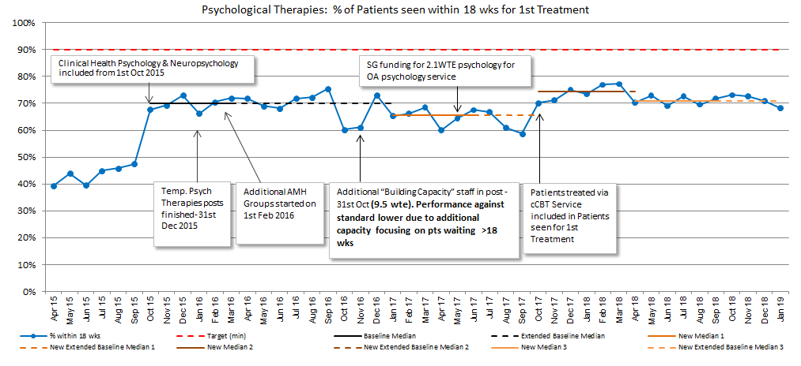

No. Of people waiting over 18 weeks across all adult services
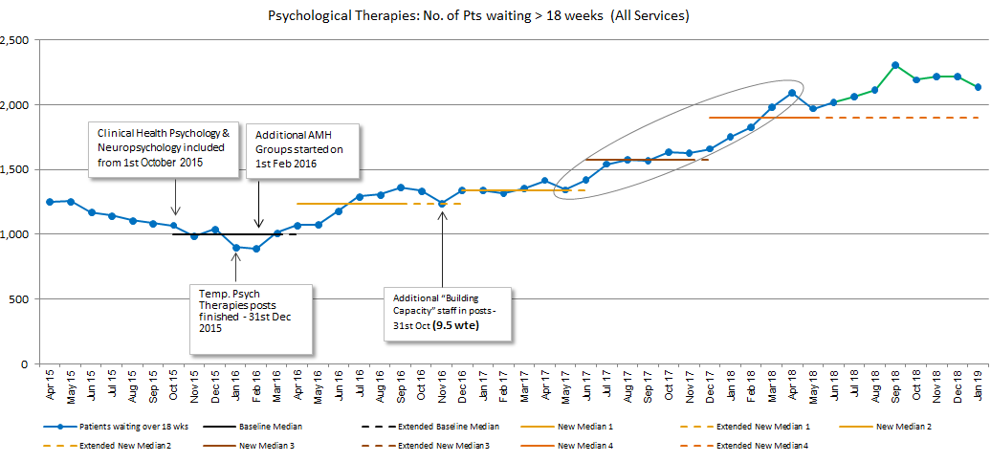
It has been identified that approximately 90% of waiting time breaches are within adult mental health general services and that this is the result of a lack of capacity, therefore, additional investment will be focussed towards ensuring that capacity meets demand in this area. DCAQ will be conducted following this to re-assess the waiting list position.
In March 2019, DCAQ analysis, supported by MHAIST colleagues, demonstrated that in general AMH services, there is an 8.0 WTE permanent staff capacity gap and 21.0 WTE temporary staff gap, which is required to treat the queue of patients who have waited over 18 weeks by August 2020 (see overleaf). The total cost to meet this gap is anticipated to be £2.28 million, with £480,000 recurring funding and £1.8 million non-recurring funding to recruit temporary staff for 18 months over 2 years. It is anticipated that the underspend of the CAMHS additional £3million investment will provide funding for the non-recurrent staffing required as well as the permanent staff until December 2020, recurring funding will require to be agreed from Midlothian and Edinburgh IJB’s to ensure that the target continues to be met beyond December 2020.
 | Current WTE capacity | Current WTE vacancies | Additional WTE capacity required to meet demand | Temporary WTE to clear  queue*
NE Edinburgh | 10.35 | 0 | 4 | 6.0
NW Edinburgh | 6.49 | 2.68 | 0 | 4.0
SE Edinburgh | 6.7 | 2.0 | 2.0 | 4.0
SW Edinburgh | 7.18 | 0.6 | 0 | 3.0
East Lothian | 9.3 | 0 | 0 | 0
Midlothian | 10.76 | 0 | 2.0 | 4.0
West Lothian | 14.03 | 0 | 0 | 0
Total | 64.81 | 5.28 | 8 | 21
Figure 1.0 WTE Requirements
* Employed for 18 months
General Adult Mental Health Services – Anticipated Waiting Time Trajectories:
Edinburgh General AMH Teams
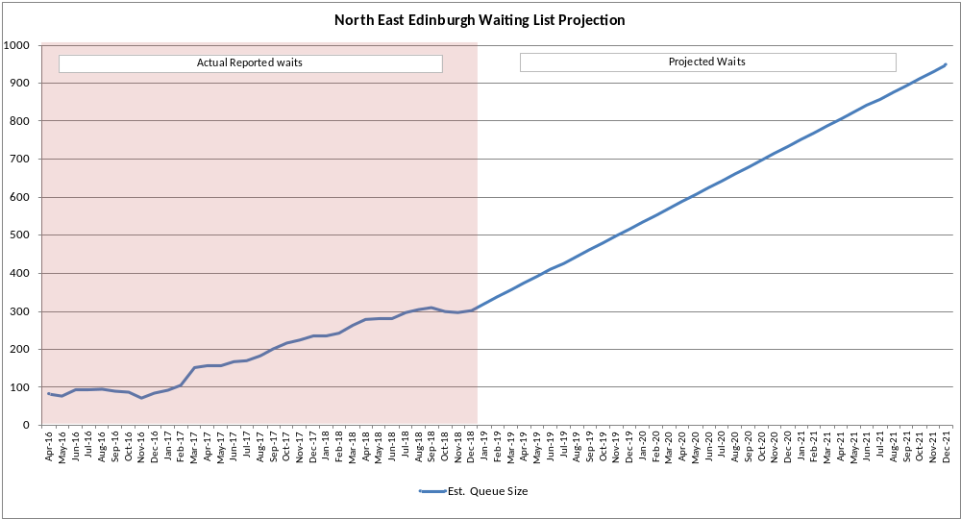
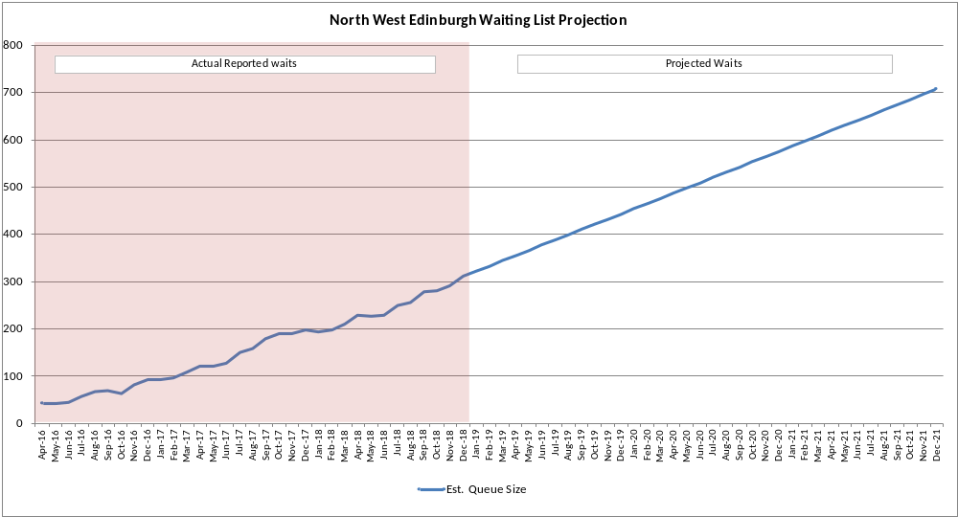
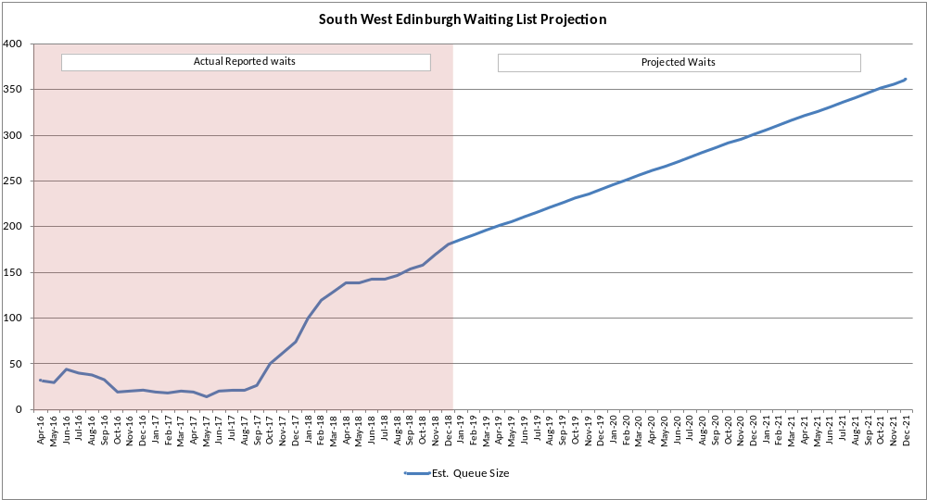
East Lothian AMH Psychological Therapies
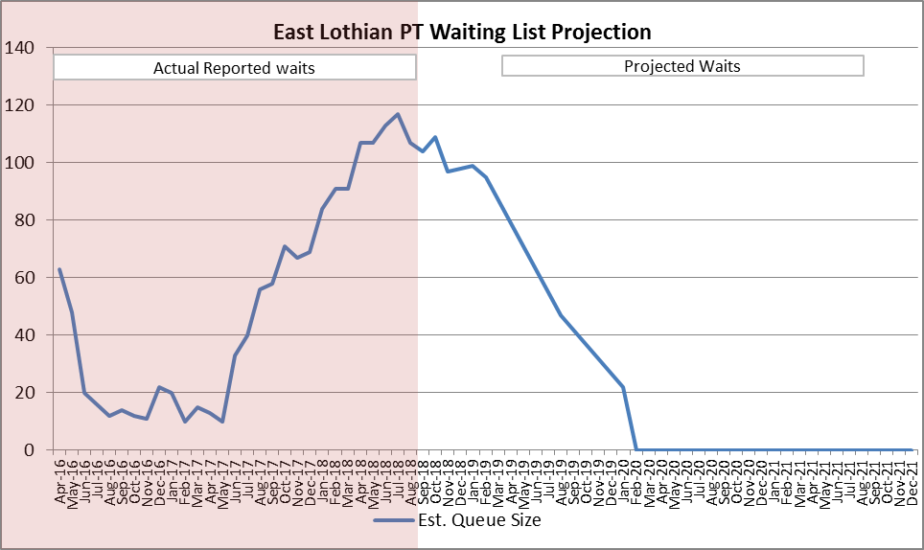

Mid Lothian AMH Psychological Therapies
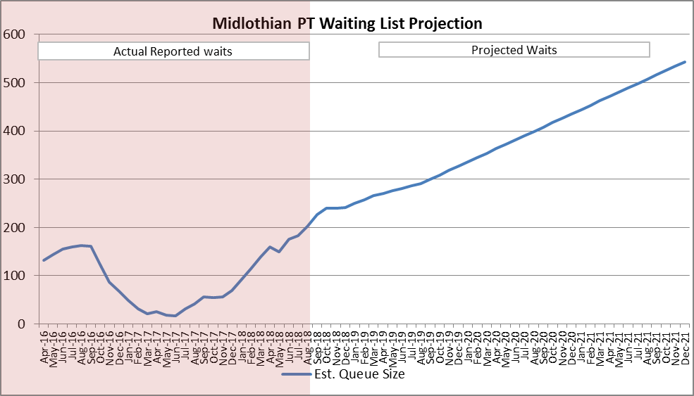

West Lothian AMH Psychological Therapies
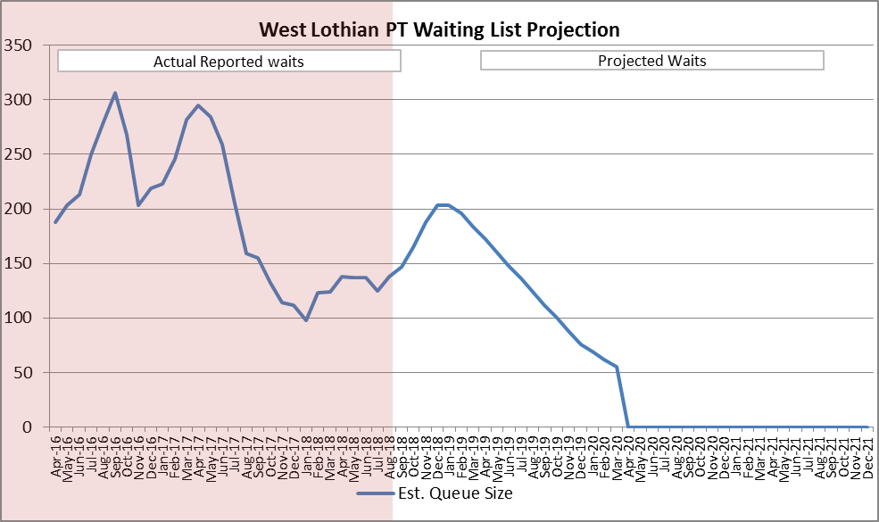
It is anticipated that additional investment within AMH general services (as described above - this does not include the AMH specialist services investment) would have the following impact:
Option | Description | 18 week performance  December 2020
1 | No investment | 38.8%
2 | Investment of £2.28m | 90%
There are a number of active improvement plans, all underpinned by Quality Improvement Methodologies, which highlight the following additional actions within AMH General services as well as the request for additional investment:
- Work is being conducted to ensure that the psychological therapies teams in each partnership act as one team, with one waiting list, which is operationally managed as one service within the general services in AMH.

- Within Edinburgh City HSCP, there are many significant improvement plans including:

  - The Edinburgh Wellbeing Public Social Partnership has created locality and city wide programmes and initiatives which bring together services to support people’s mental health and wellbeing. This co-produced work was instrumental in Edinburgh being selected as one of four UK sites (funded by the Big Lottery) to implement the lessons learnt for the Living Well Lambeth programme which transformed access to mental health services within that London borough.
  - The Therapies Team provides a range of evidence based psychological therapies and operates in each locality, alongside a number of specialist services for people with specific conditions.
  - The development of Thrives Centres and the Open Access Model (building on the lessons learned and shared from Rivers PSP to senior SG colleagues in March 2019). This will include multi agency and multi professional team input offering brief assessment and formulation leading to a jointly agreed plan with the client regarding next steps. Next steps may include support with social problems; distress brief intervention; psycho-education; community connecting; employment and meaningful activities; arts; green activities; group psychological therapy; individual psychological therapy; medication review. This will build on the work of our Edinburgh Wellbeing Public Social Partnership programmes.
  - Further development of the group psychological therapies programme with particular focus on those who present to services with more severe and enduring complex mental health difficulties (i.e. chronic depression)
  - Development of alternative treatment pathways for patients (formulation-led case management, phase-based treatment) so not all placed on list for individual therapy.

  - Review of pathways and transitions across services (eg transitions to Adult services).

- Further work and developments through Edinburgh and Lothians using the Matched Care Prospect Model:
- The Prospect Model is a matched care model for the provision of the evidence-based ‘Interpersonal Psychotherapy’ for people with differing profiles (symptoms, characteristics and level of need) delivered across a range of settings. IPT is a pragmatic, brief, focused intervention that aims to improve wellbeing and reduce symptoms by improving interpersonal functioning, especially help-seeking.
- The model supports recent policy developments in Scotland: “A Connected Scotland: Tackling social isolation and loneliness and building stronger social connections” (January, 2017); The Scottish Government’s Mental Health Strategy 2017 -27; ‘A blue print for Scottish General Practice: A strategy for a safe, secure and strong general practice in Scotland’ (2015).
- The Prospect Model elements: low level interventions which are protocol driven interventions aimed at distress; higher intensity interventions which are short-term standardised psychological therapies aimed at more severe lasting illness; and highly specialised interventions which are individually tailored interventions aimed at highly complex/ enduring illness.
- The Scottish Government, through the National Mental Health Strategy have committed to improving our response to people experiencing distress by increasing the mental health workforce in all A&Es, all GP practices, every police station custody suite, and to our prisons. While this is to be implemented shortly, the Prospect Model is being implemented in Edinburgh and is making a contribution to this strategic intent.
- Progress to date includes the development and adaptations of manualised training, and delivery in NHS Lothian, Scotland of:
- IPT (16 sessions) Major Depressive Disorder, (9 staff trained to deliver IPT to a Veteran population)
- IPT-Brief (IPT-B: 8 sessions) Major Depressive Disorder in Primary Care
- Interpersonal Counselling (IPC: 6 sessions) face to face and telephone for distress (67 staff trained)
- Telephone Interpersonal Counselling (t-IPC: 6 sessions) staff trained in delivering IPC via the telephone only (due to service provisions) (9 staff trained)
- IPT Acute Crisis: (IPT-AC: 4 sessions) acute crisis (35 staff trained)
- IPT: Low Level Offending (IPT LLO: 12 sessions) for women with depression
- IPT General Practice (IPT GP) a 10 minute IPT informed GP consultation
- IPT Formulation (IPT-F) a 20 minute IPT formulation session in Primary Care
- Interpersonal Learning: (IPT-L) a 3 hour workshop for frontline staff (125 staff trained)
- IPT Judicial: (IPT-JS) Intensive one day intervention for acute distress which halts court proceedings (6 staff able to deliver this at present, intervention began November 2018)
- (M)IPT AC BPD: Acute Crisis in those with borderline personality disorder (2 staff trained as part of development work)
- Perinatal Informed IPT: (IPT-PI) Development work on a brief intervention (2-3 sessions) that facilitates social support during the ante and postnatal period.

All the adaptations are derived from IPT and are supported by a number of national and international clinical and academic collaborators.

- Introduction of the Prospect Model in primary care settings which may have the potential to transform the primary care workforce.

- In West Lothian General AMH, there has been a reorganisation of Mental health Services to include a CMHT which will have Psychology posts embedded within it and there is a development of Primary care “Wellbeing Hubs” for those with moderate mental health difficulties.

- All staff who deliver psychological therapies within general AMH services will have dedicated time to the general services team, with agreed governance around this work.

- Teams will work to improve outcomes recording on TRAK using QI methodologies (as has been achieved in West Lothian).

- Administration processes will be streamlined to improve the efficiency of this element of the service – Patient Focussed Booking and text reminders to be established in all teams and monitored using QI methodology.
Within specialist AMH services improvement plans include, as examples, the following:
- Support the continuation of Rivers PSP implementing the revised service model building on lessons learnt from the test of concept which includes the continuation of advice clinics and the delivery of a rolling group based programmes for people with complex Post Traumatic disorder (C-PTSD). Rivers was described recently as “a shining example of collaboration, exemplifying the whole-system approach set out in the Mental Health Strategy. The innovative , flexible approach that you are taking to service delivery is showing very interesting results and offers an example of how services can adapt to people’s needs.” Clare Haughey 19th March 2019

- Continue to support V1P Lothian and ensure that data is continuing to be collected which demonstrates impact and improved outcomes and cost benefits for veterans and their families.

- Within Substance Misuse Psychology: Redistributing capacity (where possible) to match demand more closely across the areas (i.e. more capacity being shifted to West Lothian and NE Edinburgh)

- Development of a programme of Quality Improvement (QI) work aimed at improving both the efficiency and effectiveness of the services delivered (includes work on improving access to/retention in groups, reducing CNA/DNA rates etc)

- Working to develop the wider substance misuse treatment system’s capacity to deliver psychological interventions to people at lower levels of complexity (below A12 threshold). This will ensure more people access appropriate level psychological interventions, and reduce unnecessary referrals to psychology.
3.1.2 Adult Psychological Therapies – Clinical Health Psychology, Neuropsychology, Older Adults and Learning Disabilities
Similarly to adult mental health, there is a lack of capacity to deliver these services within the agreed waiting time, according to DCAQ analysis. Therefore, additional investment will be focussed to ensure that capacity meets demand, and DCAQ will continue to be monitored to show the impact of investment.
Performance - Patient’s Waiting at 3rd March 2019
Service | Total Number waiting | Within  18 wks | Over  18 wks | % within  18 wks | % over  18 wks
Learning Disability | 52 | 47 | 5 | 90.4% | 9.6%
Older Adult Services | 175 | 122 | 53 | 69.7% | 30.3%
Clinical Health Psychology | 614 | 515 | 99 | 83.9% | 16.1%
Neuropsychology | 92 | 89 | 3 | 96.7% | 3.3%
Total Waiting | 933 | 773 | 160 | 82.9% | 17.1%

It is anticipated that additional investment would have the following impact
Option | Description | 18 week performance  December 2020
1 | No investment | 86%
2 | Investment of £267,853 for applied psychology workforce  - Acute Neuropsychology 1.0 WTE  - Pain Management 1.5 WTE  - Older Adults 2.0 WTE | 90%
More detailed analysis of the impact of investment in each service is shown in the following graphs:
Neuropsychology
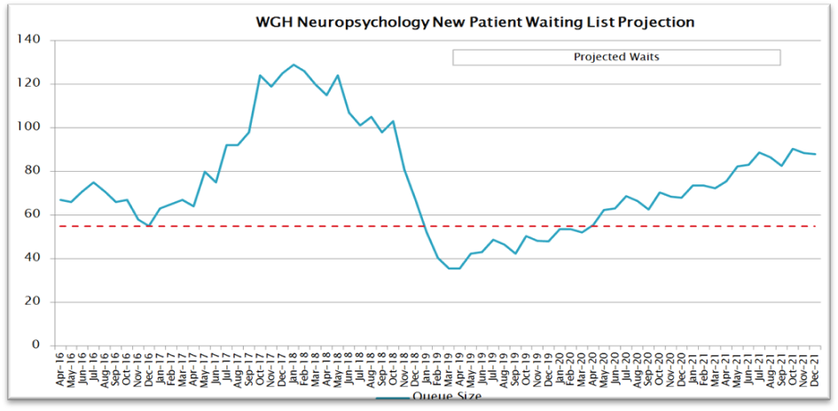
Impact of waiting list funding to finish March 2019, Waiting List Projection with Current Capacity 2019:

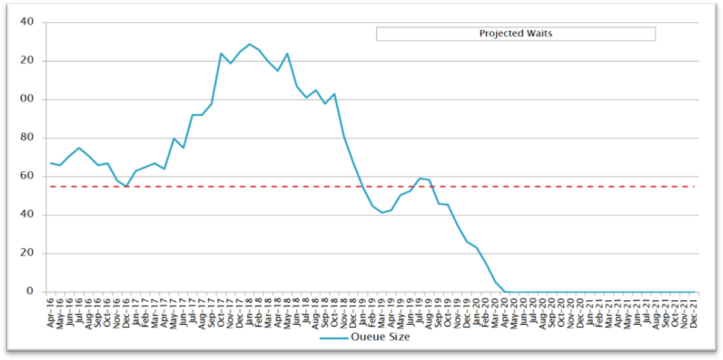
Impact of Additional 1.0WTE Acute Neuropsychology on Projected Waiting Times:
Pain Management
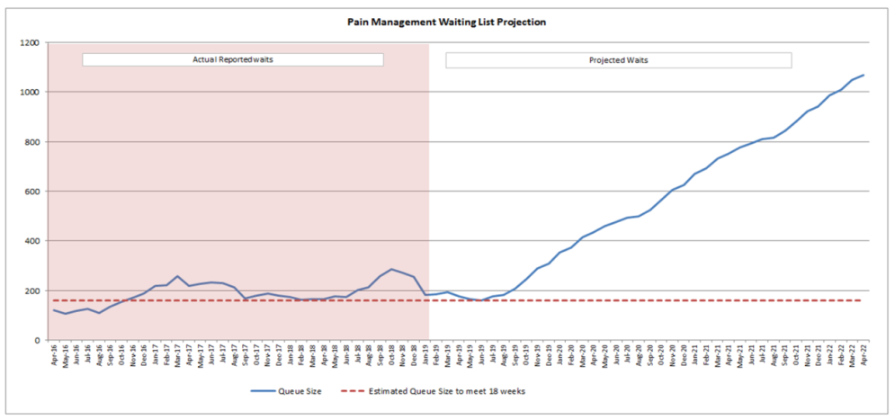
Pain Management Projections for Increase in Waiting Times from July 2019:
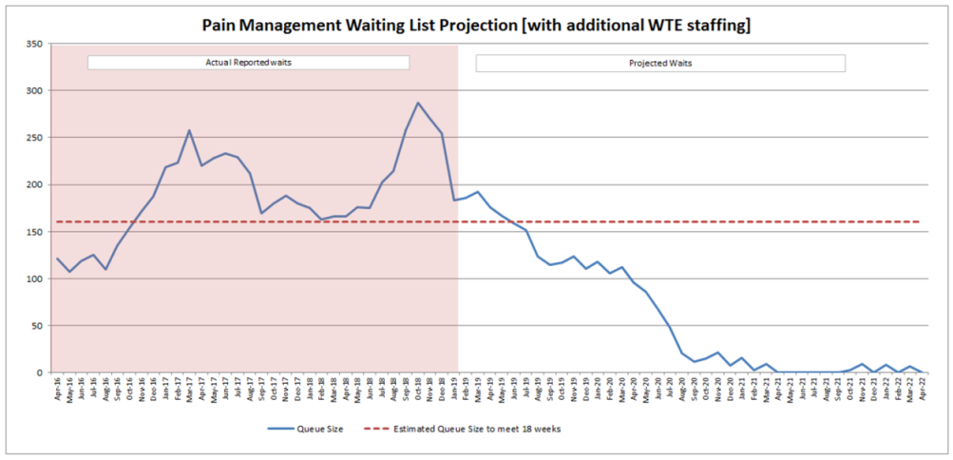
Impact of Additional Recurring Staffing 1.5WTE Pain Management Services

Older Adults
Older Adults Service: Waiting List Projections with Additional 2.0 WTE Capacity
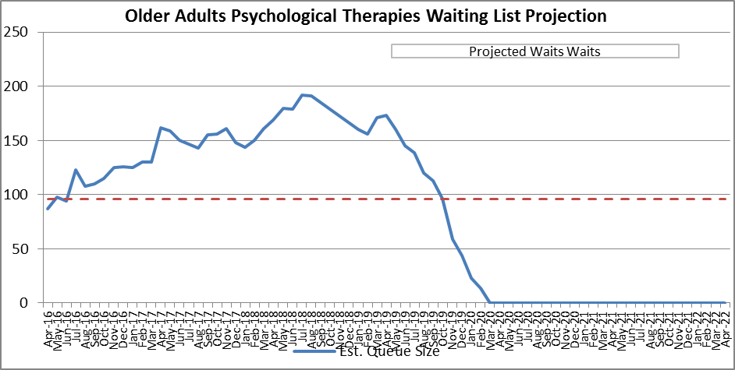
A number of additional and ongoing actions will be taken as well as the request for additional investment:
- E-Health innovations will be used to reduce Could Not Attend’s (CNA’s) and Did Not Attend’s (DNA’s), this will include text reminders, Attend Anywhere, CBT online and Patient Focussed Booking
- There will be improved consistency in application of protocols and systems with administrators managing clinicians diaries
- Work will be conducted to review unwarranted variation in the number of return appointments each clinician has on their caseload
- Quality improvement methodology will be used to assess the impact of increasing intensity of treatment intervention to reduce the duration of intervention
- Implementation of stepped care with full use of cCBT , group work and interventions from other sectors to provide lower intensity interventions as appropriate
- Quality improvement interventions to increase capacity will be balanced by reviewing outcome measures of treatment for assurance of clinical standards
3.2 Delivery of Child and Adolescent Mental Health Services (CAMHS)
DCAQ analysis shows that there is also insufficient capacity within the CAMHS service to deliver the 18 week target. There have been additional investments made in the service, but it has struggled to sustain improvement due to turnover of staff within the service, the impact of staff moving between teams and maternity leave. In response to this, temporary posts have been made permanent; however, the service has been unable to recover from the impact of this.

It is anticipated that an additional investment of £4m is required for the CAMHS service to both clear its backlog and all children waiting longer than 18 weeks, which currently sits at circa 1200 young people.
In light of this, the NHS Lothian Executive Management Team has agreed to invest £3m in CAMHS in the financial year 2019-20. DCAQ analysis anticipates that this investment would see achievement of 90% of children and young people seen within 18 weeks by December 2020. This comes with some caveats and further analysis will be required as recruitment takes place. Additionally, the additional investment of £1.2million would be required to sustain this improvement beyond December 2020. Performance may be challenged by difficulties in recruiting to vacancies, time taken to train new staff and new posts needing to cover for sickness absence. The Executive Director for Nursing responsible for this service area is continuing to work with colleagues internally and Scottish Government colleagues to agree the trajectories for this year’s annual operational plan. This should be concluded by the end of May.

A number of additional actions will be taken as well as the request for additional investment for staffing which includes:
1. Work with the national Children and Young People’s Mental Health Taskforce to make improvements and changes across all tiers of CAMHS services to ensure that children and young people receive the right help at the right time and place.
2. The CAMHS team will work with Healthcare Improvement Scotland’s analytical team to undertake Service "Diagnostic" assessment, create an improvement plan and implement its actions
3. Administrative capacity will be improved in order to streamline processes and improve consistency, specifically, timeliness of discharge letters will be improved to create flow through the pathway and the CAMHS Referral Triage Pathway will be improved, ensuring consistent referral criteria are applied for Specialist CAMHS services
4. Work will be continued to reduce combined DNA/CNA for 1st Appointment and follow up treatment , this may include exploring e-health innovations such as text reminders
5. The CAMHS team will work with adult services to improving transition experience and consistency between services
6. The CAMHS team will work with partners, including third sector and Higher Education, to develop and test e-health interventions
7. A Neuro-developmental Team will be developed in North Edinburgh based on QI work already undertaken to improve consistency and efficiency of the neuro-developmental pathways across teams
8. Conversations have begun with the voluntary sector in terms of what they might be able to support via Group work. Increasing group delivery of psychological treatment will also be tested further in CAMHS
- Development of a new Community role to support building capacity in communities – CMHW were key to the previous recovery plan in terms of having a role in the outpatient teams to target those waiting longest. This has had a negative impact on managing low level mental health issues in the Community, and is also supported by the focus of the Task Force. CMHWs in MHS Lothian has historically been funding circa 1/3 from Councils and 2/3 Health.
10. Rollout of LIAM ( Lets Introduce Anxiety Management) - expansion further than schools and school nursing to include more voluntary agency partners will increase the capacity in children’s services to intervene early l Initial outcome data indicate significant clinical improvement in the CYP and so is likely to reduce referrals to CAMHS longer term
11. Non-Medical prescribing – three nursing staff have been accepted and begun prescribing training with QMU/Napier, which will increase the capacity for access to medicines review particularly for those patients who are waiting longer than they should of medicines review and release Medical staff time to focus where needed
12. Increase in staff ADOS Trained – currently 21staff are ADOS trained, with ADOS being key to a diagnosis of Autism. 5 staff are currently undertaking training with NES, with a further 6 on the waiting list for the next course. This will increase capacity to both release Medical staff time and reduce the current delay in the overall pathway for children and young people presenting with an atypical neurodevelopmental profile

Performance - CAMHS 18 weeks RTT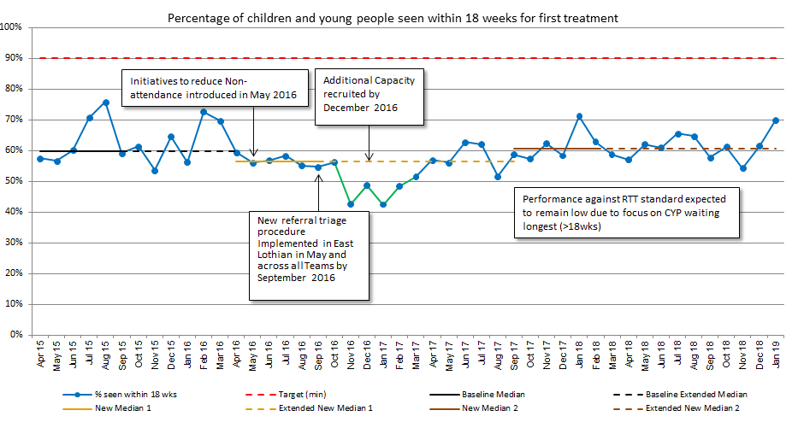
CYP waiting over 18 weeks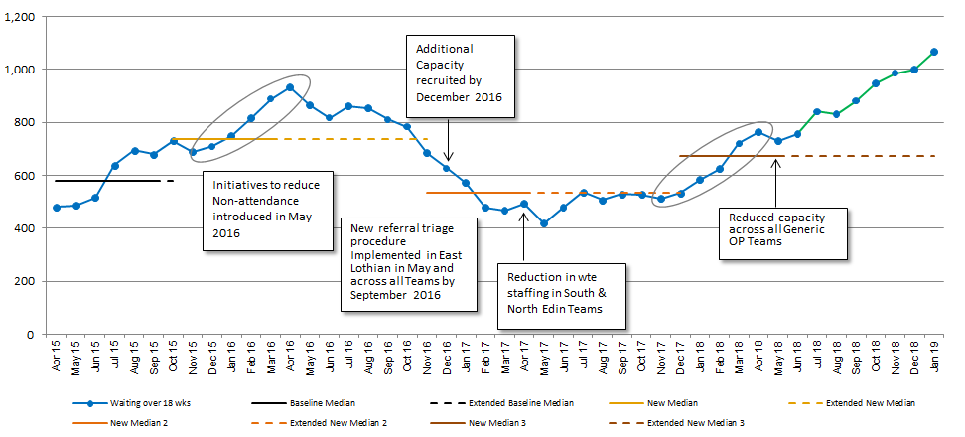
Staff turnover across all Generic Teams
Review of January data confirms that focus remains on treating longest waits first, except in cases of urgency.
It is anticipated that additional investment would have the following impact:
Option | Description | 18 week performance  December 2020
1 | No investment | 66%
2 | Investment of £4.2m | 90%

  - Associated Risks and Mitigation

Risks associated with delivery of the mental health performance standards have been identified as:
- Challenges related to recruitment, particularly to Psychiatry and Nursing posts.
- Internal moves between post may lead to a longer lead in time to reaching the full additional compliment of staff proposed
- As teams focus on the longest waits, this is likely to result in reduced performance for a period of time as the backlog is cleared

To mitigate the above risks internal and external recruitment has already commenced for the CAMHS workforce. A Director of Psychology has recently been appointed and in addition recruitment of the workforce to support improvements to meet the psychological therapies standard is also underway.

Although the initial investment is non-recurring funding, a paper seeking recurring investment will be considered by the Edinburgh and Midlothian IJB's. There is therefore a risk that this recurring funding may not be agreed for 2020-21 which means that reducing the backlog and achieving the 90% target is at risk. All of the above recruitment and improvement on performance is also predicated on NHS Lothian’s ability ‎to reduce turnover, recruit to vacancies and maintain low levels of staff illness and maternity leave.

3.4 Improving Support During Pregnancy and After Birth
In early March 2019, the Scottish Government announced over £52m national investment to improve access to mental health services for expectant and new mothers.

Given the interfaces that occur during the perinatal period between primary care, maternity, adult and child mental health services, health visiting, social care and children’s services, family nurse partnership and voluntary sector agencies amongst others, a Lothian Perinatal Mental Health Steering Group has been established to inform the development of services across all tiers to ensure women, their infants and families have their needs met and to support NHS Lothian to become an exemplar of good practice in this area.

Steering Group representatives includes clinicians and managers representing specialist perinatal mental health services, midwifery, adult mental health community and inpatient services, psychology, health visiting, primary care, obstetrics, child and young adult mental health service (CAMHS), social work, third sector, liaison psychiatry, infant mental health, family nurse partnership, substance misuse and integrated joint boards.

To ensure a person-centred approach, in keeping with NHS Lothian’s vision of safe, effective and person-centred health and social care, patient representation will be sought through maternal mental health change agents and a young patient representative will be sought to join the group through the Family Nurse Partnership.

3.5 Suicide Prevention Through Interpersonal Psychotherapy Acute Crisis (IPT-AC)
NHS Lothian supports suicide prevention through a matched care model for the provision of an ‘Interpersonal Psychotherapy’ (IPT) for people with differing profiles (symptoms, characteristics and level of need) delivered across a range of settings. IPT is a pragmatic, brief, focused intervention that aims to improve wellbeing and reduce symptoms by improving interpersonal functioning, especially help-seeking. IPT is a framework that pulls together biological, social and psychological factors to help understand the client’s distress. The focus is on working with the client’s relationships in their natural networks. IPT also emphasises acknowledging and understanding the importance of normative and non-normative life events in triggering and maintaining distress and mental illness.
At the Emergency Department (ED) of the Royal Infirmary of Edinburgh (RIE) a small pilot study with 30 patients who presented in acute distress with an episode of self-harm/poisoning at the emergency department was instigated. Three nurse therapists already working in the emergency department delivered the IPT AC intervention after receiving training and on-going supervision. Analyses showed that four sessions of IPT AC was associated with a significant reduction in depressive symptoms and core distress when pre and post treatment scores were compared. In addition, suicidal ideation was reduced. Further, anecdotal evidence from staff suggests that IPT AC appears to reduce subsequent attendances in the emergency department in those who have received the intervention compared to those who have not.

The nurses delivering the IPT AC intervention at the ED RIE received a national award for innovation for their work at the National Awards 2017 for Mental Health Nursing Practice (University of Abertay, Dundee).

IPT AC fits well with current models of suicidal behaviour (e.g. O’Connor et al, 2011) as it targets particular motivators for suicidal ideation: life events (e.g. relationship crises), social problem solving, personal goals, and social support. IPT AC also targets one of the strongest predictors of suicide: social isolation. Those who self-harm have a severe lack of social support. The pilot project demonstrated
the feasibility of delivering IPT AC to people presenting to an emergency department in crisis with suicidal ideation and/or self-harm.

Building on this successful pilot funding for three nurses has been secured from Action 15 funding. In addition three nurses will be employed to work with young people presenting at ED who will deliver an adaptation of IPT – Acute Crisis.

Gamechanger Choose Life Challenge Cup
GameChanger is an exciting and innovative n Public Social Partnership led by NHS Lothian, Hibernian Football Club and the Hibernian Community Foundation. The aim is to unlock the power and passion associated with football and to make greater use of all Hibernian’s physical, cultural and professional assets, to deliver a better, healthier future for the most vulnerable, disenfranchised or disadvantaged in communities. For the last three years GameChanger has introduced and supported The Choose Life Challenge Cup which is a chance for football teams to play together, for partners to provide information about mental health and wellbeing, and to think about how to manage stress and the importance of talking about you how feel.

Each year the two winning sides take part in a penalty shoot during half-time at a Hibernian home matches during Mental Health Week in October, when there is a particular focus across the stadium on how people can support one another’s mental health and wellbeing.

4. INTEGRATION AUTHORITIES

4.1 Lothian Integrated Care Forum
To support ministerial priorities relating to progress and pace associated with the integration of health and social care and delivery of Ministerial Steering Group Integration Indicators, a Lothian Integrated Care Forum has been established. The first meeting of the Forum took place on 4 April 2019. The forum will meet bi-monthly thereafter.

Membership of the Forum includes NHS Lothian Chair and Chief Executive, Four IJB Chairs and Vice Chairs, Chief Officer Acute Services, Chief Officers IJBs and NHS Lothian Director of Strategic Planning. Additional officers will be asked to attend as appropriate.

During 2019-20, the Forum will focus on services that fall under the ‘set aside’ agenda such as unscheduled care, emergency departments, community hospitals and inpatient mental health services and other key issues identified by forum members of over the course of the year.

The forum will also create ‘space’ for the four Lothian Integration Joint Boards (IJBs) and NHS Lothian to come together to discuss, progress and develop proposals set out in the Ministerial Strategic Group for Health and Community Care Report: Review of Progress with Integration and Health and Social Care (February 2019) and the prescribed timelines set out in the report.
The aim of the Forum, discussed and agreed at the inaugural meeting includes:
- Create an infrastructure for joint planning
- Improve relationships and understanding; including the different approaches, cultures and challenges between IJBs, Councils and NHS Lothian
- Ensure the delivery of care in Lothian is agreed in collaboration with partners; allowing more efficient strategic working and improvements to transpire that take into account the needs of all organisations
- Working towards medium and long term joint financial planning
- Ensure that the opportunities and benefits for collaborative working within as well as between organisations are recognised and realised
- Collectively target resources including staff
- Continue to recognise the need for local decision making but with a shared approach
- Share and build on good work undertaken with localities across Lothian
- Discuss a common approach to the management of set aside money across Lothian
- Progress the Ministerial Steering Group (MSG) recommendations
- Develop and agree short, medium and long term plans for unscheduled care at St John’s Hospital, Western General Hospital and Royal Infirmary of Edinburgh. Recognising responsibilities sit with a number of Integration Joint Boards
- Work together on common themes, such as workforce, housing and demographic challenges

4.2 East Lothian Strategic Plan 2019-22
The East Lothian Strategic Plan 2019-22 was developed in collaboration with a wide range of stakeholders and was approved by the Integration Joint Board (IJB) on 28 March 2019. The Strategic Plan outlines six transformation programmes of work:
- Primary Care
- Adults with Complex Needs
- Mental Health and Substance Misuse
- Shifting the Balance of Care
- Reprovision Programmes
- Carers

East Lothian IJB is committed to developing progress and pace of integration in line with Ministerial Strategic Group and Audit Scotland recommendations. A report regarding the MSG and Audit Scotland recommendations will be presented to the IJB to consider how key recommendations will be incorporated into the IJB’s strategic delivery plan. Further self-assessment against key areas to support integration will be carried out to identify local areas of development and outline future actions.

East Lothian IJB is committed to full participation in relevant planning groups to ensure the local progress aligns with best practice. Governance and accountability arrangements will be reviewed to ensure system wide efficiency and effectiveness and best use of IJB Directions. Engagement will continue to be a key priority and has been identified as a ‘Golden Thread’ within the IJB Strategic Plan 2019-2022 and will be informed by National Standards for Community Engagement.
Progress in East Lothian against MSG Integration Indicators
The East Lothian partnership has made considerable progress across several national indicators. When compared with national averages in 2017-18, East Lothian’s rates for premature mortality, emergency admission, emergency bed day, falls and the percentage of health and care resource spent on hospital stays for patients admitted in emergency are below Scottish rates. The proportion of care services graded ‘good’ or better in Care Inspectorate inspections is equal to the national average at 85%.
Over time there has also been a clear reduction of delayed discharge bed days for East Lothian patients who are ready to be discharged from acute hospitals dropping from an average of 3,389 in 2016-17 to 2,317 in 2017-18. This has been achieved through multi-disciplinary team working across services and the co-ordination of support between the Hospital at Home, Hospital to Home, Care Home and Social Care teams, working together to prevent admissions and to reduce length of stay for patients.
Over the past six years, despite an initial increase in rates of emergency bed day rates for adults admitted into acute hospitals in 2013-14 emergency bed day rates have reduced from 125,346 in 2014-15 to 120,782 in 2017-18. East Lothian rates have remained below Scottish rates during this time period.
During the period of 2012-13 to 2017-18, East Lothian’s emergency admissions rate for adults has also consistently fallen below Scottish annual rates.

4.3 West Lothian Strategic Plan 2019-23
Following consultation with a wide range of stakeholders, the West Lothian Integration Joint Board approved a new strategic plan for the period 2019-2023 in April 2019. The plan focuses on delivery of the Scottish Government’s vision to shift the balance of care and takes account of local priorities to increase wellbeing and reduce health inequalities across all communities in West Lothian. The main local priorities are:
- Tackling inequalities
- Prevention and early intervention
- Integrated and coordinated care
- Managing resources effectively

Achievement of the strategic priorities is supported by a range of transformational change programmes, underpinned by the development of new strategic commissioning plans and aligned to medium term financial plans for the period 2019-2023. A revised strategic planning and commissioning structure was also approved by the IJB and throughout 2019-20 integrated strategic planning and commissioning boards will develop commissioning intentions which maximise use of resources across the entire health and social care system in the following areas:
- Services for older people
- Mental health services
- Learning disability services
- Alcohol and Drug Partnership
- Physical disability services
- Primary care improvements
- Palliative care services
- Unscheduled care services

Transformational change programmes will continue to focus on frailty, mental health, and primary care improvements.

The population of frail elderly people in West Lothian is expected to increase significantly over the next 5 years. The Frailty Programme is being refreshed to ensure that increased demand is reflected accurately in planning and to ensure that services are developed with focus on prevention and delivery in the most appropriate setting. There are four work streams associated with that work:

- Optimising Flow
- Integrated Discharge Hub
- Home First
- Intermediate Care

The need for a strategic approach to the whole health and social care system to improve service performance across NHS Lothian, West Lothian Council and the third sector is recognised by the partnership and will be reflected in commissioning plans. It has also been identified that the next phase of development must focus on prevention and people living well in their communities. Targeted planning in this area will be developed during 2019-20.

The development of mental health services will focus on avoiding admission to hospital where possible, supporting discharge from acute care and maintaining people in the community. A significant development during 2019-20 will be the implementation of community mental health and wellbeing hubs staffed by multi-disciplinary teams of health and social care professionals to enhance the range of community supports available to people with moderate mental health problems.

Understanding Progress Under Integration
Integration Authorities are required to set objectives against the six Ministerial Strategic Group (MSG) indicators for Health and Community Care. In March 2019, the West Lothian IJB noted performance across the indicators and acknowledged that further progress was required in relation to delayed discharge.

There have been significant challenges in West Lothian over the past two years in securing care at home and care home services to facilitate timely discharge from hospital. A test of change project is underway to redesign the interface between the new integrated discharge hub at St John’s Hospital and care at home services. The project is showing positive results and is being used to inform a new care at home contract which aims to improve supply and enhance flow. During 2019-20, the ‘Home First’ work stream will also implement a discharge to assess model to further improve the flow of patients from hospital and reduce delays.

The IJB approved revised performance objectives for 2019-20 to reflect the growing West Lothian population and the key priorities for the year. Progress against those objectives will be reported to the IJB throughout the year.

4.4 Edinburgh Strategic Plan 2019-22
The Edinburgh IJB Strategic Plan 2019-2022 seeks to outline the longer-term direction of travel in outline and the next planning cycle in detail. The key themes are:
- Redefining the Edinburgh Health and Social Care Offer
- Roll out of the 3 Conversations Approach
- Home First
- Transformation (Change Programme)

Milestones will be developed within the Change Programme as project scopes and
definitions mature. Implementation is captured in two broad phases:

- Phase 1: Prelims and Launch (1July 2019 to 31 March 2021). Phase 1 will initially be focused on getting organised and aligned to the start of the Change Programme. The Good Governance Institute (GGI) will continue to work with the Edinburgh IJB at the higher level which will include refinement of the supporting sub-committees. The 3 Conversations Approach supported by Partners4Change (P4C) will be rolled out across the City from 17 April 2019. Collaboration and co-production with partners and stakeholders will be central to the programme. Edinburgh IJB Directions will flow out of the Change Programme aligned with strategic priorities.

- Phase 2: Continuation and Development (1 April 2021 to 31 March 2022). Phase 2 will bring a continuation of the projects and reviews started within Phase 1. Agreed actions and outputs will be reported to the Edinburgh IJB and Directions will follow. Concurrently, the Strategic Plan will be monitored, refined and aligned to the planning for the next strategic cycle 2022-2025 to measure performance, compliance and to ensure coherence.

The Edinburgh IJB Strategic Plan 2019-2022 presents a high-level strategic vision, intent and direction of travel which recognises the strategic context and necessity to change the way health and social care is delivered in Edinburgh. It also seeks to drive improvement in structures, planning, performance measurement, including assurance and compliance, and delivery. It embraces the five principles of the National Health and Social Care Standards and the nine National Health and Wellbeing Outcomes. The plan sets out the aspiration to redesign services through a comprehensive Change Programme, to shift the balance of care from acute to the community; the desire to work collaboratively with partners to optimise available resource and capacity, and to roll out the Three Conversations Model across the City. The intent is to progress rapidly over the next three years and beyond into future strategic planning cycles, to create the conditions to successfully transition to a modern and sustainable health and social care model for Edinburgh.

4.5 Midlothian Strategic Plan 2019-22
Midlothian Strategic Plan 2019-22 was approved by the IJB in March 2019.
The plan was developed having considered a number of pieces of evidence:
- Facts & Figures
  - Joint Needs Assessment
- Views of the Public & Staff
  - User groups
  - User and Carer representatives on planning groups and the Integration Joint Board.
  - Staff & Public consultations
- Performance measures
- Published annual performance report including the National Health & Wellbeing Indicators
- Quarterly reports providing detailed information across a range of services.
- Local Policies & Strategies

The Midlothian Strategic Plan outlines the values, challenges and strategic vision of Midlothian IJB. The Strategic Plan and various associated documents are available here.

5. PRIMARY CARE SERVICES

  - Delivery of Primary Care Services in Lothian
Planning for primary care services is a delegated function to IJBs. In addition NHS Lothian has delegated many aspects of operational delivery to Health and Social Care Partnerships (HSCPs). NHS Lothian has retained responsibility for contracts, premises, capital, IT and the employment of staff. The new General Medical Services (GMS) Contract 2018 is based upon a tripartite approach to governance and implementation involving the GP Sub Committee, HSCPs and the NHS Board. As a result of these factors NHS Lothian, the IJBs and the GP subcommittee established a GMS contract oversight group and nine sub groups.

5.1.1 Vision for the Future of Primary Care Services
In 2019 the Scottish Government issued a circular clarifying the role of NHS Boards in the GMS contract. The new contract Memorandum of Understanding (MOU) had already set out the roles of IJBs. As a result NHS Lothian has considered its role in more detail and in December 2018, NHS Lothian Board and the Strategic Planning Committee agreed that NHS Lothian should develop a vision for the future of primary care due to a number of reasons outlined below:
- The NHS Board must respond to IJB directions and these directions include implementation of the Primary Care Improvement Plans. The Board should aggregate these plans into areas of action across Lothian where appropriate.
- The NHS Board also has responsibility for the whole of the Lothian population and so must take an overview across Lothian.
- Primary Care is where 90% of healthcare contacts take place and the Board cannot have a strategic direction that does not include such an important area of service.
- The NHS Board has functions it cannot delegate to IJBs and there should be a strategic direction for these functions.
- The relationship between primary care and other service strategies (e.g. for scheduled care and diagnostics) that are not delegated to IJBs has to be articulated at Board level.

The scope to achieving a future vision for the future of primary care services includes:
- Work should take an overview for the whole population of Lothian.
- It should include strategies for primary care functions that are not delegated to IJBs e.g. contracting, premises, information technology
- It should include the primary care role in strategies for other service functions that are not delegated to IJBs e.g. scheduled care, diagnostics, cancer services
- It should include the primary care elements of other strategies e.g. quality improvement and health improvement
- It should include dental, pharmaceutical and ophthalmic services as well as general medical services
- It should cover in and out of hours services
- It should include primary care outcome measures for Lothian
- It should aggregate the directions of IJBs to NHS Lothian and show how these will be delivered
- It should not be a separate NHS Lothian Primary Care Strategy since the strategic planning function is delegated to IJBs and to a significant extent the Board’s responsibility in this area is to deliver IJB strategy

A draft of the vision for the future is expected to be ready for July 2019. The Tripartite approach will focus on the following Lothian wide areas of development of the new GMS Contract

5.1.2 Primary Care Premises
NHS Lothian has responsibility for primary care premises and associated capital, however it has been agreed that HSCPs should be driving their own priorities and leading on business case development, within a Lothian wide framework. The following primary care accommodation developments have been prioritised with a focus on areas of population growth in NHS Lothian’s Capital Plan. The priorities are at various stages of development.

Edinburgh Health and Social Care Partnership:
- Homeless Service – Strategic Business Case (SBC) approved
- Brunton Place Surgery – Initial Agreement (IA) in process
- Granton Waterfront - Pre IA
- Leith Waterfront - Pre IA
- Meadows Area - Pre IA
- Morningside Area - Pre IA
- Outer South East Edinburgh Area - Pre IA
- West Edinburgh - Pre IA

East Lothian Health and Social Care Partnership:
- Cockenzie Health Centre - SBC approved

Midlothian Health and Social Care Partnership:
- Shawfair/Danderhall – IA in process
- Rosewell/South Bonnyrigg Area – Pre IA

West Lothian Health and Social Care Partnership:
- East Calder Health Centre – IA approved
- Armadale Health Centre – Pre IA

The NHS Board and HSCPs will refresh the premises programme during 2019-20 to take account of changes since the last update in 2017-18 including loans and leases changes introduced under the new contract.

5.1.3 Vaccination Transformation
The Board has successfully moved all 0-5 immunisation activity from practices in 2018-19. In 2019-20 the focus will be on implementing sustainable delivery models for this activity to maintain and improve uptake, on implementing a new travel vaccines service model and on preparing models to test the transfer of remaining programmes away from general practice.

5.1.4 Workforce
A single Lothian workforce plan for the GMS contract will be developed in 2019-20 built up from the four HSCP workforce plans. This will be used to inform educational bodies of future demand, to manage recruitment and in house training and development programmes. The workforce group will also manage any conflicting demands that might destabilise some parts of the service.

5.1.5 Pharmacotherapy
HSCPs and the NHS Board have worked together to develop a three year programme to introduce pharmacotherapy support to practices under the new contract. There was a major recruitment process in 2018-19 which will result in additional staff in support of practices in 2019-20. There will be further recruitment in 2019-20. In addition HSCPs have agreed to support recruitment of pharmacy technicians and NHS Lothian will work with Edinburgh College to expand the intake into the programme.

5.1.6 eHhealth
Four primary care development priorities for the whole system have been agreed for 2019-20:
- Decision on what GP IT system will be supported in Lothian under the new contract for GP IT.
- Information technology support for CTACS implementation
- Electronic Prescribing
- GP to GP data transfer.

Some of these will depend upon national solutions. There will continue to be additional eHealth development work in primary care either for individual HSCP priorities or to continue implementation of existing priorities.

5.1.7 Community Treatment and Care Services (CTACS)
It has been agreed that there will be a minimum specification of service across Lothian that HSCPs can add to in order to meet local needs. The Lothian specification will enable a single eHealth solution to be put in place and allow secondary care to access CTACS across the whole of Lothian. The specification will include secondary care bloods currently done in primary care; secondary care bloods currently done in secondary care, suture removal, wound management and ear care. Lothian will develop a joint resourcing model from both PCIF and secondary care funding sources.

5.1.8 Out of Hours
Out of hours general practice is no longer part of the GMS contract. The GP out of hours service is managed as a single service across Lothian on behalf of the HSCPs. The service is facing major challenges to its sustainability in terms of medical and nursing staffing. Competing demand for nurses for in hours general practice and improving attractiveness of in hours work for GPs as a result of the new contract is making it harder to recruit and retain staff.

NHS Lothian will implement a programme of change through the Urgent Care Resource Hub Board (partly in response to the Ritchie Report) to broaden out the supports available out of hours and to implement new models of service.NHS Lothian will work to implement more shared arrangements within hours primary care e.g. shared nursing rotas, increased commitment of training practices to out of hours etc. Some of these will depend on national agreements.

5.2 Development of Primary Care Improvement Plans and Monitoring Implementation
The four Lothian HSCPs developed Primary Care Improvement Plans 2018 – 21 which were approved by the respective IJBs and GP Sub-committee and submitted to the Scottish Government in July 2018. These will be updated in April 2019 and HSCPs will also produce updated monitoring information by June 2019. It is already agreed that a large part of the NHS Board vision for the future of primary care will be driven by responding to the directions from IJBs.

5.2.1 East Lothian Health and Social Care Partnership (ELHSCP)
East Lothian’s health and social care services must continue to meet the needs of a diverse and growing population. In 2017, there were 104,840 people living in East Lothian. There is an expected increase of around 23% up to 2041, with the highest growth in the 65-74 and 75+ age bands. This is one of the highest increases in any local authority area in Scotland.

The East Lothian Local Development Plan sets out how the county will accommodate up to 13,347 new homes (6,062 of which are committed to so far) in the period from 2016 up to 2037. The bulk of building is phased over the period 2015 to 2024. This will drive a large increase on the current estimated 43,682 households in the county.
The Blindwells development located between Tranent and Cockenzie will deliver its housing over 2021 to 2037. Blindwells will create a significant expansion in primary care demand in the west of East Lothian.
East Lothian Primary Care Premises
The county’s growing and ageing population will increase demand for health and social care services. In addition, the increasing prevalence of long term conditions and, in particular, people living with multiple health conditions is projected to rise as the population ages.

Existing capital projects in East Lothian include East Lothian Community Hospital and Cockenzie Health Centre both of which are estimated for completion in 2019-2020.
During the 2018-19 cycle of capital prioritisation ELHSCP did not identify immediate capital priorities for inclusion in this process. East Lothian did, at this time, identify projects that were considered priorities but where Strategic Assessments (SAs) were still to be completed. Once SAs have been agreed, they will be reprioritised in advance of submission to the Finance and Resource Committee (F&RC) and the Lothian Capital Investment Group (LCIG). Further plans are being explored within the new Wallyford development
Service Priorities without Strategic Assessments
 | Project | Approx Value (where known) | Timescale required in (where known) | Date SA Planned
1. | Blindwells Health Centre | TBC | 2022-23 | Early 2019
2. | Haddington Health Centre | TBC | 2020-21 | Early 2019
3. | North Berwick Health Centre | TBC | 2020-21 | Early 2019
4. | East Linton | TBC | TBC | Early 2019

Development of Primary Care Improvement Plans and Monitoring Implementation
ELHSCP has identified Primary Care as one of its six main priorities within the Integration Joint Board Strategic Plan for 2019-22.

ELHSCP is currently updating the Primary Care Improvement Plan (PCIP) to highlight previous progress and outline plans for 2019-20, including completion of a 6-monthly implementation tracker outlining funding and workforce projections.
The PCIP is intended to support changes in how patients access Primary Care services and how these services are delivered to them. ELHSCP is committed to the ‘Right Person, Right Place, Right Time’ approach to health and social care delivery, recognising that individuals may require different pathways to care.
Four working groups are responsible for delivering key elements of the Primary Care Improvement Plan, including the Access and Delivery group, the Link Worker group, the Pharmocotherapy group, and the Community Treatment and Access Care Services (CTACS) group. In addition ELHSCP has collaborative links with GP practices both directly and through the two local GP Clusters and through ensuring GP representation on the Primary Care Change Board and within working groups.
The ELHSCP is committed through the four working groups to systematic engagement of all relevant stakeholders throughout the implementation of the Primary Care Improvement Plan.
Development of Patient Participation Groups has been supported locally by the ELHSCP. In addition, local Area Partnerships are supporting the development of local Health and Wellbeing groups. Further engagement with these networks will ensure patient perspectives continue to inform future service development.
Further service developments will continue to be monitored and evaluated against key measures. Local capacity for monitoring and evaluation is being developed in a number of ways including ongoing collaborations with Local Information Support Team (LIST) and Healthcare Improvement Scotland (HIS), as well as the development of a local Data group to advise on how ELHSCP can make best use of data.
Primary Care Redesign
Multi-disciplinary approaches are being developed across the county, taking into account the particular needs of each locality. A multi-disciplinary approach, the ‘Musselburgh Model’ has already been piloted to offer greater access for patients seeking same day access to primary care.

Robust evaluation of the Musselburgh Model has demonstrated reductions in outpatient referral numbers and prescribing, including significant reductions in antibiotic prescribing. There is a strong commitment from the IJB to ensure the fullest possible evaluation so that learning for the partnership and others further afield, is prioritised. This model is due for expansion, bringing the potential number of patients benefiting from this service to over 53,000 patients, over half of the East Lothian population.
Delivery of services via Community Treatment and Care Services (CTACs) ensure a more equitable service for patients, agreed treatment protocols and improved clinical outcomes. Premises for the first implementation of new CTACS services has been identified in the East Lothian Community Hospital and the pilot is expected to begin in August 2019.
The ELHSCP will also begin re-provision of Abbey and Eskgreen Care Homes and Edington and Belhaven hospitals and provision of alternative housing with care models after reaching a final decision on the strategic direction and priority actions for affected communities.
5.2.2 West Lothian Health and Social Care Partnership
West Lothian has 22 GP practices ranging in list size from: 3,132 to 15,748 patients. Over half of practices fall in the 6,000 - 9,000 patient range. A range of principles was established in the development of the Primary Care Improvement Plan (PCIP):
- Resources will be shared across all practices rather than heavily targeted at practices in difficulty, although those practices may receive additional support sooner than others

- Equally, it is important that when resources, particularly new staff, are put into teams, that practices receive sufficient resources for this to be effective and make a palpable difference. The concept of a “minimum useful level” has been developed, and the aim is to embed this level of service across all practices before offering additional resource to larger practices
- Initially, a pragmatic approach will be taken to the distribution of new resources – some services such as IT initiatives and development of mental health hubs will be offered to all practices, other services, for example, paramedics will be deployed on a geographical basis, whilst others will depend on criteria such as practice readiness or current distribution of existing support staff such as pharmacists or district nurses
- Year 3 will be a rebalancing year where the impact of the plan will be reviewed with the PCFIG, and decisions taken about which forms of support have been most effective and merit further investment. At this point consideration will also be given to which criteria should be used in the allocation of this additional resource such as list size, deprivation and demographics

The actions outlined in the PCIP describe a broad range of developments aimed at stabilising and supporting General Practitioners to move forward and provide sustainable, patient centred care over the coming years.

A report on implementation of the PCIP was submitted to the IJB in April 2019 detailing progress in relation all improvement actions. A red, amber, green rating was applied to work stream with commentary to explain the current position with further detail provided in the revised PCIP. Overall the improvement plan was rated at amber reflecting that 16 actions were green (fully implemented and on track), 12 were at amber (partially completed or scheduled to be implemented in 2019- 21), and 5 were at red, largely due to the need for national and/or regional guidance and support to be agreed.

The Board considered proposed actions for implementation during years 2 and 3 of the plan and approved submission of the PCIP tracker to the Scottish Government. The tracker will be updated on a 6 monthly basis with a further report to the IJB.

5.2.3 Edinburgh Health and Social Care Partnership
Edinburgh’s population has increased by nearly 60,000 over the last decade and is set to continue this expansion into the 2030s. In 2014, the first assessment was made of the requirement for increased primary care premises capacity required to meet the provision required for the new population. Alongside this assessment was a decision to maximise the size of existing and willing GP practices and to minimise the requirement for entirely new practices to be established. To help to phase the requirements for new builds, modest funding was made available for ‘small schemes’ to adjust existing buildings to enable the practice to allow its list size to grow. To date, over 40 such schemes have been agreed and implemented. Edinburgh practices were also incentivised with ‘List Extension Growth Uplift’ grants (LEGUPs) for practices willing to grow their lists by 500 or more over a year.

Edinburgh has minimised its requirement for entirely new practices in entirely new premises to Granton, Leith and West Edinburgh. Depending on the solution in south east Edinburgh, a new practice may also be required there. To support this, circa 12 major capital projects need to be delivered over the current planning period (to 2026).

Edinburgh has worked closely with the City planners to understand the location and timing of the population growth and develop healthcare actions to support the delivery of the Local Development Plan (LDP). This is supported by Supplementary Guidance establishing the requirement for developer contributions to the development of primary care infrastructure for the new population. This guidance is with Scottish Government at time of writing.

Edinburgh Primary Care Improvement Plan Progress
Edinburgh IJB reviewed implementation progress at its May 2019 meeting. The IJB noted the wide range of investments made to stabilise and transform primary care across the city. The PCIP has working groups relating to all areas of the contract and has made notable progress to date with the development of pharmacotherapy, mental health and linkworking, alongside a host of ‘tests of change’ designed to inject capacity into the system. At the end of March 2019, Edinburgh assessed that approximately a third of the capacity to be funded by the PCIP was already in place.

Part of the investment in increased management support was in evaluation which is key to ensuring that actual impact of all of our PCIP investments is understood. In 2019 mental health nursing, Linkworking and pharmacotherapy will all undergo initial assessments.

Edinburgh Primary Care Redesign
Edinburgh has embraced a ‘practice by practice’ bottom up approach to redesign with almost all of our 70 practices involved to testing some part or parts of the new multi-disciplinary team. This approach was established in consultation with GPs and as a result of the diverse challenges which face Edinburgh’s primary care teams.

Addressing inequality has been a longstanding focus of attention for a substantial group of Edinburgh practices and the PCIP funding was weighted to reflect this and the very elderly (+85yrs). It is believed that a better understanding of the direct workload and secondary referral/admissions consequences of supporting these groups (and others) would benefit from communication and support to different communities and how best to organise this.

Prescribing support has always been a key part of the Edinburgh Primary Care Programme. Investments in pharmacotherapy will further develop the close working and relationships which have established a leading performance on cost and quality indicators.

Part of the redesign process has been to encourage more widespread use of established technologies and operating procedures. All City practices have been offered funding which allows development of clinical administration expertise and relieve medical staff of the ‘Docman burden’.

5.2.4 Midlothian Health and Social Care Partnership
The 2018-2021 Midlothian PCIP sets out the strategic change to General Practice. It incorporates the strategic programme for primary care agreed in 2017 by the Integration Board.

In the first year of the PCIP, the strategic priorities have been:
- the establishment and expansion of the Musculoskeletal Advanced Physiotherapist Practitioner (MSK APP) service;
- extension of pharmacotherapy support and the Wellbeing Service to all practices in Midlothian; and
- transfer of childhood immunisations from the practices still providing this service

2019-20 will see further expansion of the Primary Care Mental Health team, development of a Community Treatment and Care (CTAC) model for Midlothian, transfer of travel health vaccinations from practices and development of a new model for an integrated frailty team working within practices.

Midlothian HSCP is midway through implementing its strategic plan in response to house building in Midlothian. The local authority is experiencing the largest proportionate growth across Scotland. The strategic plan for premises has delivered: new building for Loanhead Medical Group and a new practice in Newtongrange which is run as branch practice by Newbattle Medical Group. An Initial Agreement for new premises is in development. Later in 2019 and 2020 the premises used for Newbyres Practice will be extended and an Initial Agreement will be developed to build premises for a new practice in Rosewell/South Bonnyrigg.

5.3 Development of Primary Care Redesign
NHS Lothian, Health and Social Care Partnerships (HSCP) and the GP Sub-Committee are working closely together to ensure that there is a Lothian wide programme of implementation and change developed through the Oversight Group that both supports implementation of the individual HSCP plans and delivers common Lothian programmes where action should be taken once for Lothian.

- HEALTHCARE ASSOICATED INFECTION (HAI)
NHS Lothian’s Healthcare Governance Committee receive regular reports to provide updates on progress and actions to associated with the management and reduction of HAIs across the organisation, these reports also include progress updates relating to HAI standards.

A Lothian wide HAI Improvement Plan is being progressed for insertion and management of peripheral vascular devices. This includes the use of the Aseptic Non Touch Technique (ANTT) programme for education. A data analyst has been appointed to support transition of HAI reporting into dashboards to increase access to local HAI data within service areas.

6.1 Staphylococcus Aureus Bacteraemia (SAB)
NHS Scotland’s standard associated with SAB is 0.24 per 1,000 days (<184 incidences or less). NHS Lothian has achieved year on year improvement towards achieving this standard. The target has been breached as at 28 February 2019 by 21 incidences.
Target Date | Target | Actual
Year Ending 31/3/2015 | 184 | 282
Year Ending 31/3/2016 | 184 | 243
Year Ending 31/3/2017 | 184 | 240
Year Ending 31/3/2018 | 184 | 223
Status 28 February 2019 | 184 | 205

To support improvements in SAB infection control the following actions will continue to be undertaken during 2019-20:
- All cases of SAB are investigated in conjunction with the clinical team. The investigations support confirmation of the source of infection and identification of improvement actions.
- Device related SAB continues to account for a high proportion of healthcare associated infections. Roll out and reinforcement of aseptic non touch technique training will continue to optimise care of vascular access devices. Infection cases will continue to be discussed at site based infection control committee meetings
- Microbiology or the Infection Prevention Control Team (IPCT) will continue to advice ward staff that Injecting drug users with SAB should be referred to harm reduction team if not already known to the service
- IPCT are also supporting local teams to understand and improve local blood culture contamination rates
- A Health and Social Care Partnership Infection Control Committee was established in 2018 with a remit to work with and support community services in the reduction in HAI. This work has supported a decrease in community associated Staphylococcus aureus Bacteraemia reported in early 2019.

6.2 Clostridioides Difficile Infection
NHS Scotland’s standard associated with Clostridioides difficile Infection is 0.32 per 1000 bed days (<262 incidences or less). NHS Lothian has year achieved year on year improvements in reduction of C-diff infection, it is anticipated NHS Lothian will achieve the standard with expected incidence to be 0.24 per 1,000 bed days with a current incidence of 177 incidences) at 28 February 2019.

Target Date | Target | Actual
Year Ending 31/3/2015 | 262 | 393
Year Ending 31/3/2016 | 262 | 325
Year Ending 31/3/2017 | 262 | 222
Year Ending 31/3/2018 | 262 | 186
Status 28 February 2019 | 262 | 177

To support continued delivery of the Clostridioides difficile Infection standard, the following actions will continue to be supported during 2019-20:
- Incidence will continue to be monitored and monthly reports produced through the surveillance programme for appropriate action
- A number of cases during 2018-19 were noted to have exposure to C-diffogenic antibiotics (4C antibiotics). The Antimicrobial Management Team will continue to highlight risk of prescribing 4C antimicrobials in the elderly

6.3 Surgical Infection
Surgical infection rates will continue to be monitored. For Quarter 4 (October to December) 2018 surgical infection rates were noted to be slightly below the national average with the majority of infections identified post discharge to day ten.

During 2019-20, data will continue to be collected under the national mandatory surgical site infection surveillance programme and improvement measures undertaken as appropriate.

6.4 Multi-Drug Resistant Organism Screening Programme
From 1 April 2018, the previous Meticillin resistant Staphylococcus aureus Key Performance Indicator screening process has been expanded to include Carbapenemase Producing Enterobacteriaceae screening and is now referred to as the Multi-Drug Resistant Organism Screening Programme. NHS Lothian is currently the only NHS Board in Scotland pulling data from patient administration systems to support screening. The data submitted each quarter under the screening programme is validated by the Infection Prevention and Control Clinical Support Worker prior to submission and percentage clinical risk assessment compliance is calculated. The screening programme is transitioning to Excellence Care Programme in April 2019 which will assist teams in developing local improvements.

6.5 Antimicrobial Prescribing
Antibiotic Prescribing Indicators - Regular audits relating to antibiotic prescribing indicators will be undertaken to monitor compliance with the 95% standard associated with the Scottish Antimicrobial Prescribing Group quality indictor. The most recent audit undertaken in January 2019 indicates compliance with antibiotic guidelines on all acute hospital sites.

Antibiotic Use in Secondary Care - Monitoring of antibiotic use in secondary care will continue to support identification of trends in antibiotic prescribing and development of antibiotic resistance.

- QUALITY IMPROVEMENT AND COLLABORATIVE WORK

  - Scottish Patient Safety Programme
Improving Experience and Outcomes of Care through Improving Safety
NHS Lothian is committed to improving patient experience and outcomes of care by improving safety. The Safety Programme is reported through Healthcare Governance Committee (HCG) with external review from Healthcare Improvement Scotland. We aim across 2019/20 to sustain improvements achieved as set out below and make further improvements in the management of deteriorating patients (including in Paediatric Services), harm from falls, pressure ulcers, and violence & aggression, whilst monitoring NHS Lothian’s Hospital Standardised Mortality Ratio (HSMR). We will also continue to integrate clinical safety measures into all improvement programmes. To see the description of our improvement programmes and networks please go to QI Lothian

Safety Improvement Priorities
Improving the Management of Deteriorating Patients
Based on a review of cardiac arrest calls, case reviews and learning from adverse events, the key themes for improvement are: improving anticipatory care planning, recognition of acutely unwell patients, escalation, review and communication. Wards with a high number of cardiac arrests have been improving the process to identify, manage and escalate acutely unwell patients, which will continue across 2019/20. The impact has been:-

Acute Services SPSP national target - reduce cardiac arrests by 50%
NHS Lothian Adult Acute Services:-
- Western General reduction by 57%
- St John’s sustained reduction of 61%
- Royal Infirmary – starting to show improvement

Paediatric Services
In early 2018, Paediatric Services examined their available data (e.g. outcome measures and learning from adverse events) and identified priority projects for improvement. The main focus has been reliably identifying, managing and communicating about patients who are at risk of deteriorating, and includes:
- “Watchers” (patients at risk) are now identified reliably; this is communicated on their TRAK floor plan where all staff can see a star icon and can visualise where any high-risk patients are at any one time;
- The site safety huddle has site-wide oversight of all “watchers” and their plans for care;
- Documentation of the management of these patients is also more reliable and has included using a backslash TRAK prompt (\eop) which is a template of necessary information;
- The Paediatric Early Warning Score (PEWS) has been implemented since July 2018 with a supporting LearnPro module. A Short Life Working Group continues to monitor compliance, learning and improvement across 2019/20.

Neonatal Services
Keeping Mum and Baby Together – Lothian is a pilot site for Best Start. The team has also been piloting supported care of selected preterm infants on the postnatal wards next to their mothers as a way of minimising separation
- Educational support for use of the neonatal early warning score has been another area of focus
- The successful reduction in the rate of admission due to hypothermia at St. John’s to Special Care Baby Unit has been sustained and a cross-site hypothermia awareness week is planned in the coming months

Reducing Falls with Harm
Based on thematic evidence on adverse events, observation and improvement evidence, the focus has been on testing on the following, and will continue across 2019 to sustain improvement and further reduce harm:
- Reliable assessment and monitoring of patients
- Identify underlying reasons for falls, sepsis, delirium, blood pressure
- Effective team working to maintain a safe environment
- Promote mobilisation and meaningful activity
- Education and QI support, using data to drive improvement

SPSP National target is to reduce Falls with Harm of 20%
NHS Lothian Falls with Harm (including fractures) reduced by 34%.
- In Mental Health wards we are also looking to reduce falls with harm. In Canaan Ward (cares for dementia patients). There has been a reduction of 30%.

Pressure Ulcers
The National SPSP target is to reduce Grade 2-4 pressure ulcers by 50%. NHS Lothian has seen a reduction in these pressure ulcers by 22%. Work will continue across 2019-20 to further reduce harm from pressure ulcers, and has been informed by:-
- Review of Datix/adverse events
- Process mapping exercise
- Review of case notes
- Conversations with staff
- Educational needs analysis
- Conversations with patients/carers about current experience
- Ward observations
- Focus Boards
- Patient Information
- Specific change ideas tested and implemented

Violence & Aggression in Mental Health
Reductions in episodes of violence and aggression, supported by stress and distress training, are giving staff confidence in managing agitated/confused/demented patients, and this has included support from clinical psychology along with improvement work focused on improving physical health monitoring in patients.

Primary Care
Making Results Handling Safer has focused on all patients who required one or more of the most commonly requested blood tests (Haemoglobin, Liver Function Test, Thyroid Function Test, Urea & Electrolyte). Key parts of the enhanced service were to raise awareness of the safety culture within the practices to reduce avoidable harm; using data to drive change using the model for improvement; and involving patients to critically review the services offered by the practice. Patient Safety continues to be a core aspect of NHS Lothian work with General Practice and this is reflected in the 2019/20 Enhanced Service, which will be implemented across 2019/20. Building on the success of the GP QI Workbook pilot, projects included:
- Safer prescribing of DMARDS (Disease-Modifying Anti-Rheumatic Drugs)
- Poly-pharmacy reviews and safer prescribing systems for care home residents
- Transition from child to adult services
- Workflow optimisation (electronic documentation)
- Call/recall of patients managing long-term conditions

Hospital Standardised Mortality Ratio (HSMR)
The Hospital Standardised Mortality Ratio (HSMR) is a complex measure and includes deaths in hospital and post-30 days discharge.

Since December 2009, Information Services Division (ISD) has produced quarterly Hospital Standardised Mortality Ratios for all Scottish hospitals participating in the Scottish Patient Safety Programme (SPSP). The aim of the Scottish Patient Safety Programme is to reduce hospital mortality by 10% compared to the baseline of 2014 (changed from previous baseline year of 2007 in 2016).

The HSMR is based on all acute inpatient and day care patients admitted to all specialties (medical and surgical). The calculation takes account of patients who died within 30 days from admission; that is, it includes deaths that occurred in the community (out of hospital deaths) as well as those occurring in-hospital. It excludes deaths that occur more than 30 days after admission whether in hospital or not.

Hospital Standardised Mortality Ratio = Observed Deaths / Predicted Deaths. The prediction is based on data from SMR01 returns. The purpose is to adjust observed mortality for the underlying risk of death at the time of admission and it cannot be compared between sites or across Scotland.

HMSR - Quarter April to June 2018
- The current values and change from baseline are the table below
- Monitoring this system indicator will continue per quarter across 2019-20.
 | HSMR  Jan-Mar 2014  (after new baseline) | HSMR  Jan-Mar 2018 | HSMR  Apr-June 2018 | Change  from baseline
Scotland | 0.95 | 0.94 | 0.81 | -11.2%
RIE | 0.86 | 0.91 | 0.83 | -0.7%
St John’s | 0.84 | 0.80 | 0.69 | -10.9%
WGH | 0.77 | 0.76 | 0.66 | -9.8%

Improving safety is a central component of all improvement work across NHS Lothian, from safer prescribing to reduction in harm from Falls and Pressure Ulcers. NHS Lothian is an active participant in the National Patient Safety Programme, Excellence in Care, and has a range of improvement work that seeks to reduce harm.

7.2 Scottish Access Collaborative
NHS Lothian is committed to full and active engagement with the Scottish Access Collaborative and has identified Jacquie Campbell, Chief Officer, Acute Services, as the executive lead. Where appropriate we will take a leading role to advance and support this agenda. Currently NHS Lothian is involved regularly with the combined action groups, with senior members of the acute team in attendance. A number of initiatives outlined within the remit of the Scottish Access Collaborative are already under full and detailed review or implementation within the board, for example, with the use of virtual attendance and waiting list validation. It is the board’s intention that we will continue to engage with this programme of work throughout 2019-20, to develop and implement various solutions to the recognised challenges as laid out by the Scottish Access Collaborative.
7.3 Mental Health Access Improvement Support Programme
NHS Lothian Child and Adolescent Mental Health Services (CAMHS) have been working with the Mental Health Access Improvement Support Programme (MHAISP); working through the 48 point diagnostic framework. To date, stage 1 of the diagnostic is almost complete and over the next few months the focus will be on the co-production of an operational improvement plan. It is likely that the themes will be similar to those that have emerged from other Health Boards.
NHS Lothian senior managers and clinicians involved with CAMHS and Psychological Therapies (PT) are developing an overarching improvement plan, to be in place by April 2019 with clear milestones over 2 years for all CAMHS and PT Services.
- WORKFORCE PLANNING PRIORITIES
In delivering against the priorities contained within the AOP there will be a requirement for a strong focus on workforce planning. A number of the areas will require an increase and/or change in the workforce at a time when there is both growing demand nationally and at a UK level whilst there are pressures on supply in a number of areas in the workforce. The following represent the key areas of focus in the next 12 months and medium term over the next three years.

8.1 National Priorities and Local Strategies
8.1.1 Waiting Times Improvement Plan (WTIP)
Work currently underway will identify outpatient, diagnostic and Treatment Time Guarantee (TTG) activity and trajectories for required performance improvement. This will include an assessment of the workforce investment required to provide additional capacity. In-line with the nationally sponsored 6 step approach for workforce planning this will be reviewed by the WTIP Workforce Group, who will provide a detailed assessment of the workforce supply pipelines and their capacity to deliver the necessary workforce change. This group will also look at recommending actions that can help support recruitment and retention of existing staff and the development of new roles that may support capacity.

Whilst the WTIP is intended to provide a trajectory to remove delays in assessment and treatment prior to the opening of the Short Stay Elective Centre and as such provide a graduated approach to growing the workforce. This may be challenging as NHS Lothian’s (NHS) major challenge is physical capacity and therefore sourcing additional capacity from the independent sector will not necessarily enhance underlying capacity in all cases in the interim.

8.1.2 Short Stay Elective Surgical Centre (SSESC)
Development of the outline and full business cases for the SSESC and refinement of service models will be a priority in 2019-20. In doing so, the specialties will be reviewing and confirming how existing service models can be changed to maximise the opportunities of a modern state of the art facility. Initial workforce assessments within Lothian have suggested a substantial increase in the workforce within both the medical, theatres and nursing workforces, which will be challenging to achieve as this expansion has not yet been factored into national training numbers. Planning will require a focus on developing recruitment and retention within the scheduled care workforce whilst sustaining the unscheduled care workforce and not impacting negatively on neighbouring boards. NHS Lothian will continue to work closely with the Scottish Government in developing sustainable workforce planning nationally for the SSESCs.

8.1.3 Mental Health Workforce Sustainability
Within the mental health workforce there are growing workforce supply pressures:
- Recruitment to psychiatry training programmes has been poor nationally over the last 5 years, in particular within psychiatry of learning disabilities and child and adolescent psychiatry workforce. Whilst the SE region has been the exception almost fully recruiting the national labour market will inevitably shrink for at least the foreseeable future. For consultant staff NHSL typically finds vacancies easier to fill than other boards, however NHSL has experienced particular difficulty in recruiting to consultant posts within CAMHS and general psychiatry in 2018-19, with 3 rounds of recruitment having attracted no applicants. There are also significant demographic challenges for the medium to long term within the existing workforce with 43% of consultants aged over 50 years old. The phasing out of mental health officer status and changes to pension tax regulations may also increase the risk of staff choosing to retire earlier or reduce their contracted hours either of which would have a significant impact on service sustainability.
- Within acute mental health registered nursing the gap between funded establishment and in-post is approaching 5% and there are now 37% of staff aged over 50 years which represents a significant risk given the changes to pensions and phasing out of protection

To address these challenges a workforce planning group has been established including representation from medical, psychology, nursing, and allied health professions. This group is looking to understand in detail the workforce supply challenges and opportunities, reviewing current service pathways and identifying the potential for changing and extending roles within the multidisciplinary team. This will include looking at developing and extending advanced practice within nursing and the scope for the psychology workforce to further support the psychiatry workforce where appropriate. NHS Lothian is working closely with the NHS Scotland International Recruitment Service to recruit to 15 vacancies across all branches of the psychiatry workforce.

8.1.4 Regional Trauma Centre
The development of a regional trauma centre remains an important focus for NHS Lothian and the East of Scotland region. The major trauma network has been developed with the appointment of clinical and planning leads. During 2019-20 the key highlights will be:
- The third phase of recruitment of the multidisciplinary team at the Royal Infirmary of Edinburgh will continue within Emergency Medicine.
- Pre-hospital care – enhanced care teams will be available 24/7 will be in place.
- Development of a regional rehabilitation plan/prescription and associated training requirement.

Six Advanced Practitioners were recruited in October 2018 and will undergo further training with Glasgow Caledonian University as part of their role. The Scottish Ambulance Service (SAS) will add another advance paramedic team in the South East of Scotland region, to support advance care of patients in the pre-hospital setting.

The SAS have undertaken a number of projects funded through the Scottish Trauma Network. They have implemented the Trauma Desk which is manned by clinicians (advanced paramedics or nurses) to monitor calls to the SAS call handling centre to support tasking of enhanced pre-hospital care for people who have suffered serious injury. To support this, SAS are piloting the use of advanced paramedics based in Major Trauma Centres (MTCs) who will augment the treatment already available through ambulance crews. This pilot will be rolled out across the four regional MTCs in the next three years. By year three (2019/20) they will have three advanced paramedics teams in place across Scotland.

In addition the network will provide opportunities for staff to work across boards to help support skills development and service resilience. A regional workforce and education group has also been established to develop an education strategy encompassing all staffing levels, including:
- Scottish Ambulance Service
- Emergency Medicine teams
- Specialist and general nurses
- Anaesthetists and intensive Care teams
- Allied Health Professionals

The development of regional rehabilitation pathways will be progressed and will in-turn link into the education strategy.

8.1.5 Health and Social Care Integration
Each of the Health and Social Care Partnerships (HSCP) have developed a local workforce plan which seeks to bring together an assessment of the combined workforces across health and social care and set out areas of focus for workforce planning. The Scottish Government will shortly be publishing revised workforce planning guidance and timelines for the publication of workforce plans for both health boards and partnerships. During 2019-20 NHS Lothian and the East region will be looking to identify priority areas where there is agreed benefit in collaborative working to support workforce and service sustainability building on the work underway in relation to advanced practice and physician associate roles. Whilst partnership workforce plans will be locally developed and the intention is that there should be linkage across into the NHS Lothian workforce plan to help ensure that collectively they can be used to influence national planning, particularly for the controlled groups and also policy development.

NHS Lothian will also require to focus on the service and workforce planning requirements that arise from annual IJB Directions in relation to service provision.

8.1.6 New General Medical Service (GMS) Contract
The primary care improvement plans developed in 2018 set out a range of development to primary care services including:
- Vaccinations – all HSCPs have agreed to a Lothian wide programme to move vaccinations from practices to the NHS Board.
- Pharmacotheray – the development of the pharmacotherapy service consisting of additional pharmacists, technicians and associated management. Each HSCP has prioritised this differently within their PCIP.
- Community Treatment and Care Services - Each HSCP has prioritised this differently within their PCIP. It has been agreed to establish a group to develop a common core specification for all services and to address common issues once for Lothian.
- Urgent Care – varying models including Scottish Ambulance Service, Advanced Nurse Practitioners, District Nurses and physician associates.
- Additional Professional Roles – Musculoskeletal (MSK) Physiotherapists, Community psychiatric nurses, care at home team.
- Link workers
- GP Out of hours services

As part of primary care improvement plans HSCPs have obtained funding for the development of these services. However, their development will require additional workforce there is a need to work collaboratively where there is benefit in doing so. The primary care workforce planning group is developing a risk assessed overview of the planned workforce demand and highlighting key areas of supply risk to develop an overall workforce plan to both support the delivery of the new services without destabilisation of services. Work is already underway with:
- Coordinated recruitment which has started in some areas already such as pharmacotherapy services, with partnerships undertaking joint recruitment to support sustainability whilst providing staff with enhanced career opportunities.
- Continued expansion of advanced nurse practitioners (ANPs) within primary care with a further 15 in training building on the 14 in 2017-18 through the Lothian training programme which is now part of the South East ANP Academy.
- Continued expansion of district nurse (DN) training will see additional 15 DNs completing training in 2019-20. A modular programme has also been developed to enable Band 5 nurses to gain the necessary knowledge and skills and will provide an alternative route to gain the qualification and further enhance capacity.

8.1.7 Safe staffing
It is anticipated that the Health and Care Staffing (Scotland) Bill will receive Royal Assent in May 2019 and that the obligations will be applicable from April 2020. There are 12 Nursing and Midwifery Workload and Workforce Planning (NMWWP) tools and these have been mandated for use in the NHS in Scotland since 2011 (CEL32 2011). In 2018 following the application of the tools staffing level shave been reviewed and areas where there is a need for rebalancing or additional workforce have been highlighted. During 2019/20 there will be a phased transition to making required changes to funded establishments. Safe staffing legislation and the use of NMWWP tools will also be key in identifying the workforce requirements for new and redeveloped services.

8.2 Workforce planning priorities within professional groups
All professions and key service developments now have dedicated board level workforce planning groups with the exception of the medical workforce which is considered regionally and by speciality within the board. These groups and work streams which feed into the Workforce Planning and Development Programme Board.

8.2.1 Medical
Medical workforce planning is undertaken at both regional and local level to support high quality training experiences, development of regional service models where appropriate and support service sustainability. The key priorities for 2019-20 will include:
- Assessing the medical workforce requirement for the Short Stay Elective Surgical Centre and development of recruitment plans.
- Working with the central International Recruitment service to identify hard to fill vacancies for inclusion advertising campaigns.
- Supporting the further implementation of the shape of training being led by the nationally.
- Assessing the extent to which the changes in pension tax regulations will impact on future workforce availability and undertaking a risk assessment of areas of greatest risk.
- Focussing on providing high quality trainee experience
- Looking to further develop approaches to regional working to help support service resilience where necessary

8.2.2 Nursing
The nursing and midwifery workforce group covers all branches of nursing and midwifery including Acute, Community and Primary Care Nursing. The following will represent the key priorities in 2019-20:
- Safe staffing – planning workforce rebalancing to support safe staffing.
- Advancing roles - reviewing service needs for further expansion of advanced practice within nursing to support service sustainability, within both acute and primary care services.
- Sustaining district nursing - Expansion of the training opportunities for District Nursing (DN) and the skill mix within the workforce to ensure NHS Lothian can meet the requirements of the on-going population growth.
- Sustaining community nursing – as part of transforming roles a Band 4 role to support registered staff to work with more complex cases is being developed and tested.
- Retention and expansion of the theatres workforce to support the establishment of the short stay elective centre at St John’s hospital.

8.2.3 Allied Health Professions (AHP)
The NHS Lothian AHP workforce programme board covers all AHP professions and has reviewed the existing workforce profile to identify key supply drivers. Each profession is now working to:

- Complete a service specification for each service and workforce required to fully deliver.
- Development of workforce plans that will scope potential/need for service/workforce redesign.
- Gap identification in terms of numbers and skills.
- Actions pans for addressing any gaps/development requirements.

This work is on-going and will form a key priority within 2019-20 and will help support AHP capacity which will in turn be key to supporting service priorities within the annual operation plan and in responding to the Integrated Joint Board directions.

8.2.4 Pharmacotherapy
A pharmacotherapy workforce group has been established, including an identified lead to develop a workforce plan. A detailed profile of the pharmacotherapy workforce has been completed and the initial plan will be completed by the beginning of the 2019-20 financial year. This will cover workforce challenges within the Acute, Primary and community services, which will be significant given key service developments such as the introduction of the New GMS contract. The key actions contained within the plan will form the focus for workforce planning in 2019-20. Primary Care redesign will need to be taken forward on a collaborative basis with community pharmacotherapy in respect of workforce (recruitment and retention). The growth of the pharmacotherapy service will most likely impact on retention within community pharmacotherapy services, those employers are however responsible for their own recruitment and retention. In the absence of sufficient training numbers of Scottish based students there is a wider recruitment issue already within community pharmacotherapy services and pharmacotherapy roles are likely to prove attractive. There is a need to increase nationally University training numbers of Scottish domiciled students to increase both absolute training numbers and also the proportion of Scottish domiciled students.

8.2.5 Healthcare Sciences
The key areas of development with Healthcare Science (HCS) are driven by the Healthcare Science Delivery Plan; the implementation is being taken forward by the Healthcare Science Committee. The key areas of priority in 2019/20 include:
- Investigation and development of advanced roles within the various HCS streams in both the acute and primary care centres
- Development career frameworks and flexible processes that can encourage staff progression; recruitment and retention [includes the use of various levels of apprenticeships].
- Develop a youth engagement programme for HCS to attract next generation of workforce into the various professions.
- Utilise the School of Health, Science and Technology to develop broader programmes which can enable staff to move into the HCS professions.

8.3 Overarching Workforce Planning and Development Priorities

8.3.1 Early Careers and Apprenticeship Delivery plan
In 2018 NHS Lothian developed a two year early careers and apprenticeship delivery plan which set out the aim to embed modern apprenticeships as part of the organisations workforce strategy. This work is being led by the early carers and apprenticeship steering group. Central to the plan is:
- Developing and sustaining partnerships with 3rd sector experts in youth engagement and implement learning opportunities into delivery approaches.
- Working in partnership across HSCPs to identify and progress innovative opportunities for delivery that supports joint workforce development agendas across IJBs. This includes further developing partnership working with schools and colleges that supports joint collaboration in meeting workforce need and positive destinations for young people.
- We will develop a young person’s strategy for NHS Lothian that recognises dual delivery of workforce development and support to reduce health and well-being inequalities

There are now 78 Apprentices within NHS Lothian, 69 Modern Apprentices (studying ‘Higher’ to ‘HNC’ level) and 9 Graduate Apprentices studying fully funded degree programmes. Awards cover a wide selection of service areas including Estates, Soft FM, AHP, Nursing, eHealth, Administration and Healthcare Science.

In 2019, NHS Lothian will continue to develop partnerships and expand the number of apprenticeship opportunities whilst supporting apprenticeships though our Young Persons Development Network. This work will be complemented by a significant programme of primary school engagement and the national campaign #FutureNurseProject, which is supporting the general strategic development around career engagement with schools with a focus on removing gender bias.

8.3.2 Supporting Staff Retention
A key element in supporting retention is focusing on staff experience and ensuring the organisation supports staff where they face challenges. NHS Lothian, has made a commitment to putting people at the centre of everything we do using our shared values to guide how we work together, the decisions we take, and the way we treat each other. Using iMatter we have been able to measure how engaged our workforce feels and built the feedback to shape the work of the Staff Engagement and Experience Programme Board. This forms a key element of the Staff Engagement and Experience Development Framework which was launched in September 2018 and will be a key are of focus in 2019-20. The framework also looks at supporting staff health and wellbeing, recognising and celebrating success, improving staff communication and developing leadership capability.

In the face of a complex range of factors affecting workforce supply supporting the health and well-being of our existing workforce is of key importance. It is recognised that system performance is critically dependent on the health and wellbeing of the staff employed by an organisation and in the context of health & care that performance extends to patient outcomes and experience. This is true for all staff; however given Doctors in training are a high priority group due to the fluidity of their team structure and challenging nature of their work and working. A pilot study is being taken forward in partnership with the General Medical Council (GMC), NHS Education for Scotland (NES) and Professor Michael West from the King’s Fund to develop metrics that are reliable and valid; data gathering techniques that avoid survey fatigue; and a process that promotes transparency and clinical engagement. This work will seek to measure staff engagement and also psychological wellbeing and identify how NHS Lothian can improve staff experience, which will ultimately help retain and attract our workforce.

8.3.3 Technology and Artificial Intelligence (AI)
Despite the many strengths in our workforce in terms of numbers and skills the demand from a growing and ageing population mean that the future requires different approaches to healthcare provision maximising the opportunities from innovation and technology. The rapid expansion in artificial intelligence, pharmaceutical advances and robotics provide opportunities to support workforce sustainability in areas such as:
- Radiology where AI has the potential to identify malignant tumours
- Personalised medicine which provides more effective targeted treatments such as immunotherapy to improve cancer patient outcomes.
- Further expansion of robotic surgery where appropriate providing minimally invasive surgery with profound benefits to patients.

The work of the Pan-Scotland Artificial Intelligence Research in Digital Diagnostics (iCAIRD) collaboration between academia, the NHS, and industry will begin to inform future workforce planning in the coming years.

- EAST REGION PLANS
Across the region, NHS Lothian is collaborating in a way that adds value over and above the work of individual Boards.

In the south east of Scotland there has been a successful history of collaborative regional working, resulting in a wide range of services that are planned and delivered regionally, drawing on the benefits and opportunities in the interests of delivery for patient benefit.

In 2017, following the publication of the National Health and Social Care Delivery Plan, the region augmented its programme of work to include a wider range of services, assessing potential opportunities in supporting delivery of the national Delivery Plan and in pursuit of delivering against 5 agreed regional objectives:
- Shift the balance of care and investment from hospital care to primary and community care settings;
- Shift the emphasis of a system upstream from treatment of illness to prevention of ill health;
- Improve access to care and treatment in both unscheduled and elective care;
- Improve the quality of care and patient experience;
- Deliver recurring cash savings each year of 5 to 7% required to deliver financial balance and to respond to demographic change.

A number of key priorities for 2019/20 are highlighted below.

  - Laboratory Medicine
Deliver an integrated laboratory medicine service for the region which delivers high quality, equitable, affordable, sustainable and accessible services for patients creating a ‘One Laboratory Medicine Team’ approach across the region through:
- Review of workforce and seek solutions through regional working.
- Look at options for reorganising services to ensure all appropriate testing maximises current estate and technological capability (automation, robotics, digital and artificial intelligence) and reduces duplication and variation in support of laboratory quality.
- Use a single information platform to deliver benefit through integration of procurement process and consideration of single managed service contracts where applicable.

  - Ophthalmology
Through the newly established East Region Ophthalmology Network Board the focus in 2019/20 will be on outpatient service optimisation, theatre productivity and developing a regional model which will support sustainability and mitigate workforce risks, utilising community based services to shift the balance of care from acute to community.

  - Regional Trauma Network
Implementation of the Scottish Government commitment to deliver a trauma network for Scotland which will direct patients to the most appropriate level of care for their injury, save more lives and improve patient outcomes from point of injury to rehabilitation. The region is working towards establishment of a Major Trauma Centre at the Royal Infirmary of Edinburgh in 2021/22 with supporting Trauma Units and integrated rehabilitation and repatriation systems which will support improved outcomes, recovery and care as local as possible where appropriate.

  - East Region Partnership for the Prevention and Reversal of Type 2 Diabetes
As part of NHS Lothian’s commitment to prevention and upstream intervention at the regional population level, the 3 East Region Health Boards, 6 IJBs and 6 Councils have committed to developing a multi-agency approach to tackling Type 2 diabetes in the region – a largely preventable disease which incurs significant personal, financial and social consequences. Equitable and consistent weight management services are being implemented across the region, with the focus in 2019/20 on developing an approach to reversing and preventing Type 2 Diabetes through evidence based, community delivered programmes.

  - Radiology
Radiology services in the East Region, like other parts of the UK remain fragile with insufficient radiologists or radiology trainees to meet current and expected future demand. During 2019/20, the regional collaborative will look at developing a regional approach in light of recent developments with national connectivity, emerging collaboration on interventional radiology services and future national radiology programme deliverables.

  - Regional Approach to Innovation and Digital Developments
The East Region is building a coordinated, regional approach to Innovation drawing on the experience, relationships and networks developed through NHS Lothian’s experience as an Innovation Test Bed pilot site. Opportunities to exploit the commissioning and adoption of new technologies will be maximised with a focus on addressing the challenges of managing demand and patient expectation along with availability of workforce.

  - Cancer Services
Opportunities present during 2019/20 and beyond to develop a more regional approach to addressing access and workforce challenges using the existing well established regional cancer network arrangements and collaboration on the development of the new regional cancer centre.

10. FINANCIAL PLAN 2019-22

10.1 Financial Outlook 2019-22
The 2019-20 Financial Outlook was presented to NHS Lothian Board on 3 April 2019 and approved for submission to the Scottish Government.

The Financial Plan indicates a potential financial gap of £26m in 2019/20. Financial plans in the last three years have shown a broadly similar level of financial gap at the start of the year, however a breakeven position was subsequently achieved in each of these years.

There are a number of issues which impact on the achievement of a balanced financial outturn and require to be considered including:
- NHS Scotland Resource Allocation Committee (NRAC) parity – NHS Lothian remains behind NRAC parity relative to Scotland by up to an estimated £15m. Lothian will continue to highlight the ongoing inequity within overall allocations.
- Brokerage – Based on the information contained within the Plan and recent success delivering year-end breakeven from an imbalanced financial plan, there is no requirement to consider brokerage and Lothian will not be requesting this from the Scottish Government.
- Access – Plans continue to be developed to reduce waiting times across specialties. The Plan assumes that the costs associated with this additional activity will be matched by additional funding from the Scottish Government.
- Unscheduled Care – the Plan recognises investment into proposals agreed and under implementation around Unscheduled Care. There are ambitions for further developments beyond those within the Plan which have not been included. However the longer term plans to address performance are currently being developed and these will bring additional resource requirements.
- The failure to deliver significant savings in core budgets across Business Units requires to be followed up to ensure there is an enhanced organisational appetite to deliver efficiency.

A three year financial outlook showing the longer term position is outlined in Table 1 below, indicating an increasing financial gap. The information is based on a realistic assessment using the latest information available at this stage in the financial planning process.

Table 1 : Three Year Financial Outlook
 | 2019-20 | 2020-21 | 2021-22
 | £k | £k | £k
Full Year Recurring Expenditure Budget | 1,615,420 | 1,662,241 | 1,669,774
Baseline Carry Forward Pressures | (44,530) | (62,209) | (87,911)
Additional Expenditure, Growth, Uplifts & Commitments | 82,768) | (67,090) | (47,636)
Total Projected Costs | (127,298) | (129,300) | (135,547)
Total Additional Resources | 76,073 | 51,653 | 41,872
Financial Gap | (51,225) | (77,647) | (93,676)
Financial Recovery Actions | 25,240 | 4,744 | 4,101
Financial Gap after Recovery Actions | (25,985) | (72,903) | (89,575)

Additional resources available to NHS Lothian include both recurring and non-recurring funds. Table 2 below shows the split of these additional resources

Table 2: Split of Additional Recurring and Non-Recurring Resource
 | 2019-20
 | Recurring | Non Recurring | Total
 | £k | £k | £k
2.6% Base Uplift | 35,800 |  | 35,800
Additional NRAC | 7,700 |  | 7,700
OHB Income | 1,733 |  | 1,733
Additional Non-Recurring Resources |  | 19,000 | 19,000
PPRS |  | 11,840 | 11,840
Total Additional Recourses | 45,233 | 30,840 | 76,073

10.2 Financial Recovery Plans
Delivery of efficiency savings is a key component of achieving financial balance in any year. In recent years, NHS Lothian has identified circa £25m of efficiency plans for in-year delivery and this is at a similar level of required efficiency savings to be delivered in 2019-20. A significant element of the delivery of efficiency plans relate to either drug savings or non-recurrent benefits arising from the profit of disposal of assets. Therefore additional financial review meetings have been arranged with each Business Unit with the explicit intention of following up on progress on savings delivery at business unit level.

10.3 Drugs Growth and Pressures
Drugs - The most significant element of anticipated growth in 2019-20 relates to medicines. This is driven by a combination of activity related growth and predictions around the financial impact from Scottish Medicine Consortium (SMC) decisions and within this is an anticipated additional cost of £6m arising from the introduction of new drug therapies for Cystic Fibrosis. The overall financial impact of drugs growth, taking into account reductions from efficiency initiatives, is £17.5m with the bulk of this additional cost sitting within Acute Services (£15.1m). This equates to a net increase growth of 14% of 2018-19 spend.

Unscheduled Care - A key priority for NHS Lothian is to improve performance in delivery at the ‘front door’ to which a number of solutions have been implemented in advance of the financial plan being finalised. The total cost of unscheduled care initiatives across the sites which are supported in the Plan totals £7.08m.

Table 3: Unscheduled Care Initiatives
Site | Programme | £k
RIE | Minor Injuries Unit – Modular Build  AMU Expansion  Emergency Department Workforce  PACT / PLAAN  Other Investments RIE | 1,448  772  1,865  480  395
SJH | Front Door Redesign (Phase 1)  Other Investments SJH | 864  420
WGH | CDF Impact Medicine | 540
Lothian Wide | Flow Centre | 300
Total |  | 7,084

10.4 Integration Joint Board (IJB) Uplift
NHS Lothian has received a total uplift from the Scottish Government of 2.6% for 2019-20 before NRAC adjustments. In prior years, the Board has ensured that a proportionate uplift is passed through to IJBs. Communication has been passed to each IJB from NHS Lothian confirming that additional funding will be allocated to ensure the 2.6% uplift value is reached, equating to a further £5.55m of additional investment into the IJBs.

It is expected that the delegated cost pressures will be considered by the IJBs against their share of the additional resources allocated as part of their uplift. Clearly there is insufficient funding to offset all cost pressures, and IJBs will be required to make choices on where to deploy this resource. Cost pressures which remain and which do not receive additional funding should be given consideration by the IJB in their Directions, with further dialogue with the health board required.

NHS Lothian also requires to consider the utilisation of any flexible resources against cost pressures identified. Clearly the challenge of drugs growth is an area which requires further analysis and deliberation by the health board.

10.5 Additional Board Investment Priorities
In the year ahead the Board has articulated a desire to further invest resources to mitigate the current care deficit. Opportunities are currently being investigated to deliver an improvement against forecast access trajectories, giving due consideration to other potential limiting factors beyond finance. Further, the board recognises that additional resource into unscheduled care beyond the current levels may be required, as is investment into supporting CAMHS services.

10.6 Financial Planning Risks
The financial planning risks associated with NHS Lothian’s financial outlook are summarised below.

Risk Rating | Key Risks
High | Integration, Delayed Discharge, Winter Costs, Acute Medicines, Changes to Pay Terms and Conditions and Back Dated Pay Claims, Scottish Government Allocations and Pay Consequential Funding, Capital Programme, Waiting Times, Mental Health, Brexit, New Ultra-Orphan Pathways, Safe Staffing
Medium | New GP Contract, Payment as if at Work, Availability of Trained Staff, Impact of Regional and National Developments, Utilisation of Primary Care Investment Fund
Low | Pharmaceutical Price Regulation Scheme (PPRS), Employers Pension Contribution Increase, Office 365

Based on information currently available, NHS Lothian is able to provide limited assurance at this stage on the ability to deliver a balanced financial position in 2019-20.

https://www.gov.scot/binaries/content/documents/govscot/publications/report/2019/02/ministerial-strategic-group-health-community-care-review-progress-integration-health-social-care-final-report/documents/00545762-pdf/00545762-pdf/govscot%3Adocument
https://www.gov.scot/publications/main-report-national-review-primary-care-out-hours-services/
Percentage change is measured against difference between the regression line vales of January to March 2014 (first after baseline) and last quarter’s values
https://www.sehd.scot.nhs.uk/mels/cel2011_32.pdf

