Making fair Financial Decisions
Financial Improvement Programme Guidance
This document provides guidance for NHS Lothian staff who are responsible for developing proposals and making decisions about financial improvement.
Version: May 2024

- Context
Under the public sector equality duties, NHS Lothian is legally required when carrying out its public functions and when it is relevant to do so, to have due regard to equality. In NHS Lothian, we ensure compliance with our equality and children’s rights duties by assessing the impact our decisions could have on different groups of people. This means proactively considering, for each relevant protected group, the effect our decisions may have on our ability to:
- Eliminate unlawful discrimination, harassment and victimisation.
- Advance equality of opportunity and good relations.
- Reduce inequalities experienced by people facing socio-economic disadvantage and care experienced people.
- Act in a way that is compatible with children’s rights.
The requirement to make significant financial improvements means NHS Lothian must make difficult decisions to break-even. The impact and risks associated with those decisions need to be understood, including the impact on equality and children’s rights.
Our statutory equality and children’s rights duties do not prevent NHS Lothian from making difficult decisions or stopping us from making decisions that may affect one group more than another. They do enable us to demonstrate we are making lawful financial decisions in a fair, transparent, and accountable way, considering the needs and rights of different members of our community.
- Five key equality and children’s rights principles
- Equal treatment does not always produce equal outcomes.
- Proportionality is key. Assessing the impact on equality of a major financial improvement opportunity is likely to need significantly more effort and resource.
- Compelling reasons are needed to agree a financial improvement opportunity that has identified negative impacts or when opportunities to reduce inequalities are not taken up.
- Stop and rethink if an assessment shows the decision may result in actual or potential unlawful discrimination or incompatibility with children’s rights.
- There should be a written record of the consideration Financial Improvement Programmes, the Financial Improvement Group and CMT have given to equality and children’s rights.

- Equality and children’s rights legal responsibilities
When we are exercising a public function, we must give due regard to equality which means consciously considering the need to:
- Eliminate discrimination, harassment, victimisation and any other conduct that is prohibited by the Equality Act 2010
- Advance equality of opportunity and foster good relations between people who share a relevant protected characteristic and those who don’t (s.149 Equality Act 2010).
When we are making strategic decisions about how to exercise our public functions we must give due regard to doing so in a way that will help to reduce inequalities that result from socio-economic disadvantage (s.1 Equality Act 2010). This means we must consciously consider if we can do anything that can help reduce inequalities experienced by people living in or at risk of poverty.
When the Equality Act 2010 duties above apply, NHS Boards in Scotland must assess the impact of applying a proposed new or revised policy or practice by:
- considering relevant evidence,
- taking account of the results when developing the proposal
- publish the results (reg 5, Equality Act 2010 (Specific Duties) (Scotland) Regulations 2012 as amended).
When we are carrying out relevant public functions we must not act in a way that is incompatible with the UN Convention on the Rights of the Child (UNCRC) (s.6 UNCRC Scotland Act 2024). NHS Lothian has made a policy decision to incorporate compliance with UNCRC into equality impact assessments.
- Meeting the duties when making financial decisions
The statutory duties apply to new or revised financial decisions that may affect equality or children’s rights. There are different types of financial decisions that need to be made in 2024-2025 to break-even.
- Efficiency ‘doing the same for less’ decisions, which involve developing proposals about how we can reduce waste and reduce costs.

- Service impact ‘doing less for less’ decisions, which involve developing proposals about how we can:
- reduce services,
- reduce activities,
- raise thresholds for accessing treatment.
Some of these decisions may be temporary (‘pause and assess’) and some may be longer term (service change and redesign).
  - Roles and responsibilities
People who are responsible for developing proposals must:
- Identify if the duties apply.
- Carry out the ECRIA and write the ECRIA report or complete the decision not to carry out ECRIA template.
- Use the ECRIA results to develop the proposal.
- Share the ECRIA report or the decision not to carry out ECRIA template with decision-makers.
- If agree to implement proposal, arrange for ECRIA report to be published.
People who are responsible for deciding whether to agree/ implement proposals must:
- Understand if the duties apply.
- Ensure ECRIA or decision not to carry out ECRIA template has been done.
- Consider the results of the ECRIA report when deciding whether to agree the proposals.
- Ensure there is a record of the decision made and compliance with the duties.

  - Deciding if the duties apply
When we are developing and considering proposals for financial improvement we must identify if any of the legal requirements apply and if they do, we must carry out an equality and children’s right impact assessment and use the results to help make decisions about the proposal and whether to implement it. The duties will apply if:
- NHS Lothian is making a decision about a proposed new or revised way of doing something related to our core purpose, which is to promote the improvement of the physical and mental health of the people of Scotland(National Health Services (Scotland) Act 1978), and

- The proposal could affect equality, inequalities caused by socio-economic disadvantage or children’s rights.
It is important to understand if NHS Lothian is making a decision. Think of the following scenarios:
The Scottish Government decides to stop providing NHS Lothian funding for the development of regional cancer centre. There is no scope for NHS Lothian to make a decision.

NHS Lothian reviews how an existing policy is being implemented and finds that some services are not implementing the policy. NHS Lothian decides to review the policy.

NHS Lothian reviews how an existing policy is being implemented and finds that some services are not implementing the policy. NHS Lothian decides to support these services to ensure the policy is implemented.
We have a template to help decide if the legal requirements apply. If the legal requirements do not apply to a proposal, this template must be completed and included with the decision-making documents.
  - Where does an ECRIA fit into the decision-making process
We must have due regard to equality before and at the time a particular proposal is being considered, and to do so with an open mind.
There is usually up to three phases in the financial savings decision-making process. Phase one is not always needed. If the duties apply, we should be considering equality and children’s rights in each phase. How we do this in each phase will be different.

Phase one
Activity: to identify areas for potential savings.
Decision: to decide whether to proceed to develop business case.
Equality & children’s rights: to give high level consideration to potential impact.
The purpose of this initial ECRIA is to understand the likely significance on equality & children’s rights. The ECRIA guidance and ECRIA questionnaire can be used to gain an initial sense of who will be affected and how.
This consideration will be taken into account when identifying areas for savings and must be explained to decision-makers so they can decide whether to proceed.

Phase two
Activity: to develop a business case.
Decision: to decide whether to implement the business case.
Equality & children’s rights: to give detailed consideration to potential equality and children’s rights impact.
The purpose of the ECRIA is to identify any potential positive and negative impacts, any disproportionately negative impacts on particular groups and mitigating actions to reduce negative impacts.
Use the ECRIA guidance and template. We may have to carry out an ECRIA of more than one option as part of identifying preferred option.
The results of the ECRIA will be taken into account to identify the preferred option and must be explained to decision-makers so they can decide whether to implement.

Phase three
Activity: to review and evaluate whether we are achieving what we wanted to achieve.
Decision: to decide if we should continue to implement as originally planned or revise parts of implementation.
Equality & children’s rights: to monitor actual impact.
The purpose is to understand the actual impact on different groups and ensure that implementation does not result in unlawful discrimination and or restriction of children’s rights.
This is done by including equality and children’s rights considerations into performance and evaluation methodologies.
  - How we do the ECRIA
Just because we must make decisions quickly or the impact is temporary, does not mean our equality and children’s rights legal responsibilities do not apply.
We must decide if the duties apply and then how we meet them. We must take a structured approach to allow decision makers to have due regard to equality and children’s rights. When we are deciding how to approach each ECRIA we need to make sure what we do is sufficient and proportionate.
Sufficient evidence
It may not be possible to have sophisticated equality evidence or to give comprehensive scrutiny to equality and children’s rights during the timeframe given to develop a proposal and make a decision.
Collecting evidence from people belonging to the groups affected by the proposal is best practice. However, Equality Act 2010 Technical Guidance recognises that we cannot involve everyone in every decision all the time. If there are significant gaps in the equality evidence available and the proposals are likely to have a significant impact on equality or children’s rights, we may need to involve people or their representative organisations. Before deciding whether this is necessary, we should establish what information is already available and where the gaps are.
Proportionate approach
How much consideration we need to give to equality and children’s rights will depend on the circumstances and the relevance of equality and children’s rights to the decision in question. The greater relevance and potential impact means we need to give more detailed consideration and weight to equality and children’s rights. Where large numbers of disadvantaged or marginalised people are affected the need to consider equality is high. However, even if the number of people affected by a particular decision may be small the seriousness or significance of the effect of the decision may be great.
Where there is a legal challenge alleging a failure to comply with the duties the role of the court is to review whether the body challenged did have due regard. If there has been proper and conscientious focus on what the duty requires, the court cannot interfere with the decision because it would have given greater weight to the equality implications than the decision maker.
4.5 Examples
CMT gives an instruction to each business area to identify where we could reduce internal capacity for treatment and where we could stop or reduce the items we provide to people.
Step 1: scope out areas where we could change treatment criteria or the items that we could stop providing. Decide what to include in the list. Initial consideration to equality & children’s rights will help to inform list of potential options.
Step 2: CMT agrees short-list and instructs further work to be done to explore what this would look like and to come back with final proposals.
Step 3: explore options and come up with preferred options. ECRIA done for each option and results used to identify preferred options.
Step 4: CMT agrees to implement preferred options.
Step 5: review and evaluation. Equality & children’s rights built into evaluation and reporting methodology.

CMT gives instruction to review a planned investment for service development or expansion to decide whether to stop or pause planned investment.
Step 1: review business case to understand equality and children’s rights impact of the planned investment.
Step 2: carry out ECRIA of proposal to stop planned investment, primarily to identify any disproportionate negative impact on particular groups, and any mitigating actions to reduce any negative impact.
Step 3: present proposal to CMT.
Step 4: CMT makes decision.
Step 5: monitor actual impact of decision.
  - How decision-makers meet the duties
Decision-makers in each of the Financial Improvement Programmes and CMT should apply their minds to these questions to ensure NHS Lothian complies with its equality and children’s rights duties. The lawfulness of our decisions can be challenged by individuals, groups of people, and external organisations including regulators. If NHS Lothian has not complied with the equality duties, the decision can be quashed by the Courts and we can be required to remake it, this time ensuring we comply. If a decision results in unlawful discrimination or is incompatible with children’s rights NHS Lothian may be at risk of paying compensation or damages.

Overarching equality and children’s rights question
Do I have sufficient information to consider fully the proposed changes and what they mean for the people who use the service and / or work for us?
Question - when an impact assessment has not been done
Am I satisfied with the reasons and evidence used to explain why an impact assessment is not required at all, or at this time?
Questions – when an impact assessment has been done
- Are the intended outcomes clear - do I know what we want to achieve?
- Has up to date and reliable evidence been used to do the assessment?
- Am I satisfied that the risk of unlawful discrimination has been assessed?
- Am I satisfied that the risk of acting incompatibly with children’s rights has been assessed?
- Have mitigating actions have been considered to help meet people’s different needs and to reduce any potential disadvantage or inequalities?
- Do I understand the reasons for continuing with the proposal despite the negative impacts?
- How will we know what the actual impact of the proposal is once it’s implemented?
- How does this proposal relate to other financial improvement opportunities, and could there be a disproportionate cumulative negative impact on any protected groups?

  - Evidence of compliance and monitoring cumulative impact
The Financial Improvement Group and CMT will require evidence that each proposal has identified whether the duties apply and that the proposals have been developed in a way that ensures NHS Lothian has complied with its duties. Each FIG Programme Group will record the decisions made and as part of this will record for each decision whether an ECRIA is required and if it is, whether a ECRIA report has been provided and used to inform the decision.
Example of financial decision-making tracker 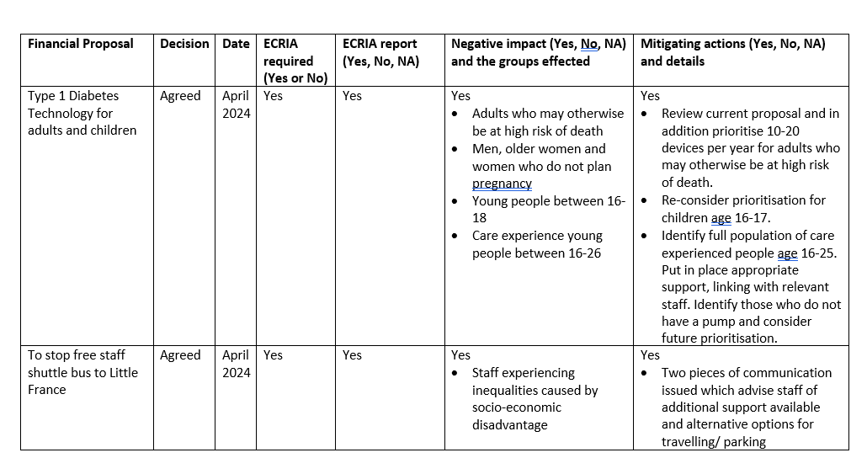
A steering group with representatives from the Value and Sustainability, Strategic Planning and Equality and Human Rights teams will review financial decision-making trackers and a sample of ECRIA reports on a quarterly basis and provide a report to FIG about compliance and any disproportionate cumulative impact on equality groups.
- Support
A wide range of guidance, flow charts, templates and evidence are available on NHS Lothian website. There is a MS Teams ECRIA Hub Team where staff can share information and get support to carry out ECRIAs. In person and online training is provided by the Equality and Human Rights Team by contacting loth.impactassessment@nhs.scot.
Flow chart: Embedding ECRIA into decision-making 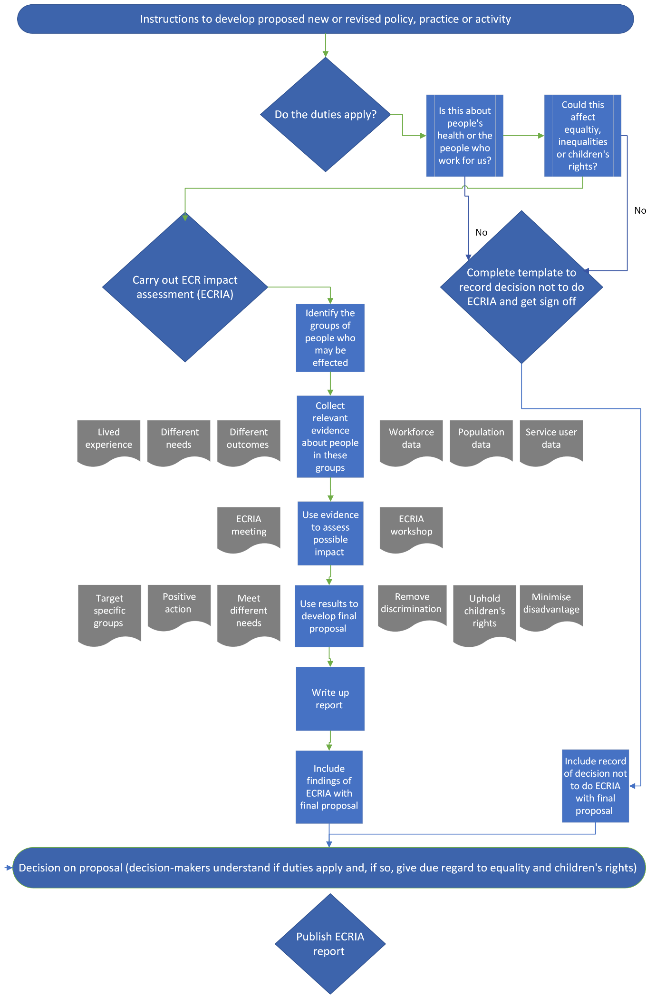
Flow chart: Decision-makers’ responsibilities
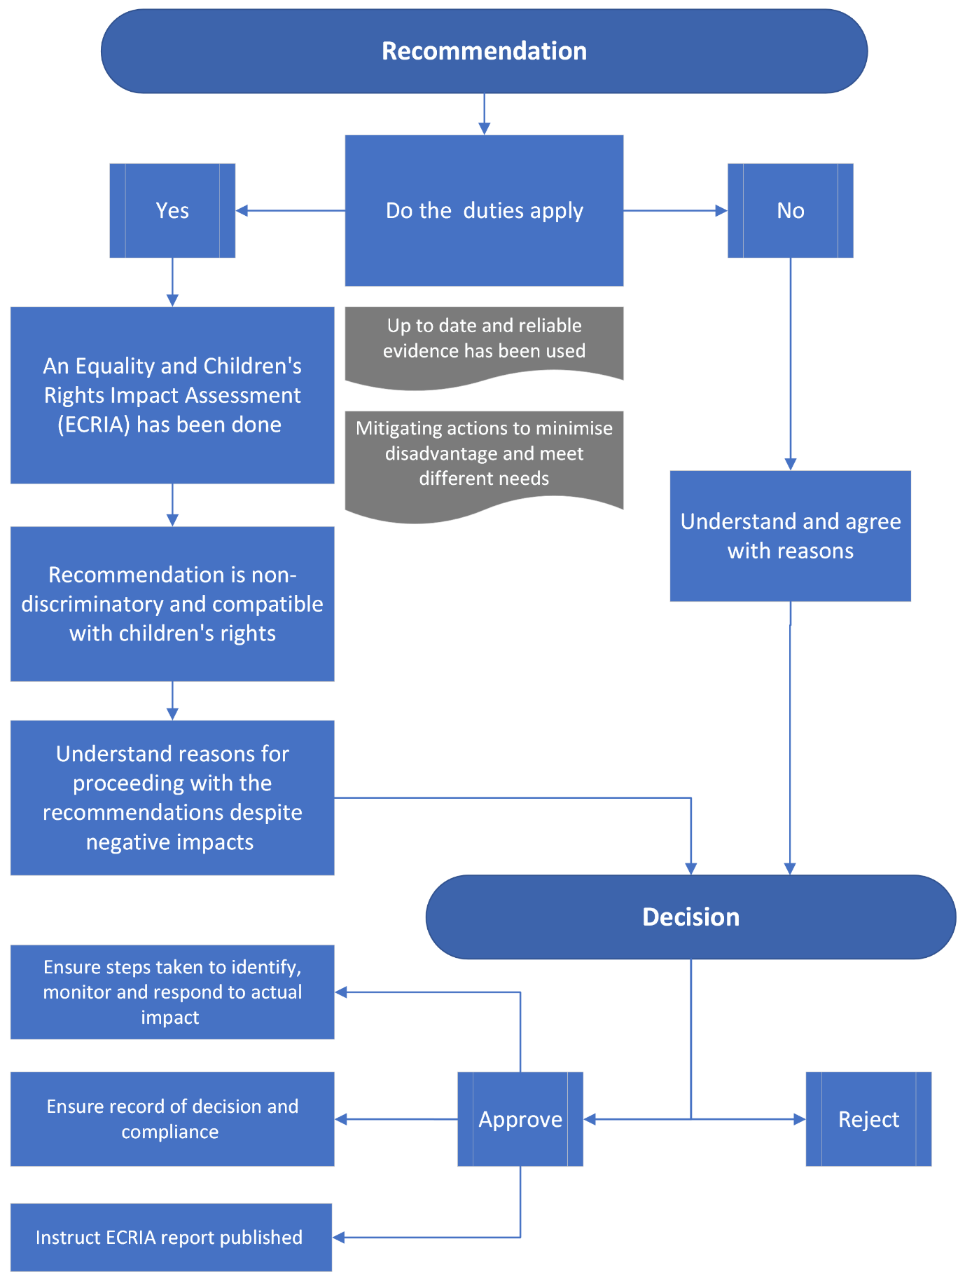

R (Brown) v Secretary of State for Work and Pension and others [2008] EWHC 3158, Aiken LJ at para 99.
Stuart Bracking and others v Secretary of State for Work and Pensions [2013] EWCA Civ 1345, McCombe LJ at para 61, approving Elias LJ in R (on the application of Hurley and Moore) v Secretary of State for Business, Innovation and Skills [2012] EWHC 201 (Admin).

